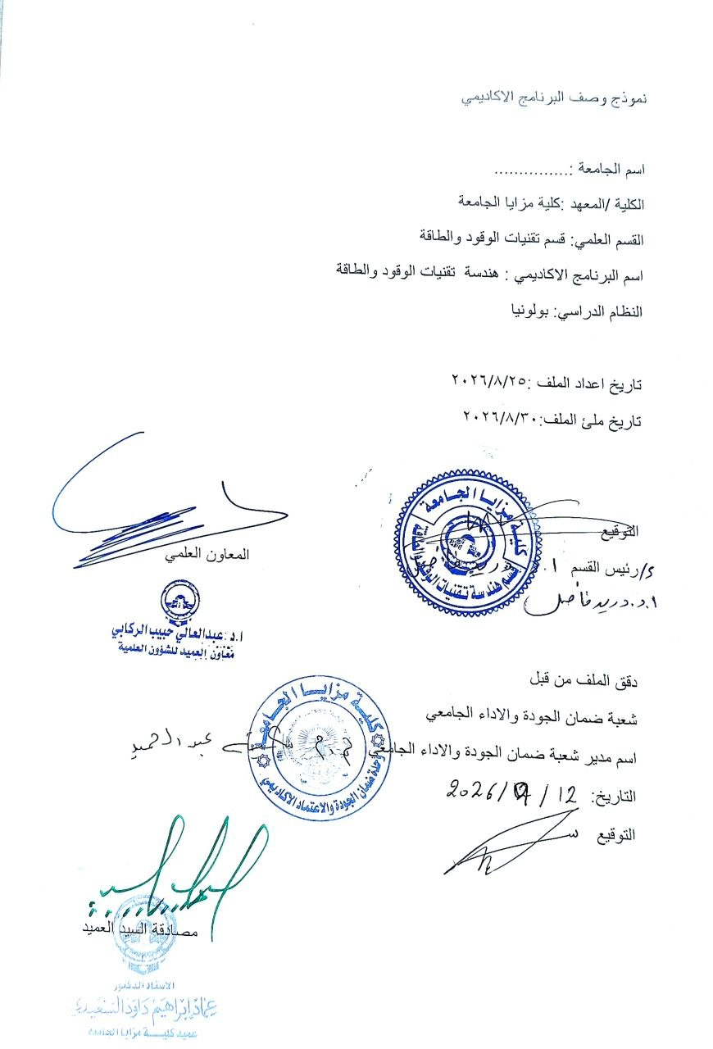
Modules Catalogue | 2025-2026 | دليل المواد الدراسية
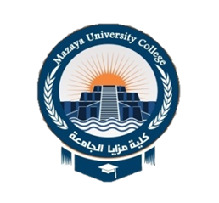
MAZAYA UNIVERSITY COLLAGE | 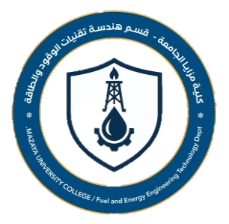
Bachelor's degree in Fuel and Energy
Technologies Engineering

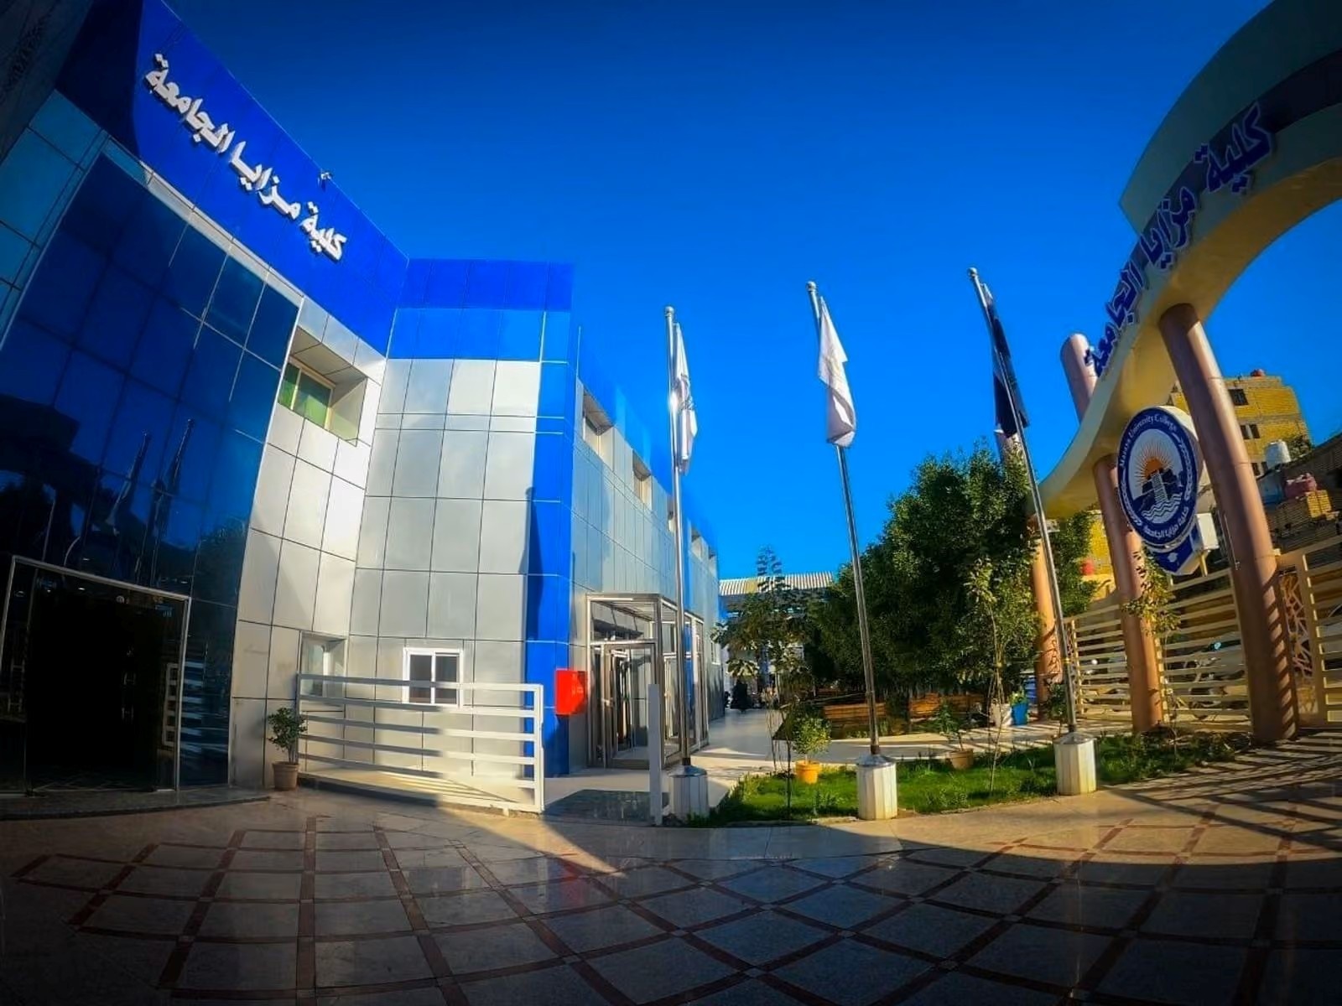

Table of Contents

- Overview
- Undergraduate Modules 2023-2024
- Contact

1. Overview
This catalogue is about the courses (modules) given by the program of Fuel and Energy
Technologies Engineering to gain the Bachelor of Science degree. The program delivers (40) Modules with (6000) total student workload hours and 240 total ECTS. The module delivery is based on the Bologna Process.
نظره عامه
يتناول هذا الدليل المواد الدراسية التي يقدمها برنامج تقنيات الوقود والطاقة للحصول على درجة بكالوريوس.
يقدم البرنامج (٤٠) مادة دراسية، على سبيل المثال، مع (٦٠٠٠) إجمالي ساعات حمل الطالب و ٢٤٠ إجمالي وحدات أوروبية. يعتمد تقديم المواد الدراسية على عملية بولونيا.

2. Undergraduate Courses 2025-2026

Module 1
Code | Course/Module Title | ECTS | Semester
FEE110 | Analytical Chemistry | 7 | 1
Class (hr/w) | Lect/Lab./Prac./Tutor | SSWL (hr/sem) | USWL (hr/w)
6 | 1 | 108 | 67
Description
This section includes a description of the module, 100-150 words

Module 2
Code | Course/Module Title | ECTS | Semester
BETC106 | Engineering Drawing | 6 | 1
Class (hr/w) | Lect/Lab./Prac./Tutor | SSWL (hr/sem) | USWL (hr/w)
6 | 0 | 93 | 57
Description
This section includes a description of the module, 100-150 words

Module 3
Code | Course/Module Title | ECTS | Semester
STU101 | English Language 1 | 2 | 1
Class (hr/w) | Lect/Lab./Prac./Tutor | SSWL (hr/sem) | USWL (hr/w)
2 | 0 | 32 | 18
Description
This section includes a description of the module, 100-150 words

Module 4
Code | Course/Module Title | ECTS | Semester
BETC107 | Physics | 6 | 1
Class (hr/w) | Lect/Lab./Prac./Tutor | SSWL (hr/sem) | USWL (hr/w)
4 | 0 | 62 | 88
Description
This section includes a description of the module, 100-150 words

.
.
.
.

Module 40
Code | Course/Module Title | ECTS | Semester
FEE409 | Industrial Unit Operation | 8 | 8
Class (hr/w) | Lect/Lab./Prac./Tutor | SSWL (hr/sem) | USWL (hr/w)
5 | 2 | 108 | 92
Description
This section includes a description of the module, 100-150 words

Contact

Program Manager:
Duraid | Ph.D. chemical engineering | prof.
Email: drduraid@tu.edu.iq
Mobile no.:07702622091

Program Coordinator:
| Ph.D. in fuel engineering|
Email:
Mobile no.:07823657117

