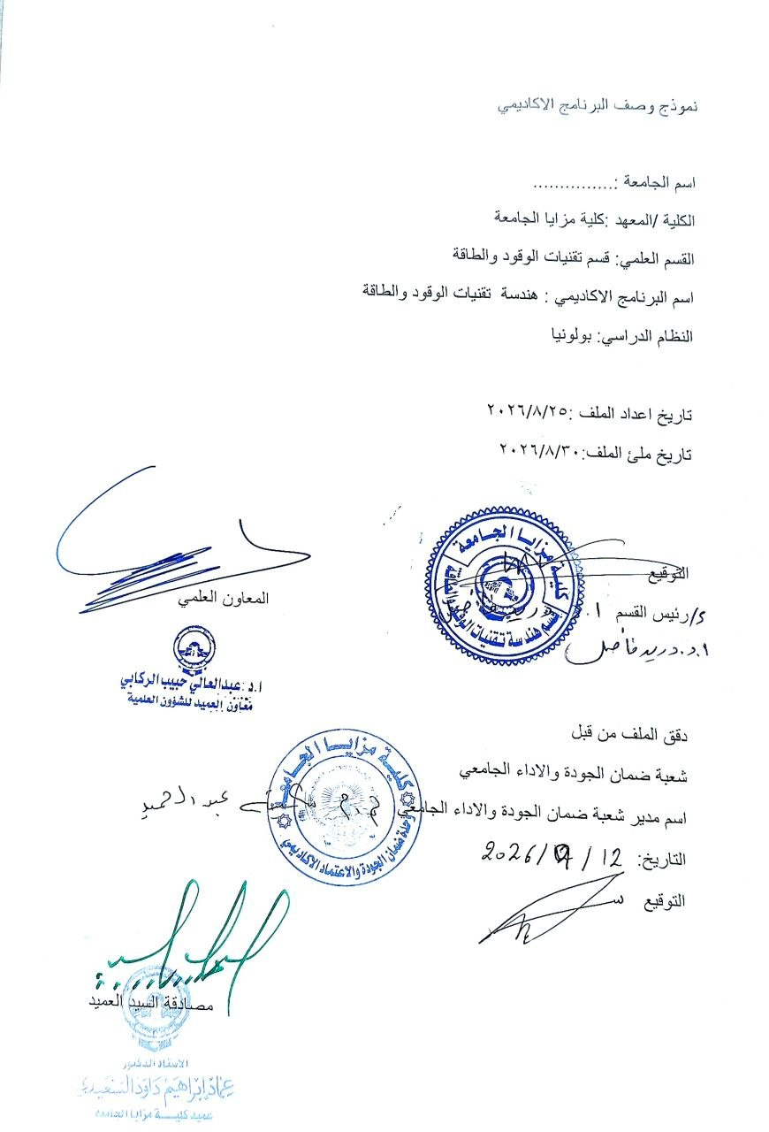

Program Catalogue | 2025-2026 | دليل البرنامج الدراسي
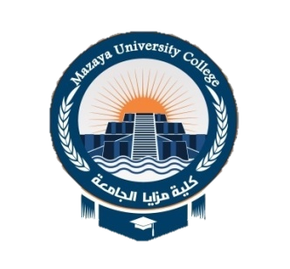
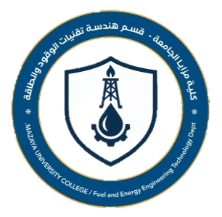
MAZAYA UNIVERSITY COLLAGE

Bachelor's degree in Fuel and Energy
Technologies Engineering

بكالوريوس في تقنيات الوقود والطاقة

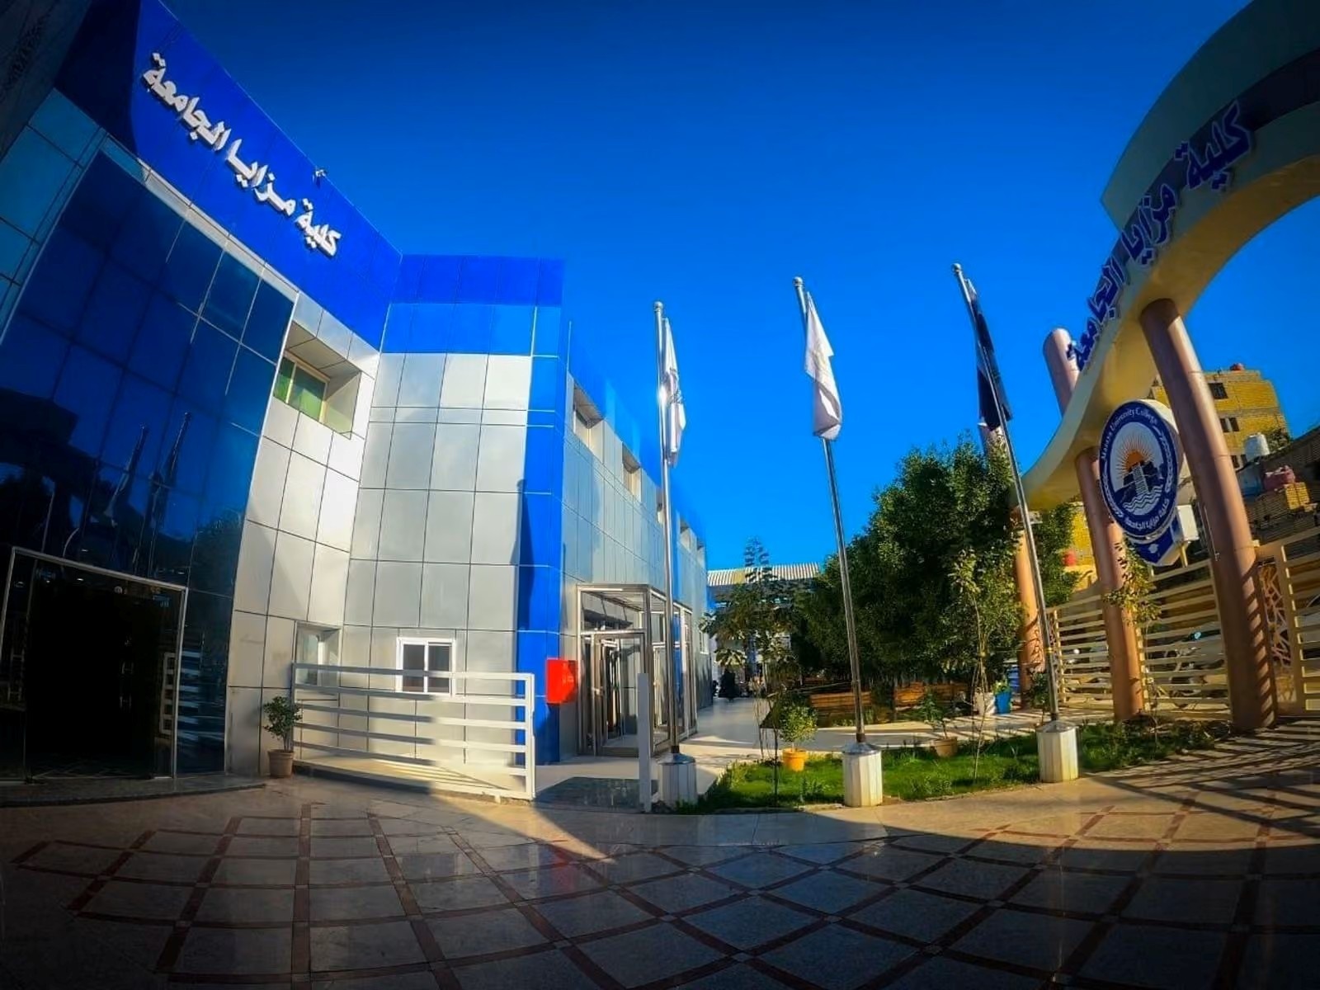

Table of Contents | جدول المحتويات

- Mission & Vision Statement | | بيان المهمة والرؤية
- Program Specification | | مواصفات البرنامج
- Program (Objectives) Goals | | أهداف البرنامج
- Program Student learning outcomes | | مخرجات تعلم الطالب
- Academic Staff | | الهيئة التدريسية
- Credits, Grading and GPA | | الاعتمادات والدرجات والمعدل التراكمي
- Modules | | المواد الدراسية
- Contact | | اتصال

Mission & Vision Statement

Vision Statement
Vision Statement
Be distinguished in the preparation of research and innovative technical cadres capable of achieving progress and sustainability in fuel and energy engineering
Mission Statement
The department of Fuel and Energy Engineering seeks to provide high-quality educational expertise to prepare fuel and energy cadres to meet the needs of the labor market with technical skills in education, research and community service

Program Specification

Fuel and Energy Technologies Engineering prepares students for careers in the fuel and energy
industries by providing them with skills to improve themselves. Thus, the student will have
extensive knowledge of refinery processing, petrochemicals, crude oil, and natural gas processing.
Fuel and energy courses are integrated into the curriculum. Developing and testing solutions to
improve industrial equipment to maximize petroleum refining Students will have the opportunity to
learn the principles of chemical engineering, energy engineering, and related materials, and they
will be prepared to keep pace with the development of modern methods required in the labor
market and companies dealing with the design, implementation, and operation of plants and
refineries. In addition, students will be equipped with knowledge of modern design techniques or
optimization of technical calculations for renewable energy in industrial settings
Level 1 exposes students to the fundamental principles of chemical engineering and chemistry, which
are suitable for progression to all programs within the department. Course-specific core topics are
covered at Level 2 and prepare for research-oriented subject modules at Levels 3 and 4. FEE
graduates are therefore trained to understand how research influences teaching, according to the
university's and department's mission statements. In levels 2, 3 and 4 FEE students cover mass
balance and energy balance after taking basic principles and covers knowledge of chemistry topics.
Students acquire skills in oil refining. Ultimately, FEE graduates will acquire knowledge and skills in
analyzing the thermodynamic cycles of steam power plants and understanding their construction.
The development of research principles begins and is developed through the implementation of
practical assignments, which are either integrated into lecture units or delivered through specialized
practical units, research seminars and tutorials. In levels 5 to 8, students acquire comprehensive
knowledge and skills related to equipment and reactor design. They develop the ability to analyze
and solve problems. In addition, they acquire knowledge of software applications and do their own
study to meet final project requirements.

Program Objectives
1. Graduating qualified and highly trained engineers capable of meeting the challenges in the fuel and energy engineering.
2. Conduct research and applied studies and encourage innovation in fuel and energyproduction.
3. Contributing to achieving the goals of sustainable development through the development of
renewable energy technologies and energy efficiency.
4. Building strategic partnerships to enhance cooperation between the academic and industrial sectors
5. Disseminating scientific knowledge in the field of sustainable energy

Student Learning Outcomes

The FEE program provides students with a solid foundation in the fuel and energy technology field, envisaging various employment capabilities and careers. Graduates have knowledge and skills in general FEE issues and, depending on the selected specialization, the knowledge and technical skills of FEE. They know the principles of fuel and sustainable energy and are well acquainted with the devices cooperating with refineries, power stations, and other related processes. They have knowledge of unit operation, measurement, and control engineering; they develop software skills and know how to design equipment and reactors They also have a basic knowledge of problems related to internal combustion engines and understand internal combustion engine methods and applications. They had the ability to deal with risks such as pollution, identify and assess risks in the workplace, and estimate damage and risks as a result of the explosion.
1. an ability to identify, formulate, and solve complex engineering problems in fuel and energy field by applying principles of engineering, science, and mathematics.
2. an ability to apply engineering design to produce solutions that meet specified needs with consideration of public health, safety, and welfare, as well as global, cultural, social, environmental, and economic factors.
3. an ability to communicate effectively with a range of audiences.
4. an ability to recognize ethical and professional responsibilities in engineering situations and make informed judgments, which must consider the impact of engineering solutions in global, economic, environmental, and societal contexts.
5. an ability to function effectively on a team whose members together provide leadership, create a collaborative and inclusive environment, establish goals, plan tasks, and meet objectives.
6. an ability to develop and conduct appropriate experimentation, analyze and interpret data, and use engineering judgment to draw conclusions.
7. an ability to acquire and apply new knowledge as needed, using appropriate learning strategies.

Academic Staff

Duraid fadil | Ph.D. chemical engineering | prof.
Email: drduraid@tu.edu.iq
Mobile:0772622091
Mahmod kamek / ph D chemical engineering
Mobile: 07823657117

Alla shehan / ph D fuel engineering
Mobile :07810804921
Waleed mohammed / msc mechanical engineering
mobile 07812388690
sukena abd / msc fuel engineering
mobile :

Credits, Grading and GPA
Credits
Southern Technical University is following the Bologna Process with the European Credit
Transfer System (ECTS) credit system. The total degree program number of ECTS is 240, 25
ECTS per semester

1 ECTS is equivalent to 25 hrs student workload, including structured and unstructured
workload.

Grading
Before the evaluation, the results are divided into two subgroups: pass and fail. Therefore,
the defined as follows results are independent of the students who failed a course.
The grading system is

GRADING SCHEME
مخطط الدرجات
Group | Grade | التقدير | Marks (%) | Definition
Success Group  (50 - 100) | A - Excellent | امتياز | 90 - 100 | Outstanding Performance
Success Group  (50 - 100) | B - Very Good | جيد جدا | 80 - 89 | Above average with some errors
Success Group  (50 - 100) | C - Good | جيد | 70 - 79 | Sound work with notable errors
Success Group  (50 - 100) | D - Satisfactory | متوسط | 60 - 69 | Fair but with major shortcomings
Success Group  (50 - 100) | E - Sufficient | مقبول | 50 - 59 | Work meets minimum criteria
Fail Group  (0 – 49) | FX – Fail | راسب - قيد المعالجة | (45-49) | More work required but credit awarded
Fail Group  (0 – 49) | F – Fail | راسب | (0-44) | Considerable amount of work required
Note:
Number Decimal places above or below 0.5 will be rounded to the higher or lower full mark (for example a mark of 54.5 will be rounded to 55, whereas a mark of 54.4 will be rounded to 54. The University has a policy NOT to condone "near-pass fails" so the only adjustment to marks awarded by the original marker(s) will be the automatic rounding outlined above.

Calculation of the Cumulative Grade Point Average (CGPA)
- The CGPA is calculated by the summation of each module score multiplied by its ECTS, all are divided by the program total ECTS.
CGPA of a 4-year B.Sc. degree:
CGPA = [ (1st ^{m}odule score x ECTS) + (2nd ^{m}odule score x ECTS) + ……] / 240

Curriculum/Modules

Contact

Program Manager:
Duraid | Ph.D. chemical engineering | prof.
Email: drduraid@tu.edu.iq
Mobile no.:07702622091

Program Coordinator:
| Ph.D. in fuel engineering|
Email:
Mobile no.:07823657117

