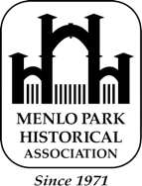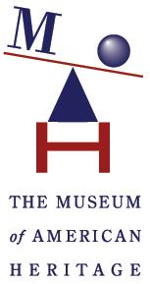
The Menlo Park Historical Association
in collaboration with The Museum of American Heritage bring you:
MidCentury Celebration Day!
Save the Date! Saturday, May 11, 2024
Where: The Museum of American Heritage (@ the Learning Center)
351 Homer Avenue, Palo Alto
Admission and talks are free, and midcentury attire is welcome.

Enjoy Exhibits: Midcentury Cars and Camper, Toasters, TV’s, Radios, and More
Special Focus: Sunset Magazine’s Influence on Menlo Park and Western Living
Raffles, Snacks, Talks, Music, Herman Miller furniture, and Prizes for best midcentury attire (optional)
Special Feature: Live Antiques-Roadshow-Inspired Valuations by Clars Auction Gallery

11:00 am: Doors open for Exhibits and people with scheduled valuations can bring in their items

11:15 to 11:30 am: Talk: Eichler and Other MCM Homes by Monique Anton & 1st Raffle

11:30 to 11:45 am: Talk: MCM Style by Deric Torres, Senior VP of Clars Auction Gallery & 2nd Raffle

11:45 to 1:20 pm: Six Valuation Sessions by Deric Torres of Clars Auction Gallery & 3rd Raffle

1:20 to 1:45 pm: Talk: Sunset Magazine, Midcentury Menlo Park, and Western Living & 4th Raffle

1:45 to 3:30 pm: Seven Valuation Sessions by Deric Torres of Clars Auction Gallery & 5th Raffle

Valuation Sessions are $30, for 1-3 items (sign-up for your session at www.mccelebration.com)
You may bring photos of large items. 100% of proceeds are fundraising for MP Historical Association.

PLEASE RESERVE YOUR VALUATION APPOINTMENT ASAP AS TIME SLOTS WILL GO FAST
We are proud to partner with Clars Auction Gallery to bring live fundraiser valuations sessions. Bring your midcentury treasures (Furniture & Decorative Arts, Fine Art, Jewelry, Timepieces). Clars' specialists have been featured on KVIE PBS (Valuation Days) and PBS television during Antiques Roadshow. Valuation Questions? Contact Talesa Eugenio at (510) 332-9619 or talesa@clars.com.
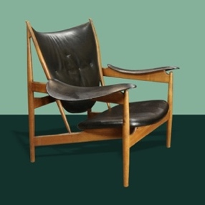 | 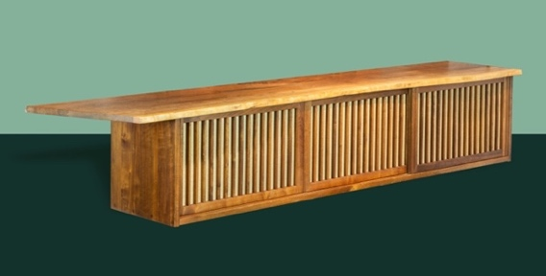 | 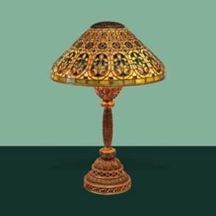
Finn Juhl for Niels Vodder  Chieftain chair. Sold: $83,200 | George Nakashima, 7' overhanging  walnut wall case, executed in 1971. Sold: $62,500 | Tiffany Studios Venetian table  lamp, circa 1910. Sold: $106,250
Special thanks to our sponsor Cheeky Monkey Toys

