
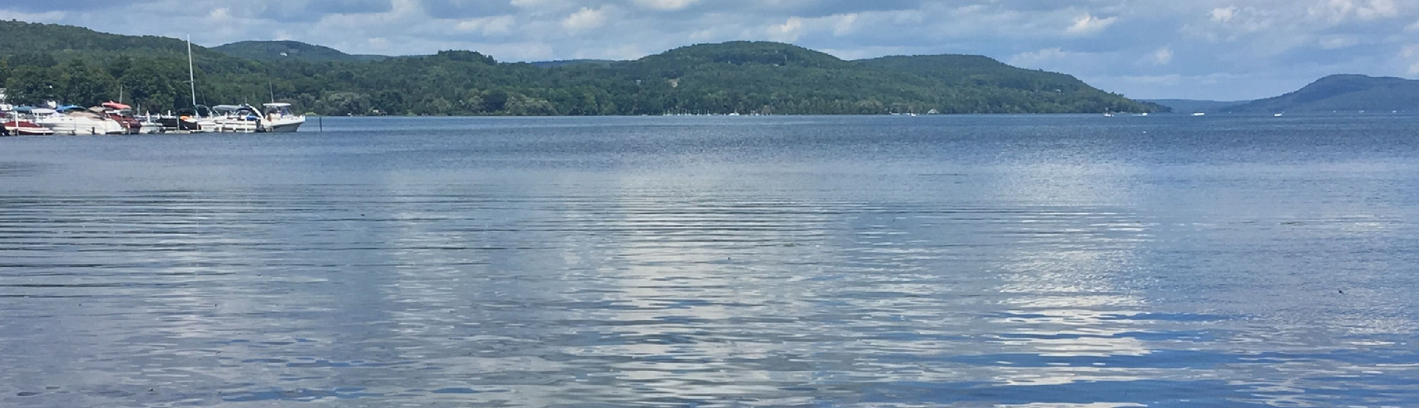
2026
C
O
M
P
R
E
H
E
N
S
I
V
E

P
L
A
N

U
P
D
A
T
E

8
1
1

C
o
u
n
t
y

H
w
y

2
6
F
l
y

C
r
e
e
k
,

N
Y

1
3
3
3
7
h
t
t
p
s
:
/
/
t
o
w
n
o
f
o
t
s
e
g
o
n
y
.
g
o
v
/
PREPARED BY

COMPREHENSIVE PLAN STEERING COMMITTEE &

MOHAWK VALLEY ECONOMIC DEVELOPMENT DISTRICT INC.
FUNDED IN PART BY A NEW YORK STATE DEPARTMENT OF
ENVIRONMENTAL CONSERVATION CLIMATE SMART
COMMUNITIES (NYSDEC CSC) GRANT PROGRAM, TITLE 15 OF THE
ENVIRONMENTAL PROTECTION FUND

PREPARED FOR TOWN BOARD

Table of Contents
Table of Contents………………………………………………………………………………..i ii
Description of the Town iii
Executive Summary………………………………………………………………………….....iv v

- Goals and Implementation Strategies
  - Local Economy and Agriculture………………………………………………..................1
  - Revitalization and Infrastructure…………………………………….…………................1
  - Transportation………………………………………………………….………..............1-2
  - Broadband……………………………………………………………………….............2-3 1.5 Recreation and Natural Resources………………………………………………...............3
  - Housing Diversity and Land Use……………… ……………………………………….3-5
  - Assessing Goal Achievement and Plan Feasibility…………………………..….............5-6
  - Implementation Schedule…………………………………………………………….....6-7
- Vision Statement…………………………………………………………………….......7-8
- Comprehensive Planning Process
  - Introduction to the Plan…………………………………………………….…...............8-9
  - Why a Comprehensive Plan?...............................................................................................9
  - Planning Process Timeline……………………………………………………………..9-11
  - Community Participation Plan…………………………………………...…………...11-12
  - Strengths, Weaknesses, Opportunities, Threats (SWOT) Analysis…………………..12-13
  - Community Survey
    - Survey Design…………………………………………………………...........14-15
    - Key themes of survey responses……………………………………….…......15-16
- Community Profile
  - Population Trends………………………………………………………...............…..16-17
  - Housing……………………………………………………………………………….17-20
  - Economic Development………………………………………………...….………...20-21
  - Transportation………………………………………………………………………...21-22
  - Cultural and Historic Resources……………………………………...………………22-24
  - Natural Resources
    - Agriculture…………………………………………………………………...24-25
    - Soils.……………………………………………………………………………..25
    - Eco Region…………………………………………………………………….....26
    - Critical Habitat………………………………………………...............................26
    - Culturally Relevant Environmental Assets……………………………………..….26
  - Land Use Trends…………………………………………………...…………………26-27
  - Community Facilities………………………...……………………………................28-29
  - Zoning Overview……………………………………………………………..............29-32
  - Stakeholders, Key Organizations, and Strategic Partners…………...……………….32-33
APPENDICES
Appendix A: Maps...................................................................................................................34-50
Appendix B: Community Survey.............................................................................................51-85
Appendix C: Public Meeting Materials...................................................................................86-134

Description of Town
The Town of Otsego was founded in 1788, making it the oldest Town in Otsego County. Its rich cultural history includes the Village of Cooperstown, located along the Town’s eastern edge. Judge Cooper and his son, author James Fenimore Cooper, were early residents. The Leatherstocking Tales describe the historic setting of Cooperstown and the Town of Otsego, with much of the landscape remaining the same as it was two hundred years ago. Fenimore Cooper’s novels have even inspired the names of area businesses, including Natty Bumpo,
Leatherstocking, and Glimmerglass. The National Baseball Hall of Fame, established 90 years ago in the Village, attracts hundreds of thousands of tourists annually. The Town’s arts, culture, and natural resources make the community a destination for many.
There has been an increase in manufacturing jobs and new companies throughout Otsego County since 1960. The Town of Otsego has been successful in preserving its small Town and rural charm amidst the changing jobs landscape. The Town has fostered sustainable community development, and protected its natural resources, including lakes, wetlands, forests, fens, and farmlands.
The Town of Otsego is well known for its historic character, natural beauty, and abundant community assets. Home to Bassett Hospital, two popular lakes (Otsego and Canadarago), and a vibrant arts and culture scene, it is a place residents are proud to call home, and visitors return to year after year. The Town’s many attractions and natural resources make it an attractive, livable community that is friendly to business and supportive of economic development. It is essential that future growth be guided by smart-growth principles so that new development enhances, rather than erodes, the Town’s historic setting, small-Town way of life, and native environmental quality.

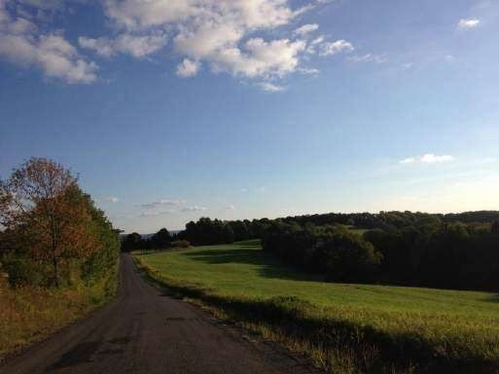

Executive Summary
The 2026 Comprehensive Plan serves as an update for the policy roadmap of Town of Otsego, bridging the original 2008 Comprehensive Plan with present day needs of the Town’s changing landscape. As the oldest Town in the county, Otsego prioritizes the preservation of rural character, historic assets, and natural beauty. The preservation of the Otsego and Canadarago Lake Watersheds are top of mind as the Town grows to attract more businesses, provide more abundant and affordable housing, and a more resilient, year-round economy. This plan serves as a unified roadmap, transitioning from the goals of the 2008 document to a system of actionable, data-driven strategies designed to balance modernization with the preservation of its cherished rural landscape and historic character.
Since the adoption of the 2008 plan, the community has faced challenges typical of smaller rural communities in New York State. There is a shortage of diverse housing options, specifically for seniors and young families. There are gaps in broadband infrastructure and access throughout the Town. As the Town grows, new vulnerabilities such as more frequent flooding and storm events with shifting weather patterns pose risks to the Town’s infrastructure and agricultural systems. This plan focuses on land use policies aligned with Smart Growth principles. These are strategies aimed at directing development towards existing hamlets, municipal centers, main streets and residential areas to prevent unchecked growth and development, also known as sprawl.
Key policy shifts of this plan include:

- Housing Diversity: Facilitating the development of Accessory Dwelling Units (ADUs) and adopting a Heritage Barn Law to allow for the adaptive reuse of historic agricultural structures.
- Environmental Resilience: Establishing a dedicated Lake Protection Zone and pursuing Climate Smart Community certification to improve energy efficiency and resource conservation.
•Infrastructure Modernization: Collaborating on county-wide broadband expansion and increasing equitable access to Electric Vehicle charging stations.
The goals outlined in this plan are heavily inspired by the community feedback gathered during the community participation steps of this planning process. The August 2025 Town wide survey, September 2025 visioning workshop, and public monthly meetings gathered public opinions and feedback. Unlike the 2008 plan, this version includes a structured implementation schedule assigning responsible parties, tasks and timelines to the outlined goals. To make sure this plan is carried on as a living document, the Town Board, Steering Committee and Planning Board commit to biennial reviews to assess progress, adjust policies, and pursue grant opportunities. This proactive framework will help maintain a community-oriented Town of Otsego for future generations.

1.0 Goals and Implementation Strategies

1.1 Local Economy and Agriculture
Create a shared local events calendar: Centralize all arts, culture, parks, and tourism/agritourism events on one page of the Town's website. This action will help the community stay better informed about events occurring throughout the Town and should increase support for the arts, cultural events, businesses, and nonprofit organizations in the area. This public facing event calendar ties into Climate Smart efforts. One example idea for the events calendar is as simple as posting a link to the “Celebrate Cooperstown” Facebook group or other social media pages.
Suggested Timeline: Ongoing. Responsible Party: Town Board
Create and expand signage for businesses and historic and cultural sites: The Town seeks funding to install visually appealing signage for culturally significant sites and businesses to encourage tourists and visitors to support by interacting with these assets. Suggested Timeline: Ongoing. Responsible Party: Town Board.
Find funding for agritourism opportunities: Agriculture is a dominant land use in the Town, and there is rising concern about farm succession. Who will inherit farms, and how will agricultural businesses thrive? To protect the economic development of farms and agricultural products, the Town specifically wants to identify and implement creative agritourism solutions. We would like to encourage and continue to promote events and attractions that focus on agritourism, specifically during peak tourist seasons. lSuggested Timeline: Ongoing. Responsible Party: Town Board.

1.2 Revitalization and Infrastructure
Provide high-quality Emergency Services: The Town will review impacts to emergency services anticipated during subdivision and site plan reviews for future construction, working with the local fire departments, highway departments, and the Sherriff’s Office. Suggested Timeline: Ongoing. Responsible Party: Town Board, Town Highway Department.
Climate Smart Communities (CSC) Task Force: A task force committee, in partnership with the MVEDD Climate Smart Communities team, was created in September 2025 to help the Town achieve CSC certification. Actions that support points in this plan include protecting drinking water, incorporating Smart Growth elements, promoting a safe and healthy community, assessing energy infrastructure to reduce greenhouse gas emissions, fostering equity in housing affordability, supporting alternative modes of transportation, and conserving natural areas, including lakes, watersheds, viewsheds, and landscapes. Suggested Timeline: ongoing. Responsible Party: Town Board, Climate Smart Task Force.

1.3 Transportation
Promote alternative modes of transportation: The Town will consider the installation of electric vehicle (EV) charging stations to support the transition to electric vehicles.
Specifically, the Town Board and CSC Task Force will research funding opportunities for EV charging stations in areas outside the Village of Cooperstown, where charging infrastructure is currently concentrated, to increase equitable access to EV charging. Increasing public awareness of transportation options through updated links on the
Town’s website and connecting community members to the Oneonta Public Transit and Otsego Express bus schedules are two priorities. Additionally, the Town seeks to compile rideshare programs and free transportation information to seniors and residents with limited means to travel. This will help increase access to healthcare, services, and shopping for essential needs.
Suggested Timeline: 2 Years. Responsible Party: Town Board.
Provide high-quality, efficient public services and infrastructure: The goal of the Infrastructure & Revitalization and Transportation subcommittee was to ensure and promote public safety in transportation. Goals are explained in greater detail below.
Highway maintenance: Review Town road construction standards and make necessary revision to meet the needs of rural roads. Ensure highway maintenance is ecologically responsible in the materials and plantings used on roadways. Review and consider public requests about reducing speed on certain roads. Evaluate the effects of new home construction on existing roads.
Suggested Timeline: Ongoing. Responsible Party: Town Board, Town Highway Department, Town, County, and New York State municipalities.
Roadway safety: Collaborate with Otsego County and the New York State Department of Transportation to identify funding for speed deterrents. Responsible Party: Highway Department, Town, County, and State municipalities.
Suggested Timeline: Ongoing. Responsible Party: Highway Department, Town, County, and State municipalities.
Consolidated Local Street and Highway Improvement Program (CHIPS): Set up annual meeting with the Association of Towns, NYS Senate and Assembly Transportation committees to advocate for more CHIPS reimbursement funding to match increasing costs of equipment, fuel, and construction materials.
Suggested Timeline: Ongoing. Responsible Party: Town Board, Highway Department.

1.4 Broadband
Increase broadband access to underserved areas: Collaborate with MVEDD and other community and industry partners to assess existing tools and programs to address broadband coverage issues. Residents and community members participated in a countywide broadband survey in 2025 and worked with the Otsego County Planning Department and Vernonburg Group to assess the best options and strategies for improving broadband access throughout the County.
Suggested Timeline: 1-Year. Responsible Party: Town Board.

1.5 Recreation and Natural Resources
Protect drinking water: Otsego Lake is located at the headwaters of the Susquehanna
River and is the drinking water source for many of the residents of the Town and the
Village of Cooperstown. The Otsego Lake Protection Plan is a municipal plan that the Town seeks to support through this Comprehensive Plan update. The Town will work with the Otsego Lake Watershed Supervisory Committee to ensure that winter road salt use, septic regulations, construction activities, traffic volume, and road maintenance do not compromise the lake’s drinking water quality.
Suggested Timeline: Ongoing. Responsible Party: Town Board Liaison to the Watershed Advisory Committee.
Increase lake protections: The original Comprehensive Plan of 2008 needed greater granularity in lake protections. The 2026 CP update seeks to clarify the zoning districts and establish a Lake Protection Zone, in addition to the Otsego Lake Protection Plan developed by the Susquehanna River Basin Commission. This goal will connect stakeholders collaborating on lake protections within the Town and broader Otsego County watershed.
Suggested Timeline: 1 year. Responsible Party: Town Board.
1.6 Housing Diversity and Land Use:
The Town of Otsego seeks to support the development of housing suitable for year-round residents, working families, and the Town's aging population. Approximately 31% of the Town's residents are age 65 or older, and about 17% are at or approaching retirement age. These demographic trends, together with rising housing costs and a gradual population decline, underscore the need for affordable, accessible, and lower maintenance housing options for working families and will allow older adults to remain in the community as their needs change. The Town seeks to expand and improve the quality and affordability of its housing stock without disrupting the integrity of its cherished landscape and watershed. With these goals in mind, the Town seeks to strengthen existing neighborhoods, avoid sprawl, facilitate multifamily and accessible housing, and allow existing residents to increase the usefulness of their lots through accessory dwellings and adaptive reuse. The zoning changes described below are intended to support these housing needs while guiding growth toward the town’s hamlets and other defined areas.
Short Term Rentals:
Explore new short-term (a period of less than 30 days) rental ordinances that reinforce and strengthen the residential quality of the Town of Otsego. Ordinances may include owner-occupancy, local (Town or County) ownership, grandfathering of existing business (until such grandfathered property is sold), regulations based on density of certain areas of the Town, etc.).
Suggested Timeline: 2 years. Responsible Party: Town, Planning and Zoning Boards
Accessory Dwelling Units (ADUs):
Update the Town of Otsego Land Use Laws addressing primary dwellings to facilitate the development of Accessory Dwelling Units (ADUs). Specifically, establish a formal definition of an Accessory Dwelling Unit in the Town of Otsego, and define a special permit for developing such units. Suggested Timeline: 1 year. Responsible Party: Zoning Board.
Hamlet Development:
Update the Town of Otsego Land Use Laws, which currently stipulate minimum lot sizes in hamlets, to facilitate greater housing density. Changes include, but need not be limited to, the following:
In recognition that New York State already imposes minimum spacing requirements between wells and septic systems, consider eliminating minimum lot sizes within the designated Hamlets. Remove existing restrictions on the number of allowable conjoined units and revise laws to support multi-family housing, including duplexes, triplexes, townhomes, and small apartment buildings. Review and consider revising surface parking requirements for housing projects proposed within 1000’ of a public transit location.
Suggested Timeline: Ongoing. Responsible Party: Town and Zoning Boards.
Agricultural (AG) Zone Density: The Town seeks to update the Agricultural (AG) Zones to preserve open space, respect historical patterns of development and habitation, and enable low-footprint housing growth in appropriate rural areas. To that end, the Town recommends the following changes:
Updated Zoning: Update Town of Otsego Land Use Laws. While recognizing the rights of property owners, the Town encourages subdivision patterns that preserve the rural landscape, protect agricultural lands and natural resources, allows for open space and that will recognize the need for additional infrastructure and long-term maintenance.
Density and Clustering: Review and revise land use laws to remove limitations on density and clustering. The Town seeks to encourage compact, community-centered development patterns rather than dispersed sprawl. While the Town seeks to monitor the subdivision of large lots, it also seeks to encourage development that minimizes its footprint on the landscape and reduces long-term infrastructure maintenance burdens. This requires supporting the development of conjoined housing, such as duplexes, triplexes, townhomes, and condominiums; incentivizing denser housing clusters over sprawl, especially when reviewing documents of larger scope or visual significance; and reviewing, removing, or adding greater specificity to the “Density Bonus” section of the existing Land Use Law. Any density bonus should provide a meaningful incentive for beneficial clustering and be paired with a meaningful disincentive to sprawl.
Heritage Barn Law: Review, revise, and assume a Heritage Barn Law intended to facilitate the adaptive reuse of the Town of Otsego's historic buildings in a manner respectful of their architectural vernacular. Specifically, create a regular path to review and permit adaptive conversions of heritage architectural buildings to single and multi-family housing, exempt from existing restrictions on lot size, occupancy, or the primary dwelling.
Suggested Timeline: 2 Years. Responsible Party: Town,Planning and Zoning Boards.
Sewers and Water Infrastructure for Future Development: Initiate review of feasibility, need, and available resources to support a sewer system or systems within hamlets of the Town of Otsego. This Smart Growth goal will support more sustainable development.
Suggested Timeline: 3 Years. Responsible Party: Town Board.

1.7 Assessing Goal Achievement and Plan Feasibility
Since adopting the 2008 Comprehensive Plan, the Town of Otsego has made meaningful progress toward several key goals. This plan update builds on that foundation by introducing a more detailed implementation schedule for housing affordability and diversity goals, with clear timelines for each recommended action. This structured approach replaces broad aspirations with greater accountability and supports measurable progress toward the community's long-term vision. This emphasis on timelines draws on best practices reflected in the Town of Middlefield’s Comprehensive Plan and New York State Department of State Smart Growth guidance documents.
To keep local laws aligned with this evolving vision, the Town commits to regular reviews either annually or every two years. Representatives from the Planning Board, Tax Assessor, Zoning Board of Appeals (ZBA), and Zoning Enforcement Officer (ZEO) will meet with the Town Board to assess alignment, recommend necessary changes, seek grant funding, propose budget adjustments, and maintain open communication among all implementing bodies.
The following Implementation Schedule is arranged by numbered program area, then by its goal/action, timeline, and responsible party.
1.8 Implementation Schedule

1.1 Local Economy and Agriculture
Create a shared local events calendar
Timeline: Ongoing
Responsible Party: Town Board
Create and expand signage for businesses and historic/cultural sites
Timeline: 1 year
Responsible Party: Town Board
Find funding for agritourism opportunities
Timeline: 1 year
Responsible Party: Town Board

1.2 Revitalization and Infrastructure
Review impacts to emergency services during subdivision and site plan review
Timeline: Ongoing
Responsible Party: Town Board
Expand the existing Climate Smart Communities Task Force and pursue certification actions Timeline: 1 year
Responsible Party: Town Board and Climate SmartTask Force Committee

1.3 Transportation
Promote alternative transportation, including EV charging, transit information, and rideshare resources
Timeline: 2 years
Responsible Party: Town Board
Review highway maintenance standards and roadway safety measures Timeline: Ongoing
Responsible Party: Highway Department, County and Town Municipalities
Advocate for increased CHIPS reimbursement funding
Timeline: Annual
Responsible Party: Town Board and Highway Department

1.4 Broadband
Increase broadband access to underserved areas
Timeline: 1 year
Responsible Party: Town Board

1.5 Recreation and Natural Resources
Protect drinking water by active participation and cooperation with the existing water resource watchdogs eg. Watershed Supervisory Committee, OCCA, Biology Field Station
Timeline: Ongoing
Responsible Party: Town Board
Increase lake protections - see groups mentioned above
Timeline: Ongoing
Responsible Party: Town Board

1.6 Housing Diversity and Land Use
Review and consider updates to Agricultural District regulations that encourage conservation-minded subdivision of larger parcels (or parcels) 40 acres or larger while balancing private property right Timeline: 1 year
Responsible Party: Town Board
Update hamlet development standards to support greater housing density
Timeline: 1 year
Responsible Party :Town Board
Update AG Zone subdivision and clustering standards
Timeline: 1 year
Responsible Party: Town & County Boards
Adopt a Heritage Barn Law for adaptive reuse
Timeline: 2 years
Responsible Party: Town Board
Study sewer and water infrastructure feasibility for future development
Timeline: 3 years
Responsible Party: Town Board
Facilitate Accessory Dwelling Units (ADUs) with the community’s goal of maintaining the Town’s rural character, natural resources, and open spaces
Timeline: 1 year
Responsible Party: Town and Planning Boards

2. Vision Statement
Nestled between the lakes and framed by our historic Hamlet, Village, and the natural beauty of the Northern Appalachian Plateau, our community is defined by a rich diversity of assets that we must carefully manage. This is our vision, the touchstone for our shared future.
We, the citizens of the Town of Otsego, cherish and wish to preserve our rural and natural landscape and are committed to its protection. We foresee a place of safety for our families, neighbors and friends. We want plentiful, accessible open spaces for future generations.
Agriculture remains central to our heritage and identity; we see it as a defining part of life in our Town. We respect our traditions and history and seek to preserve our historic architecture and the distinct sense of place that it creates. We wish to encourage new development that honors how our hamlets have looked throughout their long history. We promote careful design and placement of new buildings to complement and harmonize with existing structures. We, the citizens of the Town of Otsego, are committed to the future of our Town and are proud of our strong community identity.
We envision a future in which the Town of Otsego continues to offer a clean environment, a beautiful landscape, and a preserved rural setting. We therefore want to carefully manage growth and development, while maintaining access to natural areas.
We desire to support the development of housing suitable for year-round residents, working families, and our aging population. The Town hopes to expand and improve the quality and affordability of our housing stock without disrupting the integrity of our cherished landscape and watershed. With those housing goals in mind, we aim to grow our existing neighborhoods, avoid sprawl, facilitate multi-family housing and accessible, affordable housing, and allow existing residents to increase the usefulness of their lots through accessory dwellings and adaptive reuse.
We hope to promote increased year-round recreational and cultural opportunities, including biking, hiking, and walking trails, as well as ample access to Otsego and Canadarago Lakes. We foresee residents and visitors enjoying even more access to the arts and cultural events. We imagine accessibility as a key component of our recreational and cultural opportunities.
We want well-built, well-maintained roads that reflect our natural and historic heritage. We want traffic volume and speed control to harmonize and accommodate essential residential and business transportation needs.
We expect a Town government that works to provide both public services and reasonable taxes. We envision the Town working even more collaboratively with neighboring towns and villages across the Leatherstocking Region, promoting one another’s local businesses, services, attractions, and community assets.

3. Comprehensive Planning Process

3.1 Introduction
The Town of Otsego begins this update of the previous 2008 Comprehensive Plan with a shared commitment to guiding thoughtful growth for current residents and future generations. Across our hamlets and Town center, residents shared a clear vision for sustainable, well-managed growth through public meetings, visioning workshops, and a community survey. Funded in part by a New York State Department of Environmental Conservation Climate Smart Communities (NYSDEC CSC) grant, this plan outlines the Town's priorities and strategies to achieve the three “Es” of sustainability: Environment, economy, and equity. Comprehensive plans are intended to move municipalities toward sustainable growth. However, it is also important for these plans to consider adapting to increasing flooding events, tornadoes, and overall changes in weather patterns. This plan is also designed to focus on smart growth principles, an approach to development that limits growth to existing municipal centers with infrastructure rather than spreading out unchecked into farmland and natural areas. It invests in public spaces, diverse housing for every life stage, and mixed-use places that bring daily activities closer together. This plan seeks to define what the Town is like today, a vision for what it can become, and provide a roadmap of actions and goals to get there.
A baseline assessment completed in 2025 documented existing conditions in housing, land use, economic development, natural and cultural assets, energy infrastructure, transportation, and climate vulnerabilities, informing the Strengths, Weaknesses, Opportunities, Threats (SWOT) analysis and community profile later in this document. Housing Diversity and Affordability was a major priority for this plan, with the Housing Subcommittee creating a detailed action plan and timeline, including responsible parties, to improve the Town over the next three years.
Hazard Mitigation Plan (HMP) A HMP was updated in the Spring of 2026. It identified primary and alternate HMP points of contact and developed this plan over the course of several months, with input from many Town departments. This jurisdictional annex to the Otsego County Hazard Mitigation Plan (HMP) provides information to assist public and private sectors in the Town of Otsego with reducing losses from future hazard events. This annex is not guidance of what to do when a disaster occurs; its focus is on actions that can be implemented prior to a disaster to reduce or eliminate damage to property and people. The annex presents a general overview of Otsego, describes who participated in the planning process, assesses Otsego’s risk, vulnerability, and capabilities, and outlines a strategy for achieving a more resilient community.
Building on the strong foundation of the 2008 Comprehensive Plan, this 2026 update integrates survey data and data-driven baseline assessments in key topic areas to improve the Town's vision and goals. The Town seeks to remain anchored in its uniquely agricultural, historic, and cultural assets in Cooperstown and nearby hamlets. As the Town addresses shifting environmental landscapes, tackles housing equity, promotes smart growth, and finds creative ways to protect natural resources, there are opportunities to implement best practices for a more sustainable and accessible future. In anticipation of potential solar farm applications to our Town, a Regulating Solar Energy Systems Law was adopted in February 2026 .
3.2 Why a Comprehensive Plan?
Comprehensive Plans are policy frameworks that ask big questions. They identify potential problems in the community and determine an equitable and strategic path action plan with goals shaped by the community vision. This plan serves as the policy framework for the Town's leaders, municipalities, and partners to address current problems and build systems that balance economic growth with the natural environment and other key priorities outlined by the community. The purpose of this Comprehensive Plan is to guide future decisions in a manner that aligns with community goals, values and the Town's long-term vision.

3.3 Planning Process Timeline
The Town of Otsego began this project through a strategic partnership with the
Otsego County Conservation Association (OCCA) and the Mohawk Valley Economic
Development District, Inc. (MVEDD). Funded by a grant from the New York State
Department of Environmental Conservation through the Climate Smart Communities
(CSC) initiative, this project was designed to modernize our local planning framework. This funding allowed the Town Board to hire expert consultants to lead meetings, engage stakeholders, and facilitate the writing and revision of its 2008 Comprehensive Plan.
The project originally began in 2024 but underwent a planned one-year pause while several Town officials transitioned in and out of office. Since restarting the comprehensive planning process, the Town has worked diligently to build upon the original plan. While the 2008 plan included a build-out analysis that remains a relevant reference for our land-use laws, this 2026 update focuses on establishing new goals and zoning policies to protect and sustainably grow the Town. Other examples of this shift in priorities, aligned with the community vision, underscore the need for continued attention and adjustment to form a path forward.
To lead in this effort, the Town Board established a Comprehensive Plan Steering Committee. This committee was organized into three distinct subcommittees to address the specific needs of our community. One group focused on “Housing and Economic Development,” while another addressed “Arts and Culture and Parks and Farmland.” A third group was dedicated to “Infrastructure and Revitalization.” These committees collaborated with consultants to analyze where the Town is now, where we want to grow, and how we will get there. The committees represent the key community priorities and shared goals. The Town followed a structured timeline to ensure community values were integrated throughout the planning processes:
- February 2024: Comprehensive Plan Steering Committee met to outline steps going forward on the update to the 2008 CP.
- July 2025: Held public visioning workshops and distributed a community survey to gather input and data on the planning process.
- August 2025: Hosted an open house to refine goals and review survey findings.
- Fall 2025: Subcommittees evaluated zoning modifications and developed implementation strategies for housing, infrastructure, and the arts regularly.
- November 2025: Continued public meetings and ongoing steering committee workshops to receive feedback on the plan.
- December 2025: Completed the first full draft of the plan.
- Early 2026: The Town Board and Planning Board conducted final reviews of the drafted plan, offering individual feedback.
- June 2026: Held a public hearing regarding the plan.
This Comprehensive Plan update aligns with New York State Town Law Section 272a and integrates modern sustainability elements, including Smart Growth, alternative transportation, and resource conservation. In developing this update, the Town Board and consultants studied comprehensive plans from neighboring communities, specifically the Town of Middlefield and the Village of Richfield Springs, to adopt best practices. A new community profile and public outreach plan were established to ensure the public remained informed and included throughout the process.
A thorough baseline assessment was conducted in 2025 to analyze existing conditions in land use, infrastructure, and natural resources. As a Climate Smart Community, the Town also analyzed energy resources and climate vulnerabilities. The final plan underwent a State Environmental Quality Review Act (SEQRA) process before adoption. This structured approach ensured that our plan reflects community values and meets state standards while positioning the Town of Otsego for Climate Smart Communities certification and future infrastructure funding.
The plan is designed to welcome and encourage continued community participation. Ongoing public participation helps ensure that future decisions continue to reflect the community priorities identified in the survey and visioning workshops. We invite residents to reach out to members of the Town Board to join future subcommittee or steering committee meetings. This plan is a result of a multi-year collaborative effort and provides a clear roadmap for a resilient and sustainable future.

3.4 Community Participation Plan
Community participation is crucial to a plan's success, and the values gathered through the survey are reflected throughout this document's vision, goals, and implementation strategies. The plan is strengthened by the consistent involvement of residents, stakeholders, and local officials throughout the planning process. The Steering Committee prioritized a list of influential community stakeholders, including members and employees of nonprofit organizations, farmers, local leaders, business owners, and municipal officials.
The planning process invited many of these stakeholders onto the Steering Committee, other subcommittees, and visioning workshops. The dedicated volunteer efforts of numerous community members and the diligent work of the committees, Planning Board, and Town Board helped the Town identify its strengths, weaknesses, opportunities, and threats. As the lead consultant, MVEDD guided the public engagement process and developed accessible resources on Climate Smart Communities and comprehensive planning to help the community define its long‑term vision.
Upon receiving feedback from the Steering Committee, MVEDD distributed a community survey to gather relevant opinions on three core topics: Who we are, who we want to be, and where we are going. The survey results were used to define what the Town means to its residents and what their vision for the future is. The Steering Committee and subcommittees met consistently throughout 2025, and the public was encouraged to attend every session. All public and stakeholder input, along with consultant recommendations, were included in the Strengths, Weaknesses, Opportunities, and Threats (SWOT) analysis. Our visioning workshops included a detailed review of the 2008 plan's vision and goals, as well as consultant recommendations based on the survey results and the Town's baseline assessment. This participation plan also supported strategies that create harmony between our rural character and our desire to grow sustainably and remain safe while protecting our natural and economic assets.
The results of the survey, public meetings, and SWOT analysis were compiled into a list of opportunities and goals that the Steering Committee prioritized for actionable implementation. Transparency is a core value of the Town for all its engagement efforts, and all meeting notes and materials are available on the Town of Otsego website for convenient knowledge sharing. Detailed notes for all public meetings are included in the appendices. This community participation plan was vital for gathering resident input to improve equity and knowledge sharing, and we believe this process has ensured a true reflection of the Town's community values.

3.5 SWOT Analysis
The SWOT analysis is a cornerstone of this planning process and provides a clear picture of where the Town of Otsego stands today. By analyzing internal strengths and weaknesses alongside external opportunities and threats, the Town has created a foundation for goals that are both realistic and ambitious. This analysis was based on extensive data gathered from the community survey and the work of the three subcommittees.
The Town’s strengths are deeply rooted in the natural beauty and historic character of our region. Residents consistently identified Otsego Lake, Canadarago Lake, natural resources, our rolling agricultural landscapes, Cooperstown, and Fly Creek as the most valuable natural assets we possess. There is a profound sense of community pride and a strong spirit of volunteerism that fuels our local organizations and our municipal boards. The Town’s proximity to world-class cultural institutions, including The Fenimore Museum, The Fenimore Farm & Village, The Baseball Hall of Fame, and The Glimmerglass Festival, provides a unique economic and social engine. These assets are important to the Town’s identity and to both residents and visitors.
However, some weaknesses must be addressed to ensure a resilient future. The community survey highlighted a critical lack of housing diversity and a specific need for senior housing and affordable options for young families. Many residents expressed concern over the rising cost of living and the difficulty of maintaining infrastructure with limited resources. There are also gaps in our current zoning laws that leave the Town’s natural resources vulnerable to sprawl and unchecked development. Our Infrastructure and Revitalization subcommittee noted that without strategic investment in our water and sewer systems, we will continue to struggle to support the growth our community seeks.
The opportunities before us are significant. This Department of State grant funding allows us to modernize certain land-use policies and position the Town for future infrastructure and energy efficiency investments. We have the chance to expand our agritourism and our arts and culture sectors to create a more diverse yet stable local economy. By implementing Smart Growth principles, we can aim to guide sustainable development within the existing hamlet and preserve our vital farmland and open spaces. There is also a great opportunity to strengthen our partnerships with Otsego County, the Village of Cooperstown, and our neighboring Towns to address shared challenges in transportation and housing equity. In addition, the Town is involved in the Climate Smart Communities program.
Finally, we must be mindful of the threats that could impact our quality of life and our economic stability. Environmental risks such as increased flooding and changing weather patterns pose a direct threat to our roads, our water quality, and our agricultural productivity. Unchecked large-scale subdivisions and overdevelopment could erode the roads and rural charm that define our Town, putting undue pressure on our natural resources. Solar structures and the impact of Artificial Intelligence on our community will need careful scrutiny. The potential for pollution in the Otsego and Canadarago Lake watersheds remains a primary concern for residents, many of whom rely on these lakes for drinking water, recreation, and economic viability. By identifying these threats now, we can create actionable strategies to mitigate their impact and ensure that Otsego remains a safe and healthy community for generations to come.

Natural Resources and Environmental Resilience
The Town’s natural beauty is reflected in its scenic ridgelines, Otsego and Canadarago Lakes, and working farms. The Town has demonstrated leadership in sustainability by forming a Climate Smart Communities Task Force and committing to smart growth. At the same time, current weaknesses include limited land protection measures, including the absence of stream corridor regulations and insufficient protection of drinking water sources. These conditions present an opportunity to work with local conservation partners, including Otsego 2000, the Otsego County Conservation Association, and the Otsego Land Trust, to acquire floodplains and recreation parcels for hiking and birding trails. Doing so could improve flood resilience and public access to nature. Timely action will be important to address these issues and reduce future risk. The Town also faces threats from development that could affect prime farmland, rural character, and vital watersheds. Unchecked ridgeline development is inconsistent with the Town’s long-term vision and may be addressed through stronger zoning.

Economic Vitality and Agriculture
The Town of Otsego benefits from a robust tourism economy and a rich cultural heritage centered around our historic districts, museums, and lake recreation. We have strong agricultural potential with quality soil and a community that deeply supports its farmers. Our primary weakness remains a heavy dependence on seasonal tourism, which leads to limited year-round economic activity and a lack of dedicated zoning for lake oriented businesses and housing (such as marinas and short-term rentals). We see an opportunity to diversify our economy by supporting agritourism, niche crops, and value added products. In addition, we may expand our farmers’ market and consider creating a strategic plan for farm succession to help stabilize our agricultural base. Lastly, we must address the following threats: high property taxes and an aging agricultural workforce. These factors could force the conversion of farmland into non-agricultural uses.

Housing and Infrastructure
Our strengths include a high-quality housing stock and the preservation of historic homes, most of which were built before 1938. Our communities feature well‑maintained neighborhoods that are clean, welcoming, and safe. Ongoing volunteer efforts have contributed to the maintenance and continued use of these spaces. However, there are weaknesses in housing and infrastructure. The Town faces a gap in senior and affordable housing. This threat is addressed with action items in the goals and implementation strategies section of this plan. The Town also faces an affordability crisis because the affordability index is 4.84, twice as high as the rest of Otsego County, identifying the gap in house prices and average annual income of families. With an aging housing stock and homes priced higher than the rest of Otsego County, young families struggle to move to the Town, thereby limiting overall population growth. The Town has a steady population, with year-round residents never exceeding 4,000. However, this plan aims to address future population growth and housing needs and is outlined in the Community Profile.

3.6 Community Survey

3.6.1 Survey Design
This survey was designed to gather community perspectives on identity, needs, and the Town's future vision. The questions were open-ended and intended to invite detailed responses. There were 15 questions in total, including six focused on community vision and local assets, six focused on demographics and housing equity, and three focused on interest in community participation, volunteering, and subcommittee involvement. To support a plan that reflects community priorities, the Town gathered data on the local economy, housing needs, social equity, and sense of place. This survey provided important input that informed the plan’s response to economic, environmental, and equity-related challenges and helped ensure that the plan reflects documented community needs and priorities.

3.6.2 Key Themes of Survey Responses
The priorities were ranked according to the frequency of mentions in survey responses. Goals mentioned more often were considered more important and given a higher ranking for inclusion in the plan. The final survey and results are in Appendix B.
Key themes from the survey responses included:
- Environmental Protection
- Housing Equity and Accessibility
- Economic Development
- Infrastructure
- Social Connectivity
What We Heard
Top Actionable Priorities
- Affordable housing (including senior options)
- Protection for Otsego Lake, Canadarago Lake, and natural resources
- Improved infrastructure (roads, bridges, and related facilities)
Top Community Values and Assets:
- Rural Character
- Scenic beauty
- Preservation of agricultural lands
- Cultural assets, such as our historic hamlets and lakes
- Lakes and streams
Key Concerns:
- Overdevelopment
- Water quality
- Loss of small-Town identity
- Desiring thoughtful growth and stronger zoning enforcement
Suggested and Desired Improvements:
- Expanded recreational opportunities (parks, trails)
- Preservation of Open Spaces
- Better zoning and code enforcement
- More diverse local businesses
The results of the survey clearly show residents’ desire for growth, while pointing to gaps in senior housing, a dedication to protecting natural resources, and a preference for smart growth principles. Town residents cherish the landscape, the historic places, and the small businesses. Supporting infrastructure improvements for better EMS service emerged as a priority topic. Possible future housing developments, alignment with zoning, preservation of Town character, and smart growth principles were recurring topics. Survey responses consistently identified lake health as one of the community’s top priorities and a definitive feature of the Town. As a result, residents spoke up about their strong desire to mandate protections for both lakes, the watersheds, and water quality. Protecting drinking water is a priority of this plan and the community.

4. Community Profile

4.1 Population Trends
In 2009, the Town of Otsego had a total population of 4,047 residents. By 2024, this number had declined to 3,627, indicating a gradual population decline. According to the 2008 Comprehensive Plan, the Town’s Land Use Law and Subdivision Regulations allow for the potential construction of 7,374 new homes. Based on typical household sizes, this suggests a theoretical capacity for up to approximately 16,960 additional residents.
This gap between current population trends and full buildout capacity underscores the need for careful, sustainable growth management in future land use and housing decisions.
Current data shows there is an increased demand for housing and more employment opportunities.. There is an opportunity for the Town to focus on providing fair and accessible housing options for families and seniors. The median home value has increased from $221,800 in 2009 to $352,600 in 2024 and to $546,000 in 2026, significantly affecting housing affordability. Potential responses to this challenge are outlined in greater detail in the Housing Goals section of this plan.

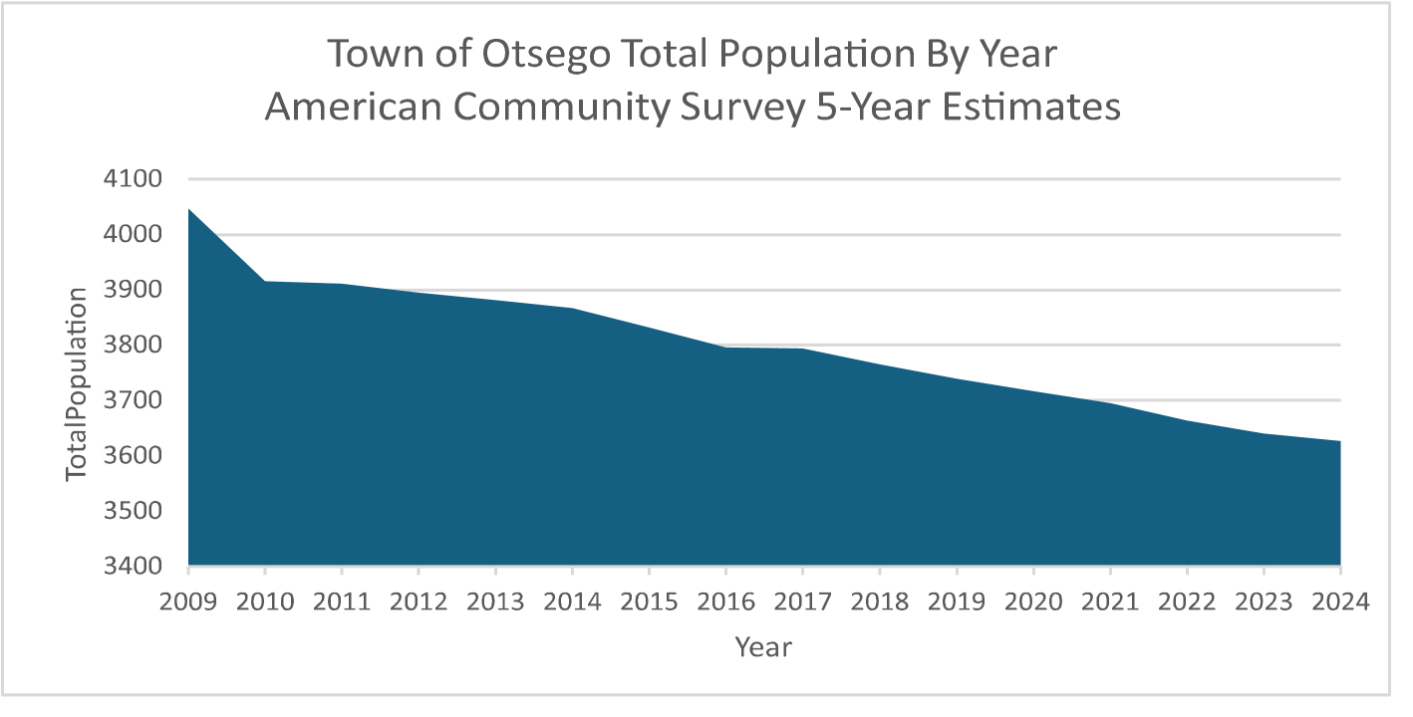
Source: American Community 2024 Survey 5-Year Estimates

Aging Population
Approximately 1,150 of the Town’s 3,641 residents are age 65 or older, meaning nearly 31% of the population is part of an aging demographic. Combined with a steady population decline over the past decade, this trend presents distinct challenges for economic development and overall livability. This comprehensive plan should therefore address the needs of older adults regarding housing, community facilities, essential services, and equitable access to recreation and community activities. Residents aged 65 and older also represent the age group experiencing the highest rates of poverty. In addition, about 625 residents are at or approaching retirement age, accounting for roughly 17% of the total population. This is a substantial share of the community and underscores the need for affordable housing with appropriate amenities, as well as livable, equitable community design that enables older residents to age in place and thrive.

4.2 Housing
The Town’s aging population has identified a clear need for affordable, senior friendly housing that serves year-round residents and individuals with limited incomes. Approximately 7.6% of residents age 65 and older are living in poverty, underscoring the importance of housing options for older adults, which should be both attainable and practical. The most needed accommodations are likely to be smaller, lower-maintenance homes located near healthcare facilities, grocery stores, pharmacies, and other community amenities. Housing should also incorporate accessible design features that support aging in place, such as easy entry and movement throughout the home, fewer stairs, and single-floor living arrangements. These features will help older residents remain in the community safely and comfortably as their needs change over time.
Several of the zoning proposals included in this Comprehensive Plan would directly support aging in place and represent some of the most feasible housing strategies for the Town of Otsego. Accessory Dwelling Units (ADUs) are among the most practical near-term options because they allow older residents to live near family members, enable caregivers to reside nearby, and provide homeowners with rental income that may help them remain in their homes. The proposed Heritage Barn Law could also expand housing opportunities by allowing the adaptive reuse of historic buildings for single-family and multifamily housing, with the potential for up to ten dwelling units, creating unique, smaller housing options while preserving community character. In addition, the proposed hamlet development changes would reduce or eliminate minimum lot size requirements within hamlets and allow greater housing density through duplexes, triplexes,
Townhouses, and small apartment buildings. These changes would improve walkability, place housing closer to essential services, and lower infrastructure costs by directing development toward existing settlement areas rather than dispersed locations. If the Town proceeds with sewer and water feasibility studies and future infrastructure expansion, additional areas may become suitable for senior-oriented housing.

Household Types and Occupancy
Household type and vacancy statistics are available for review using data compiled from the American Community Survey (ACS) 5-Year Estimates. According to the 2020 Census, the largest share of households in the Town consisted of “family households” at 35%, followed by “nonfamily households” at 29%. The number of occupied housing units far exceeded that of unoccupied (vacant) units in the Town.
The graphs on the next page show the full statistics on household type and occupancy based on the US Census Bureau data.
In 2020, the Town completed a housing stock analysis. The analysis found six key findings that informed the housing and revitalization goals of this plan. Many homes built before 1938 are in the Village of Cooperstown, identifying it as a historically preserved community. According to the US Census, the Village has far better historic home preservation than other areas of New York State.

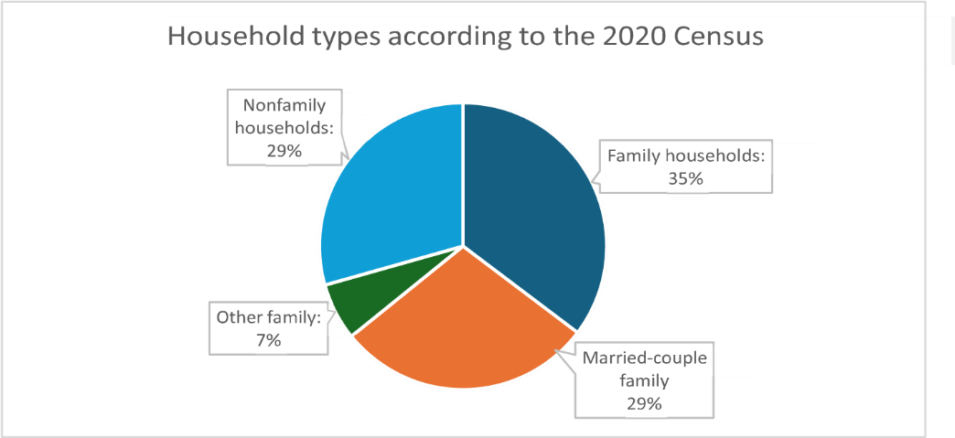
Source: American Community Survey (ACS) 5-Year Estimates, 2009-2024

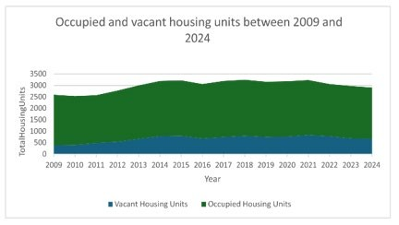
Source: American Community Survey 5-year estimates 2009-2024
.
In the 1970’s, around a quarter of all homes built in the area were constructed.
A main goal in this 2008 Comprehensive Plan was to limit unchecked development and growth within the Town of Otsego, the hamlets of Fly Creek, Oaksville and the portion of the Village of Cooperstown within Town limits.
Most homes are detached single-family, adding to the overall rural charm of this place. In the Town's non-agricultural areas, there is a greater mix of housing types. See the table below to compare housing structures over the years throughout the Town.
Housing Unit | 2009 | 2017 | 2024
1 Unit | 1,524 | 1,777 | 1,593
1, Detached | 1,468 | 1,760 | 1,564
1, Attached | 56 | 17 | 29
2 | 130 | 254 | 155
3 or 4 | 254 | 199 | 189
5 to 9 | 99 | 133 | 97
10 to 19 | 4 | 5 | 30
20 to 49 | 8 | 13 | 15
Mobile Home | 180 | 64 | 89
Boat, RV, Van | 0 | 0 | 59
Source: US Census Reporter tool

4.3 Economic Development
Economic data for Otsego County is available, including ACS 2024 five‑year estimates with employer and economic details at the county subdivision level. The Town of Otsego is a county subdivision. The hamlet of Fly Creek and the Village of Cooperstown are identified as places within the Town of Otsego.
The Comprehensive Plan identifies the Village of Cooperstown as the Town of Otsego’s largest cultural hub. The Village’s facilities and services include schools, healthcare, retail, banks, professional services, and businesses. Tourists visit the Town of Otsego because of its proximity to Cooperstown. This proximity and these statistics indicate a need for this plan to improve support for diverse business development in the
Town while maintaining effective land-use regulations that guide growth appropriately.
Industry, Occupation, and Employment Sector Trends from 2009-2024:
- Per capita income has risen 69.1% from $32,006 to $54,120.
- With a decreasing population, 49.0% of female residents of the Town work in the private sector, which is a 20.4% increase since 2009.
- With a decreasing population, 53.5% of the male population works in the private sector, which is a 29.1% increase since 2009.
- Top 3 industries for females are professional occupations, office and administration, sales, and retail.
- Top 3 industries for males are professional occupations, management/business/finance, and sales/retail, tied with construction/maintenance/extraction.
- Fewer residents have worked in the following sectors since 2009: Public and private non-profit.
- Self-employment income has decreased by 39.4% for all households since 2009. • The number of households earning between $100,000 to $124,999 has gone up 166% since 2009.
- The number of households earning between $200,000 or more has gone up 179.8% since 2009.
- Average family income has increased 87% since 2009, from $90,447 to $169,152.
Source: Social Explorer, US Census Bureau Data: ACS 5-year estimates for 2009 and 2024

4.4 Transportation Commuters
An assessment of transportation in the Town found that 22.9% of residents walk to their place of employment. Few residents use public transportation due to a lack of available routes and inadequate scheduling. Lastly, 51% of residents, the majority, drive to work. The population of work-from-home residents is close to 20% of the population. On any given day, roads need to be safe, maintained, and ready for residents to get to work. The Oneonta Public Bus Transit line and rideshare programs are low to no-cost services that are available to the community.

Biking Trails
For many residents in Fly Creek, Cooperstown, and the Town of Otsego, roads are not bicycle friendly. The Town may wish to consider road and shoulder improvements to support safer bicycle travel. This emphasis on bicycle safety could improve residents’ and visitors’ ability to access groceries, run errands, and participate in recreational activities. Many residents expressed a desire for more recreational opportunities in the community. Hiking and biking trails with better connectivity between communities were recurring themes in survey responses.

Highway Department
The Town oversees 75 miles of roads. Town roads are maintained to ensure safe winter driving, with road margins regularly cleared of debris and obstacles. Drainage networks are routinely cleaned and improved to promote proper water flow, and all road signs are kept in good condition for clear identification and traffic safety, although incidents of sign theft have increased. Crews also respond after storms to manage cleanup, conduct roadside mowing, and perform necessary bridge and guardrail maintenance. The rise in new housing along older roadways continues to create added challenges for an already understaffed highway crew, not to mention the added costs in continual road maintenance.
Additional information about Highway Department services is available on the Town website. The Roads Map is in Appendix A.

4.5 Cultural and Historic Resources
The Village of Cooperstown is the Town of Otsego’s most significant cultural asset. With its own zoning ordinances, the village works intentionally to preserve its rural charm, small-town character, and sustainable growth. Cooperstown serves as a vibrant cultural hub, drawing hundreds of thousands of visitors each year to attractions such as outdoor recreation on Otsego Lake, the National Baseball Hall of Fame, and the village’s many museums.
The Town of Otsego is proud to preserve and protect its historic district and historic sites, and the role they play in shaping the Town's identity. Local zoning laws attempt to ensure that future development does not undermine the character or feel of these historic resources. Historic resources provide a sense of place, community gathering, and culture that should be protected by comprehensive plans.
Cataloging the Town's cultural and historic assets in this profile will identify important identity-shaping places, structures, and landscapes to help make informed decisions on preservation priorities for any future development of the Town. Historic resources provide a sense of place where generations come together, continuing local traditions and culture. This inventory ensures these assets are not overlooked during future policy development and planning efforts.
The cultural and historic assets listed below play an active role in strengthening the Town of Otsego’s sense of place, connecting residents and visitors to the community’s longstanding heritage.
Historic Districts
- Fly Creek Historic District: Historically composed of three separate hamlets, this community developed around an agricultural landscape, with water-powered mills serving as its primary industry.
- Glimmerglass Historic District: Between the 1700s and 1900s, this settlement was rural with mostly agricultural land use. Starting in the early 1900s, it progressed into a cultural hot spot with a burgeoning resort and tourism culture centered around Otsego Lake.

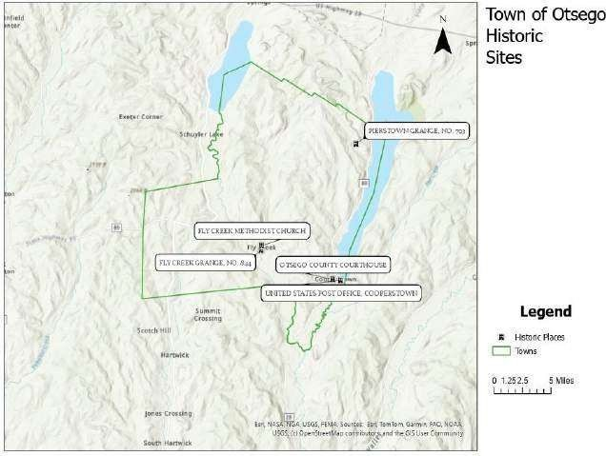

Recreation, Arts and Entertainment
Visitors to the village can also access a range of recreation areas and cultural destinations throughout the Town of Otsego and surrounding area. The following list highlights some of the community’s most notable assets, attractions, and events:
- Abner Doubleday Field
- Brookwood Garden
- Clark Sports Center
- Cooper Grounds
- Cooperstown Art Association
- Cooperstown Distillery
- Cooperstown Farmers’ Market
- Cooperstown Lakefront Park
- Cooperstown Village Library
- Fairy Springs Park
- Fenimore Art Museum
- Fenimore Farm and Country Village
- Fly Creek Cider Mill
- Fly Creek Historical Society
- Glimmerglass Festival
- Glimmerglass State Park
- Hyde Hall
- Leatherstocking Golf Course
- National Baseball Hall of Fame
- Parslow Road Conservation Area
- Samye Hermitage
- Smithy-Pioneer Gallery
- Three Mile Point Park

The Town currently relies in part on widely used online event and tourism platforms to help community members and visitors discover local attractions, events, and destinations. The Town’s goal is to promote sustainable, year-round tourism, enhance business participation, support local vendors, and create more opportunities for residents to enjoy the community year-round.

4.6 Natural Resources

4.6.1 Agriculture
The predominant agricultural land uses are field cropping, dairy farming, residential agriculture, and livestock farming. Many of these agricultural parcels are privately owned farms. A little over half of all farms are cropland, meaning they grow corn, hay, small grains, and soybeans. Some residential agricultural parcels are part-time, hobby farms, often used for small scale commercial purposes. Since farmers are a significant presence in the Town, it is important to assess the resources they need to remain operational, diversify, and remain sustainable - and to explore ways that the Town may help farmers obtain those resources.
Idle or underused farmland typically lacks successors, but the increased efforts of the Otsego Land Trust have made significant strides in helping preserve open land tracts. It is important for this plan to consider ways to protect, repurpose, and maintain farmland to preserve the Town's rural and unique cultural identity, as well as its economic development and resource conservation goals. If succession plans are not put in place, prime and residential farmland will likely be converted to other land uses, affecting the rural character of the Town this plan is working hard to protect. This issue was identified by residents as a significant community concern.

4.6.2 Soils
Soil erosion is a major concern for development in areas with steep slopes. Lake water quality, air quality, and land use are all impacted by sediment erosion. Land use in this comprehensive plan must carefully look at development in areas with specific slopes. The map shows that most of the Town’s slopes are not very steep; steep soil portions near both lakes require site plans, erosion control plans, and collaboration with the planning board to ensure that all Soil and Water Conservation District standards are evaluated in development proposals.
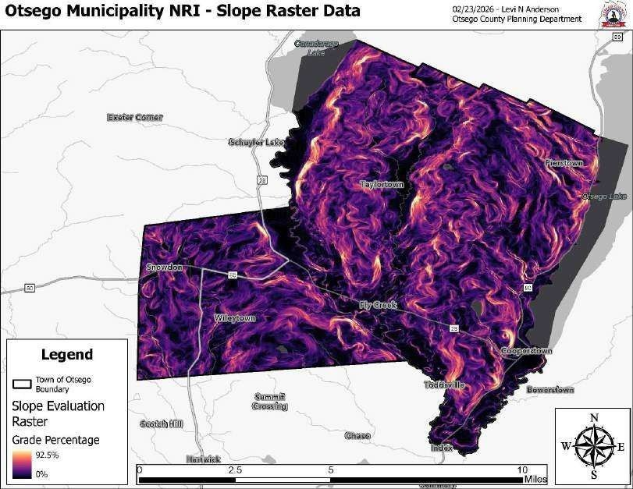

4.6.3 Ecoregion
The Town is classified as the Glaciated Low Allegheny Plateau region. This area has a humid continental climate, with 35 to 50 inches of annual precipitation, relatively even snowfall distribution, and growing seasons of 100 to 160 days. This regional landscape supports farming, woodlots, development, and other agricultural uses. The ecoregion consists of wide valleys and rolling hills, with peak elevations of approximately 1,800 feet. Soils in the Town are generally acidic. Recommended agricultural practices include hay production, cover cropping, and cattle grazing. This aligns with the Town’s existing agricultural activities in hay, dairy, and livestock, which remain a priority for the community.

4.6.4 Critical Habitat
According to the Natural Resource Inventory Tool from the Otsego County
Planning Department, there are no designated Critical Habitat Areas for the Town of Otsego. According to the NYSDEC-designated critical environmental areas (CEAs), there are no CEA lands in the Town. The Town could consider designating critical habitat areas in the future.

4.6.5 Culturally Significant Environmental Assets
- Otsego and Canadarago Lakes and tributaries require protection from pollution, erosion, and development. The efforts of the Otsego Lake Watershed Supervisory Committee have greatly helped in this regard.
- Steep slopes and farmlands west of Otsego Lake, where development is proposed, are areas of great concern about any development's effects on water quality, historic and rural character of the area, and strain on the existing infrastructure.
- Natural Resource maps are in Appendix A.

4.7 Land Use Trends
Land use regulations in hamlets, rural and agricultural areas, the Town center, and suburban regions play a crucial role in preserving the integrity of the Town's natural resources. According to the map made by the Otsego County Planning Department, the top two land uses for the Town are Seasonal Residential and Vacant Lots. Agricultural and forest land use account for small percentages of total land use. The predominant land use on the shorelines of Canadarago and Otsego Lakes is Seasonal Residential.

Town of Otsego 2026 Land Use Map

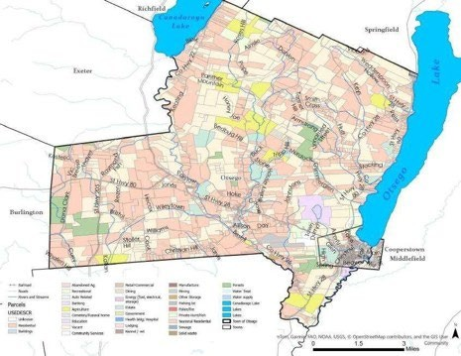

It is not a law, but New York State statutes require that all municipal land use laws be consistent with a comprehensive plan. The Town of Otsego is authorized by New York State Law Section 272-a to develop and adopt a comprehensive plan. This comprehensive plan is integral to sustainable land-use trends in the Town, as it guides current and future land-use policy.
Key Implication for Planning:
- All government agencies proposing planning or capital projects within the Town must consider this plan, giving the Town greater influence over external project proposals.
- The shared vision, goals, and strategies provide a foundation for building community consensus and support.
- The Town may adopt new programs and regulations to implement the plan, protecting resources while encouraging appropriate development and growth.
- The plan strengthens grant applications to fund its recommended actions.

4.8 Community Facilities
The Town benefits from volunteer fire protection through three districts, supplemented by the Cooperstown Fire Department contract service. Emergency Management Services (EMS) coverage combines local fire volunteer squads. The County Sheriff and the NYS Police provide primary law enforcement. Most neighborhoods in the Town are considered safe, particularly those near the schools. Education and civic involvement are a large part of the Town’s identity, as are healthcare facilities.

Fire Protection
Three fire districts serve the Town:
- Schuyler Lake Fire District Volunteer run.
Serves northern/northwest areas of the Town
- Fly Creek Fire District Volunteer run.
Serves Fly Creek hamlet and the surrounding areas.

• Otsego Fire Protection District
Service is provided through a contract with the Cooperstown Fire Department. Serves near Cooperstown Village.

Police
There is no Town of Otsego Police Department. The Otsego County Sheriff’s Office and New York State troopers serve the Town. Village of Cooperstown police serve the village only.

EMS Coverage
Volunteer EMS services are provided through fire districts.
Otsego County EMS provides 24/7 advanced life support backup.

Healthcare
Bassett Medical Center provides comprehensive healthcare services to the Town and is the main healthcare provider. Since 2020, there have been multiple expansions to the Bassett facility, increasing staffing counts.

Education
The Town's rural setting contributes to relatively small class sizes in the K-12 school system. There is a declining enrollment in students as the population ages, which may indicate pressures for future funding and enrollment levels. According to the 2020 Census, the Cooperstown Central School District enrollment dropped by about 2%, with an expected continued decrease.
Key Implication for Planning:
- Certain roads lack adequate emergency vehicle access and cellular service coverage, making EMS response a challenge.
- The aging population is likely to increase demand for EMS services.
- Tourism seasons strain summer EMS and Fire response capacities.
- Tourist traffic stresses the existing infrastructure
- With increasing staff at Bassett, there will need to be available and affordable housing located in the Town.

4.9 Zoning Overview
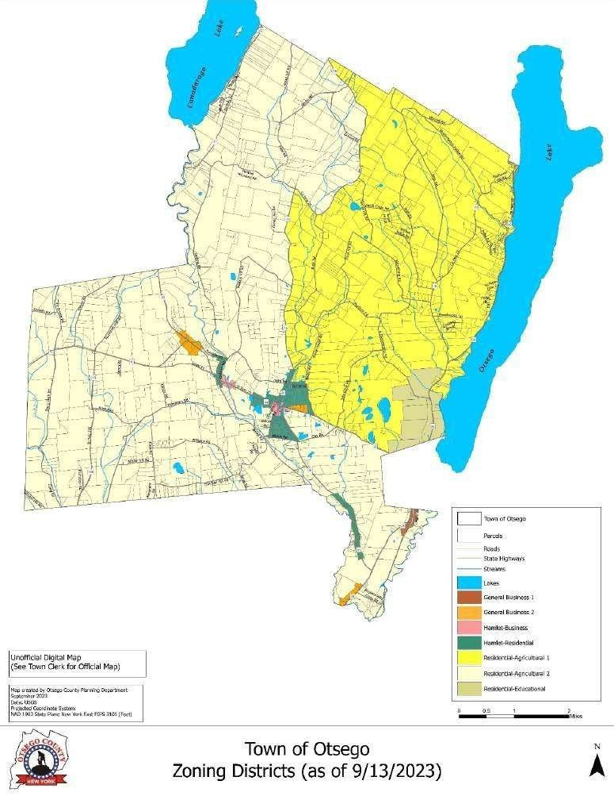

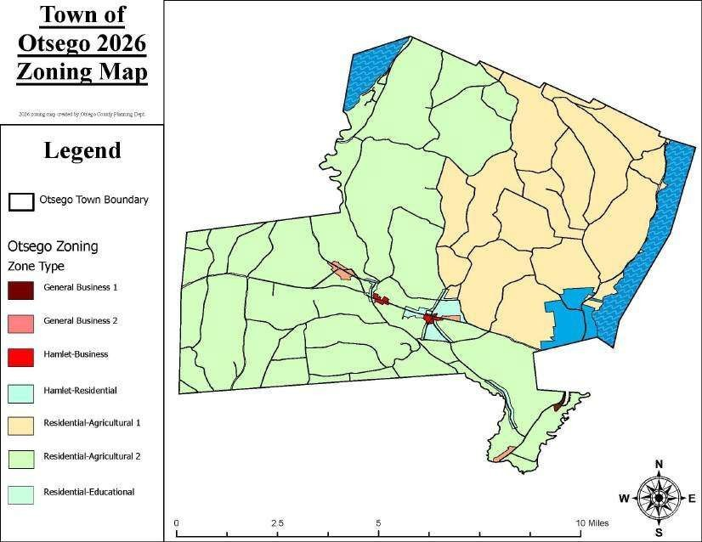

Land use districts each have a purpose, permitted uses, lot size requirements, and special permit requirements, and are important to the comprehensive planning vision, goals, and strategies. This plan recommends changes to land use regulations to support Smart Growth and equitable housing goals. The following Zoning Districts in the Town of Otsego are organized by type, purpose, permitted use, lot size, and special permits.

General Business 1
Purpose: Larger scale commercial uses than hamlet districts. Located along Route 28.
Permitted Use: None by right.
Lot Size: 10,000–20,000 square feet, depending on utilities.
Special Permits: Wide range of commercial uses, including retail, offices, car wash, storage, convenience stores, restaurants, vehicle sales/repair, shopping centers, dwellings, food trucks

General Business 2
Purpose: Commercial areas suited for moderate-scale development.
Permitted Use: None by right.
Lot Size: 1 acre (or 20,000 sq ft with utilities)
Special Permits: Minimum building sizes with a maximum footprint of 5,000 sq. ft.

Hamlet-Business
Purpose: Small scale commercial centers serving local hamlets’ needs
Permitted Use: Public offices, utilities, home occupations, and residential uses.
Lot Size: 1 acre minimum
Special Permits: Retail, personal services, offices, banks, motels (8 units), B&Bs, mixeduse buildings, small repair shops, daycares, outdoor retail, service stations, multifamily dwellings, restaurants, food trucks, light assembly, and most buildings limited to a 2,000sq-ft footprint.

Hamlet- Residential
Purpose: Existing small hamlets with mixed but primarily residential character.
Permitted Use: Home occupations, accessory uses, and one- and two-family homes.
Lot Size: 1 acre minimum
Special Permits: Small churches, private offices, B&Bs, multi-family dwellings

Residential-Agricultural 1 (RA-1)
Purpose: Low density rural residential and agricultural areas, mostly east of Route 26 and north of Route 80
Permitted Use: One and two-family homes, agriculture, forestry, wildlife management, parks, and home occupations.
Lot Size: 3 acres minimum
Special Permits: Educational institutions, small healthcare facilities, public utilities, churches, cemeteries, B&Bs, campgrounds, recreational facilities, adult housing, service trades, day care

Residential-Agricultural 2 (RA-2)
Purpose: Like RA-1, but located West of Route 26 and South of route 80/28 Permitted Use: One and two-family homes, agriculture, forestry, wildlife management, parks, and home occupations.
Lot Size: 3 acres minimum
Special Permits: Same as RA-1 but also includes animal hospitals, mineral extraction (with restrictions), motels (8 units), kennels, multifamily dwellings, and food trucks.

Residential-Educational
Purpose: Support museums, educational institutions, and recreational facilities north of
Cooperstown
Permitted Use: Country clubs, golf clubs, museums, educational institutions, and accessory uses.
Lot Size: 10 acres minimum
Special Permits: Buildings over 1,500 sq. feet require site review.

Lake Protection District “Overlay” Areas
Our Town includes portions of two lakes – Otsego on the East and Canadarago on the West. Although not currently shown or listed on our zoning map, these “Lake Protection” areas are functional overlay zones specifically described in “Article IV: Land Use Regulations About Geologic Features” of our land use law. The Otsego Lake
Protection zone is “laid over” two zones that abut Otsego Lake: RA-1 (Residential
Agricultural) and the Recreational/Educational District (R/E) Zone. The Canadarago Lake Protection Zone is “laid over” that portion of the RA2 (Residential Agricultural) zone that abuts and includes the west shore of Canadarago Lake. Section 4.04 of Article IV, titled “Otsego and Canadarago Lake Protection Area,” prohibits, for example, any point of source discharge into Otsego or Canadarago Lakes or into any waterway flowing into Otsego or Canadarago Lakes, as well as placing limits on the removal of trees and other vegetation. Limitations on water runoff, development, new construction, and reconstruction within 500 feet of the lake shore become increasingly restrictive as the proposed work approaches the shorelines. Site plan review is required for all work. Repairs or replacements of existing buildings are limited to their existing footprints and dimensions.

The Recreational/Residential/Educational District
The R/E District was established to provide for and to tie together several parcels of land north of the Village of Cooperstown. These parcels provide educational and recreational opportunities for people. Minimum lot sizes are 10 acres. Permitted uses include country clubs, golf clubs, museums, and educational institutions, as well as accessory uses necessary to operate them. Any use in this district of over 1500 square feet of building requires site plan review and approval. See Zoning Map in Appendix A.
4.10 Stakeholders, Key Organizations, and Strategic Partners

Nature Conservation and Environmental Protection
Otsego 2000
Otsego Lake Association
Otsego Watershed Supervisory Committee
Village of Cooperstown Historic Preservation Commission
Otsego County Conservation Association
Otsego Land Trust
Biological Field Station
Canadarago Lake Improvement Association
Susquehanna River Basin Commission
New York State Department of Environmental Conservation
Soil and Water Conservation District

Economic Development
Cooperstown Chamber of Commerce
Mohawk Valley Economic Development District, Inc.
Otsego County Industrial Development Agency (IDA)
Otsego Now

Organizations
Highway Department
Otsego County Planning Department: Tammie Harris, Levi Anderson
Bassett Healthcare Network
Climate Smart Communities Task Force

Steering Committee:
- Jim Brophy
- Debbie Creedon
- Greg Crowell
- Deb Dalton
- Jim Dalton
- Walter Dusenbery
- Carina Franck
- Ed Hobbie
- Bill Hribar
- Jeff Katz
- Pat Kennedy
- Chris Kjolhede
- Adrian Kuzminski
- May Leinhart
- Alex Nirenberg
- John Phillips
- Steve Purcell

APPENDIX A: Maps

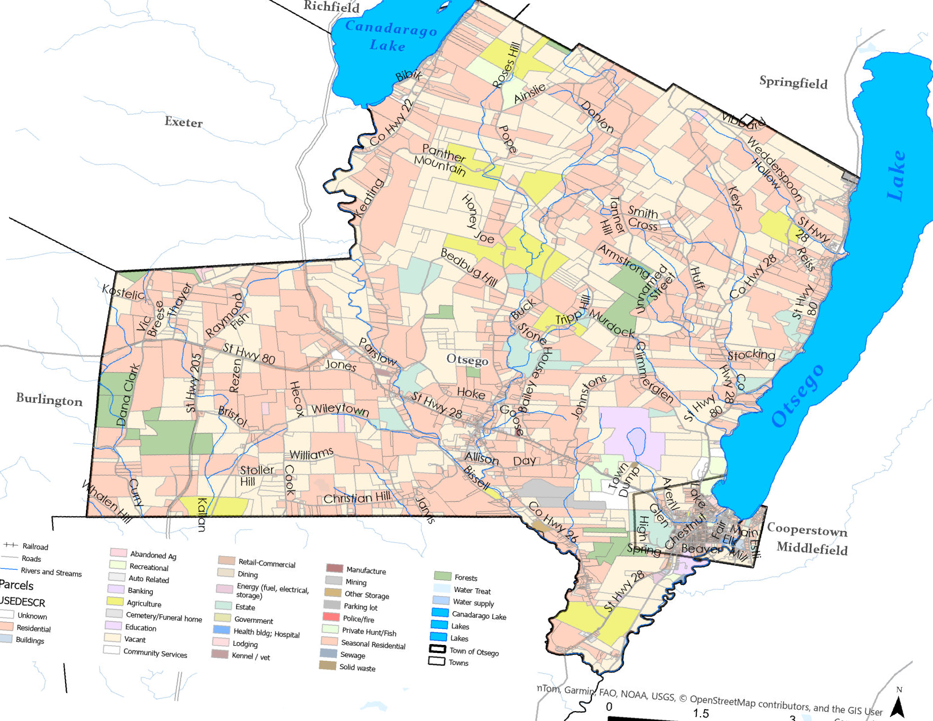
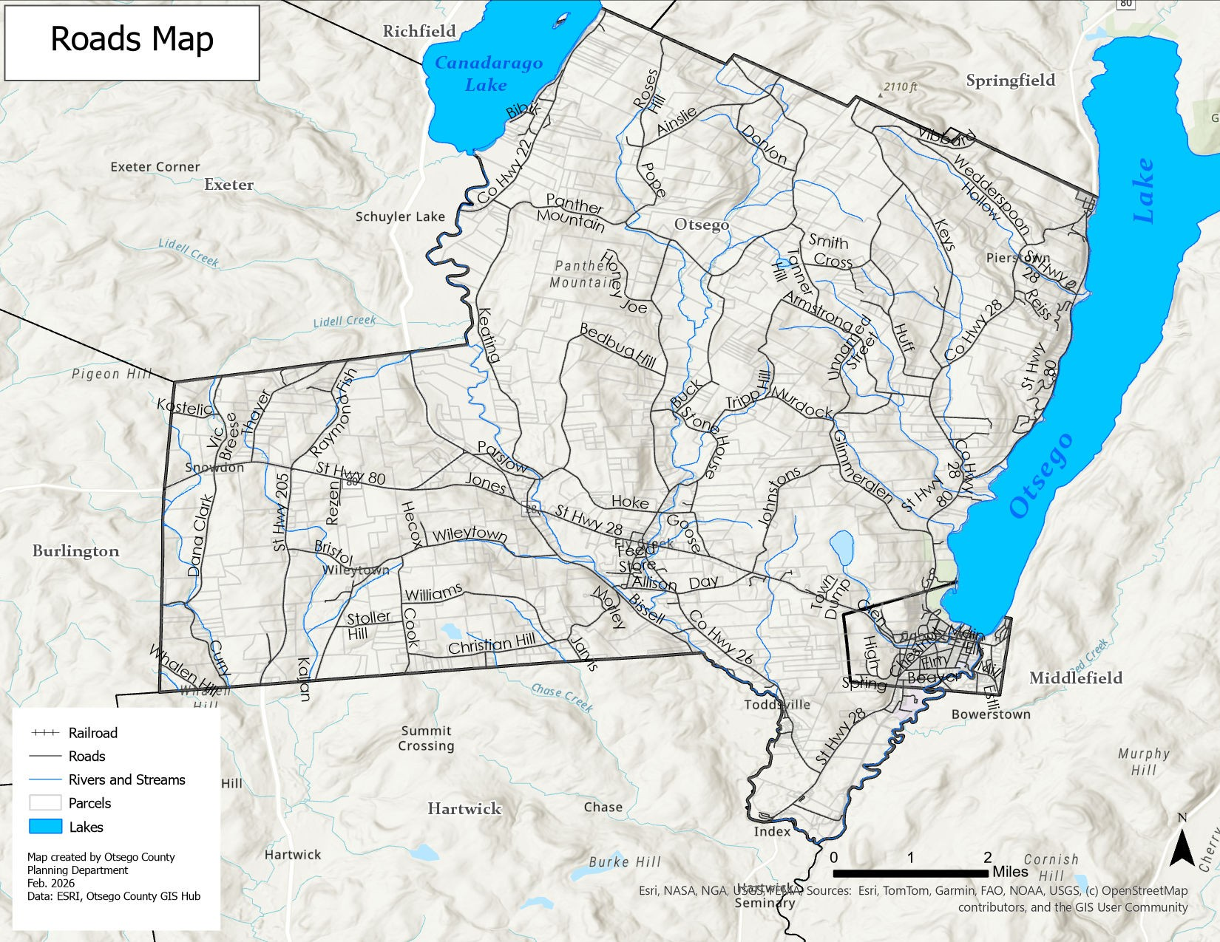
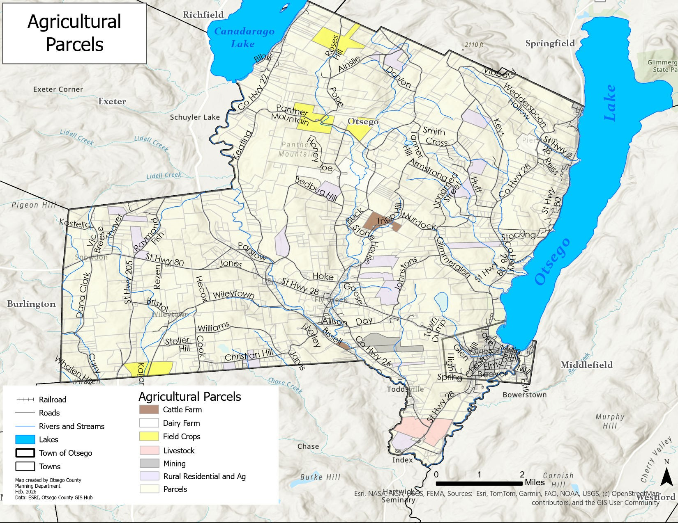
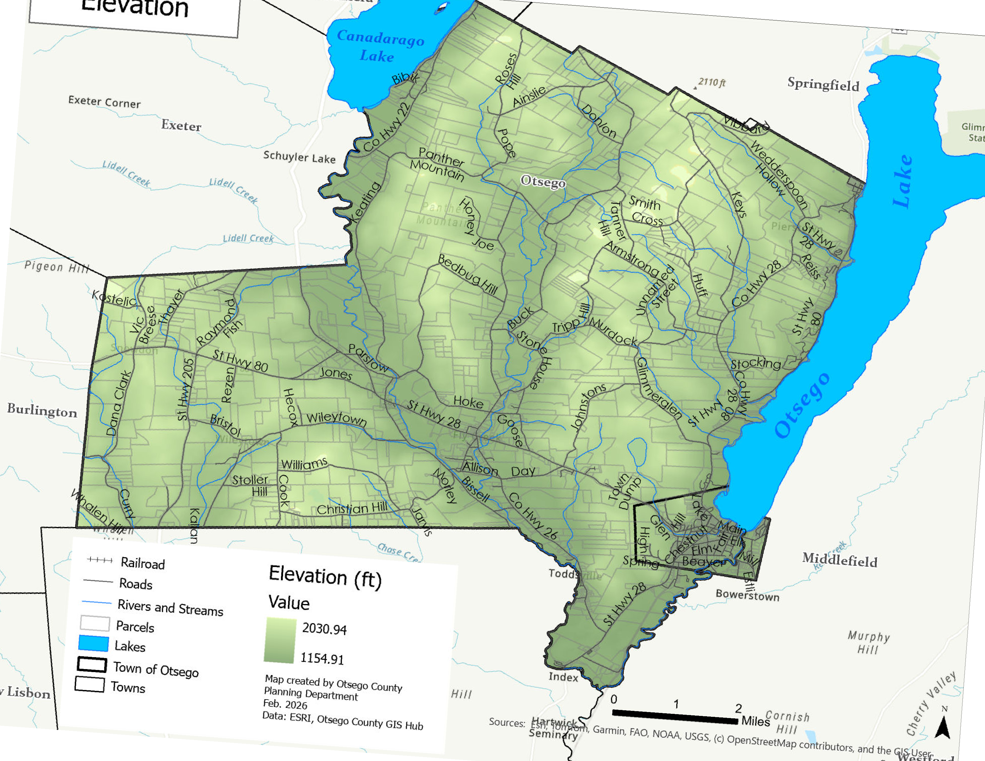
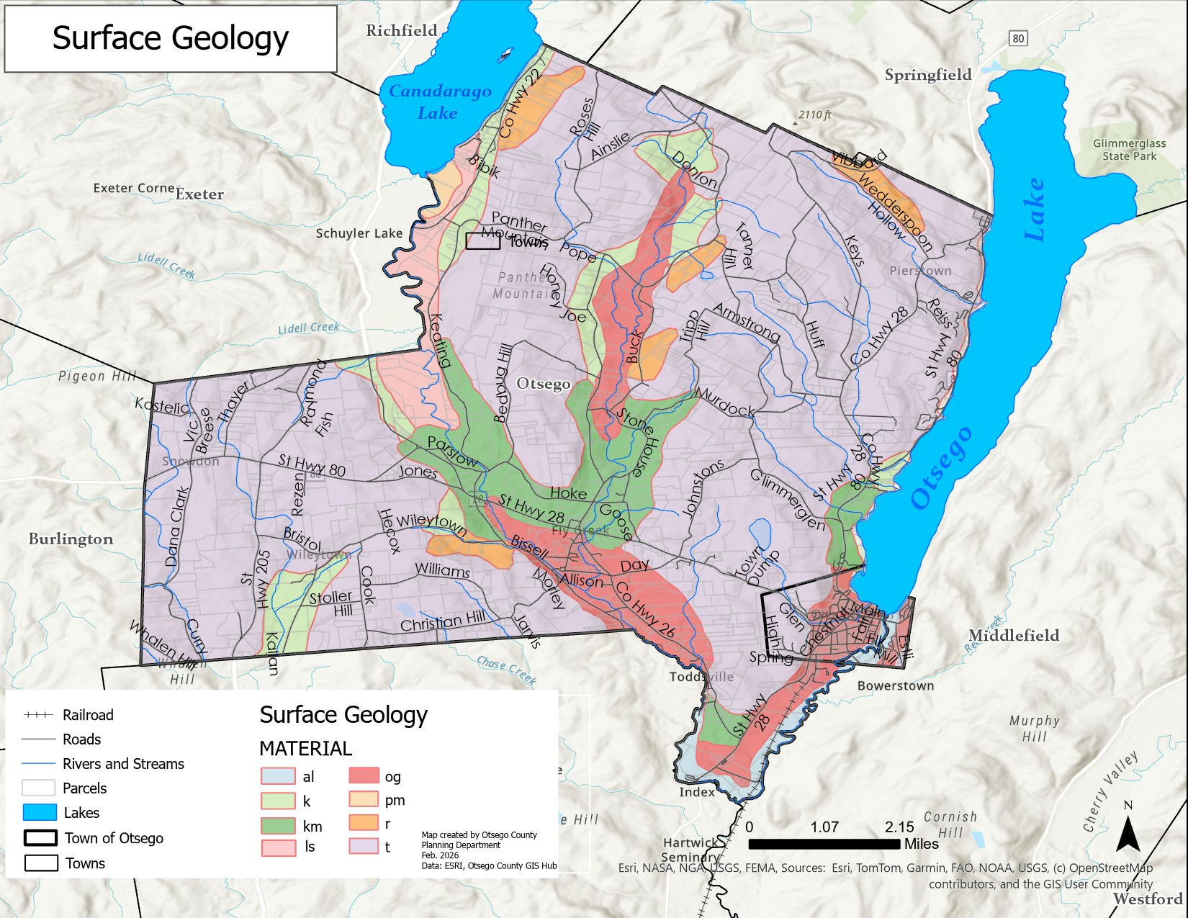

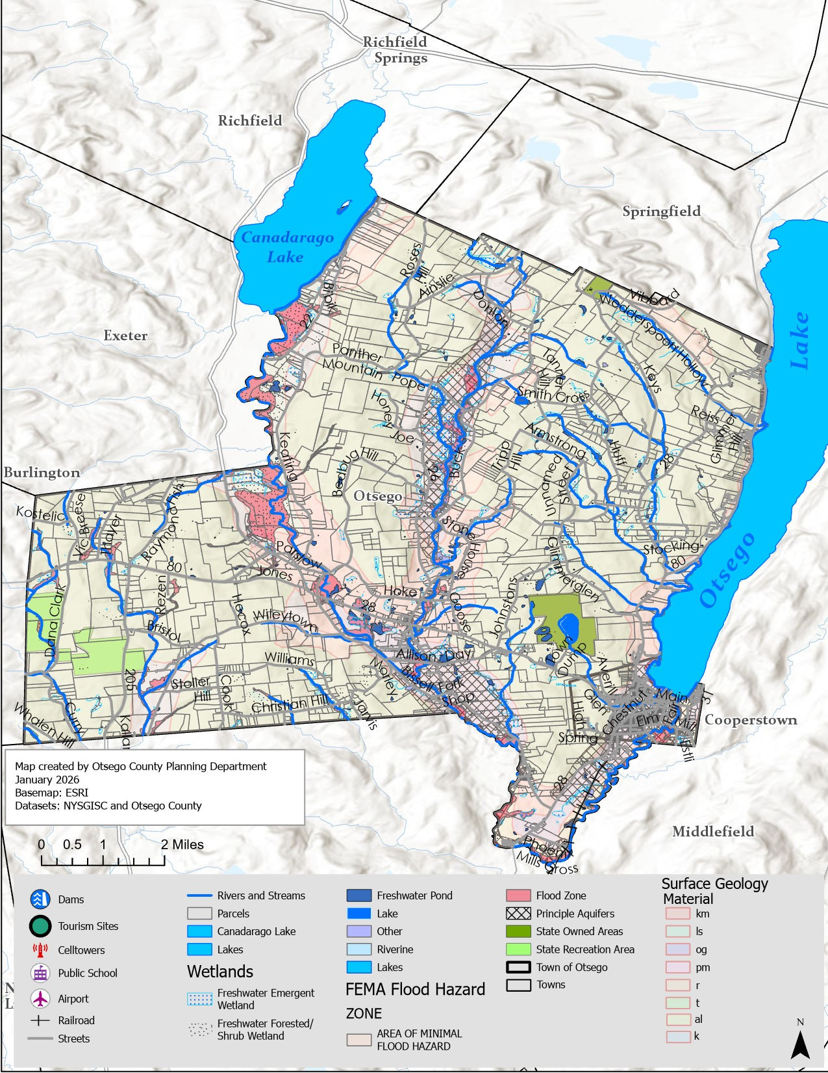
40

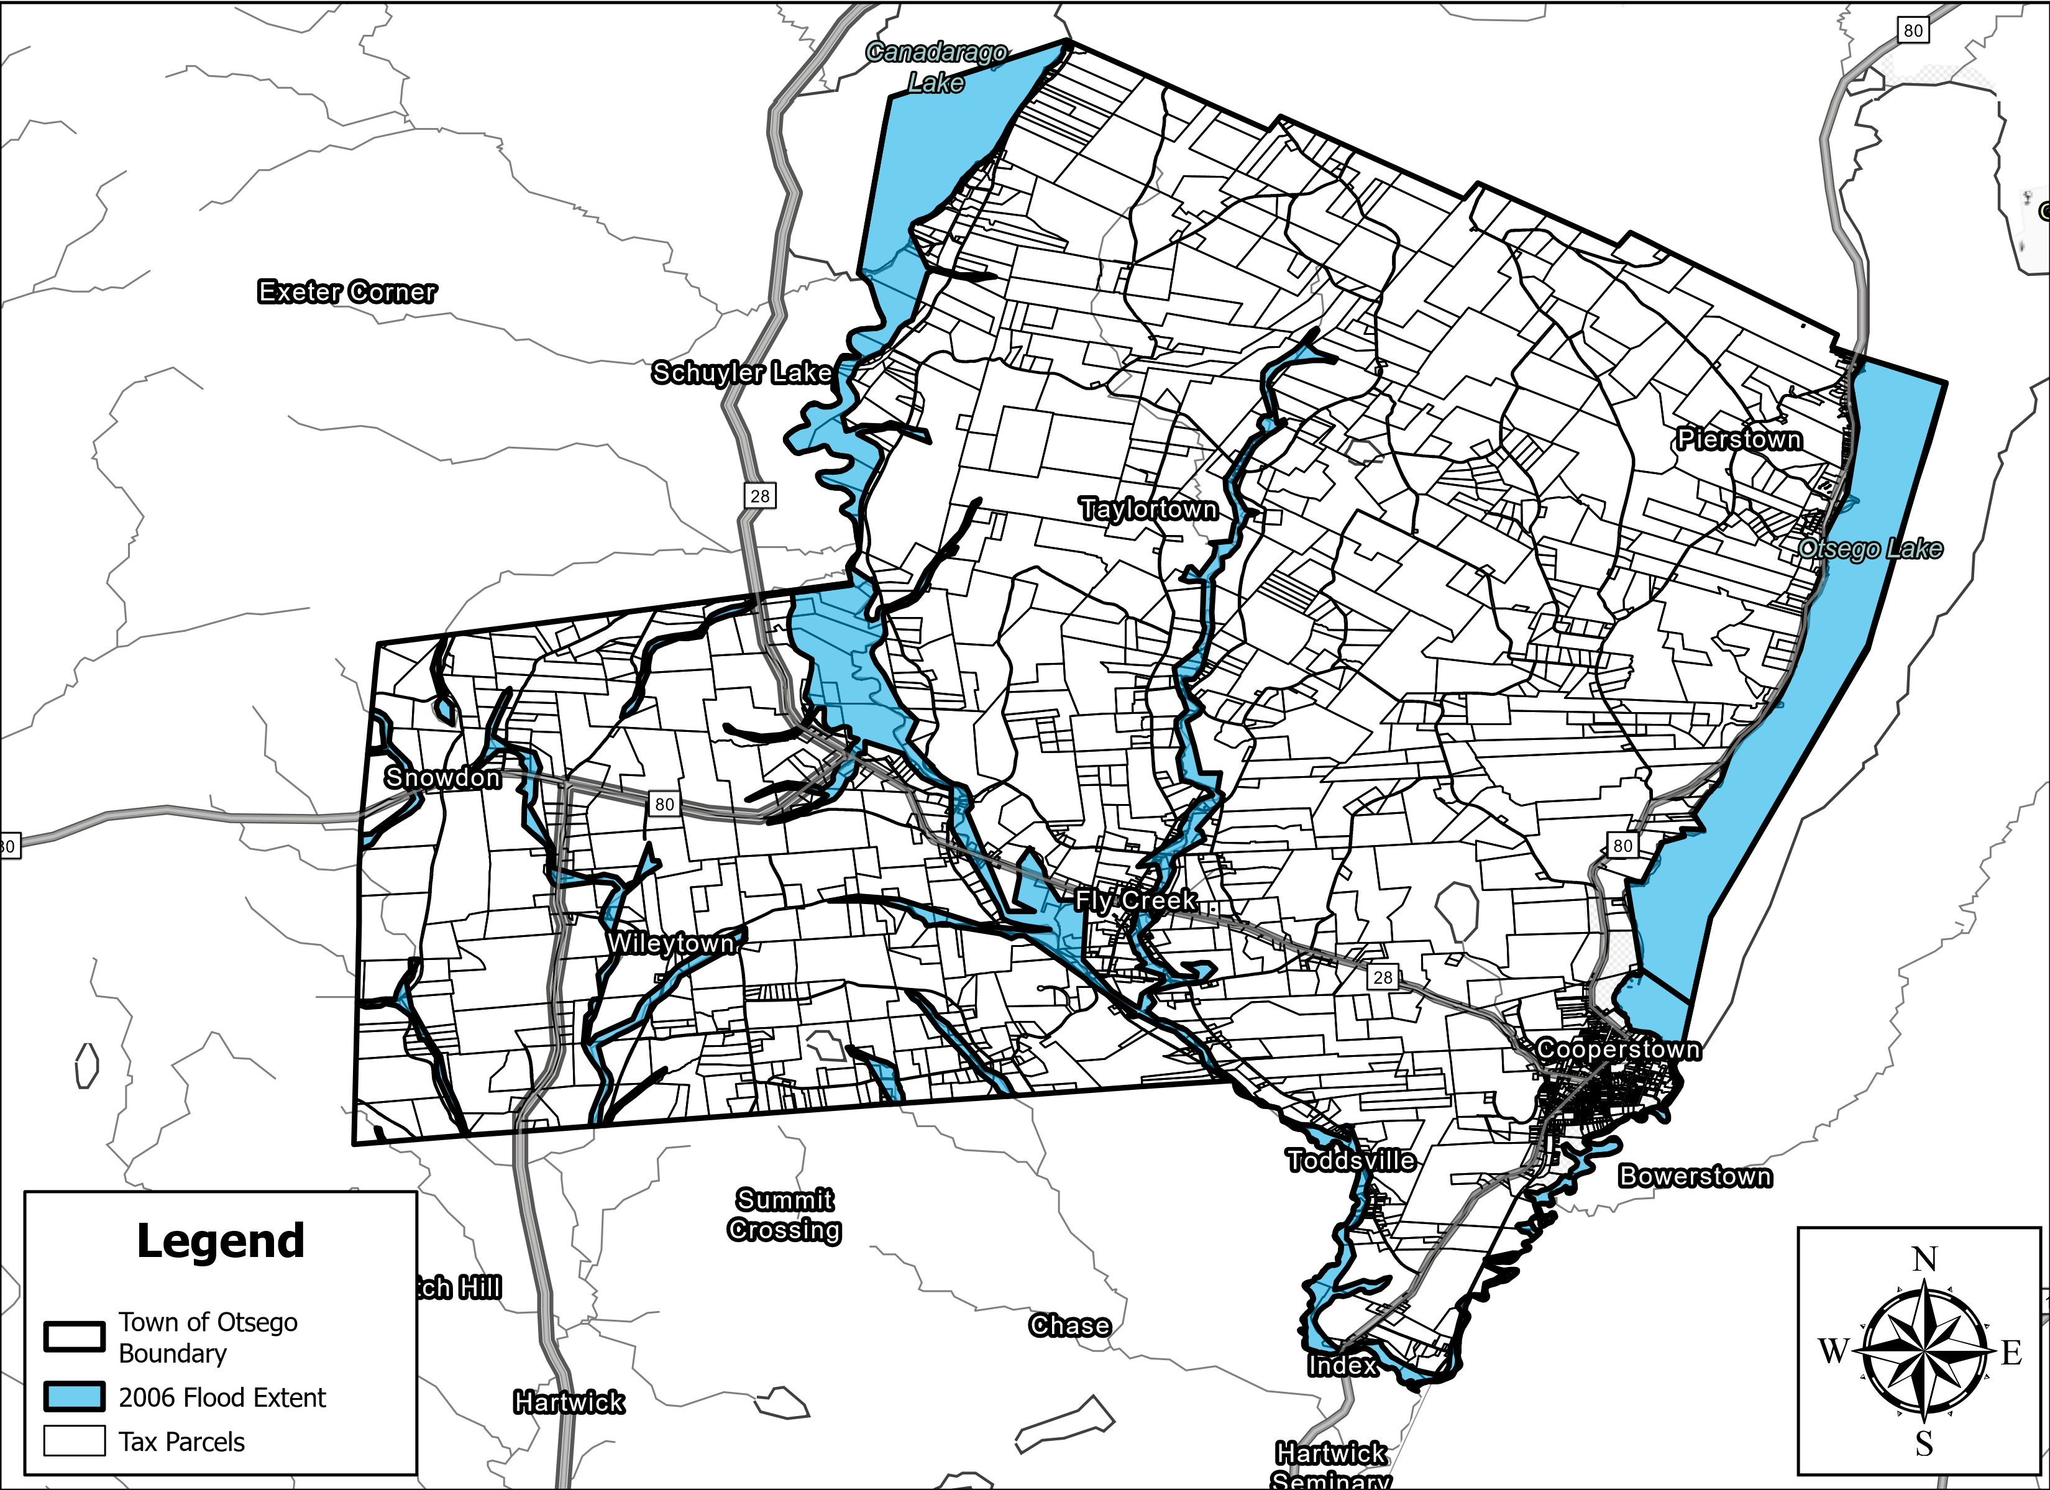
Otsego Municipality NRI - 2006 Flood Extent
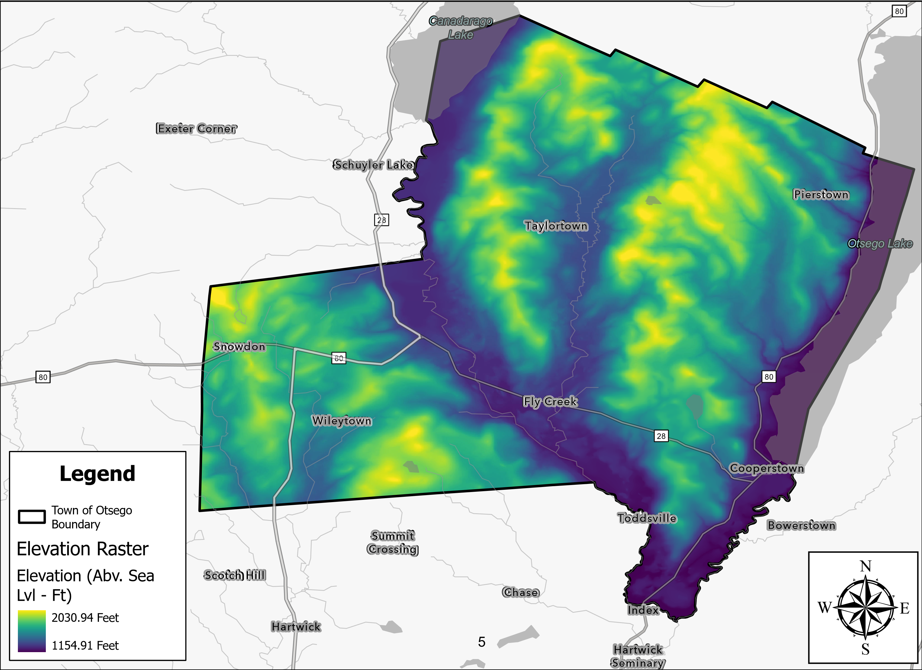
Otsego Municipality NRI - DEM Raster Data
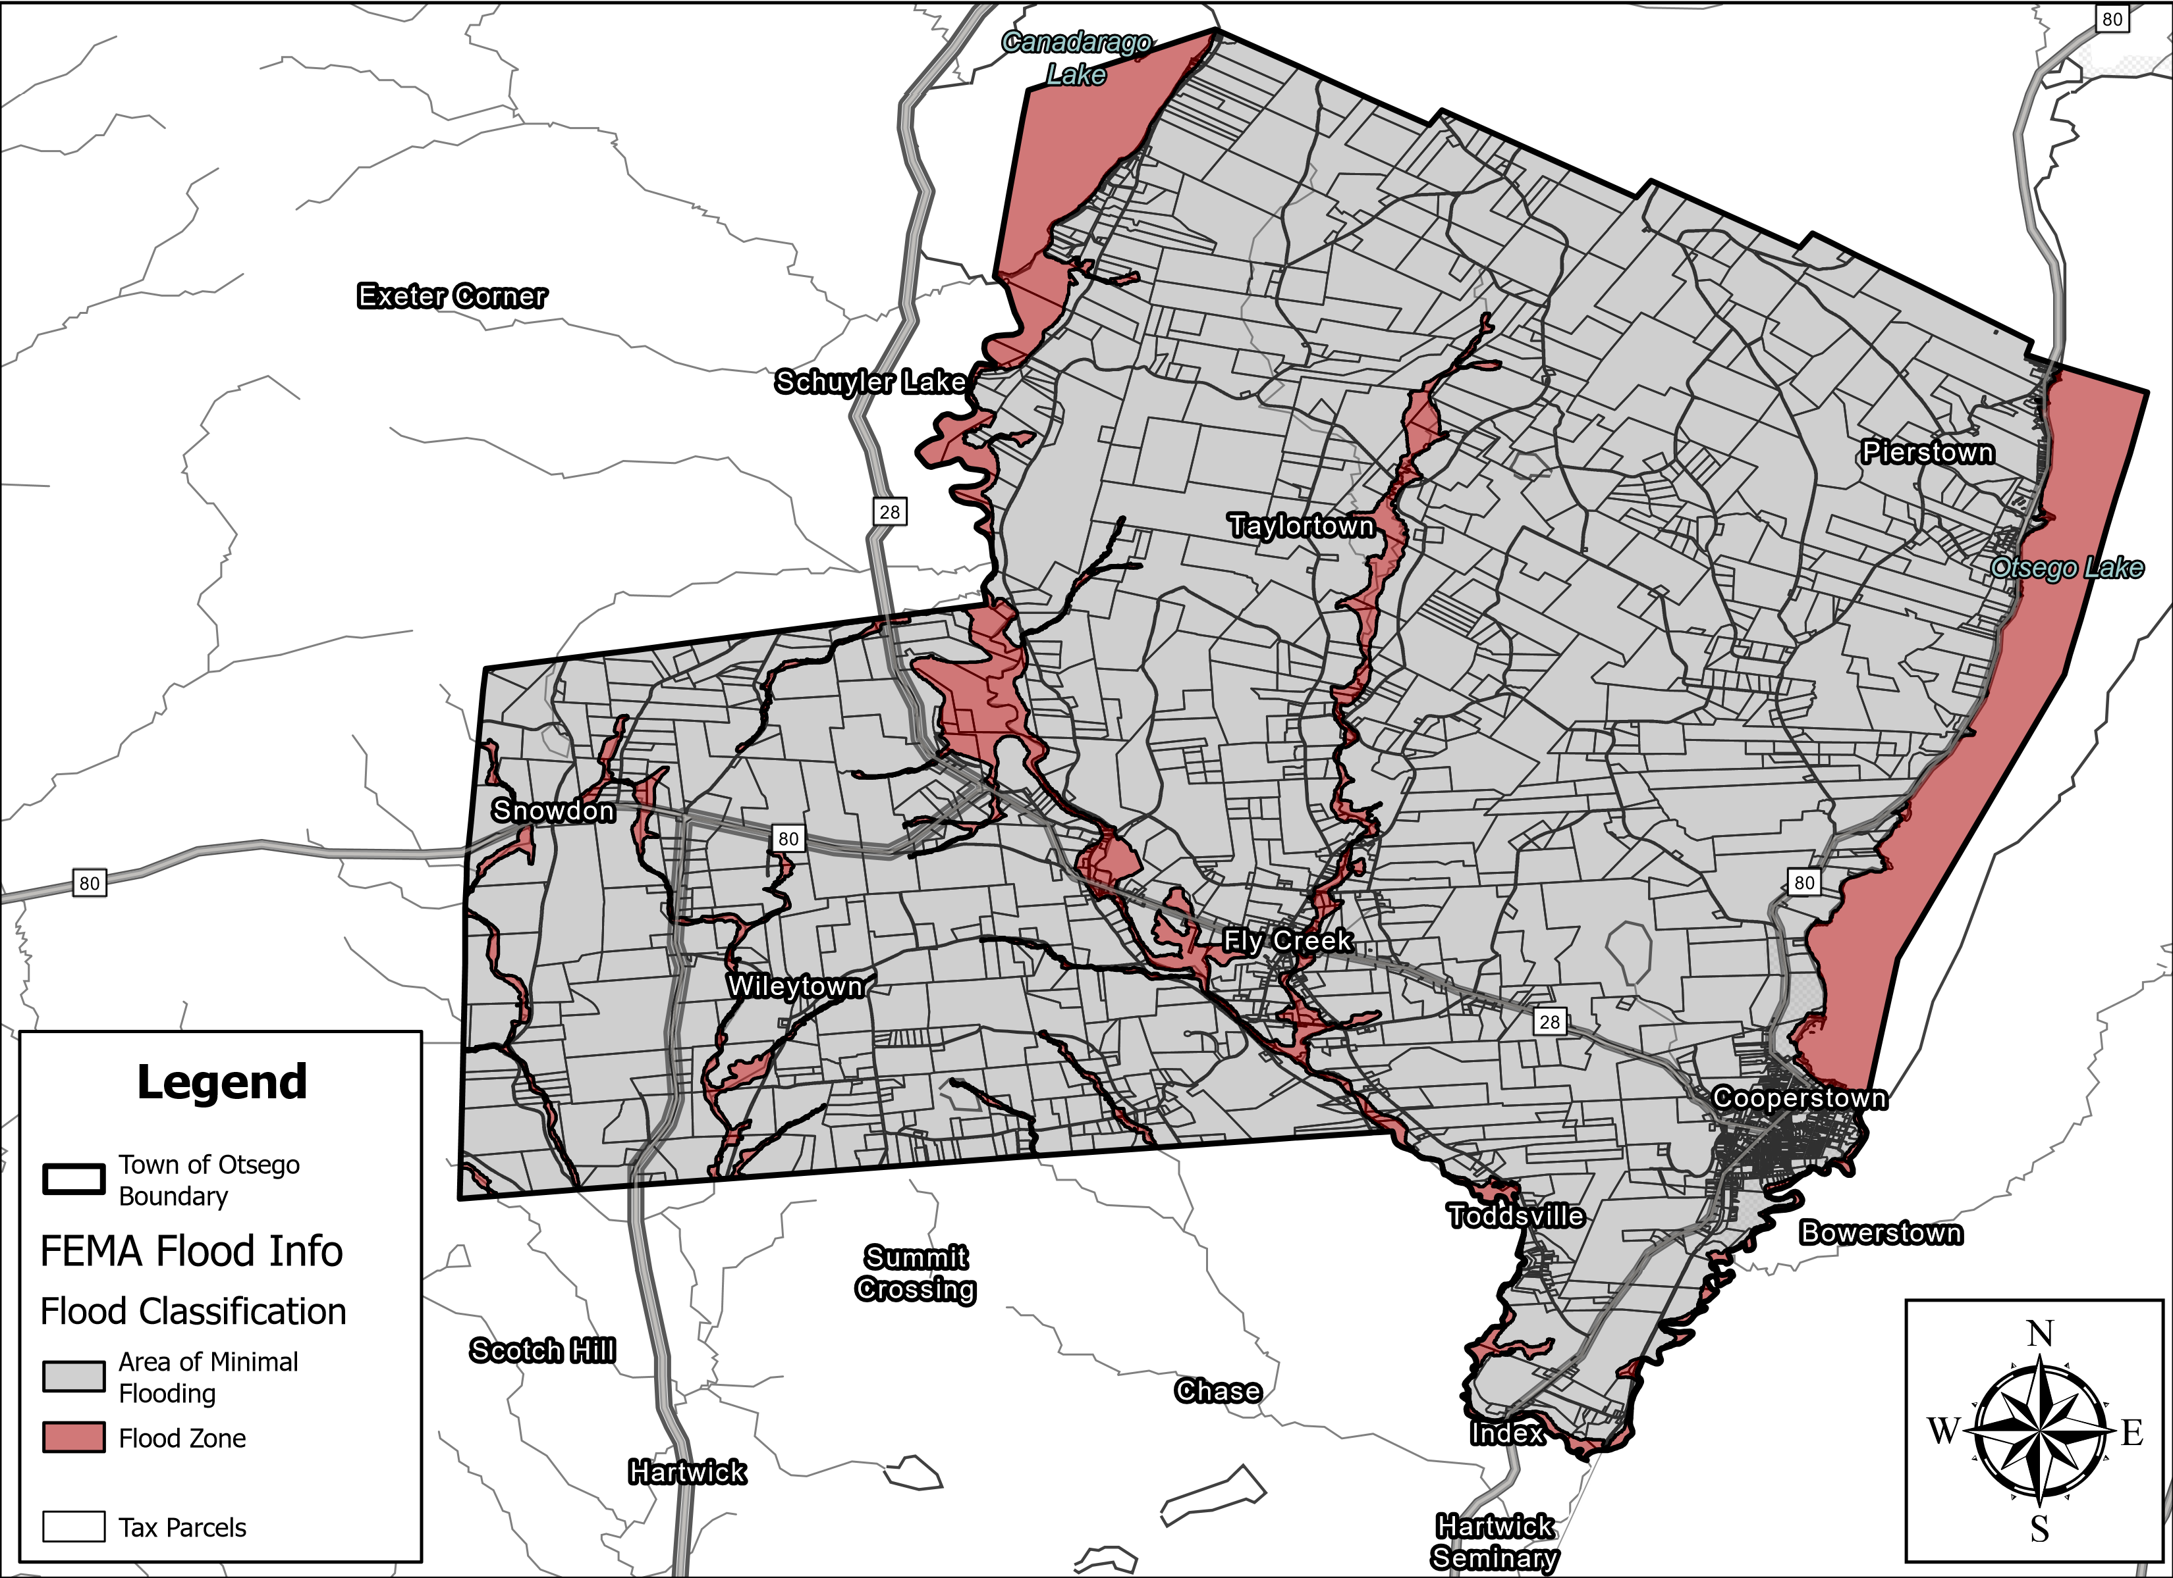
Otsego Municipality NRI - FEMA Flood Classification

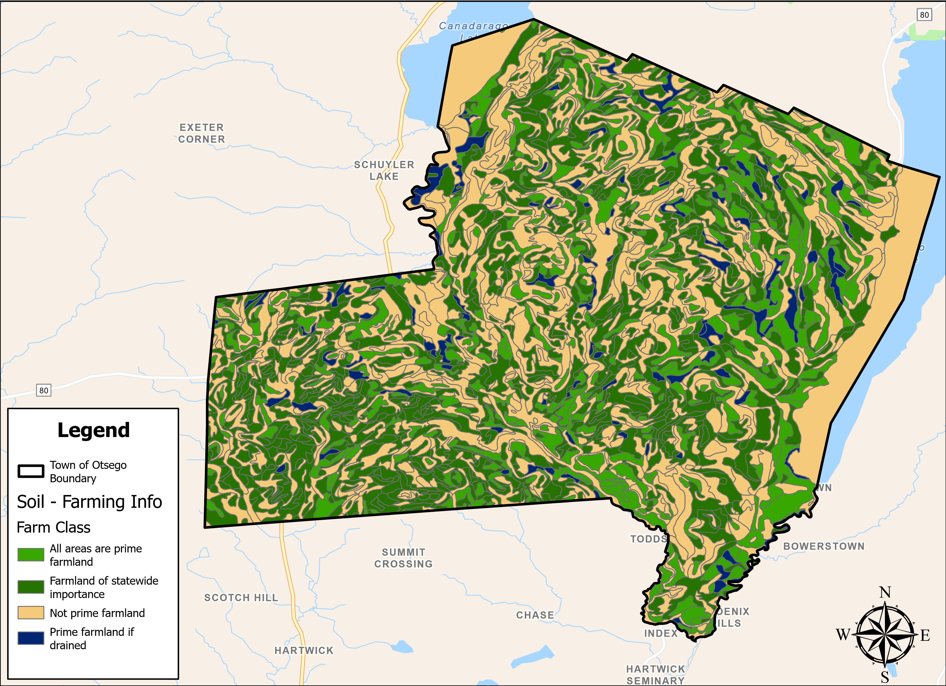
Otsego Municipality NRI - Soil Farming Info
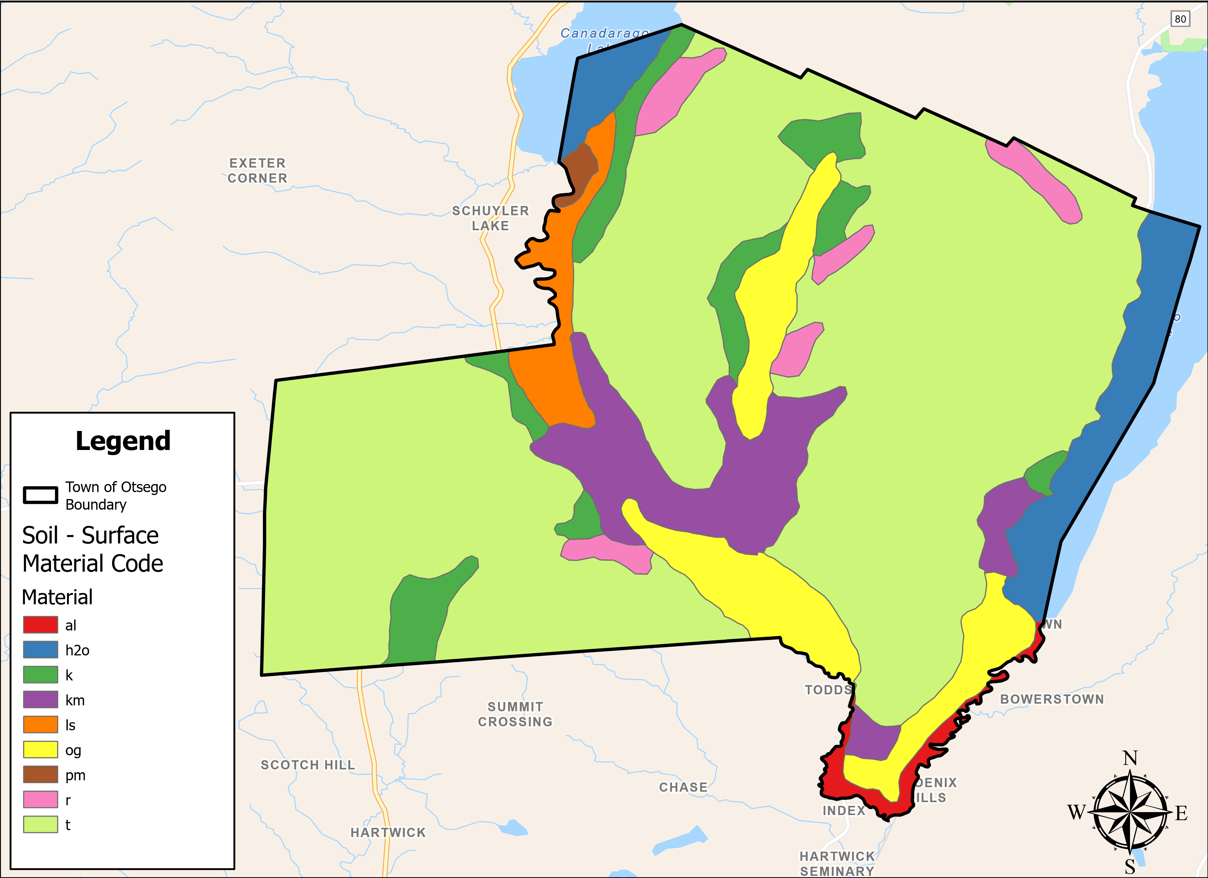
Otsego Municipality NRI - Soil Surface Material Code
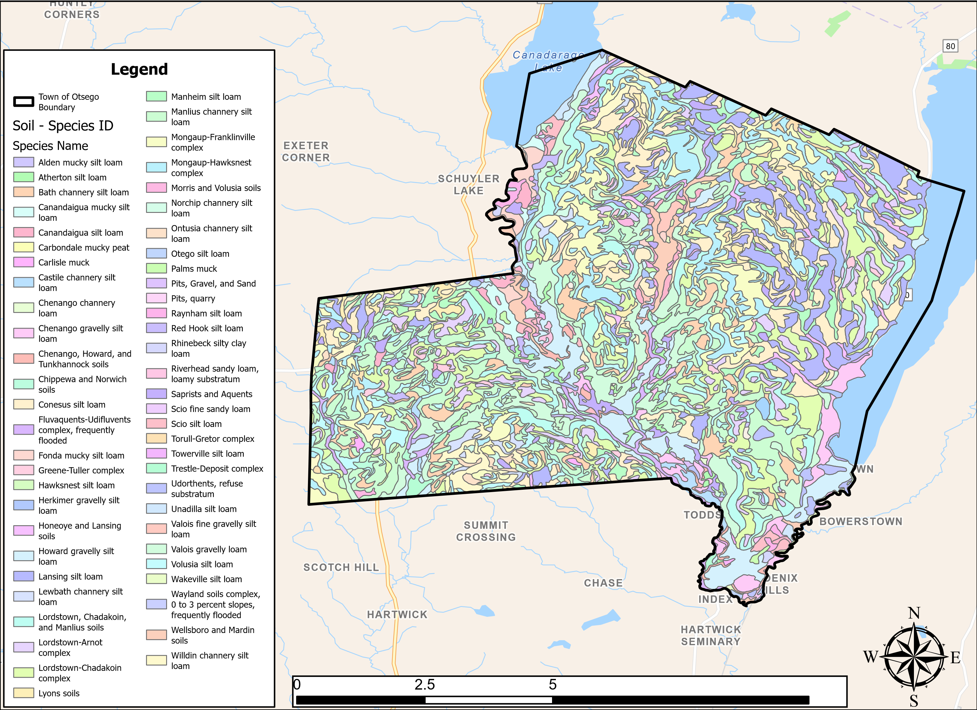
Otsego Municipality NRI - Soil Species Type

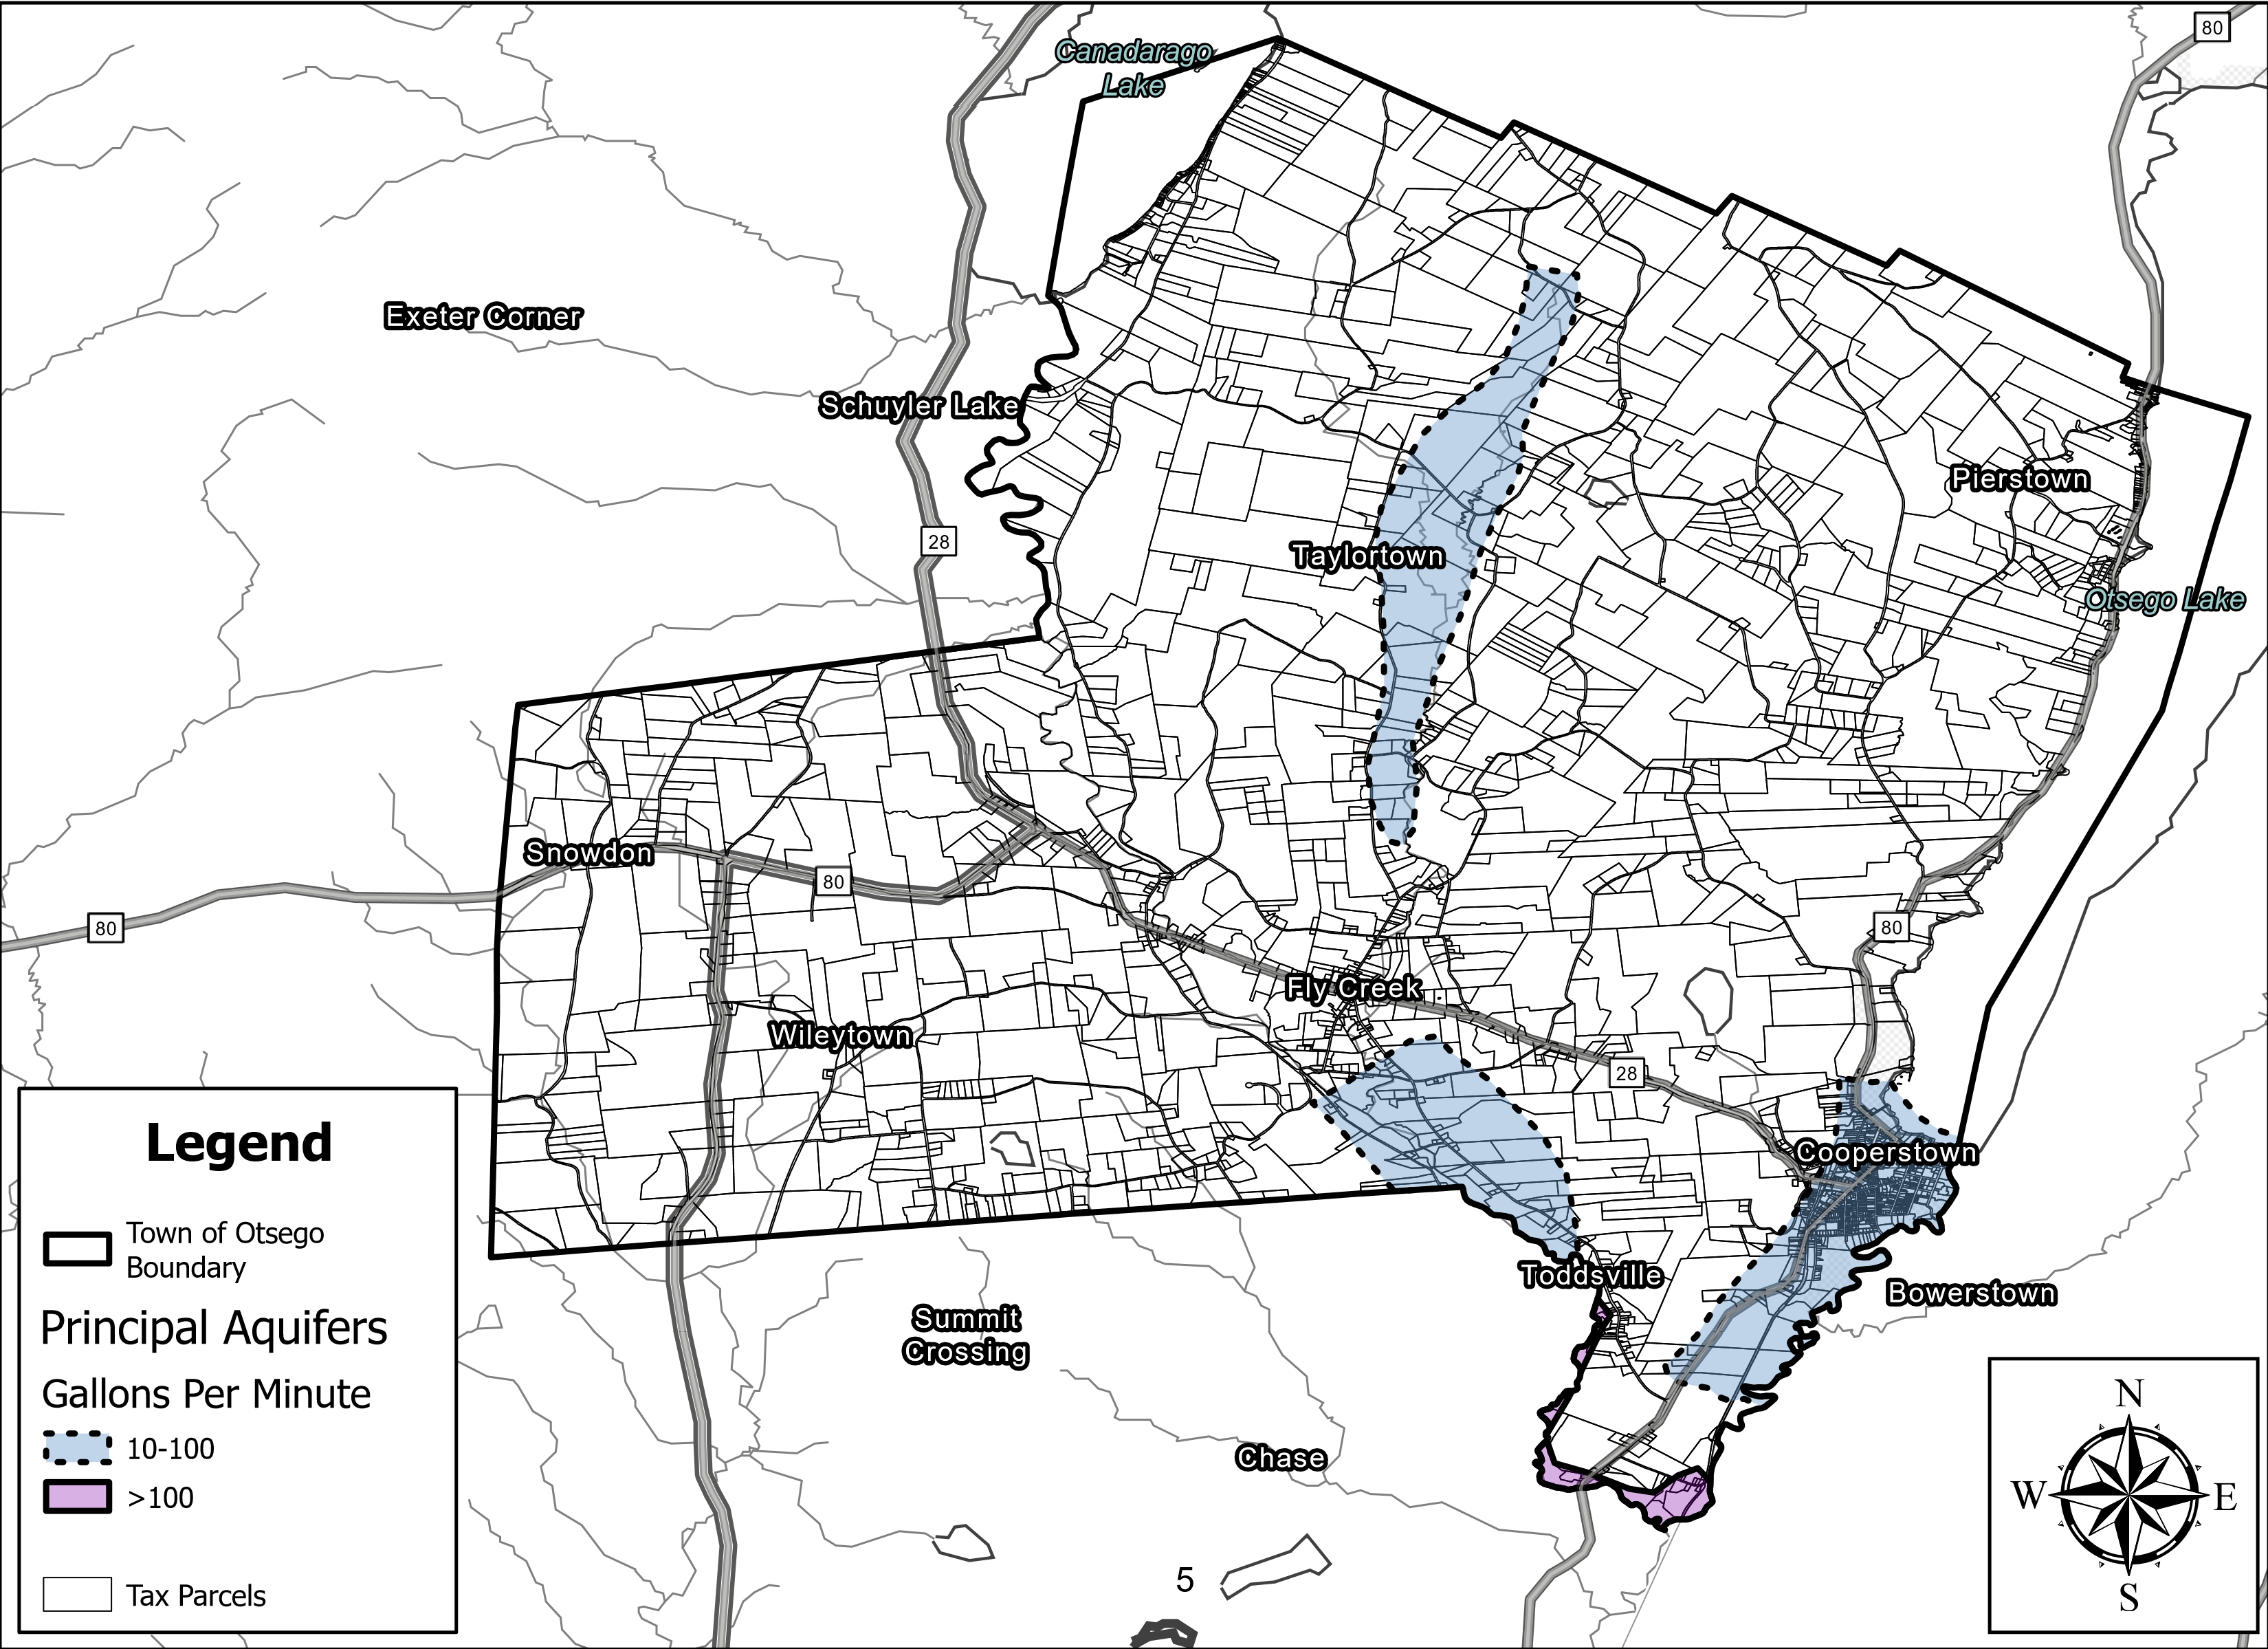
Otsego Municipality NRI - Principal Aquifers
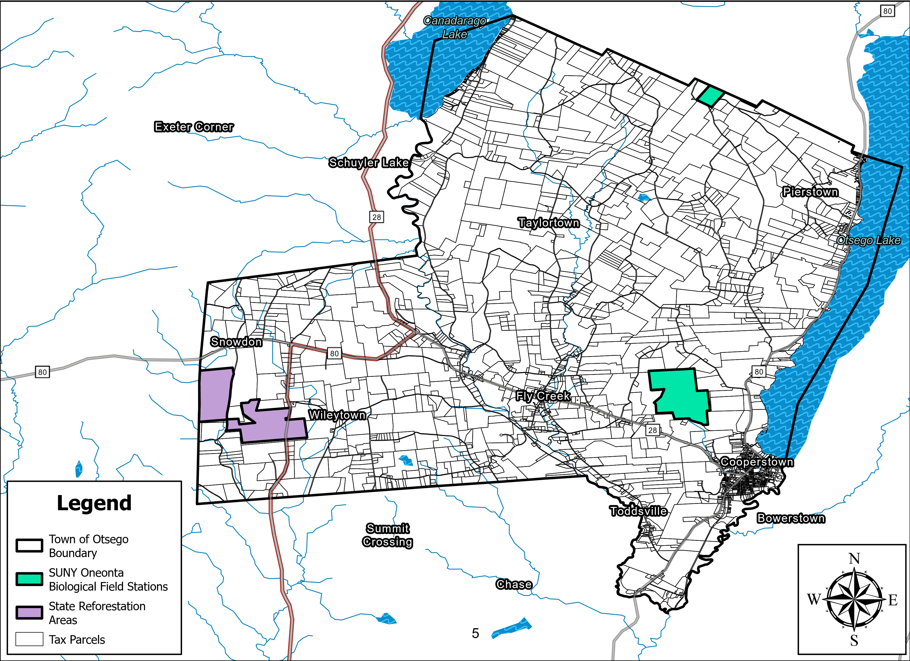
Otsego Municipality NRI - State Preserved Lands
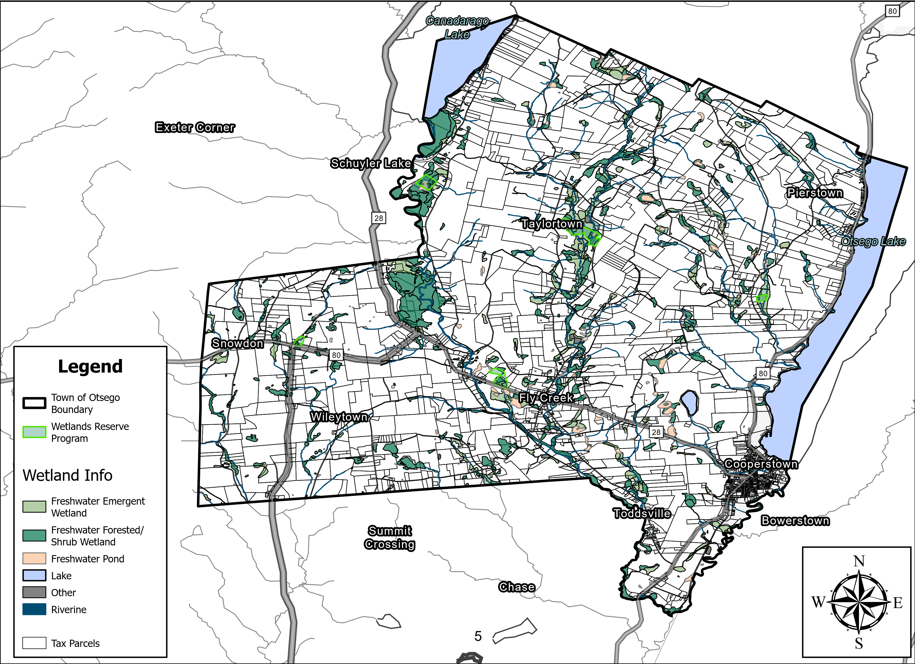
Otsego Municipality NRI - Wetland Information

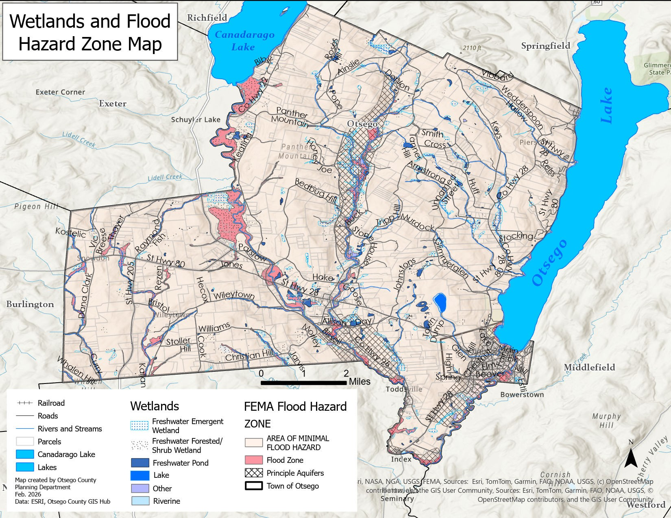

APPENDIX B: Community Survey
Town of Otsego FUTURE OF OTSEGO Open House

Join us for a chance to give your input to the Town of Otsego regarding the future of the community! Can’t make it?
Join us with your ideas ^{Fill out the} survey online!

Thursday, August 28th
5PM - 8PM Town Hall
Stop by anytime to check out what the Town of Otsego is working on for the Comprehensive Plan update and give your feedback!
Topics will include: Comprehensive Plan Overview, Housing, Tourism & Economic Development, Natural Resources, Agriculture, Historic Preservation, Parks and Recreation, Infrastructure & Safety, among others!
 Light refreshments will be served.
"This project has been funded in part by the Climate Smart Communities Grant Program, Title 15 of the
Environmental Protection Fund through the New York State Department of Environmental Conservation."52
What about the Town of Otsego is special, irreplaceable, or worthy of protecting:
Is there anything that could make you move from Otsego?
If so, what?
Please respond to the prompts as thoroughly as possible. Return completed survey in person at Town of Otsego (811 County Highway 26), by mail at PO Box 183, Fly Creek, NY 13327, or emailing a photo to ddalton@townofotsego.com Complete by 09/25/25 for your voice to be heard.
I/My family moved to/live in the Town of Otsego because:
The Town of Otsego is the best place to...
I wish the Town of Otsego had:
What’s the one thing the Town of Otsego needs more than anything else today?
Note: Turn page over for additional questions and space.

  Are you interested in serving on a subcommittee? Please choose one of the proposed focus areas:
  Housing, Neighborhoods and Economic Development
  Parks, Farmland, Natural
  Resources, Arts & Culture
  Revitalization, Infrastructure
  & Essential Service
  Contact and demographic information (optional):
  Name:
  Telephone: ( )
  Email:
  Road, address or location:
  Renter
  Resident: Year-round Part-time
  Property: Owner Other
 | Additional Space: |  |  |  |  | 54
I/My family moved to/live in the Town of Otsego because:
- Wanted to live in a small community and raise our kids there.
- We love the Cooperstown area -- especially the lake and rural area.
- Employment
- In 1970, we arrived as my father was employed at C.C.S. and my mother had already worked at NYSHA at the Fenimore House Library for seven years.
- of the beauty of Otsego lake
- We moved to the area because of a job, and chose to live in the Town of Otsego because of the walkability and community. • Bassett hospital employment
- I grew up in Otsego county.
- We moved here many years ago to be in a farming community with like minded families.
- Climate
- Work
- Of a conjunction of natural beauty, available services (health, schools, internet), economic anchor institutions, and culture.
- We had life long friends here. Wanted to get off Long Island to raise our young family .We moved here in 1984. We were impressed that people of all walks of life and economic backgrounds seemed to get along so well.
- The Cooperstown Graduate Program
- I came here for graduate school and my husband is from here. He returned for a career opportunity
- Originally, for graduate school, in 1971. After seven years away, returned for work at Fenimore House and The Farmers' Museum. After a job in Rhode Island, 1999-2018, returned in retirement because of: many good friends still here; healthcare facilities; safer weather than other regions.
- I got fired
- I enjoy the quiet natural environment and its historic character.
- Otsego offered clean air, peace, quiet, and nature. Also, affordable space.
- Cooperstown schools and rural life.
- The natural beauty and access to cultural institutions combined. Multi generational community
- December 18, 1981. We purchased our farm to dairy and poultry, now beef cattle
- Family (spouse) moved here for job/career opportunity at Bassett (1991). I moved here in 2008 when I married my husband.

- Family (spouse) moved here for job/career opportunity at Bassett (1991).
- Grew up in Fly Creek
- To start a business (Snowdon Hill Farms) in a rural setting.
- Rural & Agricultural area. Summer, fall residents on Otsego lake.
- I started to work at Bassett, but the reason the job was attractive was because I had done my residency at Bassett and was impressed with the friendliness and relaxed, beautiful environment.
- Good schools, access to healthcare, jobs in healthcare & construction, Otsego Lake.
- Rural nature, good schools, local healthcare, little crime, open spaces.
- I had family ties in Otsego County. I had admired the Fenimore farm & country village as a child and wanted to be a part of it.
- We want our children to go to Cooperstown Central School, walk to the gym, enjoy nature & being part of a community that cares about nature.
- We owned land & built our retirement home as we love this part of NY State, and also the benefit of having Bassett Medical Center
- We inherited property on lake Otsego on which we had always wanted to retire.
- Choice & job was available
- Nature
- We were familiar with area and had graduate schooling scheduled here… brought professional and military experience to the community.
- Fly Creek! We love the open space, green fields and lots of running water. It's calm, serene and just a beautiful space!
- We have known the area for decades, and wanted to live in the village of Cooperstown.
- We wanted to live in the Village of Cooperstown.
The Town of Otsego is the best place to...
- Live comfortably, with a good enough amount of things to do.
- I don't have an answer for this.
- Avoid malls, traffic, exercise, make and keep close friends
- raise a young family while pursuing a variety of career roles in a well educated rural community with outstanding medical care easily accessible.
- sit at waters' edge and reflect what beauty there is in Otsego county. It is also a quick jaunt to Cooperstown and the surrounding areas. The town of Otsego is the best place to be close to nature.
- Enjoy nature and also shops, restaurants, and community events.
- raise a family
- Experience all four seasons of the year.
- Humm.
- Spend the summer
- Grow or family or retire
- "Enjoy the beauty of central New York.”
- Live, as it is family friendly, good schools, fantastic Sports Center. Rural setting! Amazing Lake.
- Live becaue it is rural, cultural, ecologically minded, and beautiful • Relax, raise a family
- Raise a family.
- Die
- Live a private productive life without urban friction.
- Enjoy a quiet and private life with a deep sense of history.
- Wake up and go to sleep each morning.
- Access nature, on the water or in the woods.
- See nature in its beauty; go hiking; explore the Arts; raise a family.
- raise a family
- Decompress. Enjoy the outdoors. Get involved in the community - lots of volunteer options.
- Enjoy the continuing education that nature provides.
- Raise a family
- take in nature, the beautiful lake, majestic mountains. It is also a wonderful place to make friends.
- Living in the Town of Otsego is the best place to have a more rural life style and still have amenities close at hand.
- Relax.
- raise a family ... and hike...
- Live, vacation, work, recreate.
- Many things including enjoying the outdoors, small community, slower pace, rich cultural resources and THE LAKE!!
- enjoy a nice comfortable safe place to live in the country with other residents that appreciate the valuable assets that no other towns have.
- Enjoy the lake and environs. Cooperstown within Otsego has a lot of cultural things to offer
- "Swim
- Hike/walk
- Bike
- Access excellent community center"
- Xc ski, hike, kayak and attend cultural events.
- Be outside; hike; fish; get to know fun and creative people; support each other in a variety of ways, such as the Community Foundation, the Land Trust and others.
- live/work/raise kids in a quiet rural setting with healthy air, water, and soils -- and an active and engaged community.
- Has a rural environment. We visit California every year and it is always good to return as it’s peaceful,no traffic,minimal ambient light so I can see the stars, and I have room for a nice garden. Plus we have our lake!
- Enjoy beautiful natural scenery
- For me, the bucolic setting and overall less concentration of people/traffic as compared to our previous town.
- Have a good life with a high quality of meaningful attributes.
- Enjoy the remote, untouched beauty of central New York
- Relax, enjoy nature, enjoy recreational options and to raise a family in a safe, environmentally conscientious community of neighbors.
- enjoy the natural beauty of the lake and surrounding mountains throughout the year, live in peace and freedom and raise a family.
- see nature at her finest • Enjoy the outdoors, raise children
- raise a family.
- Retired
- Raise a family. Congregate with friends. Star gaze.
- Live, work, play, make life long friends wi the common interests.
- Savor small town living and enjoy unspoiled nature.

Raise a family.
live because of excellent small town stewardship exhibited by the local community.
- Enjoy a quiet peaceful lake view, the beautiful historic village of Cooperstown, great golfing, boating, swimming, music and restaurants.
- Enjoy my passion for the outdoors and daily hikes with my dog.
- The Town of Otsego is the best place to...
- Swim, fish, hike nature trails, visit museum and an opera ALL IN ONE DAY and finish with a fine dinner.
- Breathe. Drink water. See gorgeous skies, clouds during the day, stunning skies at night. Appreciate nature, beauty, forests, fields, streams/lakes, farms, animals.
- Breathe. Drink water. See gorgeous skies, clouds during the day, stunning skies at night. Appreciate nature, beauty, forests, fields, streams/lakes, farms, animals.
- To live, visit
- Live a quiet life.
- Enjoy the rural countryside.
- Live in a relaxed, beautiful environment.
- Raise a family.
- Raise a family.
- Enjoy the beauty of nature and the companionship of good people regardless of their professions.
- Slow down and enjoy life
- Enjoy a rural life with the beauty of Otsego Lake as a major part of its environment.
- Enjoy peace & quiet
- Live and raise a well-balanced family to continue growth and learning and continue to participate in community efforts.
- Enjoy nature, a kind, accepting environment for all people to go boating and hiking.
- Live as a retired couple, but also a lovely place to raise a family. Upstate NY is beautiful.
- Best place for upper income professionals. Also for part time residents and second homes.
I wish the Town of Otsego had:
- More people (of all kinds), more housing (of all kinds), more businesses.
- More Otsego and Canadarago lake access for those who don't own property on the lakes. A plan to reduce/prevent further housing growth and enlargement along the lakes. A zoning plan that focuses on, supports and defines rural affordable housing and small town business and housing. Sufficient funds and legal methods to enforce laws that protect small town, rural values. A more attractive ADA compliant, audience-friendly town hall complex. More money to improve the 75+ miles of roads the town has to protect and maintain. Climate smart buildings. Staff enough to apply for and administer grants. More diversity of all kinds -- especially places to eat.
- Rails to Trails bike path. Graduated assisted care facility for senior citizens - from independent living to nursing home levels.
- More accessible low and middle income housing available twelve months a year to hopefully attract young families with children to populate CCS once again as student enrollment has dropped by I estimate 40 % since 2000.
- limits on land development and road expansion
- More families with school age children. Cooperstown Central School needs more students. The school is the heart of the community.
- More investment in parks and recreation for families
- More developed nature trails and a dog wash.
- Less baseball on Cooperstown's main street and more options for everyday practical needs. A well managed farm store like the old Agway use to be. Not tractor Supply.
- Much better code enforcement
- Better shopping, at least nearby and neither Oneonta or Utica are adequate either
- Playgrounds, protected land, accommodation for small areas of density and mixed use.
- Safer bike lanes. Wider road around the lake. Public playground, as the Cooperstown school is not open to the public during school hours.
- Extensive senior housing opportunities; better access to the lake from the parks.
- more single family housing, better grocery stores, indoor turf
- Good nursing home/elder care. Small shopping center, other than Cooperstown.
- A viable economy
- Better sidewalks in the hamlet and code enforcement of its building laws.
- LESS BASEBALL. I did not move here to live in a baseball theme park.
Parks. The Village of Cooperstown has parks. We should have our own parks.
"Zoning laws that protect open spaces
- Increased focus on density and rehabilitating older structures in the village
- A better variety of retail outlets and quality eateries / healthy food in the village
- A plan for addressing future development
- it’s own library and ice skating rink
- "Affordable smaller housing for seniors and for the average working class resident and for new families. Kids can’t afford to stay. Seniors don’t need big houses.
- More hospital parking; more town parking.
- Eco tourism-instead of just baseball and leaf peepers. Plenty to do and, seemingly, opportunity for program development. Bike trails or wider roads on the main numbered streets (80, 26, etc) to have a bike lane.
- Small business development and assistance plan.
- More understanding of nature based learning and its importance, in established protocols for healthy child and family development.
- the ability to stay unchanged
- a good General Store, ride service so people could drink responsibility and not worry about driving, a walking path around the lake.
- We need to put a moratorium on building in place quickly!
- I’ll happy since Keys Rd was paved.
- a Wegman's
- Better land use laws to limit development and protect, preserve and encourage wise stewardship of our community's shared bounty - the forest, agriculture, soils, wildlands, wildlife, waters (wetlands, streams, lakes, rivers), historic, and cultural resources of the area.
- Stricter land use laws.
- a more comprehensive master plan that would be able to address this major subdivision that is being proposed that will protect the town's envelope.
- Some regulation to prevent degradation of the natural environment. Also worry about indiscriminate building to service short term baseball camp needs
- "More music venues that are free or reduced in cost
- More year round work
- Public transportation
- A growth plan that clearly supports affordable housing and development in already settled areas, while seeking to protect the health of the lake and the watershed by putting undeveloped land into conservation- while also making that land available
for everyone to enjoy- a hiking trail network; cross country skiing and snow shoeing network of trails; mountain biking.
- a safer 'downtown' four corners where small retail/restaurant/services could thrive from foot traffic and local residents. Alas, Rte 28 at Cty Rte 26 makes that really hard. But Fly Creek is a gem and needs to see more business activity.
- "Will move cautiously with any quick changes that will affect our current life here. An example is the dreams park which completely changes our area for several months every year,and in my opinion,not for the better"
- More affordable housing
- More diversity in its population.
- Within the last two years or so, especially during the tourist season, traffic has become more of a concern. The increase of vehicles that do not follow posted speed limits is certainly a safety concern. I also feel the speed limit within the hamlet of Fly Creek needs to be lowered.
- Unlimited ability to protect and preserve the health and beauty of Lake Otsego
- More retail store options,however ithe character of the town as is has been the reason why I call this my home.
- a revitalized downtown with every retail space thriving.
- more protected lands from being developed
- More human diversity, more benefits from the county (planning for example)
- A dedicated bike path -- the old train tracks between Cooperstown and Milford would be ideal because they start/end in two small villages that could benefit from the business.
- More public places
- "Town parks. Communal open space/trails.Stricter zoning regulations."
- More access to winter sports. Examples: downhill skiing (not possible), Nordic ski trails (attached to otesaga?), indoor tennis, hockey. I also wish we had a better quality grocery store. Wegmans would be ideal. I wish cooperstown specifically had more variety on Main Street as far as shops, food offerings etc.
- Better protections to preserve the environment, affordable housing.
- A plan to attract more businesses and employment opportunities.
- more access to the lake.
- Better control to avoid the historic district “quaint camps” properties being replaced with large ugly modern buildings with rental income motives. Stricter adherence to zoning and preserving the neighborhoods against short term rentals. Possibility limiting rental to monthly?
- A more diverse population.
More picnic sites, more farms
A movie theater, more primary care general medicine providers, more year round housing for low to medium income families; nice, affordable apartments, senior friendly housing (one levels near hamlet and village); housing for seniors at all care levels. Hiking, biking, horseback riding trails connected throughout the town.
- A movie theater, more primary care general medicine providers, more year round housing for low to medium income families; nice, affordable apartments, senior friendly housing (one levels near hamlet and village); housing for seniors at all care levels. Hiking, biking, horseback riding trails connected throughout the town.
- Homless shelters, more social services, drug rehabilitation
- Hiking-biking trail
- Better road maintenance, especially ditching and beaver control.
•
- Stricter laws that were enforced regarding the lake & development around the lake.
Section 4.1 Land Use Laws, none of the boards enforce these regulations.
- More diversity in the population, though it is improving.
- Safe bike paths, public transportation, more young people.
- Hiking trails/bike trails.
- Fewer deer.
- More variety of food choices
- Better road maintenance, it's embarassing owning a business & having poorly maintained roads & long grass on sides (not mowed)
- Lower taxes
- Lower taxes! The school tax is out of control!
- More affordable housing for older citizens. The school system and medical provisions have been very fine.
- A calmer summer that wasn't overrun with tourists, I understand the importance of it, and the benefits, but it can be crazy!
- More senior housing, but also more affordable housing and jobs to attract young people.
- More affordable housing. A better working relationship with the Village of Cooperstown. About half the town's residents live in the village.
What about the Town of Otsego is special, irreplaceable, or worthy of protecting:
- The sense of community is most important and, in changing times, stays consistent. That is the most important thing to protect.
- Otsego and Canadarago lake. Fly creek hamlet. The Fenimore Art museum and Farm. The cider mill. The general store. The FCAHS grange. The amazing views from our rural roads. The hard work of our town employees. The generosity of our neighbors.
- Undeveloped land, gorgeous countryside.
- Our scenic and rural landscape, our Bassett Medical Center, our Clark Sportscenter, our Otsego Land Trust, our Otsego Lake, our Baseball Hall of Fame, our Fenimore Farm and Art Museum, our Clark Scholarship program, our support from the Clark Foundation family, to name just a few things....
- Lake Otsego and all the land on bothsides of the lake, the surrounding trails, wildlife, aquatic life, the beauty of the countryside
- Otsego Lake, community and cultural events
- The Lake, cultural institutions, community
- Small farms
- The many acres of farm land, forests and quiet waterways, Rural America. These need to be maintained and restored before all is lost.
- Both the built and natural environment
- Otsego Lake
- Once compromised its beauty will be forever lost. The character, taste, and respect for the place are worthy and special.
- Lake Otsego and the landscape surrounding it.
- The lake; the historic district; the sense of history that permeates the entire area
- The lake, the peacefulness
- Water resources. Natural landscape. Outstanding village life in Cooperstown. Clark Sports Center. Countless contributions by The Clark Foundation. Cultural programs and organizations. Important volunteer organizations.
- History
- Its historic houses and the deep rooted connections to country's founding.
- The library, the hospital, and all the historic houses.
- The viewsheds within it.
- Our lake and our forests
- Otsego Lake; the small town atmosphere, the countryside , the beauty of the untouched land
"The beauty of the area with open farmland and natural habitats. "
- Lake. Agriculture. Outdoor recreation. Quaint downtowns and living areas. I love small town life.
- Otsego Lake, with its surrounding areas of wetlands and creeks, on which the lakes health is dependent, and thereby, also the health of our human species.
- Otsego Lake
- Otsego Lake is integral to the Town. Green mountains enhance the beauty of our Town. Lots of open spaces to walk and explore.
- Lake Otsego is our gem.
- Character.
- the view sheds, the lake, the areas around the lake, the open land, the lack of development
- The unique natural, agricultural, historical, and cultural resources of the area.
- All of our natural resources, historical resources and the rural nature of the town.
- our caring residents, Lake Otsego, eco system, water supply and slow growth that we can easily digest.
- The lake and the forests/natural environment
- "Natural environment
- Land which is offered for recreation by Jane Clark. We must protect this and not trash/ abuse this incredible resource!"
- Rural areas, the lake, the forests, the beautiful views, clean water, hiking trails
- The incredible natural beauty. The healthy and amazing lake. The creative pursuits. The people and the general sense of welcome.
- Its agricultural setting and natural resources. Its historic hamlets, architecture, barns and businesses.
- See my answer to number two above.
- The lake and the land surrounding it
- Everything. We’ve only lived here for 4+years and I’ve barely touched the surface of all the town/area has to offer.
- Our beautiful environment is like no other! Protecting our natural resources, our environment, our open spaces with insightful planning now and for the future.
- It’s natural beauty, and most beautiful lake Otsego
- The nature that surrounds us from the pristine Otsego Lake to the hills, mountains and beautiful vitas. The rural agricultural nature of this Town must be preserved.
- The natural beauty of the lake and surrounding land must be preserved. Additionally, the small town, rural farm community is what makes Cooperstown a special place and this must be preserved.
- beautiful vistas that are undisturbed, the lakes and rivers, a plentiful watershed
- Rural character, lake, history • The lake and surrounding nature.
- The lake
- Scenic beauty/open spaces. Natural resources: forest, streams, meadows, wildlife.
- Our Lake and hiking areas. Unique and irreplaceable. I love rowing and swimming and just walking along lake at pioneer park . I am very grateful that the plan for an viewing deck was aborted. I think we need to preserve the lake but not intrude on it. It’s incredible how our town sits beside it without disrupting it and we should work to preserve that unique arrangement and not compromise the lake or the serenity of the village that abuts it for the sake of enhancing the view for tourists.
- The countryside, lake and all that is unspoiled by overdevelopment.
- The sense of community.
- Otsego Lake water quality and purity. The lake has been the focal point of making Cooperstown a world renowned tourist destination.
- Protect and improve the health of the lake. Protect the quaint historic district and our neighborhood culture.
- The environment such as the forest, the lake and rural setting. The slower pace is particularly a pleasure.
- It's beauty and natural settings, hills, farms, forest, lakes, streams, etc.
- Clean, abundant water. Clean air. Agricultural lands, forests, streams, wetlands, lakes. Rural character (no suburbs). It's lack of big box stores, ugly & haphazard jumbled development that is all over the country.
- Clean, abundant water. Clean air. Agricultural lands, forests, streams, wetlands, lakes. Rural character (no suburbs). It's lack of big box stores, ugly & haphazard jumbled development that is all over the country.
- College programs for student & community
- Land & History
- Our rural lifestyle and our countryside.
- Quiet rural lifestyle.
- Our lake district & its surrounding lands
- The stunning, beautiful landscape, clean water and air, and lack of heavy traffic.
- Quality of life.
- Rural nature, great people.

The lake, the county seat, a good school and reasonable zoning laws. The Clark Foundation! The Fly Creek General Store! The Cider Mill, the Quilt Shop, and friendly road crew!
- The Lake, the forests, Nature
- Streams, lakes, ponds
- A largely unspoiled woodland and lake community, punctuated with farmland • Open spaces and large plots of land for most homeowners.
- The natural vistas and historical preservation are very important. We are interested in wildlife (birds, mammals, insects, plants, water creatures which I draw and study).
- The open spaces, neighbors not too close, and the wildlife.
- Otsego Lake
- The lake and the historic Village of Cooperstown. Also Fennimore Farm and Fenimore House.
Is there anything that could make you move from the Town of Otsego? If so, what?
- No.
- Although our town taxes continue to be the lowest in the County, housing is increasingly expensive. Supportive housing options for seniors are non-existent in the town. Transportation will be a challenge once I cannot drive -- which is not far ahead.
- Death of all my family and friends.
- If any group or individual were successful in creating a housing development with over 100 building lots to begin to change the historic rural character of our region, I'd seriously begin to explore moving away in anticipation of traffic congestion beyond our highway system network capabilities. If Bassett ever closed, I'd be looking to move as quickly as possible.
- If the lake became polluted or overcrowded with motor boats, if the roads became impassible, if more and more wildlife perished, if air, noise and air pollution became a problem.
- I live in the home my husband and I raised my (now grown) children in, and may want to downsize eventually.
- We need more housing for young people starting out, and for seniors. We will have to move when we age due to lack of senior housing options
- The increase of solar farms and windmills. I don't believe they are cost effective.
- Solar dumps, windmills, housing developments and anything else that destroys the natural beauty of what this area once was
- Over-development
- "Health care access (Bassett is experiencing a loss of capability and Doctorate degree providers)
- NYS estate tax laws.
- Possibly NYS income and other taxes"
- Becoming a suburb.
- Pollution of Lake Otsego.
- Lack of senior housing; winter; lack of public transportation • Declining population, schools, job opportunities
- Conditions that would prevent aging-in-place.
- A job offer
- Run away tourism that overwhelms the residents needs.
- I do not want the taxes to go up any more than they have done.
- Not moving unless development destroys our rural lifestyle.
Significant development that endangers our environment would make me think carefully.
- "Further development of tourism attractions;
- Political unrest; further development of residential areas."
- The passing of the Manocherian subdivision. Will destroy the beauty of this area by creating cluster housing with increase burden on the taxpayers for services . This is not affordable housing and will be millionaire’s alley.
- Unfettered/unplanned Urban sprawl.
- Contamination of Otsego Lake
- a huge increase in population
- Destruction of our water well, destruction of the trees, constant traffic and congestion, noise pollution, over development, demise of Bassett Medical Center, too many big box stores close to the Village.
- No
- Development. Loss of rural character.
- for us, it would be both kids ending up in the same city, with kids themselves -- that would be hard to resist
- Overdevelopment.
- We have several homes/investment properties in the area (town of OTSEGO, town of Springfield, village of Coop and in NYC), we honestly have it very good. The national political flavor could prompt me to flee the country, but I’m not looking to leave this area anytime unless absolutely necessary.
- Rapid commercialization.
- Degradation of the lake and natural environment. Overwhelming baseball infrastructure
- Lack of affordable housing. As a senior I can’t downsize ( which I’d like to) as there are no manageable replacements to access
- Suburbs, destroying rural areas, major developments, noise, unnecessary lighting, my friends leaving.
- Unplanned and chaotic development. Sprawl. We need to welcome and support new families to come to our community- and do it in a thoughtful way. The world as a whole needs to build out already developed areas- and preserve open lands, keep waterways and watersheds clean and cared for.
- Big box retail, industrial manufacturing, an increase in businesses and housing solely for the tourists.
- If it starts to change into an overrun,congested area with a polluted lake and air basin
- Yes, a large-scale subdivision
- Nothing at this time. We are quite happy and appreciative of our daughter’s generosity in inviting us to live here.
- The deterioration of what is here now. Also,as my husband and I continue on in years, the need for appropriate and available housing if we faced with challenging health issues.
- An overuse of resources, ie water septic, & anything leading to polluted lake Otsego
- Residential building over development. One only needs to look at Saratoga Lake and Lake George to see what over building and congestion has down to once beautiful areas of the Adirondacks. I will move if the focus of our sacred stewardship and responsibilities to preserve the natural beauty and low density of the town was to change.
- I would move away if this wonderful community allowed over-development so that it became like Lake George, which was destroyed by over population.
- developers buying up lands and building expensive housing, endangering out water table and wildlife, destroying our forests lakes and rivers • Becoming too much like the suburbs we left
- I don't think so!
- Crowds
- Industrial development. Suburban style commercial or residential development. Anything that is a detriment to the spirit of the Town.
- I would like to have stricter enforcement of rental rules in the village. We need to encourage fulll time occupants and discourage people who want to buy only to rent out space that is not well maintained and keeps cost of housing prohibitive for families. Out school census has been falling precipitously since the Dreams park opened. It has fallen faster than that would be expected with birth rate decline. We need to fight to keep this a real year round community that welcomes families. Larger census in schools allows us to offer more classes and enrichment opportunities, and likewise more attractive offering makes a more attractive school people will move here for. That is essential to attracting talented physicians and HC professionals to our hospital. We need providers to care for and participate in our community. Building up the school and hospital will make our commuting stronger. I think we need affordable housing but should be thoughtful about building multiple housing facilities, especially when disrupting nature or neighborhoods, when we could do a better job managing the housing inventory exists and is being exploited by landlords and bought up as Airbnb’s because rental rules in the village are not enforced.
Overdevelopment and pollution.
- The growing sentiment that any/all development is bad 2. The zoning board seems to always say no first, rather than helping residents understand “How” to achieve their plans within existing regulations 3. Continued reduction in population 4. Lack of housing for new families and empty nesters (which are identical in character, size and price)
- nothing.
- Overdevelopment and pollution.
- No.
- Encroachment of housing developments, solar & wind farms, increased traffic on my road which bisects our farm.
- Pollution. Crowded-ness, loss of rural character. Loss of family.
- Pollution. Crowded-ness, loss of rural character. Loss of family.
- Ill health.
- The loss of a natural resource (Lake Otsego) over development, especially around the lake, especially the west side. The Manachurian Project.
- If that landscape and relaxed environment was threatened.
- Inability to drive.
- Higher state and local taxes. Micro management by government.
- Loss of health or income that would necessitate elder care from family in another state.
- Destruction of nature and natural resources
- The closing of Bassett Medicial Center, lack of senior living opportunities and the continuing lack of road maintenance
- Overdevelopment, destruction/stress of the lake environment
- Inability to live independently due to age/health • Too much development.
- Population density and a reduction of access to everyday needs are increasing yearly (lived here 56 years). Camps and summer tourism absorb goods rapidly.
- Overcrowding
- Loss of family or close friends, problems with Bassett healthcare.
- Lack of services (medical and home care) on a reliable and consistent basis.
What's the one thing the Town of Otsego needs more than anything else today?
- A more open and inclusive mindset (and less NIMBYism).
- Only one. Yikes! An increased spirit of and realistic opportunities for volunteerism especially among the younger generations.
- More employment opportunities, improved roads, clustered housing options, restaurant in Fly Creek hamlet, housing in or near the Village and Hamlet with public transportation options, good general department store.
- Low and middle income housing for young families so new generations of children could take advantage of our many fine educational programs and grow CCS once again.
- water protection
- Housing and jobs for young people and young families.
- Affordable housing
- I cannot think of one specific thing.
- "Less is more.
- It's easy enough to get to the city for bright lights and loud noise, for concerts and theater. Let's get this area back to nature so the little children can just experience rural life to the fullest."
- Better land use plan and better code enforcement
- An organized and fully functioning government.
- A vision for development that accommodates growth without compromising character.
- A plan is needed to save our rural existence. Summer traffic is already maxed out due to the baseball parks and opera. Having a quieter town for the rest of the year is important to us. Hence, less development geared to seasonal rentals. In our opinion, our community would benefit greatly from more year round residents who could engage in and enrich our community.
- More senior housing options • year round single family housing
- Affordable housing.
- Jobs, or an economy
- Highspeed internet service at a reasonable price.
- A law to ensure that baseball renter in residential zones are QUIETER!
- Protection for water resources.
- Protection of our natural resources
- "Limit the growth of tourism
Limit the growth of residential development "
- Following the Comprehensive plan and not passing the Manocherian subdivision.
- Affordable housing.
- "Conservative principles in considering development of lands surrounding the lake, with conservation of natural resources being of upmost importance. We humans have become pretty arrogant in not considering the ecological impact of economics. We destroy ourselves by destroying our environment. Our earth home is a web of intraconnectedness in a web of intrabeing cosmos. Made of stardust we dig in the dirt to grow our food. Our separateness is a delusion.
- More land in trust
- More parking in the summer.
- A few more restaurants and fewer baseball stores. More diversity.
- Strategic planning.
- protection from negative growth
- Wise stewardship of natural, historic, and cultural resources.
- A buyer for the Fly Creek general store so it doesn’t go out of business. I’m serious, but maybe above that is the strongest protections for our rural culture and natural resources. It’s why we live here. That and the tuna on Boyd’s bread.
- A more diversified business district that is open all year round.
- Moratorium to study potential rapid growth due to proposed subdivisions and appropriately regulate to protect the natural environment
- "Affordable housing for residents
- Emphasize residents as people who live and work here"
- Better planning for major developments, instead maybe a tiny house intentional community like Ithaca has and other communities throughout the world.
- Thoughtful planning and leadership.
- year-round affordable housing (please phase out short-term rentals!).
- A through and complete evaluation on all projects that will impact our current quality of life
- Strong rules against major developments invading the rural landscape
- Unity. Locally and globally.
- "Perhaps as many people/residents/citizens being acknowledged/welcomed/encouraged to participate in community events.
- "
- Protect Lake Otsego
- More affordable housing that stays within the character of the town while allowing a location for the macro population to live, thrive and raise a family.

Affordable housing that fits into the rural character of the town.
- more land trust and zoning laws
- More intergovernmental Cooperstown with county and village
- I'm not sure.... It's such a small community that every change moves the needle quite a bit. In other words, we don't need a ton of any one thing to feel an appreciable change. I would say go thoughtfully, in a measured way, in any direction. And just because the federal or state government is offering grants to do something doesn't mean we need to do it.
- Keep the family farms
- A plan that encourages purposeful development/growth along existing corridors.
- More families who want to live and work here and contribute to the community.
Small businesses and people to support them.
- Good paying jobs, housing and environmental protections.
- New people, families, children, etc.
- more parking.
- Stricter zoning rules and enforcement
- An in place, solid plan for protecting the lake, wetlands and forest.
- Opportunities for young families.
- Affordable, energy efficient, year round housing for all income levels, especially low to medium, close to the vilage and the fly creek hamlet.
- Affordable, energy efficient, year round housing for all income levels, especially low to medium, close to the vilage and the fly creek hamlet.
- Government funding
- Roads filled, sides of roads mowed, trim back branches
- Better leadership, which is being worked on.
- Affordable housing for people who work and live in the town. We don't need more housing for wealthy, part time residents. We need housing for people who work in the hospital, County, and small businesses. Sustainable small businesses also need to be encouraged.
- Good jobs & affordable housing to attract young families.
- More elder care, assisted living facility.
- Opportunities for jobs and housing for people in support services. Fewer deer!
- Music store
- Road maintenance and side of roads trimmed & mowed
- A plan to limit development
- Affordable housing for year round residents. Kids in the school system.
The roads are becoming narrow for trucks and larger cars. The traffic on backroads is dangerous for walkers. Affordable, intelligently planned housing is getting challenging.
- Nothing - that's part of the charm!
- I agree with another responder - a plan that includes consideration of the the Village's needs.
- An updated, well thought out comprehensive plan that is integrated or least compatible with the Village's comprehensive plan.

1 | Wanted to live in a small community and raise our kids there. | Live comfortably, with a good enough amount of things to do. | More people (of all kinds), more housing (of all kinds), more businesses. | The sense of community is most important and, in changing times, stays consistent. That is the most important thing to protect. No.
2 | We love the Cooperstown area -- especially the lake and rural area. | I don't have an answer for this. | More Otsego and Canadarago lake access for those who don't own property on the lakes. A plan to reduce/prevent further housing growth and enlargement along the lakes. A zoning plan that focuses on, supports and defines rural affordable housing and small town business and housing. Sufficient funds and legal methods to enforce laws that protect small town, rural values. A more attractive ADA compliant, audience-friendly town hall complex. More money to improve the 75+ miles of roads the town has to protect and maintain. Climate smart buildings. Staff enough to apply for and administer grants. More diversity of all kinds -- especially places to eat. | Otsego and Canadarago lake. Fly creek hamlet. The Fenimore Art museum and Farm. The cider mill. The general store. The  FCAHS grange. The amazing views from our rural roads. The hard work of our town employees. The generosity of our neighbors. | Although our town taxes continue to be the lowest in the County, housing is increasingly expensive. Supportive housing options for seniors are nonexistent in the town. Transportation will be a challenge once I cannot drive -- which is not far ahead.
3 | Employment | Avoid malls, traffic, exercise, make and keep close friends | Rails to Trails bike path. Graduated assisted care facility for senior citizens - from independent living to nursing home levels. | Undeveloped land, gorgeous countryside. | Death of all my family and friends.
4 | In 1970, we arrived as my father was employed at C.C.S. and my mother had already worked at NYSHA at the Fenimore House Library for seven years. | raise a young family while pursuing a variety of career roles in a well educated rural community with outstanding medical care easily accessible. | More accessible low and middle income housing available twelve months a year to hopefully attract young families with children to populate CCS once again as student enrollment has dropped by I estimate 40 % since 2000. | Our scenic and rural landscape, our Bassett Medical Center, our Clark Sportscenter, our Otsego Land Trust, our Otsego Lake, our Baseball Hall of Fame, our Fenimore Farm and Art Museum, our Clark Scholarship program, our support from the Clark Foundation family, to name just a few things.... | If any group or individual were successful in creating a housing development with over 100 building lots to begin to change the historic rural character of our region, I'd seriously begin to explore moving away in anticipation of traffic congestion beyond our highway system network capabilities. If Bassett ever closed, I'd be looking to move as quickly as possible.
5 | of the beauty of Otsego lake | sit at waters' edge and reflect what beauty there is in Otsego county. It is also a quick jaunt to Cooperstown and the surrounding areas. The town of Otsego is the best place to be close to nature. | limits on land development and road expansion | Lake Otsego and all the land on bothsides of the lake, the surrounding trails, wildlife, aquatic life, the beauty of the countryside | If the lake became polluted or overcrowded with motor boats, if the roads became impassible, if more and more wildlife perished, if air, noise and air pollution became a problem.
6 | We moved to the area because of a job, and chose to live in the Town of Otsego because of the walkability and community. | Enjoy nature and also shops, restaurants, and community events. | More families with school age children. Cooperstown Central School needs more students. The school is the heart of the community. | Otsego Lake, community and cultural events | I live in the home my husband and I raised my (now grown) children in, and may want to downsize eventually.
7 | Bassett hospital employment | raise a family | More investment in parks and recreation for families | The Lake, cultural institutions, community | We need more housing for young people starting out, and for seniors. We will have to move when we age due to lack of senior housing options
8 | I grew up in Otsego county. | Experience all four seasons of the year. | More developed nature trails and a dog wash. | Small farms | The increase of solar farms and windmills. I don't believe they are cost effective.
 |  |  |  | The many acres of farm land, forests and quiet waterways, Rural America. These need to be maintained and restored before all
9 | We moved here many years ago to be in a farming community with like minded families. | Humm. | Less baseball on Cooperstown's main street and more options for everyday practical needs. A well managed farm store like the old Agway use to be. Not tractor Supply. | is lost. | Solar dumps, windmills, housing developments and anything else that destroys the natural beauty of what this area once was
10 | Climate | Spend the summer | Much better code enforcement | Both the built and natural environment | Over-development
11 | Work | Grow or family or retire | Better shopping, at least nearby and neither Oneonta or Utica are adequate either | Otsego Lake | Health care access (Bassett is experiencing a loss of capability and Doctorate degree providers) NYS estate tax laws.  Possibly NYS income and other taxes
12 | Of a conjunction of natural beauty, available services (health, schools, internet), economic anchor institutions, and culture. | Enjoy the beauty of central New York. | Playgrounds, protected land, accommodation for small areas of density and mixed use. | Once compromised its beauty will be forever lost. The character, taste, and respect for the place are worthy and special. | Becoming a suburb.
 | We had life long friends here. Wanted to get off Long Island to raise our young family .We moved here in 1984. We were impressed that people Live, as it is family friendly, good schools, fantastic Sports Center. Rural setting! Amazing
13 | of all walks of life and economic backgrounds seemed to get along so well. Lake. |  | Safer bike lanes. Wider road around the lake. Public playground, as the Cooperstown school is not open to the public during school hours. | Lake Otsego and the landscape surrounding it. | Pollution of Lake Otsego.
14 | The Cooperstown Graduate Program Live becaue it is rural, cultural, ecologically minded, and beautiful |  | Extensive senior housing opportunities; better access to the lake from the parks. | The lake; the historic district; the sense of history that permeates the entire area | Lack of senior housing; winter; lack of public transportation
15 | I came here for graduate school and my husband is from here. He returned for a career opportunity Relax, raise a family |  | more single family housing, better grocery stores, indoor turf | The lake, the peacefulness | Declining population, schools, job opportunities
16 | Originally, for graduate school, in 1971. After seven years away, returned for work at Fenimore House and The Farmers' Museum. After a job in  Raise a family.  Rhode Island, 1999-2018, returned in retirement because of: many good friends still here; healthcare facilities; safer weather than other regions. |  | Good nursing home/elder care. Small shopping center, other than Cooperstown. | Water resources. Natural landscape. Outstanding village life in Cooperstown. Clark Sports Center. Countless contributions by The Clark Foundation. Cultural programs and organizations. Important volunteer organizations. | Conditions that would prevent aging-in-place.
17 | I got fired Die |  | A viable economy | History | A job offer
18 | I enjoy the quiet natural environment and its historic character. Live a private productive life without urban friction. |  | Better sidewalks in the hamlet and code enforcement of its building laws. | Its historic houses and the deep rooted connections to country's founding. | Run away tourism that overwhelms the residents needs.
19 | Otsego offered clean air, peace, quiet, and nature. Also, affordable space. Enjoy a quiet and private life with a deep sense of history. |  | LESS BASEBALL. I did not move here to live in a baseball theme park. | The library, the hospital, and all the historic houses. | I do not want the taxes to go up any more than they have done.
20 | Cooperstown schools and rural life. Wake up and go to sleep each morning. |  | Parks. The Village of Cooperstown has parks. We should have our own parks. | The viewsheds within it. | Not moving unless development destroys our rural lifestyle.
21 | The natural beauty and access to cultural institutions combined. Multi generational community Access nature, on the water or in the woods. |  | Zoning laws that protect open spaces  Increased focus on density and rehabilitating older structures in the village  A better variety of retail outlets and quality eateries / healthy food in the village | Our lake and our forests | Significant development that endangers our environment would make me think carefully.
ID I/My family moved to/live in the Town of Otsego because: The Town of Otsego is the best place to... I wish the Town of Otsego had: What about the Town of Otsego is special, irreplaceable, or worthy of protecting: Is there anything that could make you move from the Town of Otsego? If so, what?
Further development of tourism attractions;
22 | Employment opportunity | See nature in its beauty; go hiking; explore the Arts; raise a family. | A plan for addressing future development | Otsego Lake; the small town atmosphere, the countryside , the beauty of the untouched land | Political unrest; further development of residential areas.
23 | Rural atmosphere and a better way of life | raise a family | it’s own library and ice skating rink | The beauty of the area with open farmland and natural habitats. | The passing of the Manocherian subdivision. Will destroy the beauty of this area by creating cluster housing with increase burden on the taxpayers for services . This is not affordable housing and will be millionaire’s alley.
24 | My husband is from here. And, we like rural living. | Decompress. Enjoy the outdoors. Get involved in the community - lots of volunteer options. | Affordable smaller housing for seniors and for the average working class resident and for new families. Kids can’t afford to stay. Seniors don’t need big houses.  More hospital parking; more town parking.  Eco tourism-instead of just baseball and leaf peepers. Plenty to do and, seemingly, opportunity for program development. Bike trails or wider roads on the main numbered streets (80, 26, etc) to have a bike lane.  Small business development and assistance plan. | Lake. Agriculture. Outdoor recreation. Quaint downtowns and living areas. I love small town life. | Unfettered/unplanned Urban sprawl.
25 | The beauty of Lake Otsego and long ancestral connections to its waterways. | Enjoy the continuing education that nature provides. | More understanding of nature based learning and its importance, in established protocols for healthy child and family development. | Otsego Lake, with its surrounding areas of wetlands and creeks, on which the lakes health is dependent, and thereby, also the health of our human species. | Contamination of Otsego Lake
26 | We love the lake! | Raise a family | the ability to stay unchanged | Otsego Lake | a huge increase in population
27 | My husband was interviewing with Bassett Hospital and I fell in love with the beauty of Cooperstown. | take in nature, the beautiful lake, majestic mountains. It is also a wonderful place to make a good General Store, ride service so people could drink responsibility and not worry about driving, a walking path around the lake. friends. |  | Destruction of our water well, destruction of the trees, constant traffic and congestion, noise pollution, over development, demise of Bassett Medical Otsego Lake is integral to the Town. Green mountains enhance the beauty of our Town. Lots of open spaces to walk and explore.  Center, too many big box stores close to the Village.
28 | 45 years ago. We moved for a job and the quality of life. The school was vibrant at the time. | Living in the Town of Otsego is the best place to have a more rural life style and still have  We need to put a moratorium on building in place quickly! amenities close at hand. |  | Lake Otsego is our gem. | No
29 | Quiet and rural environment. Low population density. | Relax. I’ll happy since Keys Rd was paved. |  | Character. | Development. Loss of rural character.
30 | high quality of life, beautiful area, great community | raise a family ... and hike... a Wegman's |  | the view sheds, the lake, the areas around the lake, the open land, the lack of development | for us, it would be both kids ending up in the same city, with kids themselves -- that would be hard to resist
31 | I grew up in the Town of Otsego (fly creek and Cooperstown) and am a third generation owner of our family's farm property in upper fly creek valley - on my father's side. On my mother's side, I am a sixth generation resident of the Town of Otsego and also part owner of a sixthgeneration family farm property in Index. To me, the Town of Otsego, including Otsego Lake and the Village of Cooperstown, my home, is the most beautiful place on earth. | Better land use laws to limit development and protect, preserve and encourage wise stewardship of our community's shared bounty - the forest, agriculture, soils, wildlands, wildlife, waters  Live, vacation, work, recreate. (wetlands, streams, lakes, rivers), historic, and cultural resources of the area. |  | The unique natural, agricultural, historical, and cultural resources of the area. | Overdevelopment.
32 | I was born here, moved away as an adult and chose to return to raise my son. The lake is the biggest draw for me | Many things including enjoying the outdoors, small community, slower pace, rich cultural resources and THE LAKE!! Stricter land use laws. |  | All of our natural resources, historical resources and the rural nature of the town. | We have several homes/investment properties in the area (town of OTSEGO, town of Springfield, village of Coop and in NYC), we honestly have it very good. The national political flavor could prompt me to flee the country, but I’m not looking to leave this area anytime unless absolutely necessary.
33 | We have coming to this area since 1987...it always felt like home. In 2018 we purchased our home and decided to retire here in 2023. | enjoy a nice comfortable safe place to live in the country with other residents that appreciate the valuable assets that no other towns have. a more comprehensive master plan that would be able to address this major subdivision that is being proposed that will protect the town's envelope. |  | our caring residents, Lake Otsego, eco system, water supply and slow growth that we can easily digest. | Rapid commercialization.
34 | Work at Bassett-to live in proximity to the hospital. Also a beautiful place to live | Enjoy the lake and environs. Cooperstown within Otsego has a lot of cultural things to  offer Some regulation to prevent degradation of the natural environment. Also worry about indiscriminate building to service short term baseball camp needs |  | The lake and the forests/natural environment | Degradation of the lake and natural environment. Overwhelming baseball infrastructure
35 | Good school  Close to family | Swim  Hike/walk More music venues that are free or reduced in cost  Bike More year round work  Access excellent community center |  | Natural environment  Land which is offered for recreation by Jane Clark. We must protect this and not trash/ abuse this incredible resource! | Lack of affordable housing. As a senior I can’t downsize ( which I’d like to) as there are no manageable replacements to access
36 | I’m a native. I moved away as a child, but came back after college for the gym, the lake, and rural living and beauty that is being destroyed everywhere else by urban sprawl and economic development. | Xc ski, hike, kayak and attend cultural events. Public transportation |  | Rural areas, the lake, the forests, the beautiful views, clean water, hiking trails | Suburbs, destroying rural areas, major developments, noise, unnecessary lighting, my friends leaving.
37 | The natural beauty and the healthy lake and watershed; the variety of outdoor activities; The community is full of smart and interesting people |  |  | The incredible natural beauty. The healthy and amazing lake. The creative pursuits. The people and the general sense of welcome. | Unplanned and chaotic development. Sprawl. We need to welcome and support new families to come to our community- and do it in a thoughtful way. The world as a whole needs to build out already developed areas- and preserve open lands, keep waterways and watersheds clean and cared for.
37 | Be outside; hike; fish; get to know fun and creative people; support each other in a variety A grwoth plan that clearly supports affordable housing and development in already settled areas, while seeking to protect the health of the lake and the watershed by putting undeveloped land into  and there is an invested group in the county working together to make the community and the county welcoming and livable for everyone. The of ways, such as the Community Foundation, the Land Trust and others. conservation- while also making that land available for everyone to enjoy- a hiking trail network; cross country skiing and snow shoeing network of trails; mountain biking.
37 | incredible arts scene- opera and an amazing museum in a small town.
38 | I grew up spending summers on Johnston Road visiting my grandparents -- our roots in the area go back to at least the early 1800s. When I was looking to leave the DC metro area, it was pretty evident that this was the place I wanted to live -- pristine air and water, agricultural and forested landscapes, no stop lights (well, one), and the chance to be in the woods or in the lake 10 minutes after leaving the office. | live/work/raise kids in a quiet rural setting with healthy air, water, and soils -- and an a safer 'downtown' four corners where small retail/restaurant/services could thrive from foot traffic and local residents. Alas, Rte 28 at Cty Rte 26 makes that really hard. But Fly Creek is a gem and active and engaged community. needs to see more business activity. |  | Its agricultural setting and natural resources. Its historic hamlets, architecture, barns and businesses. | Big box retail, industrial manufacturing, an increase in businesses and housing solely for the tourists.
39 | Moved from California for a job at Bassett Hospital in1991 | Has a rural environment. We visit California every year and it is always good to return as  Will move cautiously with any quick changes that will affect our current life here  it’s peaceful,no traffic,minimal ambient light so I can see the stars, and I have room for a  An example is the dreams park which completely changes our area for several months every year,and in my opinion,not for the better nice garden. Plus we have our lake! |  | See my answer to number two above. | If it starts to change into an overrun,congested area with a polluted lake and air basin
40 | The natural beauty and the peacefulness of the environment | Enjoy beautiful natural scenery More affordable housing |  | The lake and the land surrounding it | Yes, a large-scale subdivision
41 | My daughter moved here because she accepted a position at Bassett and we relocated to be closer to her. | For me, the bucolic setting and overall less concentration of people/traffic as compared to  More diversity in its population. our previous town. |  | Everything. We’ve only lived here for 4+years and I’ve barely touched the surface of all the town/area has to offer. | Nothing at this time. We are quite happy and appreciative of our daughter’s generosity in inviting us to live here.
42 | Having been raise in Vermont and having family within a close distance to Cooperstown, we decided to leave our home in California and try living in this rural setting in Upstate NY. In other words, it was a two year “trial”. That was 34 years ago! | Within the last two years or so, especially during the tourist season, traffic has become more of a concern. The increase of vehicles that do not follow posted speed limits is certainly a safety concern. Our beautiful environment is like no other! Protecting our natural resources, our environment, our open spaces with insightful Have a good life with a high quality of meaningful attributes.  I also feel the speed limit within the hamlet of Fly Creek needs to be lowered. planning now and for the future. |  |  | The deterioration of what is here now. Also,as my husband and I continue on in years, the need for appropriate and available housing if we faced with challenging health issues.
43 | Employment at Bassett Health Network | Enjoy the remote, untouched beauty of central New York Unlimited ability to protect and preserve the health and beauty of Lake Otsego It’s natural beauty, and most beautiful lake Otsego |  |  | An overuse of resources, ie water septic, & anything leading to polluted lake Otsego
44 | The rural beauty of the town, the magnificent hills and mountains and of course Otsego Lake. I also can't forget the small friendly close knit community. | Relax, enjoy nature, enjoy recreational options and to raise a family in a safe, The nature that surrounds us from the pristine Otsego Lake to the hills, mountains and beautiful vitas. The rural agricultural  More retail store options,however ithe character of the town as is has been the reason why I call this my home.  environmentally conscientious community of neighbors. nature of this Town must be preserved. |  |  | Residential building over development. One only needs to look at Saratoga Lake and Lake George to see what over building and congestion has down to once beautiful areas of the Adirondacks. I will move if the focus of our sacred stewardship and responsibilities to preserve the natural beauty and low density of the town was to change.
45 | of the rural character of that "Hallmark movie" downtown, the beautiful lake and the safe and friendly nature of the community. | enjoy the natural beauty of the lake and surrounding mountains throughout the year, live The natural beauty of the lake and surrounding land must be preserved. Additionally, the small town, rural farm community is a revitalized downtown with every retail space thriving. |  |  | I would move away if this wonderful community allowed over-development so that it became like Lake George, which was destroyed by over population.
45 |  | in peace and freedom and raise a family. | what makes Cooperstown a special place and this must be preserved.
46 | country nature undeveloped landscapes | see nature at her finest | more protected lands from being developed beautiful vistas that are undisturbed, the lakes and rivers, a plentiful watershed |  | developers buying up lands and building expensive housing, endangering out water table and wildlife, destroying our forests lakes and rivers
47 | Because that’s where Cooperstown is - that was the attraction  Quality of life, job, small but cosmopolitan | Enjoy the outdoors, raise children | More human diversity, more benefits from the county (planning for example) Rural character, lake, history |  | Becoming too much like the suburbs we left
48 | My family moved to the Town of Otsego from Brooklyn because we wanted easy access to protected nature and a close-knit community that is safe enough for our kids to have a great deal of freedom in the real world from a very young age. | raise a family. | A dedicated bike path -- the old train tracks between Cooperstown and Milford would be ideal because they start/end in two small villages that could benefit from the business. The lake and surrounding nature. |  | I don't think so!
49 | Charm and beauty | Retired | More public places The lake |  | Crowds
50 | Be close to friends and family. Privacy. Peace and quiet. Scenic, natural beauty. | Raise a family. Congregate with friends. Star gaze. | Town parks. Communal open space/trails.  Scenic beauty/open spaces. Natural resources: forest, streams, meadows, wildlife. Stricter zoning regulations. |  | Industrial development. Suburban style commercial or residential development. Anything that is a detriment to the spirit of the Town.
51 | To be closer to nature and still be part of a vibrant village/community. We were particularly attracted to the lake and the preserved land surrounding the lake. | Live, work, play, make life long friends wi the common interests. |  |  | I would like to have stricter enforcement of rental rules in the village. We need to encourage fulll time occupants and discourage people who want to buy only to rent out space that is not well maintained and keeps cost of housing prohibitive for families. Out school census has been falling
51 |  |  | precipitously since the Dreams park opened. It has fallen faster than that would be expected with birth rate decline. We need to fight to keep this a Our Lake and hiking areas. Unique and irreplaceable. I love rowing and swimming and just walking along lake at pioneer park . real year round community that welcomes families. Larger census in schools allows us to offer more classes and enrichment opportunities, and  More access to winter sports. Examples: downhill skiing (not possible), Nordic ski trails (attached to otesaga?), indoor tennis, hockey. I also wish we had a better quality grocery store. Wegmans I am very grateful that the plan for an viewing deck was aborted. I think we need to preserve the lake but not intrude on it. It’s likewise more attractive offering makes a more attractive school people will move here for. That is essential to attracting talented physicians and HC  would be ideal. I wish cooperstown specifically had more variety on Main Street as far as shops, food offerings etc. incredible how our town sits beside it without disrupting it and we should work to preserve that unique arrangement and not  professionals to our hospital. We need providers to care for and participate in our community. Building up the school and hospital will make our  compromise the lake or the serenity of the village that abuts it for the sake of enhancing the view for tourists.  commuting stronger. I think we need affordable housing but should be thoughtful about building multiple housing facilities, especially when disrupting nature or neighborhoods, when we could do a better job managing the housing inventory exists and is being exploited by landlords and bought up as Airbnb’s because rental rules in the village are not enforced.
52 | Quality of life, good jobs, safe place to raise a family. | Savor small town living and enjoy unspoiled nature. | Better protections to preserve the environment, affordable housing. The countryside, lake and all that is unspoiled by overdevelopment. Overdevelopment and pollution.
53 | A business opportunity. | Raise a family. | 1. The growing sentiment that any/all development is bad 2. The zoning board seems to always say no first, rather than helping residents understand  A plan to attract more businesses and employment opportunities. The sense of community. “How” to achieve their plans within existing regulations 3. Continued reduction in population 4. Lack of housing for new families and empty nesters  (which are identical in character, size and price)
54 | of the beautiful clean lake and charm of the small camps on the lake. | live because of excellent small town stewardship exhibited by the local community. | Otsego Lake water quality and purity. The lake has been the focal point of making Cooperstown a world renowned tourist  more access to the lake. nothing. destination.
55 | We love the beautiful clean lake and the historic rural feel of the old small camps and beautiful historic buildings. We love the availability of water sports, music and museums. | Enjoy a quiet peaceful lake view, the beautiful historic village of Cooperstown, great golfing, boating, swimming, music and restaurants. | Better control to avoid the historic district “quaint camps” properties being replaced with large ugly modern buildings with rental income motives. Stricter adherence to zoning and preserving the  Protect and improve the health of the lake. Protect the quaint historic district and our neighborhood culture. Overdevelopment and pollution. neighborhoods against short term rentals. Possibility limiting rental to monthly?
56 | My wife and I relocated here to live with our daughter. | Enjoy my passion for the outdoors and daily hikes with my dog. | A more diverse population. The environment such as the forest, the lake and rural setting. The slower pace is particularly a pleasure. No.
76
Are you interested in serving on a subcommittee? Are you a year-round or part Do you own or rent
1 | A more open and inclusive mindset (and less NIMBYism). | Please choose one of the proposed focus areas:  Housing, Neighborhoods and Economic Development | time resident of the Town?  Year round | your residence?  Own | Yes. In order to build a better future (and to have a future at all), the Town must look forward and encourage growth and building in ways that work for all. Succumbing to the
2 | Only one. Yikes! An increased spirit of and realistic opportunities for volunteerism - especially among the younger generations. | Revitalization, Infrastructure & Essential Service | Year round | Rent | usual negative voices ensures our decline.  Thanks to all of you who are working on this. I almost didn't submit this survey when I go the part that asked who I was and asked for contact info. My answers to the earlier Qs were no longer confidential, although many of you might have guessed the author anyway. And, I almost answered "not interested" for subcommittee work -- Not because I am not interested -- I am VERY interested. I just can't work on one more thing right now. Bravo to all of you for this valuable work!
3  4 | More employment opportunities, improved roads, clustered housing options, restaurant in Fly Creek hamlet, housing in or near the Village and Hamlet with public transportation options, good general department store.  Low and middle income housing for young families so new generations of children could take advantage of our many fine educational programs and grow CCS once again. | Revitalization, Infrastructure & Essential Service  Housing, Neighborhoods and Economic Development | Year round  Year round | Own  Own | Involvement of more of our local citizens with local government.  I'm actively following the application for development of 111 bldg lots & 1517 acres in the Town of Springfield & the Town of Otsego.
5 | water protection | Parks, Farmland, Natural Resources, Arts & Culture | Part time | Own | I am against the proposed land development and do not want major change in our landscape.
6 | Housing and jobs for young people and young families. | Parks, Farmland, Natural Resources, Arts & Culture | Year round | Own | We need to provide housing and opportunity for young people to live and work in the community. Bassett is a great draw as an employer, we need to make housing so more people can work and live in the Town of Otsego.
7  8 | Affordable housing  I cannot think of one specific thing.  Less is more. | Not interested  Not interested | Year round  Year round | Own  Own | I appreciate the winter maintenance of our roads.
9  10 | It's easy enough to get to the city for bright lights and loud noise, for concerts and theater. Let's get this area back to nature so the little children can just experience rural life to the fullest.  Better land use plan and better code enforcement | Not interested  Parks, Farmland, Natural Resources, Arts & Culture | Year round  Part time | Own  Own | I appreciate what you are doing
11 | An organized and fully functioning government. | Not interested | Year round | Own | Do not block development. We will always have NIMBYs. We need all types of housing. The proposed sub-development will still have very low density and will take years to finish out. It definitely will not overwhelm our school system, in fact we could use more students to take advantage of resources available and to expand learning opportunities.
12 | A vision for development that accommodates growth without compromising character.  A plan is needed to save our rural existence. Summer traffic is already maxed out due to the baseball parks and opera. Having a quieter town for the rest of the year is important to us. Hence, less development geared to seasonal rentals. In our opinion, our community would | Housing, Neighborhoods and Economic Development | Year round | Own | My wife and I would be happy to participate in one or two subcommittees each.
13  14 | benefit greatly from more year round residents who could engage in and enrich our community. More senior housing options | Not interested  Not interested | Year round  Year round | Own  Own | Huge logging trucks should not be permitted to travel on our very fragile rural roads.
15  16 | year round single family housing Affordable housing. | Not interested  Not interested | Year round  Year round | Own  Own | -0-
17  18 | Jobs, or an economy  Highspeed internet service at a reasonable price. | Revitalization, Infrastructure & Essential Service  Parks, Farmland, Natural Resources, Arts & Culture | Year round  Year round | Rent  Own | Phoenix is a disaster, but it is better than Otsego
19  20 | A law to ensure that baseball renter in residential zones are QUIETER!  Protection for water resources. | Not interested  Parks, Farmland, Natural Resources, Arts & Culture | Year round  Year round | Own  Own
21 | Protection of our natural resources | Not interested | Part time | Own
ID What's the one thing the Town of Otsego needs more than anything else today? Is there anything else you want the Town to know?
Limit the growth of tourism
22  23  24  25  26  27  28  29  30  31  32  33  34  35  36  37  38  39  40  41  42  43  44  45  46  47  48  49  50  51  52  53  54  55  56 | Limit the growth of residential development  Following the Comprehensive plan and not passing the Manocherian subdivision.  Affordable housing.  Conservative principles in considering development of lands surrounding the lake, with conservation of natural resources being of upmost importance. We humans have become pretty arrogant in not considering the ecological impact of economics. We destroy ourselves by destroying our environment. Our earth home is a web of intraconnectedness in a web of intrabeing cosmos. Made of stardust we dig in the dirt to grow our food. Our separateness is a delusion.  More land in trust  More parking in the summer.  A few more restaurants and fewer baseball stores. More diversity.  Strategic planning. protection from negative growth  Wise stewardship of natural, historic, and cultural resources.  A buyer for the Fly Creek general store so it doesn’t go out of business. I’m serious, but maybe above that is the strongest protections for our rural culture and natural resources. It’s why we live here. That and the tuna on Boyd’s bread.  A more diversified business district that is open all year round.  Moratorium to study potential rapid growth due to proposed subdivisions and appropriately regulate to protect the natural environment  Affordable housing for residents  Emphasize residents as people who live and work here  Better planning for major developments, instead maybe a tiny house intentional community like Ithaca has and other communities throughout the world.  Thoughtful planning and leadership.  year-round affordable housing (please phase out short-term rentals!).  A through and complete evaluation on all projects that will impact our current quality of life Strong rules against major developments invading the rural landscape  Unity. Locally and globally.  Perhaps as many people/residents/citizens being acknowledged/welcomed/encouraged to participate in community events.  Protect Lake Otsego  More affordable housing that stays within the character of the town while allowing a location for the macro population to live, thrive and raise a family.  Affordable housing that fits into the rural character of the town. more land trust and zoning laws  More intergovernmental Cooperstown with county and village  I'm not sure.... It's such a small community that every change moves the needle quite a bit. In other words, we don't need a ton of any one thing to feel an appreciable change. I would say go thoughtfully, in a measured way, in any direction. And just because the federal or state government is offering grants to do something doesn't mean we need to do it.  Keep the family farms  A plan that encourages purposeful development/growth along existing corridors.  More families who want to live and work here and contribute to the community. Small businesses and people to support them.  Good paying jobs, housing and environmental protections.  New people, families, children, etc. more parking.  Stricter zoning rules and enforcement  An in place, solid plan for protecting the lake, wetlands and forest. | Not interested  Revitalization, Infrastructure & Essential Service  Housing, Neighborhoods and Economic Development  Housing, Neighborhoods and Economic Development  Not interested  Not interested  Housing, Neighborhoods and Economic Development  Housing, Neighborhoods and Economic Development  Not interested  Parks, Farmland, Natural Resources, Arts & Culture  Parks, Farmland, Natural Resources, Arts & Culture  Housing, Neighborhoods and Economic Development  Parks, Farmland, Natural Resources, Arts & Culture  Not interested  Not interested  Not interested  Not interested  Parks, Farmland, Natural Resources, Arts & Culture  Not interested  Not interested  Housing, Neighborhoods and Economic Development  Not interested  Not interested  Not interested  Parks, Farmland, Natural Resources, Arts & Culture  Not interested  Not interested  Not interested  Not interested  Housing, Neighborhoods and Economic Development  Not interested  Not interested  Not interested  Housing, Neighborhoods and Economic Development  Not interested | Year round  Year round  Year round  Year round  Year round  Year round  Year round  Year round  Year round  Part time  Year round  Year round  Year round  Year round  Year round  Year round  Year round  Year round  Year round  Year round  Year round  Year round  Year round  Year round  Year round  Year round  Year round Part time  Year round  Year round  Year round  Year round  Part time  Part time  Year round | Own  Own  Own  Own  Own  Own  Own  Own  Own  Own  Own  Own  Own  Own  Own  Rent  Own  Own  Own  Own  Own  Own  Own  Own  Rent  Own  Own Own  Own  Own  Own  Own  Own  Own  Own | Create a way to protect the interests of local residents over tourism.  I’m originally from So. Lake Tahoe, Ca. I loved it there when Hwy 50 was a two lane road through the mountains and our house was in a quiet neighborhood. Then, everyone discovered it. It changed so fast, without real planning. In the late 70s, Our neighboring lots filled fast and people, not happy with being told no, petitioned to change the zoning so they could build in the Lake’s flood zones (it hadn’t flooded in years). Just as the town was ready to approve, the Lake flooded, thank goodness. Because of the fast build up, the town put a moratorium on building while they figured out road, water and sewer issues. They didn't do good prior planning, hadn’t foreseen or expected as much growth, and ended up with a mess to clean up. I don’t want to see that happen here.  People move to a place because it calls to them, then they start missing things and want more. So, they want to change what they once loved under the guise of improvement. I think the plan needs to allow for improvement, but it’s got to be planned (change is inevitable).  Respectfully submitted.  P.s. while we are able, we leave in the winter. But, I’d be willing to help out where needed, when we’re here.  All of us are in the process of learning our interdependence on each other.  I am very concerned about the 110 homes that could be built in the Towns of Otsego and Springfield. That density will potentially pollute local ground water/wells, pollute Otsego Lake, destroy too many trees, potentially destroy Rt 80 which is the evacuation route for the Village, put stress on resources including, fire/rescue, plowing/sanding, school busing, congestion.  The board members are doing a great job.  Listen to your permanent year round residents.  Please enact a moratorium on development subdivisions of more than 5 lots until a new comprehensive plan can be completed and zoning and land use ordinances amended and adopted to implement the comprehensive plan.  I’d like my comments to remain anonymous but am happy to share my name and email to keep updated.  A lot of the residents that I spoke after the meetings never heard about it. We need a solid information pipeline for our residents.  No  The natural environment ( lake, ponds, forests, etc) is a critical piece of this area. Any major changes need to be examined very carefully and cautiously. Moratoriums for major proposals should be always considered in this time of severe climate change.  Stop the Manocherion development and others such as this.  Our community is unique because there aren’t major developments. It’s rural and beautiful, thanks in part to the Clark family.. Let’s keep it that way and reject the lure of money for a change.  Thank you for this survey. Thank you for your thoughtful approach.  Thank you for your hard work in moving the comprehensive plan forward, and for your public service.  When my daughter was considering the purchase of her home on Red House Hill Road the rural setting was paramount in her decision to buy. We all certainly understood the possibility of homes being built in the area. However, the scope of the Manocherian project is profoundly concerning for many reasons of which you are aware. On a personal level, our daily lives will be impacted from day one if this project happens.  I appreciate and value the time and effort those in the town government positions spend in service.  Overuse of resources for private wells and septic for Pierstown housing development plan must be stopped by all means necessary to save and protect the impact on the health of Lake Otsego  The preservation of the rural character of the town and it's natural resources must be preserved.  This community is a wonderful. The Hall of Fame and other attractions make this community shine in the summer season. However, the fall, winter and spring offer so much as well. The rural nature and small town feel must be maintained or the character of the area will be lost.  I oppose the Manchuran development it is not affordable housing nor is it ecologically sound for our water table and clean air and water quality  It will have a negative impact on our beautiful Otsego Lake  Call for a moratorium  The recently proposed development along the northern edge of the Town is a detriment to the Town and its residents. The negative impacts on the environment and pace of life are vast. The benefits of such a project only favor a few, at the expense of us all.  In happy to help! Civic hours conflict with my work schedule but I would like to be involved.  Appreciate the mix of farming, local healthcare and tourism to support the economy. It creates an interesting and diverse mix of people. We also appreciate the rich music, film and art scene as well as our local library. We feel grateful to live in this beautiful community.  There needs to be better coordination between the town and other organizations such as the county, the Otsego Lake watershed supervisory committee, and local resources with pertinent data such as the SUNY Biological Field Station. There needs to be stricter enforcement of construction with inspections throughout a project rather than at the end of building when mistakes are difficult/expensive or impossible to correct.  I will support any efforts to keep Otsego on track to remain the beautiful town it is.
77

 | ID |  | I/My family moved to/live in the Town of Otsego because: |  | The Town of Otsego is the best place to...
 | 1 |  | Wanted to live in a small community and raise our kids there. |  | Live comfortably, with a good enough amount of things to do.
 | 2 |  | We love the Cooperstown area -- especially the lake and rural area. |  | I don't have an answer for this.
 | 3 |  | Employment |  | Avoid malls, traffic, exercise, make and keep close friends
 | 4 |  | In 1970, we arrived as my father was employed at C.C.S. and my mother had already worked at NYSHA at the Fenimore House Library for seven years. |  | raise a young family while pursuing a variety of career roles in a well educated rural community with outstanding medical care easily accessible.
 | 5 |  | of the beauty of Otsego lake |  | sit at waters' edge and reflect what beauty there is in Otsego county. It is also a quick jaunt to Cooperstown and the surrounding areas. The town of Otsego is the best place to be close to nature.
 | 6 |  | We moved to the area because of a job, and chose to live in the Town of Otsego because of the walkability and community. |  | Enjoy nature and also shops, restaurants, and community events.
 | 7 |  | Bassett hospital employment |  | raise a family
 | 8 |  | I grew up in Otsego county. |  | Experience all four seasons of the year.
 | 9 |  | We moved here many years ago to be in a farming community with like minded families. |  | Humm.
 | 10 |  | Climate |  | Spend the summer
 | 11 |  | Work |  | Grow or family or retire
 | 12 |  | Of a conjunction of natural beauty, available services (health, schools, internet), economic anchor institutions, and culture. Enjoy the beauty of central New York.
 | 13 |  | We had life long friends here. Wanted to get off Long Island to raise our young family .We moved here in 1984. We were impressed that people Live, as it is family friendly, good schools, fantastic Sports Center. Rural setting! Amazing of all walks of life and economic backgrounds seemed to get along so well. Lake.
 | 14 |  | The Cooperstown Graduate Program Live becaue it is rural, cultural, ecologically minded, and beautiful
 | 15 |  | I came here for graduate school and my husband is from here. He returned for a career opportunity Relax, raise a family
 | 16 |  | Originally, for graduate school, in 1971. After seven years away, returned for work at Fenimore House and The Farmers' Museum. After a job in  Rhode Island, 1999-2018, returned in retirement because of: many good friends still here; healthcare facilities; safer weather than other Raise a family. regions.
 | 17 |  | I got fired Die
 | 18 |  | I enjoy the quiet natural environment and its historic character. Live a private productive life without urban friction.
 | 19 |  | Otsego offered clean air, peace, quiet, and nature. Also, affordable space. Enjoy a quiet and private life with a deep sense of history.
 | 20 |  | Cooperstown schools and rural life. Wake up and go to sleep each morning.
 | 21 |  | The natural beauty and access to cultural institutions combined. Multi generational community Access nature, on the water or in the woods.
22 |  | Employment opportunity |  | See nature in its beauty; go hiking; explore the Arts; raise a family.
23 |  | Rural atmosphere and a better way of life |  | raise a family
24 |  | My husband is from here. And, we like rural living. |  | Decompress. Enjoy the outdoors. Get involved in the community - lots of volunteer options.
25 |  | The beauty of Lake Otsego and long ancestral connections to its waterways. |  | Enjoy the continuing education that nature provides.
26 |  | We love the lake! |  | Raise a family
27 |  | My husband was interviewing with Bassett Hospital and I fell in love with the beauty of Cooperstown. |  | take in nature, the beautiful lake, majestic mountains. It is also a wonderful place to make friends.
 |  | 45 years ago. We moved for a job and the quality of life. The school was vibrant at the time. |  | Living in the Town of Otsego is the best place to have a more rural life style and still have amenities close at hand.
 |  | Quiet and rural environment. Low population density. |  | Relax.
 |  | high quality of life, beautiful area, great community  I grew up in the Town of Otsego (fly creek and Cooperstown) and am a third generation owner of our family's farm property in upper fly creek valley - on my father's side. On my mother's side, I am a sixth generation resident of the Town of Otsego and also part owner of a sixthgeneration family farm property in Index. To me, the Town of Otsego, including Otsego Lake and the Village of Cooperstown, my home, is the |  | raise a family ... and hike...
 |  | most beautiful place on earth. |  | Live, vacation, work, recreate.
ID | I/My family moved to/live in the Town of Otsego because: | The Town of Otsego is the best place to...

32 | Many things including enjoying the outdoors, small community, slower pace, rich cultural I was born here, moved away as an adult and chose to return to raise my son. The lake is the biggest draw for me resources and THE LAKE!!
33 | enjoy a nice comfortable safe place to live in the country with other residents that We have coming to this area since 1987...it always felt like home. In 2018 we purchased our home and decided to retire here in 2023. appreciate the valuable assets that no other towns have.
34 | Enjoy the lake and environs. Cooperstown within Otsego has a lot of cultural things to  Work at Bassett-to live in proximity to the hospital. Also a beautiful place to live offer
35 | Swim  Hike/walk  Good school Bike  Close to family Access excellent community center
36 | I’m a native. I moved away as a child, but came back after college for the gym, the lake, and rural living and beauty that is being destroyed  Xc ski, hike, kayak and attend cultural events. everywhere else by urban sprawl and economic development.
37 | The natural beauty and the healthy lake and watershed; the variety of outdoor activities; The community is full of smart and interesting people  Be outside; hike; fish; get to know fun and creative people; support each other in a variety  and there is an invested group in the county working together to make the community and the county welcoming and livable for everyone. The of ways, such as the Community Foundation, the Land Trust and others.
37 | incredible arts scene- opera and an amazing museum in a small town.
38 | I grew up spending summers on Johnston Road visiting my grandparents -- our roots in the area go back to at least the early 1800s. When I was looking to leave the DC metro area, it was pretty evident that this was the place I wanted to live -- pristine air and water, agricultural and forested landscapes, no stop lights (well, one), and the chance to be in the woods or in the lake 10 minutes after leaving the office. | live/work/raise kids in a quiet rural setting with healthy air, water, and soils -- and an active and engaged community.
39 | Moved from California for a job at Bassett Hospital in1991 | Has a rural environment. We visit California every year and it is always good to return as it’s peaceful,no traffic,minimal ambient light so I can see the stars, and I have room for a nice garden. Plus we have our lake!
40 | The natural beauty and the peacefulness of the environment | Enjoy beautiful natural scenery
41 | My daughter moved here because she accepted a position at Bassett and we relocated to be closer to her. | For me, the bucolic setting and overall less concentration of people/traffic as compared to our previous town.
42 | Having been raise in Vermont and having family within a close distance to Cooperstown, we decided to leave our home in California and try living in this rural setting in Upstate NY. In other words, it was a two year “trial”. That was 34 years ago! | Have a good life with a high quality of meaningful attributes.
43 | Employment at Bassett Health Network | Enjoy the remote, untouched beauty of central New York
44 | The rural beauty of the town, the magnificent hills and mountains and of course Otsego Lake. I also can't forget the small friendly close knit community. | Relax, enjoy nature, enjoy recreational options and to raise a family in a safe, environmentally conscientious community of neighbors.
45 | of the rural character of that "Hallmark movie" downtown, the beautiful lake and the safe and friendly nature of the community. | enjoy the natural beauty of the lake and surrounding mountains throughout the year, live in peace and freedom and raise a family.
46 | country nature undeveloped landscapes | see nature at her finest
47 | Because that’s where Cooperstown is - that was the attraction  Quality of life, job, small but cosmopolitan | Enjoy the outdoors, raise children
48 | My family moved to the Town of Otsego from Brooklyn because we wanted easy access to protected nature and a close-knit community that is safe enough for our kids to have a great deal of freedom in the real world from a very young age. | raise a family.
49 | Charm and beauty | Retired
50 | Be close to friends and family. Privacy. Peace and quiet. Scenic, natural beauty. | Raise a family. Congregate with friends. Star gaze.
51 | To be closer to nature and still be part of a vibrant village/community. We were particularly attracted to the lake and the preserved land surrounding the lake. | Live, work, play, make life long friends wi the common interests.
52 | Quality of life, good jobs, safe place to raise a family. | Savor small town living and enjoy unspoiled nature.
53 | A business opportunity. | Raise a family.
54 | of the beautiful clean lake and charm of the small camps on the lake. | live because of excellent small town stewardship exhibited by the local community.
 | We love the beautiful clean lake and the historic rural feel of the old small camps and beautiful historic buildings. We love the availability of water sports, music and museums. | Enjoy a quiet peaceful lake view, the beautiful historic village of Cooperstown, great golfing, boating, swimming, music and restaurants.
 | My wife and I relocated here to live with our daughter. | Enjoy my passion for the outdoors and daily hikes with my dog.

ID |  | I wish the Town of Otsego had: |  | What about the Town of Otsego is special, irreplaceable, or worthy of protecting:
1 |  | More people (of all kinds), more housing (of all kinds), more businesses. |  | The sense of community is most important and, in changing times, stays consistent. That is the most important thing to protect.
2 |  | More Otsego and Canadarago lake access for those who don't own property on the lakes. A plan to reduce/prevent further housing growth and enlargement along the lakes. A zoning plan that focuses on, supports and defines rural affordable housing and small town business and housing. Sufficient funds and legal methods to enforce laws that protect small town, rural values. A more attractive ADA compliant, audience-friendly town hall complex. More money to improve the 75+ miles of roads the town has to protect and maintain. Climate smart buildings. Staff enough to apply for and administer grants. More diversity of all kinds -- especially places to eat. |  | Otsego and Canadarago lake. Fly creek hamlet. The Fenimore Art museum and Farm. The cider mill. The general store. The  FCAHS grange. The amazing views from our rural roads. The hard work of our town employees. The generosity of our neighbors.
3 |  | Rails to Trails bike path. Graduated assisted care facility for senior citizens - from independent living to nursing home levels. |  | Undeveloped land, gorgeous countryside.
4 |  | More accessible low and middle income housing available twelve months a year to hopefully attract young families with children to populate CCS once again as student enrollment has dropped by I estimate 40 % since 2000. |  | Our scenic and rural landscape, our Bassett Medical Center, our Clark Sportscenter, our Otsego Land Trust, our Otsego Lake, our Baseball Hall of Fame, our Fenimore Farm and Art Museum, our Clark Scholarship program, our support from the Clark Foundation family, to name just a few things....
5 |  | limits on land development and road expansion |  | Lake Otsego and all the land on bothsides of the lake, the surrounding trails, wildlife, aquatic life, the beauty of the countryside
6 |  | More families with school age children. Cooperstown Central School needs more students. The school is the heart of the community. |  | Otsego Lake, community and cultural events
7 |  | More investment in parks and recreation for families |  | The Lake, cultural institutions, community
8 |  | More developed nature trails and a dog wash. |  | Small farms
9 |  | Less baseball on Cooperstown's main street and more options for everyday practical needs. A well managed farm store like the old Agway use to be. Not tractor Supply. |  | The many acres of farm land, forests and quiet waterways, Rural America. These need to be maintained and restored before all is lost.
10 |  | Much better code enforcement |  | Both the built and natural environment
11 |  | Better shopping, at least nearby and neither Oneonta or Utica are adequate either |  | Otsego Lake
12 |  | Playgrounds, protected land, accommodation for small areas of density and mixed use. |  | Once compromised its beauty will be forever lost. The character, taste, and respect for the place are worthy and special.
13 |  | Safer bike lanes. Wider road around the lake. Public playground, as the Cooperstown school is not open to the public during school hours. |  | Lake Otsego and the landscape surrounding it.
14 |  | Extensive senior housing opportunities; better access to the lake from the parks. |  | The lake; the historic district; the sense of history that permeates the entire area
15 |  | more single family housing, better grocery stores, indoor turf |  | The lake, the peacefulness
16 |  | Good nursing home/elder care. Small shopping center, other than Cooperstown. |  | Water resources. Natural landscape. Outstanding village life in Cooperstown. Clark Sports Center. Countless contributions by The Clark Foundation. Cultural programs and organizations. Important volunteer organizations.
17 |  | A viable economy |  | History
18 |  | Better sidewalks in the hamlet and code enforcement of its building laws. |  | Its historic houses and the deep rooted connections to country's founding.
19 |  | LESS BASEBALL. I did not move here to live in a baseball theme park. |  | The library, the hospital, and all the historic houses.
20 |  | Parks. The Village of Cooperstown has parks. We should have our own parks. |  | The viewsheds within it.
21 |  | Zoning laws that protect open spaces  Increased focus on density and rehabilitating older structures in the village  A better variety of retail outlets and quality eateries / healthy food in the village |  | Our lake and our forests
22  23  24  25  26  27 | A plan for addressing future development it’s own library and ice skating rink  Affordable smaller housing for seniors and for the average working class resident and for new families. Kids can’t afford to stay. Seniors don’t need big houses.  More hospital parking; more town parking.  Eco tourism-instead of just baseball and leaf peepers. Plenty to do and, seemingly, opportunity for program development. Bike trails or wider roads on the main numbered streets (80, 26, etc) to have a bike lane.  Small business development and assistance plan.  More understanding of nature based learning and its importance, in established protocols for healthy child and family development.  the ability to stay unchanged a good General Store, ride service so people could drink responsibility and not worry about driving, a walking path around the lake. |  | Otsego Lake; the small town atmosphere, the countryside , the beauty of the untouched land  The beauty of the area with open farmland and natural habitats.  Lake. Agriculture. Outdoor recreation. Quaint downtowns and living areas. I love small town life.  Otsego Lake, with its surrounding areas of wetlands and creeks, on which the lakes health is dependent, and thereby, also the health of our human species.  Otsego Lake  Otsego Lake is integral to the Town. Green mountains enhance the beauty of our Town. Lots of open spaces to walk and explore.
 | We need to put a moratorium on building in place quickly! |  | Lake Otsego is our gem.
 | I’ll happy since Keys Rd was paved. |  | Character.
 | a Wegman's  Better land use laws to limit development and protect, preserve and encourage wise stewardship of our community's shared bounty - the forest, agriculture, soils, wildlands, wildlife, waters |  | the view sheds, the lake, the areas around the lake, the open land, the lack of development
 | (wetlands, streams, lakes, rivers), historic, and cultural resources of the area. |  | The unique natural, agricultural, historical, and cultural resources of the area.
ID | I wish the Town of Otsego had: | What about the Town of Otsego is special, irreplaceable, or worthy of protecting:
32  33  34  35  36  37  38  39  40  41 | Stricter land use laws.  a more comprehensive master plan that would be able to address this major subdivision that is being proposed that will protect the town's envelope.  Some regulation to prevent degradation of the natural environment. Also worry about indiscriminate building to service short term baseball camp needs  More music venues that are free or reduced in cost More year round work  Public transportation  A grwoth plan that clearly supports affordable housing and development in already settled areas, while seeking to protect the health of the lake and the watershed by putting undeveloped land into conservation- while also making that land available for everyone to enjoy- a hiking trail network; cross country skiing and snow shoeing network of trails; mountain biking.  a safer 'downtown' four corners where small retail/restaurant/services could thrive from foot traffic and local residents. Alas, Rte 28 at Cty Rte 26 makes that really hard. But Fly Creek is a gem and needs to see more business activity.  Will move cautiously with any quick changes that will affect our current life here  An example is the dreams park which completely changes our area for several months every year,and in my opinion,not for the better More affordable housing  More diversity in its population. | All of our natural resources, historical resources and the rural nature of the town.  our caring residents, Lake Otsego, eco system, water supply and slow growth that we can easily digest. The lake and the forests/natural environment  Natural environment  Land which is offered for recreation by Jane Clark. We must protect this and not trash/ abuse this incredible resource!  Rural areas, the lake, the forests, the beautiful views, clean water, hiking trails  The incredible natural beauty. The healthy and amazing lake. The creative pursuits. The people and the general sense of welcome.  Its agricultural setting and natural resources. Its historic hamlets, architecture, barns and businesses.  See my answer to number two above. The lake and the land surrounding it  Everything. We’ve only lived here for 4+years and I’ve barely touched the surface of all the town/area has to offer.

42  43  44  45  46  47  48  49  50  51  52  53  54 |  | Within the last two years or so, especially during the tourist season, traffic has become more of a concern. The increase of vehicles that do not follow posted speed limits is certainly a safety concern. Our beautiful environment is like no other! Protecting our natural resources, our environment, our open spaces with insightful
 |  | I also feel the speed limit within the hamlet of Fly Creek needs to be lowered.  Unlimited ability to protect and preserve the health and beauty of Lake Otsego  More retail store options,however ithe character of the town as is has been the reason why I call this my home.  a revitalized downtown with every retail space thriving.  more protected lands from being developed  More human diversity, more benefits from the county (planning for example)  A dedicated bike path -- the old train tracks between Cooperstown and Milford would be ideal because they start/end in two small villages that could benefit from the business.  More public places  Town parks. Communal open space/trails. Stricter zoning regulations.  More access to winter sports. Examples: downhill skiing (not possible), Nordic ski trails (attached to otesaga?), indoor tennis, hockey. I also wish we had a better quality grocery store. Wegmans would be ideal. I wish cooperstown specifically had more variety on Main Street as far as shops, food offerings etc.  Better protections to preserve the environment, affordable housing.  A plan to attract more businesses and employment opportunities. more access to the lake. |  |  | planning now and for the future.  It’s natural beauty, and most beautiful lake Otsego  The nature that surrounds us from the pristine Otsego Lake to the hills, mountains and beautiful vitas. The rural agricultural nature of this Town must be preserved.  The natural beauty of the lake and surrounding land must be preserved. Additionally, the small town, rural farm community is what makes Cooperstown a special place and this must be preserved. beautiful vistas that are undisturbed, the lakes and rivers, a plentiful watershed  Rural character, lake, history  The lake and surrounding nature.  The lake  Scenic beauty/open spaces. Natural resources: forest, streams, meadows, wildlife.  Our Lake and hiking areas. Unique and irreplaceable. I love rowing and swimming and just walking along lake at pioneer park . I am very grateful that the plan for an viewing deck was aborted. I think we need to preserve the lake but not intrude on it. It’s incredible how our town sits beside it without disrupting it and we should work to preserve that unique arrangement and not compromise the lake or the serenity of the village that abuts it for the sake of enhancing the view for tourists.  The countryside, lake and all that is unspoiled by overdevelopment.  The sense of community.  Otsego Lake water quality and purity. The lake has been the focal point of making Cooperstown a world renowned tourist destination.
 |  | Better control to avoid the historic district “quaint camps” properties being replaced with large ugly modern buildings with rental income motives. Stricter adherence to zoning and preserving the neighborhoods against short term rentals. Possibility limiting rental to monthly? |  |  | Protect and improve the health of the lake. Protect the quaint historic district and our neighborhood culture.
 |  | A more diverse population. |  |  | The environment such as the forest, the lake and rural setting. The slower pace is particularly a pleasure.
 | ID |  | Is there anything that could make you move from the Town of Otsego? If so, what? | What's the one thing the Town of Otsego needs more than anything else today?
 | 1 |  | No. | A more open and inclusive mindset (and less NIMBYism).
 | 2 |  | Although our town taxes continue to be the lowest in the County, housing is increasingly expensive. Supportive housing options for seniors are non-  Only one. Yikes! An increased spirit of and realistic opportunities for volunteerism - especially among the younger generations. existent in the town. Transportation will be a challenge once I cannot drive -- which is not far ahead.
 | 3 |  | Death of all my family and friends. More employment opportunities, improved roads, clustered housing options, restaurant in Fly Creek hamlet, housing in or near the Village and Hamlet with public transportation options, good general department store.
 | 4 |  | If any group or individual were successful in creating a housing development with over 100 building lots to begin to change the historic rural character of our region, I'd seriously begin to explore moving away in anticipation of traffic congestion beyond our highway system network Low and middle income housing for young families so new generations of children could take advantage of our many fine educational programs and grow CCS once again. capabilities. If Bassett ever closed, I'd be looking to move as quickly as possible.
 | 5 |  | If the lake became polluted or overcrowded with motor boats, if the roads became impassible, if more and more wildlife perished, if air, noise and air water protection pollution became a problem.
 | 6 |  | I live in the home my husband and I raised my (now grown) children in, and may want to downsize eventually. | Housing and jobs for young people and young families.
 | 7 |  | We need more housing for young people starting out, and for seniors. We will have to move when we age due to lack of senior housing options | Affordable housing
 | 8 |  | The increase of solar farms and windmills. I don't believe they are cost effective. | I cannot think of one specific thing.
 | 9 |  | Solar dumps, windmills, housing developments and anything else that destroys the natural beauty of what this area once was | Less is more.  It's easy enough to get to the city for bright lights and loud noise, for concerts and theater. Let's get this area back to nature so the little children can just experience rural life to the fullest.
 | 10 |  | Over-development | Better land use plan and better code enforcement
 | 11 |  | Health care access (Bassett is experiencing a loss of capability and Doctorate degree providers) NYS estate tax laws.  Possibly NYS income and other taxes | An organized and fully functioning government.
 | 12 |  | Becoming a suburb. | A vision for development that accommodates growth without compromising character.
 | 13 |  | Pollution of Lake Otsego. | A plan is needed to save our rural existence. Summer traffic is already maxed out due to the baseball parks and opera. Having a quieter town for the rest of the year is important to us. Hence, less development geared to seasonal rentals. In our opinion, our community would benefit greatly from more year round residents who could engage in and enrich our community.
 | 14 |  | Lack of senior housing; winter; lack of public transportation | More senior housing options
 | 15 |  | Declining population, schools, job opportunities | year round single family housing
 | 16 |  | Conditions that would prevent aging-in-place. | Affordable housing.
 | 17 |  | A job offer | Jobs, or an economy
 | 18 |  | Run away tourism that overwhelms the residents needs. | Highspeed internet service at a reasonable price.
 | 19 |  | I do not want the taxes to go up any more than they have done. | A law to ensure that baseball renter in residential zones are QUIETER!
 | 20 |  | Not moving unless development destroys our rural lifestyle. | Protection for water resources.
 | 21 |  | Significant development that endangers our environment would make me think carefully. | Protection of our natural resources
Further development of tourism attractions; Limit the growth of tourism
22
Political unrest; further development of residential areas. Limit the growth of residential development
The passing of the Manocherian subdivision. Will destroy the beauty of this area by creating cluster housing with increase burden on the taxpayers
- Following the Comprehensive plan and not passing the Manocherian subdivision.
for services . This is not affordable housing and will be millionaire’s alley.
- Unfettered/unplanned Urban sprawl. Affordable housing.
Conservative principles in considering development of lands surrounding the lake, with conservation of natural resources being of upmost importance. We humans have become pretty arrogant in not considering the ecological impact of economics. We destroy ourselves by destroying our environment. Our earth home is a web of intraconnectedness in a web of intrabeing cosmos. Made of stardust we dig in the dirt to grow our food. Our separateness is a delusion.
- Contamination of Otsego Lake
- a huge increase in population More land in trust
Destruction of our water well, destruction of the trees, constant traffic and congestion, noise pollution, over development, demise of Bassett Medical
27 | More parking in the summer.
27 | Center, too many big box stores close to the Village.
 | No | A few more restaurants and fewer baseball stores. More diversity.
 | Development. Loss of rural character. | Strategic planning.
 | for us, it would be both kids ending up in the same city, with kids themselves -- that would be hard to resist | protection from negative growth
 | Overdevelopment. | Wise stewardship of natural, historic, and cultural resources.
ID | Is there anything that could make you move from the Town of Otsego? If so, what? | What's the one thing the Town of Otsego needs more than anything else today?
32  33  34  35  36  37  38  39  40  41  42  43 | We have several homes/investment properties in the area (town of OTSEGO, town of Springfield, village of Coop and in NYC), we honestly have it very good. The national political flavor could prompt me to flee the country, but I’m not looking to leave this area anytime unless absolutely necessary.  Rapid commercialization.  Degradation of the lake and natural environment. Overwhelming baseball infrastructure  Lack of affordable housing. As a senior I can’t downsize ( which I’d like to) as there are no manageable replacements to access Suburbs, destroying rural areas, major developments, noise, unnecessary lighting, my friends leaving.  Unplanned and chaotic development. Sprawl. We need to welcome and support new families to come to our community- and do it in a thoughtful way. The world as a whole needs to build out already developed areas- and preserve open lands, keep waterways and watersheds clean and cared for.  Big box retail, industrial manufacturing, an increase in businesses and housing solely for the tourists.  If it starts to change into an overrun,congested area with a polluted lake and air basin Yes, a large-scale subdivision  Nothing at this time. We are quite happy and appreciative of our daughter’s generosity in inviting us to live here.  The deterioration of what is here now. Also,as my husband and I continue on in years, the need for appropriate and available housing if we faced with challenging health issues.  An overuse of resources, ie water septic, & anything leading to polluted lake Otsego | A buyer for the Fly Creek general store so it doesn’t go out of business. I’m serious, but maybe above that is the strongest protections for our rural culture and natural resources. It’s why we live here. That and the tuna on Boyd’s bread.  A more diversified business district that is open all year round.  Moratorium to study potential rapid growth due to proposed subdivisions and appropriately regulate to protect the natural environment  Affordable housing for residents  Emphasize residents as people who live and work here  Better planning for major developments, instead maybe a tiny house intentional community like Ithaca has and other communities throughout the world.  Thoughtful planning and leadership.  year-round affordable housing (please phase out short-term rentals!).  A through and complete evaluation on all projects that will impact our current quality of life Strong rules against major developments invading the rural landscape  Unity. Locally and globally.  Perhaps as many people/residents/citizens being acknowledged/welcomed/encouraged to participate in community events.  Protect Lake Otsego
Residential building over development. One only needs to look at Saratoga Lake and Lake George to see what over building and congestion has down
44  45  46  47  48  49  50  51  52 | to once beautiful areas of the Adirondacks. I will move if the focus of our sacred stewardship and responsibilities to preserve the natural beauty and low density of the town was to change.  I would move away if this wonderful community allowed over-development so that it became like Lake George, which was destroyed by over population. developers buying up lands and building expensive housing, endangering out water table and wildlife, destroying our forests lakes and rivers Becoming too much like the suburbs we left  I don't think so!  Crowds  Industrial development. Suburban style commercial or residential development. Anything that is a detriment to the spirit of the Town.  I would like to have stricter enforcement of rental rules in the village. We need to encourage fulll time occupants and discourage people who want to buy only to rent out space that is not well maintained and keeps cost of housing prohibitive for families. Out school census has been falling | More affordable housing that stays within the character of the town while allowing a location for the macro population to live, thrive and raise a family.  Affordable housing that fits into the rural character of the town. more land trust and zoning laws  More intergovernmental Cooperstown with county and village  I'm not sure.... It's such a small community that every change moves the needle quite a bit. In other words, we don't need a ton of any one thing to feel an appreciable change. I would say go thoughtfully, in a measured way, in any direction. And just because the federal or state government is offering grants to do something doesn't mean we need to do it.  Keep the family farms  A plan that encourages purposeful development/growth along existing corridors.
44  45  46  47  48  49  50  51  52 | precipitously since the Dreams park opened. It has fallen faster than that would be expected with birth rate decline. We need to fight to keep this a real year round community that welcomes families. Larger census in schools allows us to offer more classes and enrichment opportunities, and likewise more attractive offering makes a more attractive school people will move here for. That is essential to attracting talented physicians and HC More families who want to live and work here and contribute to the community. Small businesses and people to support them.  professionals to our hospital. We need providers to care for and participate in our community. Building up the school and hospital will make our commuting stronger. I think we need affordable housing but should be thoughtful about building multiple housing facilities, especially when disrupting nature or neighborhoods, when we could do a better job managing the housing inventory exists and is being exploited by landlords and bought up as Airbnb’s because rental rules in the village are not enforced.  Overdevelopment and pollution. Good paying jobs, housing and environmental protections.
1. The growing sentiment that any/all development is bad 2. The zoning board seems to always say no first, rather than helping residents understand
- “How” to achieve their plans within existing regulations 3. Continued reduction in population 4. Lack of housing for new families and empty nesters New people, families, children, etc. (which are identical in character, size and price)
- nothing. more parking.
Overdevelopment and pollution. Stricter zoning rules and enforcement
No. An in place, solid plan for protecting the lake, wetlands and forest.
ID | Are you interested in serving on a subcommittee? Please choose one of the proposed focus areas: | Are you a year-round or part time resident of the Town? | Do you own or rent your residence? | Is there anything else you want the Town to know?
1 | Housing, Neighborhoods and Economic Development | Year round | Own | Yes. In order to build a better future (and to have a future at all), the Town must look forward and encourage growth and building in ways that work for all. Succumbing to the usual negative voices ensures our decline.
2 | Revitalization, Infrastructure & Essential Service | Year round | Rent | Thanks to all of you who are working on this. I almost didn't submit this survey when I go the part that asked who I was and asked for contact info. My answers to the earlier Qs were no longer confidential, although many of you might have guessed the author anyway. And, I almost answered "not interested" for subcommittee work -- Not because I am not interested -- I am VERY interested. I just can't work on one more thing right now. Bravo to all of you for this valuable work!
3 | Revitalization, Infrastructure & Essential Service | Year round | Own | Involvement of more of our local citizens with local government.
4 | Housing, Neighborhoods and Economic Development | Year round | Own | I'm actively following the application for development of 111 bldg lots & 1517 acres in the Town of Springfield & the Town of Otsego.
5 | Parks, Farmland, Natural Resources, Arts & Culture | Part time | Own | I am against the proposed land development and do not want major change in our landscape.
6 | Parks, Farmland, Natural Resources, Arts & Culture | Year round | Own | We need to provide housing and opportunity for young people to live and work in the community. Bassett is a great draw as an employer, we need to make housing so more people can work and live in the Town of Otsego.
7 | Not interested | Year round | Own
8 | Not interested | Year round | Own | I appreciate the winter maintenance of our roads.
9 | Not interested | Year round | Own
10 | Parks, Farmland, Natural Resources, Arts & Culture | Part time | Own | I appreciate what you are doing
11 | Not interested | Year round | Own | Do not block development. We will always have NIMBYs. We need all types of housing. The proposed sub-development will still have very low density and will take years to finish out. It definitely will not overwhelm our school system, in fact we could use more students to take advantage of resources available and to expand learning opportunities.
12 | Housing, Neighborhoods and Economic Development | Year round | Own | My wife and I would be happy to participate in one or two subcommittees each.
13 | Not interested | Year round | Own
14 | Not interested | Year round | Own | Huge logging trucks should not be permitted to travel on our very fragile rural roads.
15 | Not interested | Year round | Own
16 | Not interested | Year round | Own | -0-
17 | Revitalization, Infrastructure & Essential Service | Year round | Rent | Phoenix is a disaster, but it is better than Otsego
18 | Parks, Farmland, Natural Resources, Arts & Culture | Year round | Own
19 | Not interested | Year round | Own
20 | Parks, Farmland, Natural Resources, Arts & Culture | Year round | Own
21 | Not interested | Part time | Own
22  23  24  25  26  27 | Not interested  Revitalization, Infrastructure & Essential Service  Housing, Neighborhoods and Economic Development  Housing, Neighborhoods and Economic Development  Not interested  Not interested | Year round Year round  Year round  Year round  Year round Year round | Own Own  Own  Own  Own Own
Create a way to protect the interests of local residents over tourism.
I’m originally from So. Lake Tahoe, Ca. I loved it there when Hwy 50 was a two lane road through the mountains and our house was in a quiet neighborhood. Then, everyone discovered it. It changed so fast, without real planning. In the late 70s, Our neighboring lots filled fast and people, not happy with being told no, petitioned to change the zoning so they could build in the Lake’s flood zones (it hadn’t flooded in years). Just as the town was ready to approve, the Lake flooded, thank goodness. Because of the fast build up, the town put a moratorium on building while they figured out road, water and sewer issues. They didn't do good prior planning, hadn’t foreseen or expected as much growth, and ended up with a mess to clean up. I don’t want to see that happen here.
People move to a place because it calls to them, then they start missing things and want more. So, they want to change what they once loved under the guise of improvement. I think the plan needs to allow for improvement, but it’s got to be planned (change is inevitable).
Respectfully submitted.
P.s. while we are able, we leave in the winter. But, I’d be willing to help out where needed, when we’re here.
All of us are in the process of learning our interdependence on each other.
I am very concerned about the 110 homes that could be built in the Towns of Otsego and Springfield. That density will potentially pollute local ground water/wells, pollute
Otsego Lake, destroy too many trees, potentially destroy Rt 80 which is the evacuation route for the Village, put stress on resources including, fire/rescue, plowing/sanding,

school busing, congestion.
Housing, Neighborhoods and Economic Development | Year round | Own | The board members are doing a great job.
Housing, Neighborhoods and Economic Development | Year round | Own | Listen to your permanent year round residents.

Not interested | Year round | Own
Parks, Farmland, Natural Resources, Arts & Culture | Part time | Own
Please enact a moratorium on development subdivisions of more than 5 lots until a new comprehensive plan can be completed and zoning and land use ordinances amended and adopted to implement the comprehensive plan.
ID | Are you interested in serving on a subcommittee? Please choose one of the proposed focus areas: | Are you a year-round or part time resident of the Town? | Do you own or rent your residence? | Is there anything else you want the Town to know?

32  33  34  35  36  37  38  39  40  41  42  43  44  45  46  47  48  49  50  51  52  53  54 | Parks, Farmland, Natural Resources, Arts & Culture  Housing, Neighborhoods and Economic Development  Parks, Farmland, Natural Resources, Arts & Culture  Not interested  Not interested  Not interested  Not interested  Parks, Farmland, Natural Resources, Arts & Culture  Not interested  Not interested  Housing, Neighborhoods and Economic Development  Not interested  Not interested  Not interested  Parks, Farmland, Natural Resources, Arts & Culture  Not interested  Not interested  Not interested  Not interested  Housing, Neighborhoods and Economic Development  Not interested  Not interested  Not interested | Year round  Year round  Year round  Year round  Year round  Year round Year round Year round Year round  Year round  Year round  Year round  Year round  Year round  Year round  Year round  Year round Part time  Year round  Year round  Year round  Year round  Part time | Own  Own  Own  Own Own  Rent  Own Own Own  Own  Own  Own  Own  Own  Rent  Own  Own  Own  Own  Own  Own  Own  Own | I’d like my comments to remain anonymous but am happy to share my name and email to keep updated.  A lot of the residents that I spoke after the meetings never heard about it. We need a solid information pipeline for our residents.  No  The natural environment ( lake, ponds, forests, etc) is a critical piece of this area. Any major changes need to be examined very carefully and cautiously. Moratoriums for major proposals should be always considered in this time of severe climate change.  Stop the Manocherion development and others such as this.  Our community is unique because there aren’t major developments. It’s rural and beautiful, thanks in part to the Clark family.. Let’s keep it that way and reject the lure of money for a change.  Thank you for this survey. Thank you for your thoughtful approach.  Thank you for your hard work in moving the comprehensive plan forward, and for your public service.  When my daughter was considering the purchase of her home on Red House Hill Road the rural setting was paramount in her decision to buy. We all certainly understood the possibility of homes being built in the area. However, the scope of the Manocherian project is profoundly concerning for many reasons of which you are aware. On a personal level, our daily lives will be impacted from day one if this project happens.  I appreciate and value the time and effort those in the town government positions spend in service.  Overuse of resources for private wells and septic for Pierstown housing development plan must be stopped by all means necessary to save and protect the impact on the health of Lake Otsego  The preservation of the rural character of the town and it's natural resources must be preserved.  This community is a wonderful. The Hall of Fame and other attractions make this community shine in the summer season. However, the fall, winter and spring offer so much as well. The rural nature and small town feel must be maintained or the character of the area will be lost.  I oppose the Manchuran development it is not affordable housing nor is it ecologically sound for our water table and clean air and water quality  It will have a negative impact on our beautiful Otsego Lake  Call for a moratorium  The recently proposed development along the northern edge of the Town is a detriment to the Town and its residents. The negative impacts on the environment and pace of life are vast. The benefits of such a project only favor a few, at the expense of us all.  In happy to help! Civic hours conflict with my work schedule but I would like to be involved.  Appreciate the mix of farming, local healthcare and tourism to support the economy. It creates an interesting and diverse mix of people. We also appreciate the rich music, film and art scene as well as our local library. We feel grateful to live in this beautiful community.
 | Housing, Neighborhoods and Economic Development | Part time | Own | There needs to be better coordination between the town and other organizations such as the county, the Otsego Lake watershed supervisory committee, and local resources with pertinent data such as the SUNY Biological Field Station. There needs to be stricter enforcement of construction with inspections throughout a project rather than at the end of building when mistakes are difficult/expensive or impossible to correct.
 | Not interested | Year round | Own | I will support any efforts to keep Otsego on track to remain the beautiful town it is.

APPENDIX C: Public Meeting Materials


Comprehensive Planning
August 2025
Subcommittee
Workbook
Mohawk Valley Economic Development District, Inc





info@mvedd.org
(315) 866-4671
www.mvedd.org
3
5
4
2
1
Survey Logistics
The cost of collecting survey data depends on many factors,
including how the survey is designed, distributed, collected, and
analyzed. Establishing whether responses will be collected online,
by mail, or both, what kinds of questions will be posed, and what
information you hope to glean will all save time in the long run.
Training and Resources
Webinars and other training materials are available through NY
Department of State at their
website
, and through other
agencies. Please contact us using the information below to learn
more about how to support your comprehensive planning work.
Review Other Local Plans
Plans can range widely in terms of content and complexity.
Reviewing plans from nearby communities and keeping a list
of topics you hope to cover will provide context as well as
ideas for candidate solutions to address issues previously
faced by other communities.
Organize Subcommittees
In addition to the steering committee, plans typically rely on
several smaller groups focused on specific subject areas (e.g.
housing, transportation, infrastructure, etc.) Members should
have knowledge relevant to the subcommittee.
Assemble Steering Committee
Consider who will comprise the core group overseeing the
process. Members should be prepared to attend meetings
consistently, and the committee should be as representative as
possible. It can include town officials, business owners, and
other prominent and trusted community members.
Comprehensive Planning
First Steps

Subcommittee Formation
A subcommittee is a small group of people assigned to focus on one particular aspect of the comprehensive plan and its importance to the community and
report back findings to the steering committee. The subcommittee typically
meets for a relatively shorter time than the steering committee and looks at the comprehensive plan through a smaller lens than the complete plan. The subcommittee does not typically review the draft plan or establish the goals of the overall comprehensive plan.
Who should be on Subcommittees?
The subcommittees should include Planning board members representatives from a large range of ethnic, Community representatives
social, and cultural backgrounds and a diverse Community stakeholders
range of stakeholders, such as residents, civic Residents
leaders, business owners, elected officials, Community groups environmental experts, and/or municipal board Business owners
members. Elected officials
Environmental experts
Historic preservation groups Fire and rescue personnel
Roles & Responsibilities
Focus on Specific Topic
The subcommittees focus on specific topics and provide in depth insight and recommendations pertaining to the comprehensive plan.
Stakeholder Engagement
The subcommittees engage with residents, businesses, and other potential stakeholders regarding their topic.
Research and Analysis
The subcommittees consider the current conditions while they identify challenges, potential issues, opportunities, and then develop ideas and recommendations based on findings.
Connection to Overall Plan
The subcommittees provide recommendations that are then included in the overall comprehensive plan.
Report back to Steering Committee
Subcommittee Information
Subcommittees
Housing,
Tourism/Business &
Economic Development
Natural Resources,
Agriculture, Historic
Preservation, and Parks
& Recreation
Infrastructure & Safety
Community Considerations:
Do you have volunteers to participate throughout the duration of the process?
How do you see volunteers participating in this process?
Who is the point person for the subcommittee?
How often will the committee meet?
When - Time of day, day of week, etc.
Where - Location can be at municipal building, community business, etc. How - In person meetings or virtual options.

Name
Contact

Availability
(315) 866-4671
What will each members role, specialty, or interest be?
Who are some stakeholders that are or are not represented? Homeowners, community members, youth, seniors, business owners, etc.

Subcommittees
Roles: Point of contact, notetaker, expert, outreach, communication, schedule meetings, etc.
Expertise: This can be your expertise, experience, interest related to your profession, personal experience, family dynamic, past experiences, unique point of view, etc. This can lead to subcommittee creation.
Stakeholder Engagement

Name

Stakeholder Type
How to Contact

Potential Stakeholders
Community Members
Business Owners
Government Departments
Families
Parents
Varying age groups
Varying economic groups
What is the best way to gather their feedback?
How can you get engagement from stakeholders?
(315) 866-4671
A stakeholder is anyone in the community who might have insight into the
subcommittee topic. Brainstorm who your potential stakeholders may be, and
how to contact and engage with them.
Community Considerations:
Who are the relevant and represented stakeholders to your subcommittee?
Research and Analysis
Community Considerations:
What are the current conditions like in the community?
What are potential challenges or issues?
What are some of the available opportunities?
What are some potential ideas or strategies?
What type of data or information would you need?
Are there any places you can ask for help or may have information available?
(315) 866-4671
Brainstorm some initial ideas of what type of information you may be
interested in finding, potential challenges, opportunities, and any other
information. The next page will go over a SWOT analysis.

Community SWOT Analysis
Strengths, Weaknesses, Opportunities, & Threats
A SWOT analysis helps you identify the strengths, weaknesses, opportunities, and threats that may impact your community, giving you a clear picture of where you stand and where you can improve.

Strengths
Strengths are mostly internal, the things that you and your community, employees and any other partners bring to the community.
Strengths can include community members, employees and volunteer groups, your location, natural resources, buildings and equipment, grants, revenue and potential sources of income, and past experiences that will be building blocks for learning and success. What makes your community attractive? Location, services, placemaking, etc.
What do your residents see as your strengths? What do residents like about your community? Ask your residents what they think through a community survey. Why do residents and businesses choose to move to or stay in the community?

Opportunities
Opportunities are considered mostly external. Opportunities will most often relate to future trends in your region, the economy, potential funding sources, changes in your community demographics, age, race, gender or culture, community growth, regional trends, state and federal regulations, and local, national or international events.
What trends, impacts, or projects are facing your community?
What is happening in your community that can be advantageous? Are there new job opportunities, community services, housing developments, etc. What is the press/media coverage of your community? Are there tools and resources that you’re not leveraging to full capacity?

Weaknesses
Weaknesses are also internal factors you'll need to address such as lack of revenue, the community not being supportive, community services, etc.
What could you improve? What is holding you back?
What little changes might make big impacts? What should you avoid? Have you completed a financial analysis of your community to evaluate opportunities? What do other communities do better than you? What are things your community lacks? What do residents dislike about your community?
‘The best part about SWOT analysis is that one item can offset another. Strengths can be used to
overcome threats, opportunities can be used to overcome weaknesses, etc.‘

Threats
Threats are also external because they come from outside your community and will directly affect you. Threats are the flip side of opportunities in that they are external and have a potential to impact your community.
What obstacles do you face?
What trends, impacts, or projects are facing your community?
Do changes in technology threaten your community?
Does your financial position threaten your community? Could any particular weakness seriously threaten your community?
Unforeseen development, dissolution of markets, changing regulatory environment, and adverse weather may also have negative effects on your community.

SWOT is a group activity, the people most directly involved with the community should participate in a SWOT analysis. This would include the Comprehensive
93
Planning Committee (CPC), municipal officials, municipal employees, community members, local business owners, outside advisors, etc.
Community SWOT Analysis
Strengths, Weaknesses, Opportunities, & Threats
A SWOT analysis helps you identify the strengths, weaknesses,
opportunities, and threats that may impact your community, giving you a
clear picture of where you stand and where you can improve.
Strengths
Weaknesses
Opportunities
Threats
info@mvedd.org
(315) 866-4671
www.mvedd.org

Identify Goals
Identify Community Goals
SMART goals—Specific, Measurable, Achievable, Relevant, and Time-bound— will guide you in seeing realistic, actionable objectives that align with your
long-term community plan. Once you define your SMART goal for yourself and your community, you can break it down into smaller objectives and tasks.

Specific
Who is involved? What do you want to accomplish?
Create your goal as an instruction whereby you tell yourself what to do.
Being specific helps incorporate the method in the goal, not just the outcome.
Start by stating the objective you wish to meet as specifically as possible.
Set a specific activity-related goal to help define the pathway more clearly.

Measurable
How will we know that a change has occurred? How much change is expected?
Adding quantifiable or measurable criteria to your goal will allow you to measure progress as you work towards achieving your goal.
Being able to strike off the numbers as you progress will feel good, and measuring can help keep you from cheating.

Achievable / Attainable
Are the limitations and constraints understood?
Break larger goals into smaller goals and spell out the process required to achieve your objectives.
Don’t set yourself up for failure by selecting unattainable goals.
Make sure that the process is also realistic so that you can achieve all the individual steps you need. If you don’t have time, supplies, or the right location, adjust your methods and goals.

Relevant / Realistic
Does the objective accurately address the scope of the problem?
Each step of attaining the goal should make sense to you and have some level of importance or relevance.
Goals should be inspiring enough that it motivates you to succeed.
Your goal should be meaningful to you and set by you—not set by someone else.

Time-bound / Timely
When will you achieve your goal or meet this objective? You need to choose a time that is realistic but not too far off into the future.
When can short term and long-term outcomes be expected?
Create a reasonable schedule and foreseeable finish line, you can reevaluate along the way and set a new goal based on progress and interest.
info@mvedd.org (315) 866-4671 www.mvedd.org

Identify Goals
Identify Community Goals
What would you like your community to look like in 5 years, 10 years, 20 years?
What is one aspect of that vision that is possible to accomplish? This is your goal.
info@mvedd.org
(315) 866-4671
www.mvedd.org
What will the goal accomplish?
When will the goal be accomplished by?
What makes this goal achievable?
How will this goal be accomplished? (What will your community do)
How will you measure that the goal has been met? (What is the metric, number, percentage, etc.)
Write one SMART Goal for your community using the worksheet above. Make it as short as possible while creating a Specific, Measurable, Achievable, Relevant and Time-bound goal.
"It takes as much energy to wish as it does to plan." - Eleanor Roosevelt

Comprehensive Planning

Example Goals
Goal: Increase employment and business development that builds the [Village/Town/City’s] tax base, to the extent reasonably practical, by furthering the installation of clean energy systems.
Objective A: To increase local economic value, incentivize locally generated sources of energy rather than importing nonlocal fossil fuels
Objective B: Encourage the development of education and training programs for clean energy employment opportunities
Goal: Balance clean energy development and continued agricultural operations.
Objective A: Minimize the siting of ground-mounted solar arrays on farmland identified by the NYS Department of Agriculture and Markets as Mineral Soil Groups 1-4
Objective B: Limit the introduction of non-agricultural uses in farming areas that may conflict with continued agricultural use of adjacent property
Objective C: Allow clean energy projects in agricultural areas only if mitigation for agricultural impacts have been identified and addressed
Objective D: Encourage solar and other renewable energy production that is compatible with agriculturalrelated businesses and alternative crop production
info@mvedd.org
(315) 866-4671
www.mvedd.org
Goal: Balance clean energy development with environmental protection and sustainability.
Objective A: Mitigate the impacts of clean energy systems on environmental resources, such as forests, wildlife, and other protected resources
Objective B: Establish local policies, plans, and regulations that seek to balance growth and clean energy development with potential loss of open space, habitats, and natural resources
Goal: Encourage a sense of pride in the community by cultivating a culture of environmental awareness, stewardship, and respect.
Objective A: Support outreach efforts to educate the public on the benefits of clean energy technologies.
Goal: What you hope to achieve. Objectives: How you plan to achieve it.

AARP Livable Communities
A livable community is one that has affordable and appropriate housing,
supportive community features and services, and adequate mobility options, which
together facilitate personal independence and the engagement of residents in civic and social life.
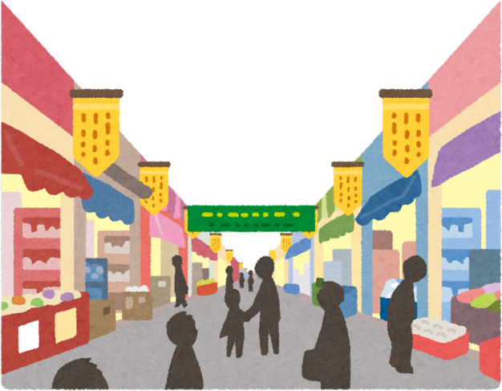
“I am prepared for the worst, but hope for the best.” – Benjamin Disraeli Comprehensive Planning

Resources
Senior Housing and Livable Community Resources

American Planning Association – Accessory Dwelling Units Homes and Community Renewal – Plus One ADU Program One ADU program interest form ADU Model State Act and Local Ordinance (aarp.org) Ordinances and Built Examples of ADUs (nahb.org) Expanding ADU Development and Occupancy ADUs Explained Archives — Shelterforce Model Code for Accessory Dwelling Units | Accessory Dwellings AARP The ABCs of ADUs Livable New York Resource Manual AARP Livable Communities: An Evaluation Guide Westchester County: Livable Communities Initiative MAP: My Aging Plan The Asset-Based Community Development Institute (ABCD) ABCD Tool Kit ABCD Training Videos and Resources
info@mvedd.org
(315) 866-4671
www.mvedd.org
Renewable Energy & Clean Energy Resources
Clean Energy and Your Comprehensive Plan
NYSERDA Battery Energy Storage Guidebook
NYSERDA Wind Energy Guidebook
EV Charging Station Permitting Resources
NYSERDA Clean Energy Siting Resources
DOS Land Use Moratoria
Hosting Capacity Maps
Additional Planning Resources

Planning & Land Use Regulation Resources
NYS DOS Division of Local Government Services Local Laws Search
NYS DOS Division of Local Government Services Training and Assistance
NYS DOS Division of Local Government Services
Planning and Zoning Training Series New York Planning Federation
Additional Model Law Resources
Tug Hill Commission Resources
DOS Basic Land Use Tools for Resiliency
DOS Local Law Search
Department of Financial Services (DFS) Zombie
Property Maintenance
Department of Agriculture and Markets –
Guidance for Municipalities relative to municipal dog control and shelter services

Property Topics and Concepts
American Planning Association Are You Solar Ready?
American Planning Association

Planning Implementation Tools: Overlay Zoning
University of Wisconsin-Stevens Point
Vision Exercise

Building a vision together takes a few steps, and we’ve outlined questions to guide your strategy development.

o What do you love about your town today? o What should the town look and feel like in 10 years? o What must change—and what must stay the same?

Examples
RICHFIELD / RICHFIELD SPRINGS VISION STATEMENT
“The Town of Richfield and the Village of Richfield Springs will work collaboratively to create a thriving economy around our rural agricultural heritage, Canadarago Lake, and a vibrant Village, while protecting and preserving our natural and aesthetic resources. With these foundations, we will preserve and develop our significant historical treasures, expand on our diverse cultural backgrounds and continue to invest in our recreational assets. These invaluable resources will be the cornerstone for our community to sustain itself for years to come.”
TOWN OF ROSEBOOM VISION STATEMENT
This vision statement reflects the views of the townspeople through their input at workshops, focus groups, and the updated survey of 2015. This statement will serve as a benchmark for decision-making and actions for the Town. It is meant to set the stage for the Town’s future direction; it gives the citizens’ views as to what they desire now, and what they envision for the Town in the years to follow. The Town continues to look for growth opportunities and grant funding.
The Town of Roseboom is located on the eastern side of Otsego County within the State of New York. The Town cherishes and desires to protect and preserve the rural character, natural resources and landscapes, scenic vistas and clean and safe land, air and water, with the full enforcement of all Local, State and Federal laws and mandates.
Priorities of the highest order include preservation of and accessibility to open spaces, maintenance of safety and security for residents and future generations, viability of agriculture and the farming community, and safeguarding of the Town’s rural character.
The people want to assure continued accessibility to all the Town’s plentiful open spaces for their families’ recreation and health. It is also important to the economy of Roseboom that we preserve our active agricultural and farming community. We desire safe environmental conditions for future generations to live and grow, while maintaining the town’s important national historic character. Our Town is rich with the history of America’s earliest colonial beginnings, and we want to keep that in mind while we enter the 21st century infrastructure.
In the coming years, we will responsibly manage and improve new growth while respecting property rights to protect the integrity of our town. We do need well-built and maintained roadways, but we also need traffic volume and speed controlled, to be in harmony with the gentle nature of our Township.
We wish to set quality design standards to ensure that new growth and development will enrich our community aesthetics. We wish to hold together the existing fabric of our Town and its hamlets, while still connecting the people of Roseboom to the rest of the world. As such, this Vision Statement and Comprehensive Plan must be an ever-changing and ongoing document.

TOWN OF MIDDLEFIELD VISSION STATEMENT
VISION STATEMENT Background: The 1989 Master Plan of the Township of Middlefield established four general goals as a de facto Vision Statement for the future of the Town:
- That the senior citizens of the Township may continue to live here in a manner which they find harmonious.
- That men and women of the current generation who live and work on these lands may prosper in an environment that is both flexible and secure.
- That, perhaps more importantly, future generations shall inherit these lands in a condition which allows for a healthful, prosperous and independent way of life.
- That improvement of land be encouraged and fostered in a manner which benefits the community, but that development of land in a manner which threatens the health or wellbeing of the community as a whole be prevented.
To these four goals, the following additional goals were set out by the Planning Board in an addendum (1989):
- To sustain the viability of farmlands where possible and to encourage and foster improvement that does not diminish farm lands.
- To preserve the health of the watershed, including Otsego Lake, the wooded areas harboring game, and the important aesthetic and historic characteristics of the Middlefield Township.
In 2011, The Town of Middlefield Profile and Inventory (February 2011) was included as an addendum in support of this Master Plan. This Profile and Inventory is excerpted from the Final Generic Environmental Impact Statement (FGEIS) on the Capacities of the
Cooperstown Region (accepted by the Town in December 2002). The Profile and Inventory and associated maps highlight important natural resources that the people of the Township desire to be protected.
In planning for the future of the Town, the Vision Statement of the original Master Plan of Middlefield remains relevant and vital to this day. To the stated long-term objectives set out above, the Town of Middlefield 2024 Comprehensive Plan adds the following:
1. To acknowledge, plan for, and respond to impending climate, demographic and economic changes in a way that fosters resilience both in the Town’s communities and in its infrastructure and public services.

The purpose of this worksheet is to evaluate the 2008 Vision Statement and inform updates for the 2025 Comprehensive Plan. Your thoughtful reflections are crucial in shaping the future of Otsego!
Step 1: Review the 2008 Vision Statement
Instructions: Please read the 2008 Vision Statement (provided separately). Consider the following questions as you review it:
How well does the 2008 Vision Statement reflect the current realities of Otsego?
What aspects of the vision still resonate today?
What aspects feel outdated or incomplete?
Does the vision adequately address the needs and aspirations of all community members?

“We, the Town of Otsego citizens, cherish and protect our rural and natural landscape. We assure that plentiful, accessible open spaces continue to exist. We see agriculture as a continuing important part of the town's economy and character. We respect our traditions and history and so preserve the town's historic architecture and character. We wish to encourage new development to honor the ways our hamlets have looked through their long histories. Hence, we promote careful design and placing of new buildings to complement and harmonize with those already here. We town citizens are committed to involvement in its future and are proud of our strong community identity.
Vision Statement
Evaluation
Informing the 2025 Comprehensive Plan
We foresee the future Town of Otsego as continuing to have a clean environment, beautiful landscape, and a rural character. We foresee carefully managed growth and development, maintaining access to our natural areas. We foresee a place of safety for us and our families.
We expect increased year-round recreational and cultural opportunities, including biking, hiking, and walking trails, and ample access to Otsego and Canadarago lakes. We see residents and visitors here enjoying even more access to the arts and cultural events.
We want added economic growth, with more diverse year-round businesses that serve both residents and visitors. We want low-impact, family-owned small businesses to flourish, not only in
Cooperstown, but in Fly Creek, the town's secondary center for retail service operations. We want the town of Otsego to develop housing and jobs to draw young families here.
We foresee high quality and diverse housing for all income levels and ages, with special attention given to housing our elderly so that they can continue life right here. We want residential development, concentrated in and around the hamlets, to strengthen our neighborhood, economy, and sense of community. We foresee hamlet amenities like sidewalks and street trees adding to its desirability as a place to live. Beyond the hamlets, we foresee a mix of current size and some smaller, affordable homes surrounded by open land and farms. We foresee all homes and neighborhoods be safe and well maintained.
We want roads well built, maintained, and reflective of our rural and historic heritage. We want traffic volume and speed control to harmonize with the Town as a place of homes.
We foresee high quality schools for our youngsters and a town government that works to provide both public services and reasonable taxes. We foresee the town working even more cooperatively with the towns and villages in the Leatherstocking region, promoting their good and ours.
This is our vision, the touchstone for our shared future.”

Step 2: Reflect on What’s Been Accomplished
Instructions: What progress has Otsego made toward achieving the 2008 Vision? List specific accomplishments, projects, or initiatives that demonstrate positive change. Consider environmental, economic, social, and cultural achievements.
________________________________________________________________________________
________________________________________________________________________________
________________________________________________________________________________
________________________________________________________________________________
________________________________________________________________________________
Step 3: Identify Gaps and Emerging Needs
Instructions: What are the key gaps or emerging needs that the 2025 Comprehensive Plan should address? These might be areas where progress has been limited or new priorities that have emerged since 2008. Consider challenges, opportunities, and unmet needs of the community.
________________________________________________________________________________
________________________________________________________________________________
________________________________________________________________________________
________________________________________________________________________________
________________________________________________________________________________
Step 4: Draft Updated Themes
Instructions: Based on your reflections, propose updated themes for the 2025 Vision Statement. These themes should capture the essence of what Otsego aspires to be in the future. Aim for concise, inspiring, and actionable themes.
________________________________________________________________________________
________________________________________________________________________________
________________________________________________________________________________
________________________________________________________________________________ ________________________________________________________________________________

Step 5: Optional Follow-Up - A Personal Vision
Instructions: Imagine it's 2035. Otsego has successfully implemented the 2025 Comprehensive Plan. Write a brief personal vision statement describing what Otsego looks and feels like. What are the defining characteristics of our community? What are you most proud of?
________________________________________________________________________________
________________________________________________________________________________
________________________________________________________________________________
________________________________________________________________________________ ________________________________________________________________________________ Thank you!

Quick Guide to Comprehensive Planning
"This project has been funded in part by the Climate Smart Communities Grant Program, Title 15 of the
Environmental Protection Fund through the New York State Department of Environmental Conservation."
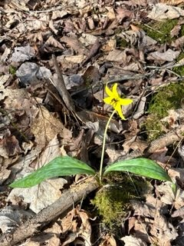





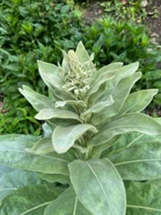
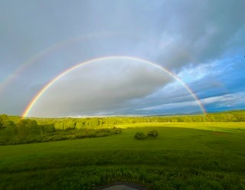
We’re Here!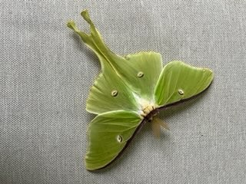
3
5
4
2
1
Survey Logistics
The cost of collecting survey data depends on many factors,
including how the survey is designed, distributed, collected, and
analyzed. Establishing whether responses will be collected online,
by mail, or both, what kinds of questions will be posed, and what
information you hope to glean will all save time in the long run.
Training and Resources
Webinars and other training materials are available through NY
Department of State at their
website
, and through other
agencies. Please contact us using the information below to learn
more about how to support your comprehensive planning work.
Review Other Local Plans
Plans can range widely in terms of content and complexity.
Reviewing plans from nearby communities and keeping a list
of topics you hope to cover will provide context as well as
ideas for candidate solutions to address issues previously
faced by other communities.
Organize Subcommittees
In addition to the steering committee, plans typically rely on
several smaller groups focused on specific subject areas (e.g.
housing, transportation, infrastructure, etc.) Members should
have knowledge relevant to the subcommittee.
Assemble Steering Committee
Consider who will comprise the core group overseeing the
process. Members should be prepared to attend meetings
consistently, and the committee should be as representative as
possible. It can include town officials, business owners, and
other prominent and trusted community members.
Comprehensive Planning
First Steps
Comprehensive Planning

Committee Formation
Who should be on the Comprehensive Planning Committee and and Subcommittees?
The Comprehensive Planning Committee should have at least one member from the planning board and shall include
The members of the Comprehensive Planning
Committee (CPC) conduct/oversee the planning process and the development of the Comprehensive
Plan, participate in meetings, generate ideas and build consensus, provide relevant information reflective of the community’s current condition and needs (including a list of completed and ongoing local planning efforts and initiatives), review drafted
materials drafted and provide constructive feedback,
support each of the proposed public participation and outreach efforts, and set the stage for cooperation and the plan’s implementation.
representatives from a large range of ethnic, social, and
cultural backgrounds and a diverse range of stakeholders, such as residents, civic leaders, business owners, elected officials,
environmental experts, and/or municipal board members.
Planning board members
Community representatives
Community stakeholders
Residents
Community groups
Business owners
Elected officials
Environmental experts
Historic preservation groups
Fire and rescue personnel
Comprehensive Planning
Subcommittee Formation
Proposed Subcommittees
Encourage Housing, Tourism/Business & Economic
Development

Protect
Natural Resources, Agriculture, Historic
Preservation, and Parks & Recreation
^{Maintain} Infrastructure & Safety
Comprehensive Planning
4
5
6
7
8
Evaluate Plan
Plan must include maximum intervals for review
Amend plan as needed
Implement Plan
Suggestions to promote concepts outlines in plan
Amend land use regulations
Develop design guidelines
Budget for capital improvements
Implementation matrix
Adopt Plan
Governing Board adopts plan by resolution or other local
enactment
Adopted plan must be considered by other governmental
agencies when planning for capital projects.
Evaluate Alternatives
Are goals achievable financially?
Are there more attainable/sustainable alternatives?
What are cost effective ways to achieve goals?
Draft Plan
When do you have enough research to begin writing
Primary concerns are addresses
Public meetings held (statutorily required and others)
All special board meetings are open to the public
Planning Committee
Public meeting within 90 days of receiving draft plan
Monitor consultant’s progress
Review to ensure consistency with community’s vision
1
3
2
Community Inventory / Survey
Take a community inventory of assets within the community,
not paper survey. Topics can include:
Agriculture
Historic / Cultural / Archeological
Park & Recreation
Environment
Demographics
Housing
Economy
Public Services
Transportation
Identify Goals
Based on Identified Issues (SWOTs)
Goals become priorities for future policy development
Goals are measurable and achievable
SMART Goals (Specific, Measurable, Achievable,
Relevant, and Time-bound)
Identify Issues
Complete a SWOT Analysis for your Community.
Strengths
Weaknesses
Opportunities
Threats
Source:
De
partment of State
(
DOS
)
Com
prehensive Plannin
g
Website

DOS Com
prehensive Plannin
g
Webinar
(Step-by-Step at 53:10)
Step-by-Step
Comprehensive Planning
Basic Plan Outline
- Introduction and/or executive summary
- Existing conditions
- Trends
- Environmental framework
- Development goals & policies
- Land use constraints & opportunities
- Land use development plan
- Fiscal impacts
- Implementation strategies
- Maps
- Appendices
Appendices can include your survey, public meeting notes and summaries, regulations, design guidelines, budgets for capital improvements, grant applications, etc.
Your Community’s Comprehensive Plan shouldn’t be something that sits on a shelf and collects dust. It should be something that your community uses and reflects on when making decisions and to move your community
forward. Make your Comprehensive Plan something that you will use, it can
be short and sweet, have pictures and graphs, be aesthetically pleasing, etc.
"I love it when a plan comes together." - Colonel Hannibal Smith
Comprehensive Planning
Community Demographics

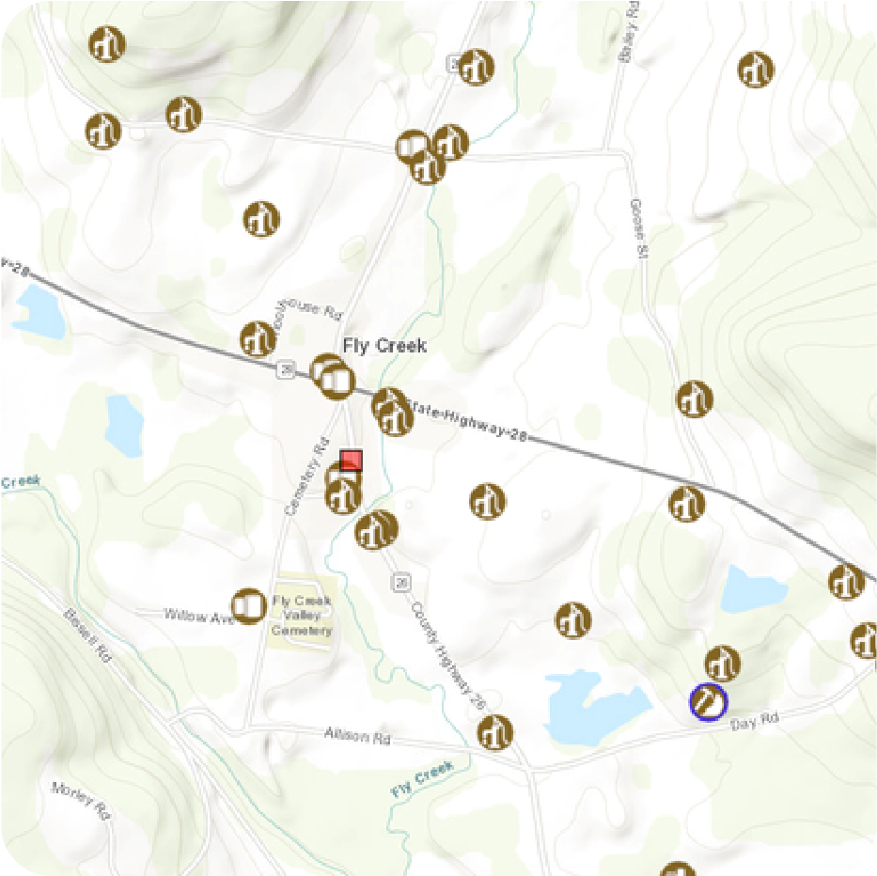
Maps of the Community
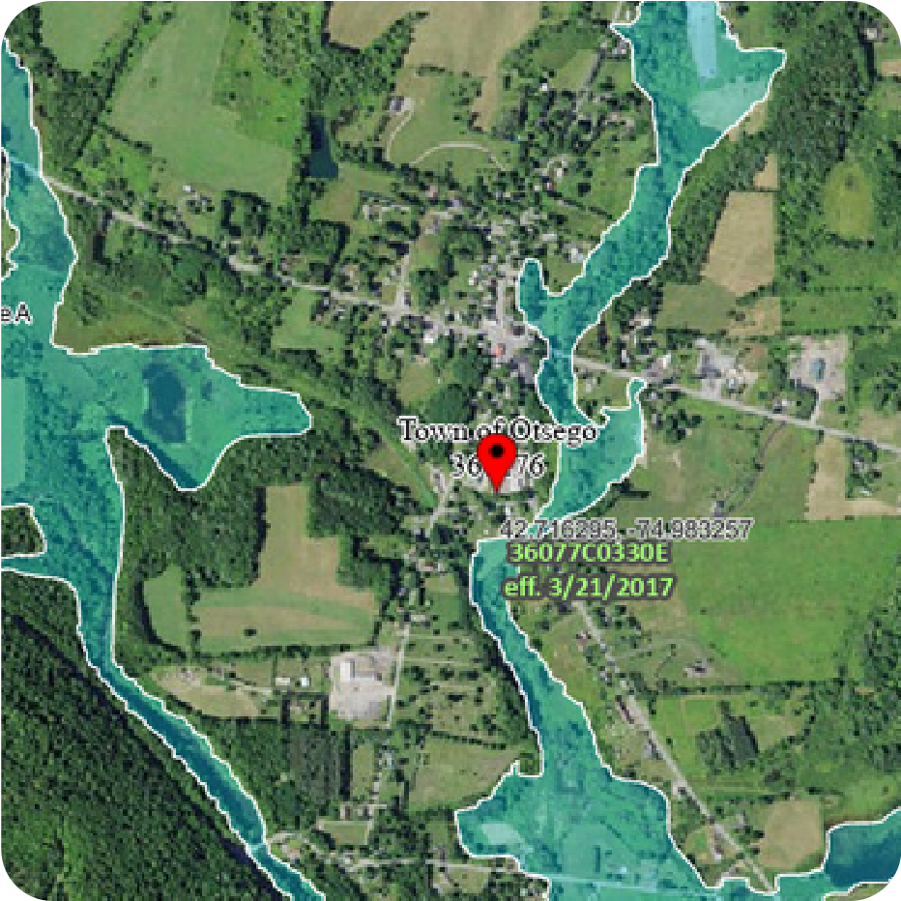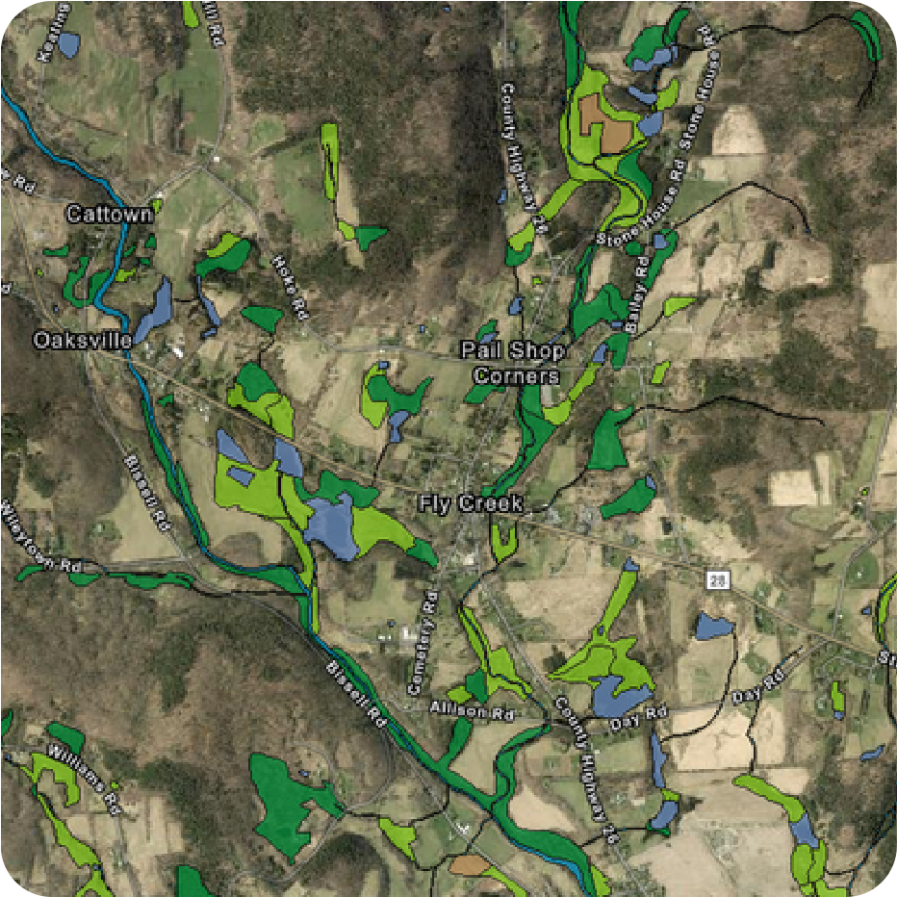
FEMA Flood Map US Fish and Wildlife Wetlands
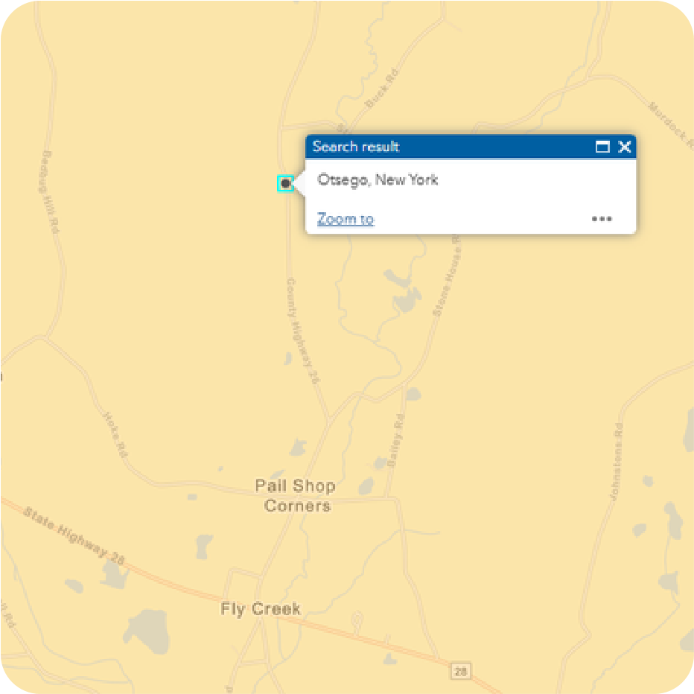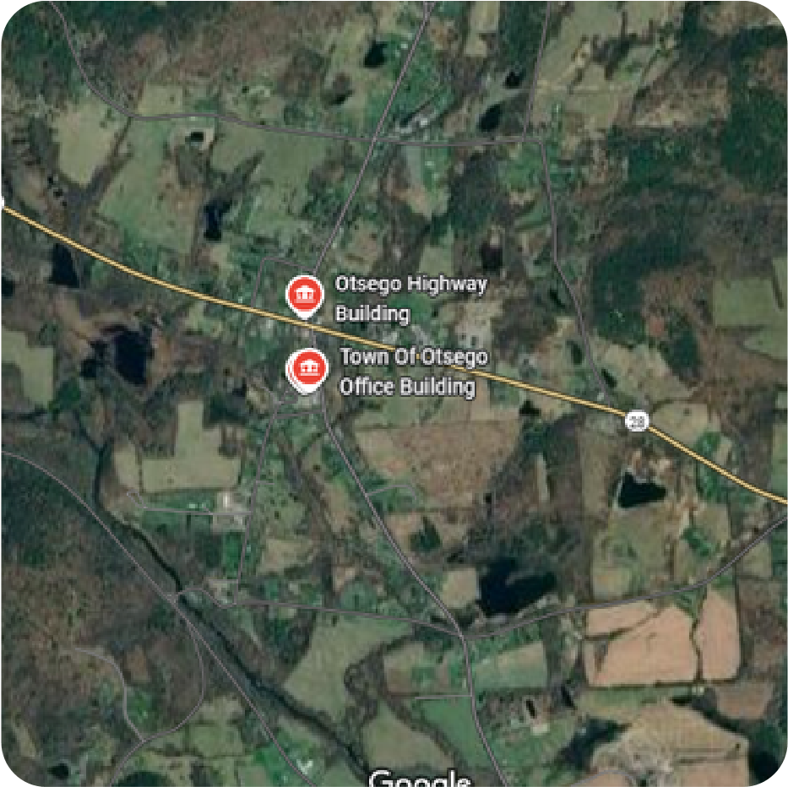
Economically Distressed Areas (ESD) Community Map
DECinfo Locator
Map Insight
The community is considered slightly
distressed. There are some flood risk areas in the
community. The town is mostly rural with the hamlet being more concentrated.
Community Quick Facts
Population (2020): 2,756
Median households Income: $72,716
Persons under 18: 16.1%
Persons 65 and over: 22.8%
Average travel time to work: 22.8 Minutes
Homeownership rate: 71.1%
Households: 1,165
Disabled population: 15.4%
Employment Rate: 48.2%
Percent Poverty: 12.6% Work from home: 3.3% (2023 ACS)
Census Data

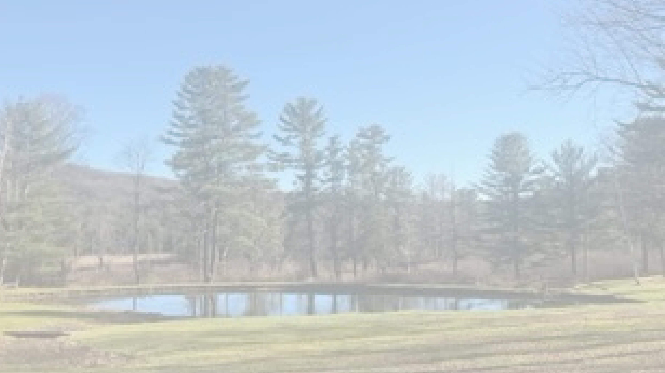
How your community presents itself to the outside world
Provides clear vision and direction for your community
Legal basis for projects within your community
Agencies must refer to your comprehensive plan when
completing projects in your community
Assist with grant funding opportunities
Provides framework for community development
Protects community resources and character
Comprehensive Planning
Importance of a Comprehensive Plan
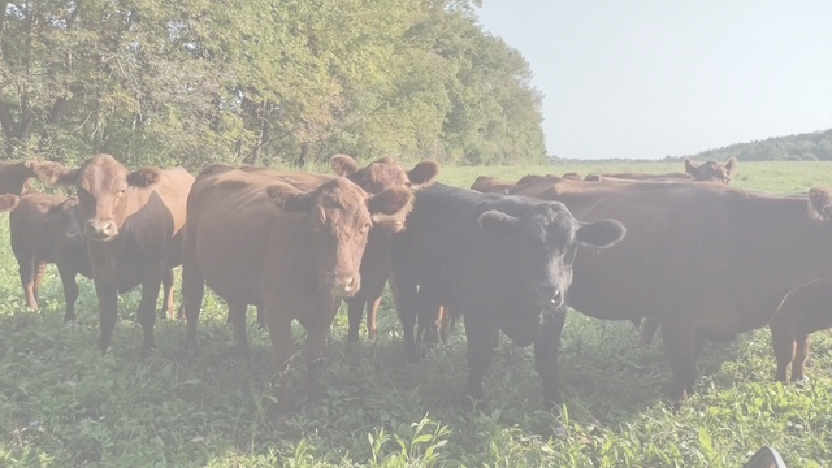
Comprehensive Planning
Importance of a Community Input
Grounds the plan in reality and speaks to what your community
wants for the future
Identifies your communities priorities and needs
Ensures that the plan is developed with the whole community in
mind
Creates a trusting, transparent, and engaging partnership
Creates realistic goals and strategies for your community
Provides input for potential grant funding opportunities
Creates a more useable and beneficial comprehensive plan
What can you do?

Link to Survey

Complete a survey
join a subcommittee share the survey with your friends, family, and neighbors attend community meetings
Community Vision
From 2008 Comprehensive Plan
We, the Town of Otsego citizens, cherish and protect our rural and natural landscape. We assure that plentiful, accessible open spaces continue to exist.
We see agriculture as a continuing important part of the Town's economy and character. We respect our traditions and history, and so preserve the Town's
historic architecture and character. We wish to encourage new development to
honor the ways our hamlets have looked through their long histories. Hence we promote careful design and placing of new buildings to complement and harmonize with those already here. We Town citizens are committed to involvement in its future and are proud of our strong community identity.
We foresee the future Town of Otsego as continuing to have a clean
environment, beautiful landscape, a rural character. We foresee carefully
managed growth and development, maintaining accessto our natural areas. We
foresee a place of safety for us and our families.

We expect increased year-round recreational and cultural opportunities,
including biking,hiking, and walking trails, and ample access to Otsego and
Canadarago Lakes. We see residents and visitors here enjoying even more
accessto the arts and cultural events.
Community Vision
From 2008 Comprehensive Plan
We want added economic growth, with more diverse year-round businesses
that serve both residents and visitors. We want low-impact, family-owned small
businesses to flourish, not onlyin Cooperstown, but in Fly Creek, the Town's
secondary center for retail and service operations. We want the Town of
Otsegoto develop housing and jobs to draw young families here.
Community Vision
From 2008 Comprehensive Plan
Community Vision
From 2008 Comprehensive Plan
We foresee high quality and diverse housing for all income levels and ages, with special attention given to housing our elderly so that they can continue life right here. We want residential development, concentrated in and around the
hamlets, to strengthen our neighborhood, economy, and sense of community.
We foresee hamlet amenities like sidewalks and street trees adding to its desirability as a place to live. Beyond the hamlets, we foresee a mix of current size and some smaller, affordable homes surrounded by open land and farms.
We foresee all homes and neighborhoods safe andwell maintained.
We want roads well-built, maintained, and reflective of our rural and historic
heritage. We want traffic volume and speed controlled to harmonize with the
Town as a place of homes.

We foresee high-quality schools for our youngsters and a Town government that
works to provide both public services and reasonable taxes. We foresee the
Town working even
more cooperatively with the Towns and Villages in the Leatherstocking region,
promoting their good and ours.
This is our vision, the touchstone for our shared future.
Community Vision
From 2008 Comprehensive Plan

Town of Otsego Comprehensive Plan Committee Meeting Draft Agenda
Monday February 5, 2024 / 6:00PM / Town of Otsego Office
6:00 - 6:05 pm - Welcome
6:05 - 6:15 pm - Share asset map, other new materials, contract template
6:15 - 6:45 pm - Feedback on surveys from other communities
- Town of Ancram, Columbia County
- Town of Enfield, Tompkins County
- Town of Chatham, Columbia County
- Village of Geneseo, Livingston County
- Town of Hartwick, Otsego County
- Town of Lexington, Greene County
6:45 - 7:00 pm - Organization of subcommittees
- Intergovernmental cooperation
- Land use
- Demographics
- Environment
- Transportation
- Housing
- Economic development
- Education
- Public health
- Arts and culture
- Tourism
- Infrastructure
- Public works
7:00 - 7:10 pm - Outreach strategy
7:10 - 7:15 pm - Next steps
- Schedule next meeting
- Action items for MVEDD & committee members

Town of Otsego Comprehensive Plan Committee Meeting Agenda
Monday January 8, 2023 / 6:00PM / Town of Otsego Office
6:00 - 6:05 pm - Introductions
6:05 - 6:10 pm - Recapping biggest challenges from 11.9.23 meeting
- Population decline (aging population/young people leaving the area)
- Cost of housing
- Seasonal residents/tourism based economy
- Environmental quality, especially in lakes & waterways
- Threats to viability of healthcare industry
- Rural broadband access
- Childcare
6:10 - 6:25 pm - Asset mapping exercise
- Brainstorm physical, cultural, assets in and around Town
6:25 - 6:40 pm - Survey development and logistics
- Review survey examples
- Discuss preference for content, length, complexity
- Discuss preferred delivery methods (online, hard-copies, direct mail)
6:40 - 7:00 pm - Discuss potential subcommittees & membership
7:00 - 7:10 pm - Discuss additional stakeholders
- Other people, organizations, businesses, groups etc.
7:10 - 7:15 pm - Next steps
- Tentatively schedule next meeting
- Action items for MVEDD & committee members
121

Town of Otsego
Comprehensive Plan Agenda
07/23/2025
- Quick Introductions – Town of Otsego officials, MVEDD Team, Committees, and Dan
- Review 2008 Comp Plan
a. Goals set in February 2024: Housing, Zoning/Natural Resources/Agriculture,
Parks & Recreation, Tourism/Business & Economic Development, Infrastructure & Safety
- Timeline to complete comp plan
- Subcommittee goals and expectations
- Public Engagement
      - Mailed Survey
      - In-person public meeting
- Next steps
Dear Town of Otsego Comprehensive Plan Steering Committee (CPSC )
You are the ears and voice of your fellow Otsego Town residents. With this in mind, please talk up the Comprehensive Plan; what is good, bad, needs changing?
  - Please, look at this link which will bring you to the survey our Town of Otsego residents can fill out online: https://forms.cloud.microsoft/r/f7aLdnfiKe
  - You will notice there are three areas of focus listed in question # 7:
    - Housing, Neighborhoods and Economic Development
    - Parks, Farmland, Natural Resources, Arts and Culture
    - Revitalization, Infrastructure and Essential Services
  - Please come to the meeting on August 19th with an idea of where you would most like to concentrate your CPSC efforts. The three categories are intentionally broad. Once you have decided on a category, take a look at the existing Town of Otsego Comprehensive Plan. What needs to be updated in the content or wording as it currently exists? Consider looking at the Town of Middlefield’s recently created Comprehensive Plan for some ideas:
https://www.middlefieldny.org/comprehensive-plan.html.
  - Everyone on the CPSC should assign themselves to one of the three areas above. A Town of Otsego Board Member will be the chairperson.
      - Tom Craig: Housing, etc
      - Chris Kjolhede: Parks, etc
      - Deb Dalton: Revitalization, etc
Please plan to meet with your group as needed to come up with wording to amend the existing Comprehensive Plan and be ready to report back before our September meeting.
We do not need to remind you how very important this exercise is for the future of our town.
With many thanks for your sense of civic duty!
Town of Otsego
Comprehensive Plan Steering Committee
Agenda, 08/19/2025 1PM

  - Welcome
  - Outstanding items from last meeting – open
  - Outline details and signup times for open house (08/28/2025 from 5pm-8pm)
  - Printed surveys – where are we distributing – 500 copies are here, take some
  - Homework assignment
      - Which area do you want to focus on?
      - Is there anything we need to include in an update today?
VI. Closing – do we set a regular time to meet?

Town of Otsego
Comprehensive Plan Steering Committee
Agenda, 9/16/2025 1PM
- Welcome
- Introduce Sara Bouillon – MVEDD
- Review of Open House
- Survey Outreach update
    - Responses/Engagement
    - Subcommittee formation update:
o A Town of Otsego Board Member will be the chairperson
Tom Craig: Housing, etc
Chris Kjolhede: Parks, etc
Deb Dalton: Revitalization, etc
• Key observations/suggestions from subcommittees for overall comp plan
- Next steps & schedule next meeting
Thank you!
CP Subcommittee Mtg – Revitalization, Infrastructure, Safety etc.
Minutes: Sept 25th 2025
Present: Deb Dalton. Pat Kennedy, Dan Sullivan
Bill Hribar working on roads, John Phillips and Ed Hobbie out of town.
Discussion:
We all agreed that the Middlefield’s CP format had many strengths:
  - Listing of goals, action plan, parties responsible.
  - Continually reviewing (at the least annually) goals and strategies
To add as goals in the CP:
TRANSPORTATION
  - Set up annual public meeting where HWY Crew can present their current activities and give public opportunity to ask questions and better understand why and how they prioritize road work.
  - Set up annual meetings with NY state Senate and Assembly Transportation committees to lobby for more $$ CHIP reimbursement to match increased costs of equipment, fuel, and road work construction materials. Lobbyists do not necessarily need to be TO Board officials.
  - Continue to ensure the HWY budget is adequate to meet demands – establish proposed budget to TB in late Spring prior to anticipate Budget creation in Fall.
INFRASTRUCTURE
  - Revisit methods for protecting our lakes and watershed
  - Clarify zoning districts, and in particular establish a Lake Protection Zone – in harmony with Otsego Lake Protection Plan, the Susquehanna River Basin Commission, and other entities dealing with health of our watershed.
BROADBAND
Otsego County officials are working on ensuring broadband access to ALL Otsego Cty residents.
Respectfully submitted
Deb Dalton 9/26/25
Comprehensive Land Use Plan
Sub-committee on Parks, Farmland, Natural Resources, Arts and Culture
Sept 8, 2025
In attendance: Walter Dusenbery, Carina Franck, Steve Purcell, Alex Nirenberg, Deb Creendon, Chris Kjolhede
Attendees were asked to reflect on the 2008 Comprehensive Land Use Law:
Cemeteries as parks;
Population density, promote bull’s eye approach;
Farmland desirable but who will farm? Hay is the major crop that can support livestock-based farms; how can the town support farms: value and assessments to promote farming; zoning and tax benefits; leasing land for benefit;
Preserve the lake (lawn care products get into the lake), algae blooms, developments effect the lake
Bucolic nature of the area; how to wed the ‘area’ with the economics of being at a distance, eg internet
Competition between baseball camps and families and workers who must live at a distance; rentals
Zoning enforcement; consider technologies for enforcement
Ensure drinking water quality; run-off from lawns, golf courses, agriculture
Invasive species
Comprehensive Plan Town of Otsego
Subcommittee – * Revitalization, Infrastructure & Essential Service
Meeting held Thursday September 4, 2025 1pm at Town Building
Present: Deb Dalton, Ed Hobbie, Pat Kennedy, John Phillips. Bill Hribar had hwy duties so absent but had talked with Deb prior.
Group discussed what the terms * Revitalization, Infrastructure & Essential Service really mean in our Town.
Revitalization encompasses:
*Places for people to live and work
*Encourage reuse of existing properties being sensitive to neighborhood needs, milieu
*Discussed the Heirloom Barn Law which has been used in the past - see Real Property Tax Law Section 483-B.
Infrastructure encompasses :
Built environment – roads, bridges
Looked at # 12 on page 7 of the existing CP which states: Evaluate conditions and plans for development along all seasonable roads and the projected costs for improvement of these roads.
We propose changing this to read: Continuously reevaluate road conditions consistent with trends in rural road repair. …
Discussed need to have a 5 year plan to outline how the TO plans to pay for road repair, equipment, and safety for the highway crew.
Essential services and Safety encompasses:
ES = Fire, snow, ambulance, water, sewer, Townwide broadband access,
Safety = Fire, emergency services , road sign safety, appropriate speed limits
Other topics discussed:
Pursue grant writing to pay for some of Town improvements – like NY Forward
Promote home occupied businesses and ease hurdles(permits) to allow this.

Respectfully submitted,
Deb Dalton
9/8/25

Meeng Minutes
Next meeng is 11.18.25 at 1pm
Subcommitee minutes
- Infrastructure and Revitalizaon
Goals:
  - maintain roads to safe and high quality status.
  - Talk to Assemblyman for transportaon CHIPS grant funds for roads in Town of Otsego.
  - Increase public awareness about road and transportaon services on our website. Provide mapping services of current public transportaon.
Acon items:
  - Post to bullen boards in local shops, libraries and public buildings. Make Facebook post or create a blog post for Mohawk Valley today (Mohawk Valley Today), because they have high site traffic.
  - Look into feasibility study for water and sewer for Canadarago lake
  - Parks: create signage with QR code to online resources about the park on our website.
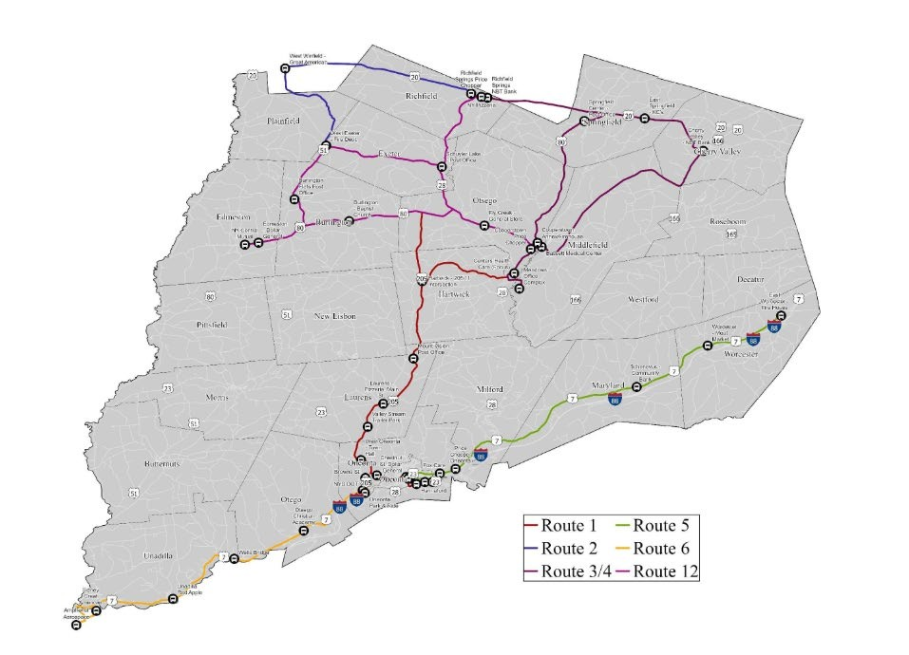
Source: Otsego County, NY
- Housing
Goals: Update zoning and land use laws.
Acon items: Provide edits to Land Use and Housing writeups of comprehensive plan.
Acons Taken during meeng
Vision Statement Evaluaon
Notes: The goal of our vision statement is to be future looking, and describe what we want to see. We covered topics of housing, aging in place, resource use, land use, broadband, historic structure preservaon,farmers and agriculture, past mistakes and wins. Thank you everyone for parcipang in the exercise, I think we were able to highlight what fits and what should be added next from the original 2008 vision statement.
Some comments about what did not change since the last vision statement from ’08: We did not get the sidewalks, housing, civic engagement or housing tourism we sought to resolve. These issues are sll currently going to be addressed in our revised vision statement as of
10.21.25.
Next Steps:
Rewrite vision statement to include that we envision increasing outreach for greater community parcipaon.
Some helpful resources for everyone:
Amanda created a super helpful list based on talking points from the meeng!
- NYS LTAP Center - Cornell Local Roads Program | CALS o Local roads programs, resources, trainings
- Lake Zones – Canadarago Lake Improvement Associaon o Example of lake zone
- Protecon of Waters Program - NYSDEC o Resources from DEC
- NYS Archives Grants and Awards Overview | New York State Archives o Offer grants for record management and digizaon
- Welcome to Upstate New York's Mohawk Valley
- We want to hear from you! Contact Mohawk Valley Today
  - Mohawk Valley Today – Submit Events
- Barn Preservaon — Preservaon League of NYS
- New York State Historic Barn Rehabilitaon Tax Credit - NYS Parks, Recreaon &
Historic Preservaon o Can’t be used for residences
- All About Accessory Dwelling Units
- Agricultural assessment program: overview o There is no minimum gross sales value required for crop acreage either set aside or rered under federal supply management or soil conservaon programs.
  - Otsego County Soil and Water Conservaon District – Can be a resource o Agricultural Environmental Management | Agriculture and Markets o DEC Partners – Stream Erosion
- Zoning and Codes Enforcement | Town of Webb, NY o Short Term Rentals
  - On November 22, 2022, the Town Board adopted a local law creang Chapter
387 of the Code of the Town of Webb to regulate short-term residenal rentals. On May 1, 2023, the Town of Webb began using a new online registraon and payment system called GovOS for short-term rental properes. For more informaon about using GovOS, click here. Contact the Code Enforcement Office at 315-369-3001 for an account number and acvaon code to register your property in GovOS and to schedule an inspecon. Click this short-term rental criteria link for a list of the typical items to be inspected. Aer compleng the above, go to htps://townofwebb.munirevs.com to register.
- Fly Creek Valley Cemetery o Find a Grave - Millions of Cemetery Records Revised Vision statement:
Edits in orange red
“We, the Town of Otsego cizens, cherish and protect our rural and natural landscape. We town cizens value civic engagement and are taking steps to beter share our goals and vision, so that all members of our community may take part in shaping our future. We welcome and respect the voices of our neighbors, stakeholders, and fellow cizens, and will carry their insights forward as we work together to build a more vibrant and sustainable Town of Otsego. We assure that plenful, accessible open spaces connue to exist. We see agriculture as a connuing important part of the town's economy and character. We respect our tradions and history and so preserve the town's historic architecture and character. We wish to encourage new development to honor the ways our hamlets have looked through their long histories. Hence, we promote careful design and placing of new buildings to complement and harmonize with those already here. We town cizens are commited to involvementn its future and are proud of our strong community identy. We foresee the future Town of Otsego as connuing to have a clean environment, beauful landscape, and a rural character. We foresee carefully managed growth and development, maintaining access to our natural areas. We foresee a place of safety for us and our families. We expect increased year-round recreaonal and cultural opportunies, including biking, hiking, and walking trails, and ample access to Otsego and Canadarago lakes. We see residents and visitors here enjoying even more access to the arts and cultural events. We want added economic growth, with more diverse year-round businesses that serve both residents and visitors. We want low-impact, family-owned small businesses to flourish, not only in Cooperstown, but in Fly Creek, the town's secondary center for retail service operaons. We want the town of Otsego to develop housing and jobs to draw young families here. We foresee high quality and diverse housing for all income levels and ages, with special atenon given to housing our elderly so that they can connue life right here. We want residenal development, concentrated in and around the hamlets, to strengthen our neighborhood, economy, and sense of community. We foresee hamlet amenies like sidewalks and street trees adding to its desirability as a place to live. Beyond the hamlets, we foresee a mix of current size and some smaller, affordable homes surrounded by open land and farms. We foresee all homes and neighborhoods be safe and well maintained. We want roads well built, maintained, and reflecve of our rural and historic heritage. We want traffic volume and speed control to harmonize with the Town as a place of homes. We foresee high quality schools for our youngsters and a town government that works to provide both public services and reasonable taxes. We foresee the town working even more cooperavely with the towns and villages in the Leatherstocking region, promong their good and ours. This is our vision, the touchstone for our shared future.”

Thanks!

Town of Otsego
Comprehensive Plan Steering Commitee Agenda, 10/21/2025 1PM

- Before meeng: Distribute Dra Secons via email – Sara Bouillion, MVEDD
· Vision Statement, Land Use Constraints and Opportunies, Land Use Development Plan · Edits due 11/15/2025
We are not eding together in this meeng. We have a Visions exercise that I’m excited to share! It takes 20-30 minutes

- Subcommitee Updates
· Housing Subcommitee – Edits complete (Alex)
· Parks Subcommitee – Meeng scheduled for 10/20 (Chris Kjolhede)
· Infrastructure and revitalizaon Subcommitee – Needs to reconvene (Deb Dalton)

- Stakeholder Input
· Has the Steering Commitee spoken to any new stakeholders?

- Vision Statement reflecon exercise (2008 vs. now) – see worksheet

- Next Steps & Homework Assignments
· Confirm responsible pares and melines/Assignments for next meeng
· Plan for integrang subcommitee edits into dra secons
· Edits due by 11/15/2025

