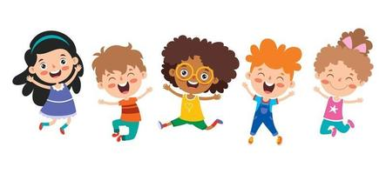
PK1 Supply list
(3) Rolls of paper Towels
(1) Box of 8 count crayons
(1) XL labeled Ziploc bag for naptime items
(1) ream of copy paper
(2) Boxes of kleenex
(1) Snack box: labeled clearly with child’s name and the word “snack”
(1) Lunch box: labeled clearly with child’s name and the word “lunch”
Diapers and wipes
Drink cup labeled with child’s name and date: must be updated daily

Optional
- Box of trash bags with drawstrings

