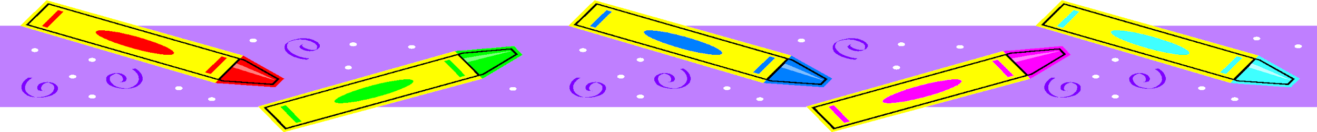
PK2 Class Supply List
For Personal Use:
1 Full Size Backpack
1 Lunch box- Lunch and snack labeled separately, if not in two separate boxes. All drinks must be labeled daily with your child’s name, date and time the drink was prepared. Please send utensils daily with your child’s lunch/snack.
1 Large Zip-loc bag with blanket, pillow, and sleep buddy (if they need one)
1 Complete change of clothes in a zip-lock bag – labeled with your child’s name
Pull ups /Wipes (if not already potty trained)
For classroom Use:
1 Package of 3 or more paper towels (select a size)
1 Box Zip-lock bags
3 Boxes Kleenex
1 Ream of copier paper
6 Count glue sticks
1 Folder with 3 prongs
Crayons
Set of 8 Water Color Individual Set
Play Doh
Stickers
Optional
1 Box of trash bags 33 Gallon
A big smile!!
Bunches of hugs for your teachers!!
Thank you in advance for the class supplies!
We are very excited about this school year and about meeting each of you.

