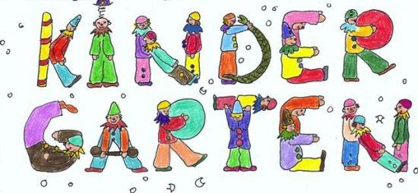
K5 Supply List

1 Backpack (small size - no rolling backpacks, they will not fit in cubbies)

1 Snack box for their snack

1 Lunch box for their lunch

1 SMALL refillable water bottle to be brought to school each day

2 1” notebook binders

2 Single subject notebooks

1 Plastic pencil box

3 Boxes of 24 Crayola crayons

2 Packs of glue sticks

2 Packs of erasers for pencils

4 Rolls of paper towels

3 Boxes of Kleenex

2 Reams of copier paper (20wt)

1 Pack of card stock (colored)

Optional
1 Box of 13-gallon trash bags

1 Box of Ziploc sandwich size bags

1 Box plastic spoons

1 Package of paper plates (Please no Styrofoam)

*A KJV Bible will be supplied during the school year to your student as part of a classroom set

We have an abundance of pencils. Please do not send pencils or pencil sharpeners.

