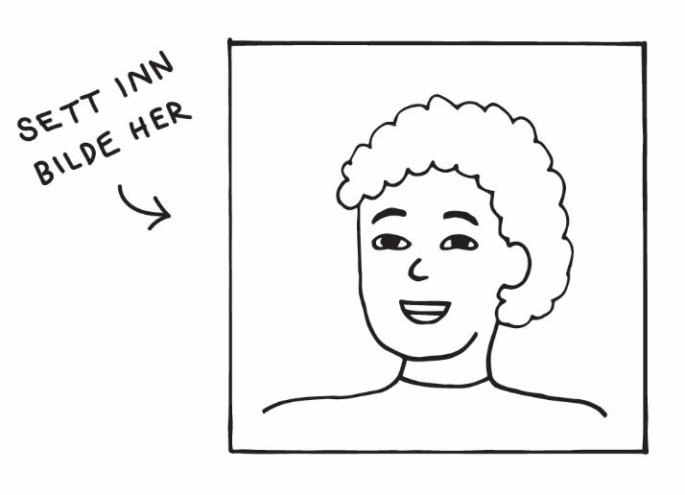
George Tiston
Address Møllergata 3d, 0179 Oslo
Phone +47 99 31 31 63
Email george.tiston@gmail.com
Date of birth 24.02.1999

EDUCATION

09.2018–09.2020 Birbeck College, London
Majored in Economics and Physics

09.2015–09.2018 Emanuel School, London
Secondary School
EXPERIENCE

09.2020–now Chef, Tunco Oslo Street Food
Part-time. Prepare food, take orders and customer service

02.2018–09.2020 Waiter and bartender, Limonchella Restaurant, London
Part-time. I waited tables, served food and mixed cocktails in the bar

04.2017–06.2018 Shop Assistant, London Harrods Accessories
Part-time. Managed the cashier, customer service and cleaning

OTHER

Languages English, mother tongue
French, intermediate level, written and orally

Computer skills Adobe Photoshop, Basic HTML

REFERENCES

Marius Hansen: Manager, Tunco Oslo Street Food | Phone: +47 99 31 31 63 | marius@tunco.no
Lionel Dominiki: Owner, Limonchella Restaurant | Phone: +44 99 31 31 63 | lionel@limo.uk

