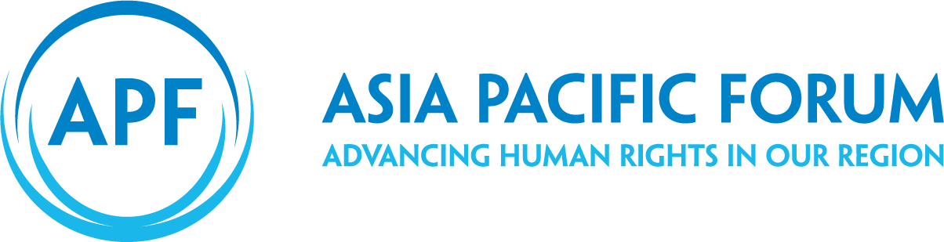Guide to Strategic Planning

for National Human Rights  
Institutions in the Pacific

#### Note

The designations employed and the presentation of the material in this publication do not imply the expression of any opinion whatsoever on the part of the APF concerning the legal status of any country, territory, city or area, or of its authorities, or concerning the delimitation of its frontiers or boundaries.

*Guide to Strategic Planning*

© Copyright Asia Pacific Forum of National Human Rights Institutions, February 2020

No reproduction is permitted without prior written consent from the APF.

Asia Pacific Forum of National Human Rights Institutions

GPO Box 5218

Sydney NSW 1042

Australia

# Contents

Acknowledgements 4

Glossary 5

Introduction for users 6

Module 1: Thinking Strategically 8

Section 1.1. Why develop a strategic plan? 9

Section 1.2. Strategic thinking and strategic planning 12

Section 1.3. Gender mainstreaming 14

Section 1.4. Setting your mission, vision and values 16

Module 2: Thinking Outwards 18

Section 2.1. Conducting your environmental scan 19

Section 2.2. Setting your strategic priorities 24

Module 3: Thinking Inwards 32

Section 3.1. Identifying your interventions 33

Section 3.2. How to handle emerging issues 36

Section 3.3. Organisational health and capability 40

Section 3.4. Drafting your strategic plan 46

Module 4: Thinking Ahead 52

Section 4.1. Developing your operational plan 53

Section 4.2. Reviewing your operational and your strategic plans 54

Tools Roadmap 60

# Acknowledgements

This resource is the first of its kind in the world for national human rights institutions. We are grateful for the professional services provided by MartinJenkins Consultancy, and their close collaboration with the APF, to bring this guide to life. In particular, we would like to acknowledge the contribution of Joanna Collinge and Robin Veenis.

In addition, the APF would like to acknowledge:

The Office of the Ombudsman of Samoa/NHRI, for sharing their experience and learnings from developing a strategic plan

Chris Sidoti, Rosslyn Noonan, Dr Jill Chrisp, Michael Kelly and James Iliffe, for their advice and insights

The New Zealand Human Rights Commission, for permission to include their models and frameworks

Aishath Fasoha and Kate Turner-Mann, for their vision and coordinating the development of this resource.

# Glossary

**Strategic plan** A document that sets out what you intend to achieve, usually over a three-to-five-year period

**Mission** Sets out what you do. It describes who you are and why you exist – the purpose of your organisation

**Vision** Sets out where you are headed – what you want to achieve through your mission

**Values** Your guiding principles that set out how will behave with each other and with stakeholders

**Strategic priority** These are the key human rights issues NHRI that your NHRI will focus on to advance your mission and vision; e.g. “family violence”

**Intervention** The activity(ies) that you will undertake to achieve your impact and contribute to your outcome; e.g. “draft and publish a report on family violence issues in our country”

**Output** The product or service that you will deliver through the intervention; e.g. “a report on family violence in our country”

**Impact** The result that you are hoping to achieve through the intervention (shorter-term); e.g. “policymakers establish a national Family Violence Prevention Office as a result of our report”

**Outcome** The outcome that you are contributing to through your impact (longer-term); e.g. “rates of family violence decrease, and the safety and well-being of women and children increases”

**Gender mainstreaming** Gender mainstreaming is a strategy to achieve gender equality – the equal rights, responsibilities and opportunities for all genders

# Introduction for users

#### About this guide

This resource provides a step-by-step guideline for your national human rights institution (NHRI) to develop a strategic plan.

There is an abundance of material about human rights laws, policies and practices. However, much less information exists about how to build and sustain a truly effective NHRI, about the importance of high-quality management or about the organisational challenges in leading an NHRI. This resource, and the online APF Strategic Planning Community[1], aims to bridge that gap.

#### Who is this guide for?

This guide is for leaders of NHRIs, including Ombuds, Commissioners, senior executive officers and senior managers. Of course, strategic planning is more effective when everyone in your NHRI can contribute and when it is informed by the perspectives and insights of your stakeholders.

#### How to use this guide

You can use this guide for individual learning at any time your choose, and together with your colleagues when you begin the strategic planning process.

The guide consists of four modules:

**THINKING STRATEGICALLY**Build capability and understanding to undertake strategic thinking and planning, and set the foundations for strategy

**THINKING OUTWARDS**Assess your external environment and set priorities

**THINKING INWARDS**  
Identify how you will advance your priorities, including by strengthening your organisational capability and capacity, and draft your strategic plan

**THINKING AHEAD**  
Execute your plan, and review it to assess progress and make adjustments where needed

You should work through the modules in order, as they progressively build the steps you need for effective strategic planning. Each module includes:

Information to learn about the topic, as well as exercises and tools to help you reflect on and apply that learning

A case study describing how the Samoan Ombudsman’s Office approached each stage of the strategic planning process, and what they learned for the future

Ideas for integrating gender mainstreaming throughout your strategic planning process, with practical examples, resources and advice.

In each module, we use the symbols below as a guide to the different types of tools.

**CASE STUDIES**will describe how the Samoan Ombudsman’s Office developed it’s strategic plan

**CHECKLISTS**will show you what you need to do

**FURTHER READING**  
will let you explore a module in more depth

**KEY POINTS**  
will describe what you will be able to do by the end of each module

**PRACTICAL EXERCISES**will let you try out the tools straight away

**REFLECT AND DISCUSS**will prompt discussion with key questions on how to approach strategic planning

At the end of the guide, we provide:

****A **TOOLS ROADMAP**, which gives you a snapshot of all the tools and how they fit together.

A link to download the [**TOOLS TEMPLATES**](https://www.asiapacificforum.net/resources/strategic-planning-guide-tools) which you can print off and use with your colleagues.

You can also find this guide in the APF Strategic Planning Community at [www.asiapacificforum.net/resources/strategic-planning-guide](http://www.asiapacificforum.net/resources/strategic-planning-guide). The online version includes videos and links to other resources. It also provides opportunities for you to share and learn with experts in the field and with other NHRIs.

Module 1:  
Thinking Strategically

This module sets out the value of a strategic plan for your NHRI, as well as the importance of thinking strategically and setting your mission, vision and values before you begin the strategic planning process. It also introduces gender mainstreaming and explains how to include it in your strategic thinking and planning process.

At the end of this module you will be able to:

* Describe the benefits of developing a strategic plan and the challenges it will help you to address
* Identify the key strategic thinking questions and use these to develop your mission, vision and values, which will guide your strategic planning

Understand what gender mainstreaming is, why it is important and how to include it in your strategic thinking and planning.

# Section 1.1. Why develop a strategic plan?

A strategic plan is a document which sets out what you intend to achieve, usually over the coming three-to-five-year period.

Strategic planning is often a requirement from government and funders. Sometimes, it can feel like a burden. However, beyond compliance, there are many advantages to having a strategic plan.

NHRIs face many competing challenges when they set their priorities. These include:

Managing the complexity of a broad human rights mandate, with wide ranging functions and diverse external stakeholders, all within finite resources

Huge – and sometimes unrealistic – expectations, internally and externally

Meeting national and international accountabilities

Being accessible to all people and responsive to unforeseen developments

Having impact by making human rights a reality in people’s day-to-day lives and being able to demonstrate this.

Strategic planning provides a way to address these challenges. It is a robust and principled approach to help you identify your priorities, integrate gender mainstreaming into your work, make decisions about allocating resources and ensure that everyone is working to the same end.

It also helps you to manage expectations:

Externally, by listening to your stakeholders about what you should be doing and then communicating back your priorities and the reasons for your choices

Internally, by helping your NHRI to work through the preferred priorities of individual Ombudsperson, Commissioners and staff, before deciding how best to allocate resources between them.

A strategic plan will help you to:

Define what your NHRI wants to achieve, within your mandate

Prioritise which human rights issues and organisational development areas to focus on, incorporating a gender mainstreaming lens

Ensure a shared understanding of what you are doing and why, internally and externally, to support teams work together towards common goals

Monitor and evaluate your progress and adjust as needed.

Reflect and discuss in your own words

* How can a strategic plan benefit our NHRI?

What specific challenges do I want to be able to address by having a strategic plan?

why the samoan ombudsman’s office developed a strategic plan

Background

The Office of the Ombudsman in Samoa was established under the *Ombudsman’s Act 1988* with a mandate to promote good governance. In 2013, an amendment to the Act gave powers to the Office to conduct special investigations into the conduct of agencies and to promote and protect human rights across the country. As a result, the Office now has a dual mandate as Ombudsman and as the country’s NHRI.

Challenges

Following the 2013 amendment, the Office was organised into three units: Good Governance, Human Rights and Special Investigations. However, a 2014 capacity assessment of the Office by the APF found that the three mandates – and the units delivering them – were siloed and needed to better integrate and align their activities. Furthermore, an existing strategic plan did not reflect the expanded mandate of the Office, did not connect activities to its overall purpose and lacked any measures.

As a consequence, staff did not have anything to guide their actions, particularly the staff of the new mandates, and were unclear as to what was expected of them. At the time, the Office also lacked capacity in its corporate services function, which meant that planning, budgeting and reporting presented challenges. There were not enough staff to do the work.

Maiava Iulai Toma, who has been the Ombudsman since 1994, recognised that a new strategic plan was needed. He believed this would address the challenges identified in the capacity assessment by:

* Defining the purpose and values of the Office, so that all three units could work towards a common goal, in a common way
* Integrating the work of the three units, recognising that human rights underpin good governance and good governance is needed to realise human rights
* Identifying priority projects, with defined objectives and measures, so that teams and staff could understand their role and their individual performance expectations
* Establishing a corporate services function to provide coordination and support for human resources, financial management and monitoring and evaluation.

“It’s very important to forecast ahead… it helps us deal with responsive tasks when we come across as a lot more organised.”

Maiava Iulai Toma  
Ombudsman of Samoa

The Office decided to develop a 2016–20 Strategic Plan to provide focus and direction, better support for the different teams and improve productivity and impact.

With limited capacity, the Office engaged two consultants to support them through the process, both experts in strategic planning. One was a consultant from Samoa, with good local knowledge, and the other from the APF, with knowledge of NHRIs operating in the Asia Pacific region.

# Section 1.2. Strategic thinking and strategic planning

Thinking strategically is about looking at your big picture and long-term direction. It helps you create a mission and a vision for your NHRI, as well as develop a set of values to guide your actions. These provide the foundation your NHRI needs in order to plan its work.

Strategic planning helps your NHRI define how you will move from where you are now to where you want to be. It translates the strategic thinking behind your mission and vision into defined priorities and goals. It also sets out the steps you will take to achieve them.

Both strategic thinking and strategic planning are necessary for success. However, organisations tend to jump into strategic planning before they do any strategic thinking. It is important to understand what strategic thinking is before you start to develop your strategic plan.

Strategic thinking asks the fundamental questions about why your organisation exists and what value it can add. For NHRIs, this includes understanding the challenging environment in which you operate and how this affects your strategy.

For NHRIs, this will be defined by:

* The national environment in which you operate
* International human rights standards
* The requirements of the Paris Principles
* Expectations of stakeholders

Financial constraints.

further reading

International human rights standards: [www.ohchr.org/en/professionalinterest/pages/internationallaw.aspx](https://www.ohchr.org/en/professionalinterest/pages/internationallaw.aspx)

The Paris Principles: [www.ohchr.org/EN/ProfessionalInterest/Pages/StatusOfNationalInstitutions.aspx](https://www.ohchr.org/EN/ProfessionalInterest/Pages/StatusOfNationalInstitutions.aspx)

Strategic thinking requires you to consider the following questions:

* Who are we and why do we exist?
* How do we explain the value of human rights to our country?
* Where are we going and why?
* What will make us successful (in what we do and how we do it)?
* Who can help us?
* Why would they want to work with us?
* What are our risks?

Reflect and discuss in your own words

* What is strategic thinking, what is strategic planning, and why do we need both?

How would I answer the strategic thinking questions?

# Section 1.3. Gender mainstreaming

Gender mainstreaming is an important part of strategic thinking and planning for your NHRI. It is about ensuring that gender is considered when you make decisions about what your NHRI will do and how it will do it. It is about making sure your organisation is fair, inclusive and accessible to all people.

#### What is gender mainstreaming?

The term ‘gender’ refers to socially constructed roles of, and power relations among, men, women and gender diverse people, all of whom may be affected differently by an NHRI’s activities.

Gender mainstreaming is a strategy to achieve gender equality.

Gender equality refers to the equal rights, responsibilities and opportunities for people of all genders. It means that the aspirations and needs of all genders are considered, valued and favoured equally.

Gender mainstreaming is a process to assess gender implications across all activities of an organisation, and then taking action to achieve gender equality and ensure gender inequality is not perpetuated.

It also recognises and responds to the fact that other characteristics – such as age, race, disability and sexuality – can compound gender inequalities.

This guide draws on the APF’s *NHRI Guidelines for Mainstreaming the Human Rights of Women and Girls into Our Everyday Work*, which provide practical advice on integrating gender into your strategic planning process.

further reading

APF (2019) *NHRI Guidelines for Mainstreaming the Human Rights of Women and Girls into Our Everyday Work*: [www.asiapacificforum.net/resources/nhri-guidelines-mainstreaming-rights-women/](https://www.asiapacificforum.net/resources/nhri-guidelines-mainstreaming-rights-women/)

#### Gender mainstreaming in strategic planning

You can use the checklist below to apply gender mainstreaming in your strategic planning. This is known as applying a ‘gender lens’ to your thinking, your activities and your decisions.

gender mainstreaming checklist

Is there a gender balance in our workshops and interventions as we develop our strategic plan?

Does our NHRI have a gender policy and/or a gender strategy? Do we have specific funds set aside for gender specialisation and gender mainstreaming work?

How can we consider strategies for achieving gender equality when analysing our organisational health and capabilities? For example, do we need to ensure additional learning, development and promotion opportunities for under-represented genders? (more in Module 4)

How do our interventions promote gender equality and positive perceptions of all genders? For example, is our complaints process accessible and safe for all genders?

Have we consulted stakeholders who can provide insights and perspectives into gender issues?

Have we identified human rights violations disproportionately experienced by different genders, particularly women and girls, transgender people and intersex people? Should we consider selecting these issues as strategic priorities?

Have we set measures and indicators that will enable us to monitor our progress towards gender equality?

Do we have in-house expertise on gender mainstreaming or do we need to identify external support with gender expertise?

# Section 1.4. Setting your mission, vision and values

Once you have answered the strategic thinking questions, you are ready to set your mission, vision and values. These are the glue that hold your organisation together. While your priorities may change in response to your environment, your mission, vision and values remain solid and guide your decisions about what you do and how you do it.

Your mission sets out what you do. It describes who you are and why you exist – the purpose of your organisation. As an NHRI, your mission should reflect your legislative mandate.

Your vision sets out where you are headed – what you want to achieve through your mission. A vision is about how you will deliver your mission. It can be aspirational and should be motivating. It sets a clear direction that everyone in the organisation will work towards.

Your values are the guiding principles of your NHRI, setting out how everyone in the organisation will behave with each other and with your stakeholders.

Your mission and vision statements should be no more than two sentences each and you should have no more than five values. Being concise means everyone can remember them.

You can develop your mission, vision and values through a workshop. The workshop must include your Ombuds/Commissioners and senior executive officer, who will be responsible for driving your mission and vision and ensuring everyone lives your values. It can include all staff or staff can contribute through a survey on the strategic thinking questions or by giving feedback on the draft mission, vision and values.

It is important that you have a balance of genders contributing to the discussion and that your mission, vision and values do not perpetuate gender inequality. You may want to invite trusted external participants who can help provide a gender balance, if this is needed.

how the samoan ombudsman’s office set its mission, vision and values

To develop its 2016–18 Strategic Plan, one of the first activities of the Samoan Ombudsman’s Office was to set their mission, vision and values. This incorporated their expanded mandate and meant that everyone could plan towards a common goal.

**Mission** (for human rights mandate)

To promote and protect human rights and freedoms as the national human rights institution.

**Vision**

Dignity, Protection, Equality and Fairness for All – The promotion of integrity in governance, the protection and promotion of human rights in Samoa, and equal and fair treatment of people.

**Values**

* Honesty, Integrity and Impartiality
* Ethics, Fairness and Dignity
* Accessibility, Accountability and Transparency
* Efficiency and Effectiveness
* Consistency, Responsiveness and Diligence

Culture and Rule of Law.

mission, vision and values workshop

It is best to divide your workshop into three parts: to consider your mission first, then your vision, and finally your values. This is because they build on each other.

An external facilitator can help provide structure for the workshop and ensure the process is interactive and that all views are reflected.

For each part of your workshop, start with each participant writing their answers to the questions below on stick-its (as many answers and stick-its as they want), drawing on your strategic thinking discussion from section 1.2. All the stick-its are then put on a wall and grouped into themes.

The picture you create provides the basis for a discussion and you can even “vote” on the themes. Don’t try to get the wording perfect at the workshop – this can be done by one or two people afterwards and draft statements tested with workshop participants and wider staff.

**Mission**

* What are we here to do?
* How do we do it?
* Who do we do it for?
* What value do we bring?

**Vision**

* What are our big goals, our hopes and dreams?
* What will our country look like if we succeed?
* Who and what are we inspiring to change?

**Values**

* How do we need to behave towards each other and our stakeholders to achieve our mission and vision?

What words best describe this behaviour?

Module 2:  
Thinking Outwards

Building on strategic thinking, and guided by your mission, vision and values, you can now move to the foundation of your strategic plan. This is where you build a comprehensive understanding of the key human rights issues and your external stakeholder environment through an “environmental scan”. This will help you to assess which human rights issues you should focus on over the next three-to-five years and provides the basis for selecting the programs or interventions in your strategic plan.

At the end of this module you will be able to:

* Analyse your external environment and the human rights issues in your country
* Identify your key stakeholders and engage with them to gain their insights and perspectives

Set criteria, select your human rights priorities and test them with stakeholders.

# Section 2.1. Conducting your environmental scan

An environmental scan is a process to gather information about current events and issues and their relevance to the mission and vision of your NHRI. It draws on available data and insights and analyses this through a framework. The purpose of an environmental scan is to help you make evidence-based choices about what you should focus on. The scan can be scaled to your capacity but it should include engagement with your key stakeholders. It enables you to identify all the relevant issues in your external environment and helps decide which priorities to focus on.

#### Using PESTEL to analyse your external environment

The PESTEL analysis is a useful tool for conducting an environmental scan. It analyses the Political, Economic, Social, Technological, Environmental and Legal issues that impact your NHRI.

This section outlines how to complete your own PESTEL analysis. It begins with an example that includes prompting questions and a blank template for you to complete.

Gender mainstreaming can be integrated into the PESTEL analysis by asking relevant, gender-related questions in each category, and drawing on regional data and information. The prompting questions in the PESTEL framework include gender mainstreaming questions. There are also links to Pacific-related data on gender in the Further Reading box below.

Once you have completed your PESTEL, including your insights and those of your stakeholders, make a list all the key human rights issues in your country, as well as the external factors that provide opportunities and challenges. This is your environmental scan.

further reading

UNICEF (2015) *SWOT and PESTEL: Understanding your external and internal context for better planning and decision-making*: [www.unicef.org/knowledge-exchange/files/SWOT_and_PESTEL_production.pdf](https://www.unicef.org/knowledge-exchange/files/SWOT_and_PESTEL_production.pdf)

Asian Development Bank *Gender Facts and Figures*: [www.adb.org/themes/gender/facts-figures](https://www.adb.org/themes/gender/facts-figures)

Pacific Island Forum Secretariat (2018) *First Quadrennial Pacific Sustainable Development Report 2018*: [www.forumsec.org/wp-content/uploads/2018/10/First-Quadrennial-P.S.D.R.-Full-Report.pdf](http://www.forumsec.org/wp-content/uploads/2018/10/First-Quadrennial-P.S.D.R.-Full-Report.pdf)

APF (2019) *NHRI Guidelines for Mainstreaming the Human Rights of Women and Girls into Our Everyday Work*: [www.asiapacificforum.net/resources/nhri-guidelines-mainstreaming-rights-women/](https://www.asiapacificforum.net/resources/nhri-guidelines-mainstreaming-rights-women/)

#### Engaging with stakeholders

It is important to reach out to your stakeholders when you conduct your PESTEL analysis. They will provide valuable perspectives and insights. It also part of your responsibility under the Paris Principles to consult with other organisations responsible for the promotion and protection of human rights. You can use the stakeholder engagement guidance and checklist in this section to identify and consult with your key stakeholders.

“It’s always important to hear the feedback of our stakeholders to ensure the work we are doing is all linking together … as well as ensuring that it’s in line with our overall national goals and Samoa’s efforts to achieve the SDGs.”

Charles Dean, Legal Officer, Samoan Ombudsman’s Office

Reflect and discuss in your own words

* What sources of information provide solid data on the human rights issues in our country?
* Who are our key external stakeholders?
* How can we best engage with them?

How can we apply gender mainstreaming to our data gathering and stakeholder engagement?

#### How to engage with stakeholders

Under the Paris Principles, your NHRI is obliged to consult – at a minimum – with government bodies and relevant NGOs, including those connected to communities addressing gender inequality.

Engaging with stakeholders can be scaled up or down depending on the capacity of your NHRI. If you have enough time and resources, stakeholder engagement can be an extensive face-to-face activity across your country. However, it can also be enough to keep your engagement to a small number of key stakeholders.

Your government will have an agenda that promotes and impacts on human rights issues in your country. Your engagement can focus on identifying where you can help to advance their agenda; for example, through the Sustainable Development Goals (SDGs). Engagement with government is also important so you are informed of their budget and can make timely requests for resources.

NGOs have strong links to communities and are also an important source of insights and information. Your stakeholder engagement can be face-to-face, through visits or workshops. Alternatively, you can make use of indirect methods, such as reading their reports, asking them to complete surveys and questionnaires, and inviting them to review draft documents.

Ideally, you should engage with your stakeholders at three points in your strategic planning process:

* In this analysis of your external environment
* To test your selection of strategic priorities (see section 2.2 in this module)
* To get feedback on your draft strategy plan (see Module 3).

It is also valuable to engage with the APF. They may be available to provide assistance and can also provide technical advice; for example, whether your strategic plan supports your compliance with the Paris Principles.

stakeholder engagement checklist

You can use this checklist to identify and list your key stakeholders and expand and refine it according to your NHRI’s capacity. Please note this is an example of possible stakeholders.

Government agencies

Non-governmental organisations (NGOs)

Human rights defenders

International organisations

Academics

Youth organisations

Women’s groups and others who can advise on gender issues

Business

Media

Trade unions

#### PESTEL Framework with prompting questions

Adapted from UNICEF (2015) SWOT and PESTEL: *Understanding your external and internal context for better planning and decision-making*.

|  |  |  |  |  |  |
| --- | --- | --- | --- | --- | --- |
| **Political** | **Economic** | **Social** | **Technological** | **Environmental** | **Legal** |
| * What is the government’s human rights agenda and how can we help advance this? * What SDGs have our government adopted and might our work align with? * What government policies are impacting our work (national, state/provincial, local)? * What influences/pressures are we getting from:   Interest and civil society groups (local, national, international)  International actors (e.g. other governments and international organisations)?   * What is the expected direction of future political change (e.g. upcoming elections, other relevant political trends)? * Are government policies impacting gender as they relate to human rights? | * How is the economic situation impacting our work (local, national, regional, global)? * What is the economic situation of specific communities or population groups, including vulnerable and marginalised groups? What does the economic situation impact on women and girls? * Are there external resources (e.g. funding) available for human rights? | * What is the population’s health situation and what are the human rights impact of this? What if we apply a gender lens? * Do people have access to basic services? Is this also the case for vulnerable and marginalised groups and if we apply a gender lens? * What is the education level? How about for vulnerable and marginalised groups? What is the situation for girls? * How do customs, traditional beliefs and attitudes (e.g. towards children, adolescents, people with disabilities, women and girls) affect human rights? * What is the expected direction of social change? What are the broad trends in change of social attitudes? | * Do all population groups have access to technologies? How about vulnerable and marginalised groups? How about women and girls? * What are the patterns of use of existing technologies? * What new technologies may impact our context significantly? Can they be used to achieve our objectives? | * What environmental issues may impact our work: global (e.g. climate change), regional (e.g. flooding, droughts etc.) or local (e.g. contamination of water supplies)? * Do these environmental impacts have a disproportionate effect on vulnerable and marginalised groups? What about when viewed through a gender lens? * What relevant environmental regulations or requirements are impacting our work (e.g. when assessing potential climate change impacts, conforming to national or international environmental regulations, etc.)? * What trends or expected future developments in the environment may impact us? | * What existing legislation impacts on human rights? * What pending or future legislation will impact on human rights? * What international treaties/agreements, either existing or in preparation, impact or may impact human rights? * What standards, oversight, regulation and regulatory bodies, or expected changes in these, impact or will impact human rights? * Viewed through a gender lens, which legal issues impact or may impact our work? |

#### tool iconpractical exercise iconPESTEL Framework Template

You can use the prompts on the preceding page to fill out your PESTEL.

|  |  |  |  |  |  |
| --- | --- | --- | --- | --- | --- |
| **Political** | **Economic** | **Social** | **Technological** | **Environmental** | **Legal** |
|  |  |  |  |  |  |

# Section 2.2. Setting your strategic priorities

#### Selecting your criteria

It is unlikely that your NHRI will be able to address all the human rights issues and external factors identified in your environmental scan. You also won’t be able to meet all stakeholder expectations. To focus your efforts, you should select a small number of strategic priorities. These are the key human rights issues that will best advance your NHRI’s mission and vision. Aim to have just three or four strategic priorities. In order to select these, it is useful to set criteria to evaluate your options as this ensures:

**A principled approach to the selection of priorities**. Developing sound criteria to evaluate your many options enables you to set priorities based on value and impact.

* **That you can communicate why specific priorities were selected**. This will help you manage external and internal expectations about why an issue should or should not be a focus.

You should develop criteria specifically for your NHRI, based on your mandate and external environment, and taking into account government priorities that you can support; for example, progress on the SDGs. Using the data from your environmental scan, you can do this in two steps:

1. Answer the questions in the **Human Rights Issue Selection Tool** to decide which are the most pressing human rights issues.

2. Use the **Criteria Decision Tree** to decide which of these issues should be a priority.

#### Human Rights Issue Selection Tool

Drawn from international human rights standards, the Human Rights Issue Selection Tool enables you to analyse human rights issues from six angles, in order to decide which are most important. It is adapted from the New Zealand Human Rights Commission’s Human Rights Framework.

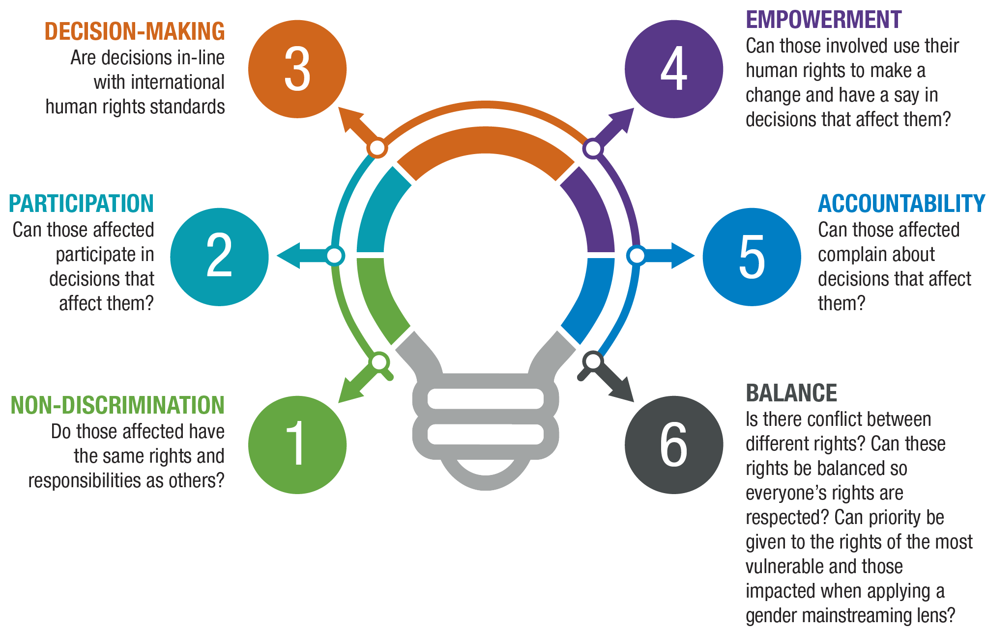

PRACTICAL EXERCISE

Consider the key human rights issues in your country identified in your environmental scan. Identify the most pressing using the questions in the Human Rights Issue Selection Tool.

#### Criteria Decision Tree

Once you have identified the most pressing human rights issues, you need to decide which issues your NHRI will prioritise. You may choose an issue because it aligns with your government’s agenda and SDG commitments or because it advances gender equality. There may be reasons not to select a pressing human rights issue; for example, it is not within your mandate, you do not have the capability to address it or it is already being addressed by another organisation and your NHRI would not add value.

You also need to consider your capacity. This is not only the size of your NHRI and your budget but also what you are obliged to do. For example, if you have a complaints function, this will take up a significant amount of your resources and will impact on other priorities. You are also likely to have international reporting obligations during the period of your strategic plan; for example, to the Universal Periodic Review or to one or more human rights treaty monitoring bodies. You must allocate resources to these activities before you consider other strategic priorities.

The **Criteria Decision Tree**, adapted from the New Zealand Human Rights Commission, provides an example of criteria for selecting which human rights issues to engage on and the process you can follow. You can use this as a sample to develop your own Criteria Decision Tree (potentially with different criteria) and include gender mainstreaming as one of your criteria.

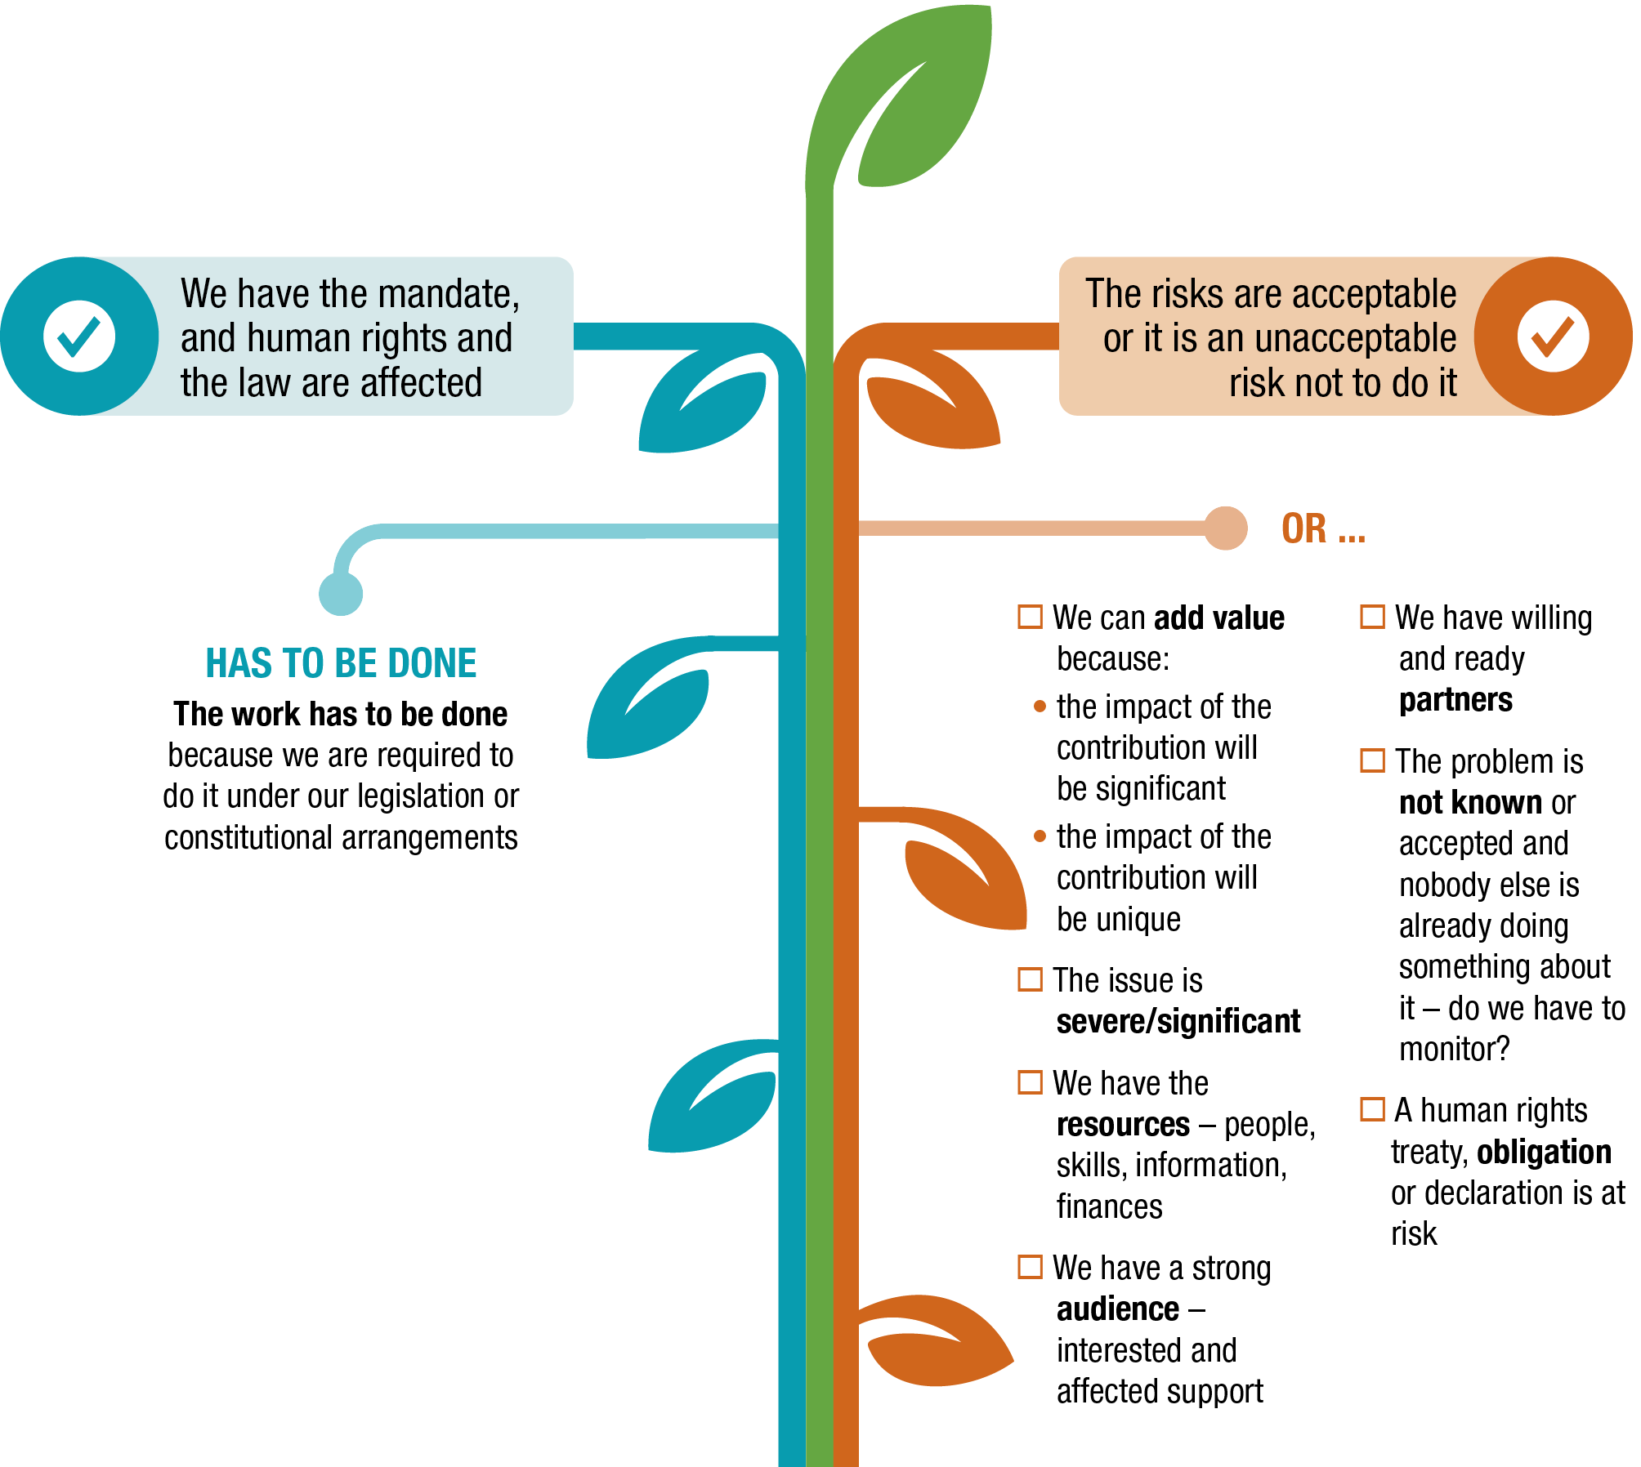

PRACTICAL EXERCISE

Consider the external challenges and opportunities identified in your environmental scan. Use the Criteria Decision Tree to select which human rights issues identified you should focus on, given these external factors.

Once you have analysed the issues through your criteria, draft priorities will start to emerge. These will be issues that:

* Were identified in the environmental scan
* Were highlighted by key stakeholders
* Meet the criteria you have set.

Through this process, you may have identified issues that are not top priorities. You can list these as matters you will work on in some small way. This is important as it enables you to meet your mandate by focusing on a few core priority issues, while also engaging, even in a limited way, on a wider set of human rights issues. Examples of this process is set out below.

1. In the first example, family violence is identified as a priority human rights issue.

2. In the second example, high unemployment is identified as an issue to go on your NHRI’s ‘watching brief’.

#### Example 1: Domestic violence

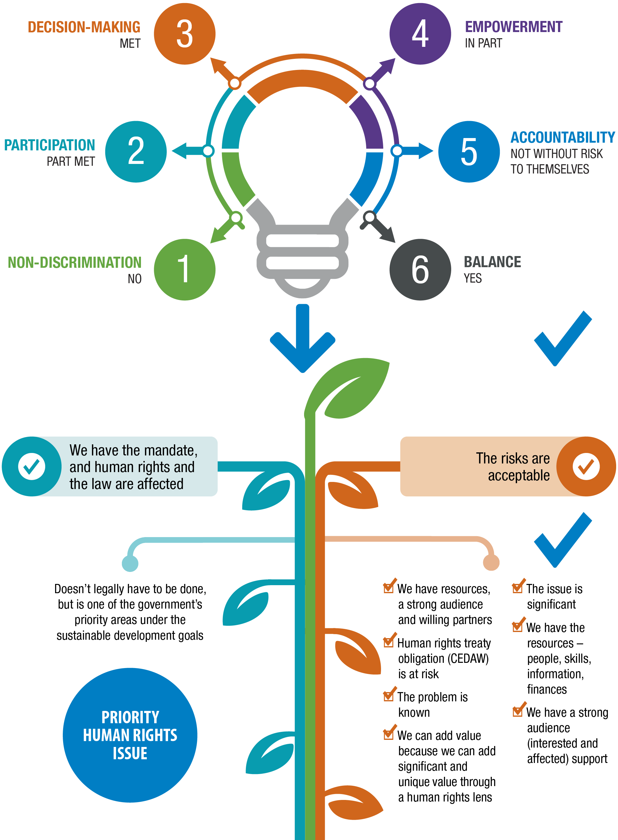

#### Example 2: High unemployment

You should set out your priorities as outcomes, as shown in the Mini Outcomes Framework below. You can then test these draft priorities with your key stakeholders before you finalise them. Provide stakeholders with the criteria you have used and ask for their feedback. A suggested checklist of questions is provided below. Once you have gone through all the feedback, you can finalise your strategic priorities.

sample questions for stakeholders

This is an example – you can expand or refine this list.

Do these priorities make sense to you against the criteria for selection we have developed?

Do you support some or all of these priority areas?

Do the draft priorities take gender into account?

Have we missed anything crucial?

#### Defining your outcomes

Having narrowed down your strategic priorities, the next step is to define your outcomes through the Mini Framework below (which you will use again in the Outcomes Framework in Module 3). Remember, you will not achieve these outcomes alone. You will contribute, with others, to this outcome through the mission of your NHRI.

mini outcomes framework

Fill out the table below by entering your strategic priorities, then think about your intended outcome(s).

|  |  |
| --- | --- |
| **Strategic priorities** | **Outcomes** |
| **Strategic priority 1** *e.g. Family violence* | **Outcome 1** *e.g. Reduction in family violence* |
| **Strategic priority 2** | **Outcome 1** |
| **Outcome 2** |
| **Strategic priority 3** | **Outcome 1** |
| **Outcome 2** |
| **Outcome 3** |

learnings from the samoan ombudsman’s office

The Samoan Ombudsman’s Office undertook the thinking outwards and thinking inwards stages of their strategic planning process at the same time. The process they used is set out in Modules 3 and 4.

With the 2016–20 Strategic Plan, the Office had a strategic plan to cover its dual mandate as Ombudsman and NHRI. The plan included an outcomes framework, with clear priorities and measures. It gave them a clear direction for their work and clear expectations, helping them to stay focused, accountable and able to deliver some significant projects, including a disability rights review and a national inquiry into family violence.

Through their strategic plan, they strengthened the Corporate Services Unit, which enabled them to make strong progress in future planning, as well as in monitoring and evaluation. It also meant they had the capacity to develop good relationships with the Samoan Treasury and other government agencies with an impact on their budget and resources. They had also prepared a draft budget in time for the government’s budget allocation round.

“For me it’s about being able to manage the work and the team a lot more smoothly. It’s so important to know how everything we are doing is linking together and has a purpose…because if we aren’t able to see that…what we are doing on the ground has no meaning.”

Loukinikini Villi  
Director, Human Rights

The Office shared some of the learnings from the ‘thinking outwards’ stage that they will incorporate into their next strategic planning process:

* It was helpful to have an experienced local consultant involved who understood government and could help align their plan to the government planning cycle. However, it was important to ensure that the consultant only supported and advised so that process and the decisions on priorities were owned by the Office.
* The process would have been more robust if they had consulted with external stakeholders about their priorities.
* Whilst there had been good consultation with communities to develop the Ombudsman’s first Human Rights Report, which informed the current strategic plan, the Office did not consult with any stakeholders through its 2016–20 strategic planning process. As a result, they were not informed by key government documents and some priorities duplicated the activities of government ministries.
* The priorities were also not aligned to the government’s agenda, including the SDGs, which was a missed opportunity. This meant that the strategic plan did not create a mutual understanding with stakeholders about priorities.
* In their next strategic planning process, the Office plans to consult with a wide range of stakeholders, including the Ministry for Women, human rights NGOs, police and prisons.

Not enough time was set aside to respond to new or unforeseen human rights issues. This meant that when they launched an inquiry into a responsive matter in 2016, they did not have the capacity to accommodate the extra work and progress against their strategic priorities was delayed. For their new strategic plan, they have decided to dedicate 10–20 per cent of their capacity to respond to new or unforeseen issues.

Module 3:  
Thinking Inwards

This stage of strategic planning enables your NHRI to identify how to advance selected priorities. It takes account of your current internal capacity and capability, as well as the external environment. It also recognises that not everything can be planned and that you need to leave room for unexpected issues.

At the end of this module you will be able to:

* Identify which interventions to pursue to advance your priorities
* Develop your outcomes framework
* Know how to consider new and unexpected issues as and when they emerge
* Identify your capabilities and assess any skills, systems and processes your NHRI needs to establish or strengthen in order to deliver your strategic priorities

Draft your strategic plan.

# Section 3.1. Identifying your interventions

In the previous module, you identified your strategic priorities and outcomes. In this module, you will identify the interventions that will achieve your strategic priorities. For example, you may have identified family violence as a strategic priority. However, there are many interventions that can address this issue; for example, media campaigns and advocacy. This module sets out how to select the best intervention.

Your intervention must be within your mandate. Beyond that, gut feeling, intuition and judgement also matter. The trick is to select the intervention that is most likely to have the desired impact, with the least expenditure of resources. For example, a single, well-timed letter to a key decision maker may be just as effective, if not more effective, than a full-blown Inquiry.

Likewise, an issue addressed through disputes resolution that has a systemic outcome, such as a change in government policy, can have more impact than litigation. Conversely, an issue that is not well understood, and where there are many interested parties with different perspectives, may be best addressed through an inquiry.

further reading

APF (2019) *NHRI Guidelines for Mainstreaming the Human Rights of Women and Girls into Our Everyday Work*: [www.asiapacificforum.net/resources/nhri-guidelines-mainstreaming-rights-women/](https://www.asiapacificforum.net/resources/nhri-guidelines-mainstreaming-rights-women/)

#### Conducting your SWOT analysis

In order to identify which interventions to pursue, you can use a SWOT analysis to:

* Understand your strengths and weaknesses
* Identify the opportunities available to you and the threats you face.

Having a better sense of your strengths (e.g. your relationships, your staff) and your weaknesses (e.g. lack of resources) will help you assess your internal capacity and capability. For example, does your NHRI have the capacity to write a complex report? Is a letter or a short advocacy campaign more realistic?

Understanding your opportunities (e.g. a change of government) and threats (e.g. a tightening human rights environment for women) will also inform which interventions to pursue. For example, are there incoming Ministers you can engage on specific issues? What is the best timing for this?

This section will help you to complete your own SWOT analysis. There is an example with prompting questions, followed by a blank template for you to complete.

Gender mainstreaming can be integrated into the SWOT analysis by asking gender-related questions in each category and by drawing on gender-related data and information published by international organisations, such as UN Women, as well as government agencies and academic bodies.

#### SWOT analysis – prompt questions

|  |  |
| --- | --- |
| **STRENGTHS** *Current capabilities and resources that we can draw on to advance a priority* | **WEAKNESSES** *Current internal weaknesses that need to be considered when deciding how to advance a priority* |
| * What connections do we have with decision makers or with people who can influence them? * What experience, knowledge and credibility do we have in relation to this priority, including the gender issues involved? * How connected are we with the people whose rights are affected by this priority? * What capacity and capability do we have to advance this priority? * How capable are we in mainstreaming gender in our NHRI and in our strategic priorities? | * What gaps exist in our ‘strengths’ analysis that we need to address? * What future weaknesses might we have; for example, staff with critical skills and knowledge who leave or a reduction in our budget? * What do we know our organisation struggles with and will be hard to address? * What other competing priorities might reduce our capacity to advance the priority? |
| **OPPORTUNITIES** *Current external opportunities that we could take advantage of to advance a priority* | **THREATS** *Current external threats that could limit our ability to advance a priority* |
| * What current events or trends provide opportunities to advance this priority? These can be political, economic, social, technological, environmental and legal; for example, new legislation, new research or recommendations from a UN monitoring body (Use the PESTEL framework in Module 2). * What relationships or partnerships do we have that can help advance this priority? * Are our stakeholders or other organisations focusing on this priority? This could provide opportunities for partnership or to support others advance this priority. | * What events or trends from the ‘opportunities’ analysis could create barriers to advancing this priority? * Are there other parties who might seek to undermine this priority and our credibility? * Are there other parties who might seek to undermine the people whose rights are affected by this priority? * In advancing this priority, what are the external risks to our other priorities? |

Once you have completed your SWOT analysis, the best interventions for you to advance each of your human rights strategic priorities will begin to emerge. The interventions you choose should use your strengths and opportunities, while also managing your weaknesses and threats.

Reflect and discuss in your own words

* Based on our strengths, weaknesses, opportunities and threats, what interventions should we pursue?
* Are there areas where we have significant strength and/or where there are good opportunities?

Are there interventions that we *shouldn’t* pursue (e.g. ones where we are weak, where there is limited opportunity or where the threats are too high)?

#### tool iconpractical exercise iconSWOT analysis template

You can fill out this SWOT analysis template using the prompt questions on the preceding page.

|  |  |
| --- | --- |
| **STRENGTHS** *Current capabilities and resources that we can draw on to advance a priority* | **WEAKNESSES** *Current internal weaknesses that need to be considered when deciding how to advance a priority* |
|  |  |
| **OPPORTUNITIES** *Current external opportunities that we could take advantage of to advance a priority* | **THREATS** *Current external threats that could limit our ability to advance a priority* |
|  |  |

# Section 3.2. How to handle emerging issues

At any point, a human rights issue, not previously prioritised or foreseen, might emerge and require your attention. It is important that your NHRI reserves capacity for this and has a consistent and principled approach to assess and potentially address new human rights issues (‘responsive matters’) or those issues that have not been identified as strategic priorities (‘non-priority matters’).

#### How to approach responsive matters

Responsive matters are issues that have not yet come up but must still be planned for. Using a consistent and principled approach to decision making supports your NHRI’s ability to manage stakeholder expectations and either accept or decline requests to intervene. You can use the checklist below.

responsive matters checklist

Choose your responsive matters based on:

The severity of the situation, assessed against international human rights standards

The difference an intervention by your NHRI could make

Whether your NHRI has the capacity to intervene

Do these criteria apply a gender lens to the issue?

Are we able to revisit our strategic priorities if the responsive matter requires our attention?

#### How to approach non-priority matters

Some issues that came up in your environmental scan and during your stakeholder engagement will not be in your final set of strategic priorities. These issues can be labelled ‘non-priority matters.’

While they are not immediate priorities, these issues may become more important to your work. Resources can be allocated to undertake limited activities and to continuously scan the issues, known as a ‘watching brief’. This can assist future discussion on strategic priorities and, if necessary, enable timely alerts on changes in the external environment that may mean the issue is elevated in importance by your NHRI. This can include a re-assessment of the priorities in your strategic plan.

Reflect and discuss in your own words

* Based on our strengths, weaknesses, opportunities and threats, what interventions should we pursue?
* Are there areas where we have significant strength and/or where there are good opportunities?

Are there interventions that we *shouldn’t* pursue (e.g. ones where we are weak, where there is limited opportunity or where the threats are too high)?

#### Developing your outcomes framework

Having completed your SWOT analysis, you have a better sense of how you are placed to address the strategic priorities and outcomes you identified in Module 2.

An outcomes framework is a useful tool for linking what you want to do (interventions) with what you are trying to achieve (impacts and outcomes). It helps you select which interventions to pursue in two ways:

Bottom up: Helping you check that your outputs are achieving the intended impacts; whether your intended impacts are contributing to your intended outcomes; and whether your intended outcomes are contributing to the intended strategic priority. For example, if an output is not having the intended impact, you may want to think about changing that output.

Top-down: Helping you check that your strategic priorities inform your outcomes; that those outcomes inform your impacts; and that these impacts inform your outputs. For example, if your strategic priorities change, this may have a ‘trickle down’ effect and may change your outcomes, impacts and outputs.

Having an outcomes framework helps you communicate how your interventions are improving the human rights situation in your country by making your impacts more tangible and measurable.

#### Sample outcomes framework

|  |  |  |  |  |
| --- | --- | --- | --- | --- |
| **STRATEGIC PRIORITY 1: DOMESTIC VIOLENCE** | | | | |
| **Outcome** | **Description** | **Example** | **Timeframe** | **Indicators** |
| The change in society achieved by the contribution of the NHRI | Reduction in domestic violence | Long-term, possibly over generations | How you will measure that you are making an impact. For example, the number of reported domestic violence incidents decrease |
| **Impact** | The specific, identified improvement through their intervention (probably with the contribution of others) | Decision-makers accept and implement all NHRI report recommendations on reducing domestic violence | 1-5 years |  |
| **Output** | The product or service that you will deliver, set out as specific, measurable, achievable, realistic and timed | NHRI produces a report with recommendations for reducing domestic violence | 1-2 years |  |

For each intervention, you can identify the:

* Output (the product or service) that you will deliver
* Impact that you are hoping to achieve
* Outcome that you are contributing to through this impact
* Strategic priority that this outcome contributes to.

Indicators help you to track whether your intervention is having an impact. They also keep staff accountable for their work. You can set broad indicators that enable you to measure progress and make adjustments, if necessary. You can also include indicators to track progress in gender-related outcomes.

These may later form the basis of a detailed monitoring and evaluation framework.

#### practical exercise icontool iconOutcomes Framework

|  |  |  |  |  |  |  |
| --- | --- | --- | --- | --- | --- | --- |
| **Strategic priority**  **Outcome** | **STRATEGIC PRIORITY 1** | | | **STRATEGIC PRIORITY 2** | | |
| **Description** | **Timeframe** | **Indicators** | **Description** | **Timeframe** | **Indicators** |
|  |  |  |  |  |  |
| **Impact** |  |  |  |  |  |  |
| **Output** |  |  |  |  |  |  |

# Section 3.3. Organisational health and capability

#### Assessing and developing your capability

Your next step is to assess what you need to work on internally in order to deliver your strategic priorities. This will be a mixture of capacity (the number of staff and the size of your budget) and capability (the level and nature of your knowledge, skills and experience).

A capability framework can help you to:

* Assess your NHRI’s capability to deliver on your strategic priorities and to operate effectively.
* Identify any skills, systems and processes your NHRI needs to establish or strengthen in order to deliver your strategic priorities and to operate effectively.

The nine capabilities listed below are crucial to the functioning of an NHRI. They are adapted from the GANHRI framework but extended to include organisational culture and effective ways of working.

1. Leadership

2. Institutional arrangements

3. Knowledge

4. Accountability

5. Protecting human rights

6. Promoting human rights

7. Advice and assistance to government

8. Stakeholder engagement

9. Human rights monitoring

You can assess your NHRI against these capabilities using the capability framework prompt questions and template on the following pages. You can use the findings from your SWOT analysis (particularly the strengths and weaknesses) from Module 2 to feed into your capability framework.

Once you have completed the capability framework, you can:

* Assess the most important areas for organisational development, based on what you need to be able to do in order to deliver the interventions in your strategic priorities.

Select two to three priorities for capability development, which you will include in your strategic plan.

further reading

APF (2019) *Capacity Assessment Manual for National Human Rights Institutions*: [www.asiapacificforum.net/resources/capacity-assessment-manual/](http://www.asiapacificforum.net/resources/capacity-assessment-manual/)

APF (2019) *NHRI Guidelines for Mainstreaming the Human Rights of Women and Girls into Our Everyday Work*: [www.asiapacificforum.net/resources/nhri-guidelines-mainstreaming-rights-women/](https://www.asiapacificforum.net/resources/nhri-guidelines-mainstreaming-rights-women/)

Gender mainstreaming can be integrated into your organisational health and capability assessment by asking gender-related questions under each category. You should capture and include gender disaggregated data on the composition of your staff and Ombuds/Commissioners (as provided to the APF each year), as well as gender data on complaints and policies.

The prompt questions in the capability framework include gender mainstreaming questions, and the link in Further Reading to the APF’s *NHRI Guidelines for Mainstreaming the Human Rights of Women and Girls into Our Everyday Work*, provides guidance on developing a gender mainstreaming strategy. You can consider incorporating this into your organisational health priorities.

#### Capability framework prompt questions

| **QUESTIONS TO ASSESS CAPABILITY** | |
| --- | --- |
| **Leadership** | How diverse is our leadership group?  Are we independent? Do we have capacity to withstand pressure from government authorities?  What is our reputation and credibility like?  Do we have capacity to understand and implement our mandate and strategic priorities?  Do we have the capacity to fully utilise staff skills and expertise?  Do we foster an environment where all are motivated and feel ‘heard’?  Do we promote diversity, including through gender mainstreaming strategies?  Do we have communications and engagement activities to ensure everybody can contribute to, and is aligned around, our values, strategy and priorities? |
| **Institutional arrangements** | What is our organisational structure like? Do we have clear definitions of roles and our reporting structure?  Is our NHRI accessible to people (e.g. geographically accessible to people in different parts of the country, including in remote regions and rural areas)?  Are we accessible to marginalised or vulnerable populations? Are we accessible to different groups of women and girls?  Are we accessible online?  Have we mainstreamed gender at all levels of the organisation and into programming? Do we have internal capacity to undertake a gender mainstreaming analysis?  Do we have quality processes, systems and activities to support cross-team working and efficiency? |
| **Knowledge** | Do we have capacity to understand and implement: (1) our mandate, strategic priorities, interventions and outputs? (2) the law, including international human rights law?  Do we have the skills, experience and knowledge required across our staff to deliver on strategic priorities, as well as the supporting systems and processes we need to work effectively?  Can staff access training opportunities?  Do we have effective knowledge management structures?  Do we have databases to serve as an electronic repository of public information?  Does staff have a good understanding of gender mainstreaming and what it looks like in practice? |
| **Accountability** | Do we have monitoring and evaluation (M&E) systems in place for monitoring and reporting on progress and risk, and undertaking evaluation to support learning?  Does our M&E system capture the results of our gender mainstreaming work?  Have we translated our strategic plan into an operational plan, with clear outputs and indicators?  Does the operational plan incorporate our gender mainstreaming work?  External accountability (see “Promoting human rights”) |
| **Protecting human rights** | Do we have capacity to undertake impartial/thorough investigations in a timely manner and provide follow up recommendations?  How effective is our complaint handling process? Do we have clear workflows and decision points?  Is our approach to screening and triage of issues effective? Do we provide timely communication to the parties involved in a complaint?  Can we identify and address urgent complaints? |
| **Promoting human rights** | How effective are we at promoting human rights through:   * Media campaigns? * Education curricula? * Promotional materials for public education and advocacy? * Training public officials? * Formal consultations? * Undertaking training of trainers? |
| **Advice and assistance to government** | Do we have the capacity to liaise with government institutions and law enforcement agencies?  Can we access support when we develop national human rights action plans and similar human rights planning tools, including business and human rights? |
| **Stakeholder engagement** | Are we increasing our visibility and public respect?  Are we using training opportunities to engage stakeholders by including non-governmental organisations (NGOs) and grassroots groups as trainers and trainees?  Do we integrate gender mainstreaming into approach to stakeholder engagement?  Do we finance civil society organisations through our programmatic activities? |
| **Human rights monitoring** | Do we have appropriate skills and expertise related to our mandate?  Can we support systematic and unannounced inspections or visits?  Do we have specialised gender guidelines for inspecting detention facilities? |

#### tool iconpractical exercise iconCapability Framework Template

You can use the prompt questions on the preceding pages to fill out the template.

| **QUESTIONS TO ASSESS CAPABILITY** | |
| --- | --- |
| **Leadership** |  |
| **Institutional arrangements** |  |
| **Knowledge** |  |
| **Accountability** |  |
| **Protecting human rights** |  |
| **Promoting human rights** |  |
| **Advice and assistance to government** |  |
| **Stakeholder engagement** |  |
| **Human rights monitoring** |  |

# Section 3.4. Drafting your strategic plan

You are now ready to draft your strategic plan. The plan should be explicit about your gender mainstreaming priorities and activities.

#### Strategic Plan Template

|  |  |
| --- | --- |
| **Foreword** | This section is signed by the Ombudsperson/Chief Commissioner or President and presents key messages that your NHRI would like to communicate. These may include:   * A short history of the NHRI, your operating environment (identified in your SWOT analysis) and the direction you intend to take * Messages about working in partnership with civil society organisations and to support government meet its human rights responsibilities. |
| **Who we are and how we work** | * A statement of your mission and vision. * The role and mandate of the NHRI, covering statutory functions under domestic legislation, the Paris Principles and the international human rights standards, and international monitoring and reporting obligations. * A statement of the values that guide what you do and how you do it. This should, as a minimum, mention the importance of working in partnership with key stakeholders from civil society and government, in accordance with the Paris Principles. * Any memberships, particularly of national and international bodies, and how this benefits the NHRI and the country. |
| **How we developed our strategic plan** | This explains the process you followed, including reviewing documents and stakeholder engagement, and the criteria you used to select your priorities. |
| **Strategic context** | This sets out the key human rights issues in your country, as well as any relevant political issues identified from your environmental scan and your process to select your priorities. |
| **Strategic priorities** | This section sets out the three or four human right priorities you have chosen. Under each strategic priority, describe:   * Why does it matter – why this issue has been selected as a priority. Identify where the priority aligns to the government’s agenda and relevant SDGs * What success looks like – the outcomes you are working towards and the measures that will show your progress * Key interventions your NHRI will undertake.   In addition, note:   * Your expected engagement with UN monitoring bodies during this period * How you will maintain capacity to address emerging issues and the process for deciding when to undertake them. Also identify those issues where your NHRI will maintain a watching brief. |
| **Organisational health and capability** | This section sets out two or three priorities to develop the health and capability of your organisation. Describe why these priorities have been selected and the expected benefits, both for the efficient and effective running of your organisation and your ability to deliver your strategic human rights priorities. |
| **Outcomes framework** | Set out your strategic priorities in a one-page outcomes framework. You can also include your organisational priorities underneath, where these will support you to deliver your human rights priorities. |
| **Implementing, reporting and reviewing the plan** | This section sets out, at a high level:   * How you will develop an operational plan that will identify the activities and resources to implement the activities in your strategic plan, with teamwork across the organisation. * How you will develop indicators and measures, and a monitoring and evaluation plan, so you can track and report progress on your strategic plan and adjust as needed. Note any reporting requirements to government. * When you will review the strategic plan and adjust it, particularly the interventions, based on your monitoring and any new external developments. |

#### tool iconpractical exercise iconStrategic Plan Template

This template helps you complete your own strategic plan. You will likely require several pages.

|  |  |
| --- | --- |
| **Foreword** |  |
| **Who we are and how we work** |  |
| **How we developed our strategic plan** |  |
| **Strategic context** |  |
| **Strategic priorities** |  |
| **Organisational health and capability** |  |
| **Outcomes framework** |  |
| **Implementing, reporting and reviewing the plan** |  |

#### Consulting stakeholders on your strategic plan

Once you have drafted your strategic plan, it is a good idea to send it to the same stakeholders that you consulted for your environmental scan and selecting your strategic priorities. Ask your stakeholders for their feedback. They will feel engaged in your work and it also helps you to sense-check your plan.

The checklist below provides a set of questions you can ask. It is best to ask the same questions to all stakeholders so you can compare the different responses. Once you have considered the feedback, and made any changes, your strategic plan is complete.

STAKEHOLDER CHECKLIST FOR TESTING YOUR DRAFT  
STRATEGIC PLAN

Choose your responsive matters based on:

Have we accurately reflected our strategic priorities that emerged from our consultations?

Have we selected the right issues for our ‘watching brief’?

Does our outcomes framework have the right interventions?

Will our organisational priorities help strengthen our institution?

thinking outwards and thinking inwards with the  
samoan ombudsman’s office

The Office undertook the ‘thinking outwards’ and ‘thinking inwards’ stages of their strategic planning process at a two-day retreat in 2015.

A local consultant helped the Office prepare for the retreat by undertaking a desktop review of the existing 2014–18 strategic plan. She also drew on the Ombudsman’s first Human Rights Report, published in 2015, which linked the values and principles of human rights with *Fa’asamoa* (the Samoan way) and identified the most pressing issues at that time. She consulted with senior staff and then drew all this information together in a working document for the retreat.

The retreat was the first opportunity that everyone was able to take part in a cross-team discussion. This allowed them to discuss and agree on a single mission and vision, as well as their organisation’s values (as described in Module 1).

To select the Office’s priorities:

Firstly, each Unit identified a number of key issues under their mandate, informed by their knowledge of the external environment. For example, the Human Rights Unit identified family violence as a key issue, based on data from the Ministry of Police, recommendations of UN human rights treaty bodies, local media stories and from the Ombudsman’s own Human Rights Report. Each Unit also defined the outcome they wanted to achieve and the supporting interventions, as well as clear and achievable objectives and measures.

Secondly, each Unit presented their draft priorities to the whole group. These were refined through discussion to ensure that the final set of priorities was aligned with the strategic objectives of the Office. Following this exercise, they developed an outcomes framework.

After the retreat, the local consultant prepared a draft strategic plan, which was shared for feedback and then finalised. Sharing the draft plan was an important step because it meant everyone had ownership of the final document, even though it had been written by an external consultant.

Module 4:  
Thinking Ahead

This final module focuses on operational planning, including reviewing and adjusting your strategic plan. It introduces the operational planning process, which sets out how you are going to execute your strategic plan. It also describes how to ensure that your strategic plan remains fit for purpose and can be adjusted to respond to internal and external changes.

At the end of this module you will be able to:

* Know how to develop an operational plan

Know how to review your progress and adjust your strategic plan so it remains fit for purpose.

# Section 4.1. Developing your operational plan

No strategic plan is complete without a clear and achievable process to execute it. While your plan sets out your high-level strategic priorities and outcomes, your annual operational plan sets out the steps to implement it. Your operational plan breaks down the strategic plan into concrete steps about who will do what, by when and with what resources. A strategic plan generally runs over three-to-five years, but an operational plan will only cover one year.

Your operational plan should include:

The steps or activities you will take to implement the interventions under each priority human rights issue.

The allocation of resources (human and financial) against each intervention. Your interventions are likely to involve people from different parts of your NHRI, and this shows everyone what they need to do and where they need to work together.

Activities that develop the capability and capacity of the organisation or are required for legal compliance.

A monitoring and evaluation framework (see Module 3) and a system for reporting progress, to assess how well the intervention was delivered and whether it achieved the intended outputs, impacts and outcomes.

Review points when you will evaluate and adjust your operational and your strategic plan.

The steps should be specific, measurable, achievable, realistic and time-bound (SMART). A template for an operational plan is provided in this section.

#### Team and individual work plans

The operational plan should provide the foundation for team and individual work plans and professional development objectives, which are also monitored. Team and individual plans ensure everyone knows what they are responsible for and where their work connects with others across the organisation.

# Section 4.2. Reviewing your operational and your strategic plans

You should plan your reviews well in advance and to book them in as soon as your strategic and your operational plans are finalised.

You should review your operational plan every four months. This helps you to assess how well you are doing in delivering your plan and identify any adjustments you might need to make.

Prior to your review, you should gather all the relevant information you have and consider the following questions:

What have we delivered, and how has that gone? Are there any learnings to reflect on?

What have we not delivered? Why? What do we need to do to get back on track?

How well have we delivered on our gender mainstreaming goals?

Is there anything that we need to change or add because of changing internal or external circumstances?

Are there any implications for resources? If so, what trade-offs do we need to make?

Towards the end of each planning year, you should undertake a ‘light touch’ check on your strategic plan, before you develop your next operational plan. This is best done through an internal workshop for a few hours. This workshop is an opportunity to discuss how implementation has been going and agree on any adjustments to the plan. This can be limited to the NHRI leadership but should include progress reports from staff. You will also work through the same questions as for the operational plan. The conclusions of the workshop will inform your next operational plan.

After two or three years, you should undertake a deep check of your strategic plan. This should include all NHRI staff and your external stakeholders. This process can revisit the PESTEL and SWOT analysis and also draw on new data. It is likely to involve adjustments to your strategic plan.

#### Operational Plan Template

Your operational plan will be developed by drawing on the strategic plan. Be explicit about your gender mainstreaming activities.

|  |  |
| --- | --- |
| **Introduction** | * A statement of your mission and vision. * The role and mandate of your NHRI, covering the statutory functions under domestic legislation, the Paris Principles and the international human rights standards, and international monitoring and reporting obligations. * A statement of your values and/or principles that guide what you do and how you do it. This should at least mention the importance of working in partnership with key stakeholders from civil society and government, in accordance with the Paris Principles. * Any memberships, particularly of national and international bodies, and the benefits this provides the NHRI and the country. |
| **Strategic priorities** | This section sets out the three to five human right priorities you have chosen. Under each strategic priority:   * Describe what the strategic priority is, the impact and outcome you are seeking, and the measures you will use (taken from the strategic plan) * Under each key intervention from the strategic plan:   What SMART action will happen and by when?  The indicators and measures you will use to assess progress  The lead officer responsible for each intervention  Which team(s) in your NHRI will contribute to this intervention.   * Which issues your NHRI will keep a watching brief on, and for each issue:   What SMART action will happen and by when  The indicators and measures you will use to assess progress  The lead Commissioner responsible for each intervention  Which team(s) in your NHRI will contribute to this intervention.   * What capacity will be maintained to address emerging issues, the process for deciding to undertake action, and who is responsible for leading and contributing? |
| **Engaging internationally** | Set out any interaction with, or reporting to, UN monitoring bodies, APF and GANHRI in this period: For each engagement and interaction, set out:   * What SMART actions will happen and by when * The indicators and measures you will use to assess progress * The lead officer responsible for each activity * Which team(s) in your NHRI will contribute to this activity. |
| **Organisational health and capability** | This section sets out the two or three to priorities you have chosen to develop the health and capability of your organisation.  Under each priority, describe what the priority is and the expected benefits (taken from your strategic plan) and:   * What SMART actions will happen and by when * The indicators and measures you will use to assess progress * The lead officer responsible for each intervention * Which team(s) in your NHRI will contribute to this intervention. |
| **Budget** | Provide a table which allocates your budget against each of the activities in the operational plan. |
| **Monitoring and reviewing the plan** | This section sets out:   * Your monitoring and evaluation framework * The points when you will report and review progress and, if required, adjust your operational plan. |

#### tool iconPractical exercise iconOperational Plan Template

You can use this template to complete your own operational plan. You will likely require several pages.

|  |  |
| --- | --- |
| **Introduction** |  |
| **Strategic priorities** |  |
| **Engaging internationally** |  |
| **Organisational health and capability** |  |
| **Budget** |  |
| **Monitoring and reviewing the plan** |  |

thinking ahead in the samoan ombudsman’s office

Creating the strategic plan meant that the Samoan Ombudsman’s Office had a clear understanding of the link between their vision and their interventions. They also had measures so they knew what success should look like. Having a corporate services function with full capacity means they have been able to develop a one-year operational plan, which shapes their team and individual workplans. This has been highly valued by the staff and helped them to:

* Know what they are accountable for and stay focused on delivery
* Adapt international best practice
* Plan and work together across the different Units, allowing them to apply a wider set of skills and knowledge to projects
* Monitor and report on interventions so they can review progress.

The Office held a second retreat in 2019 to undertake a review of their strategic plan. This gave staff an opportunity to celebrate what they had achieved to advance their strategic priorities and agree where they should adjust and refocus their efforts.

It also enabled them to identify the lessons for their next strategic plan, set out in Module 2. They concluded that more frequent reviews would be valuable.

With the insights and new energy gained from their 2019 retreat, the Office is now ready to develop their next strategic plan. Their goal is to continue to make a difference in the day-to-day lives of the people of Samoa so everyone can enjoy their human rights.

# Tool iconTools Roadmap

You can download and print out all the tools below from [www.asiapacificforum.net/resources/strategic-planning-guide-tools](https://www.asiapacificforum.net/resources/strategic-planning-guide-tools).

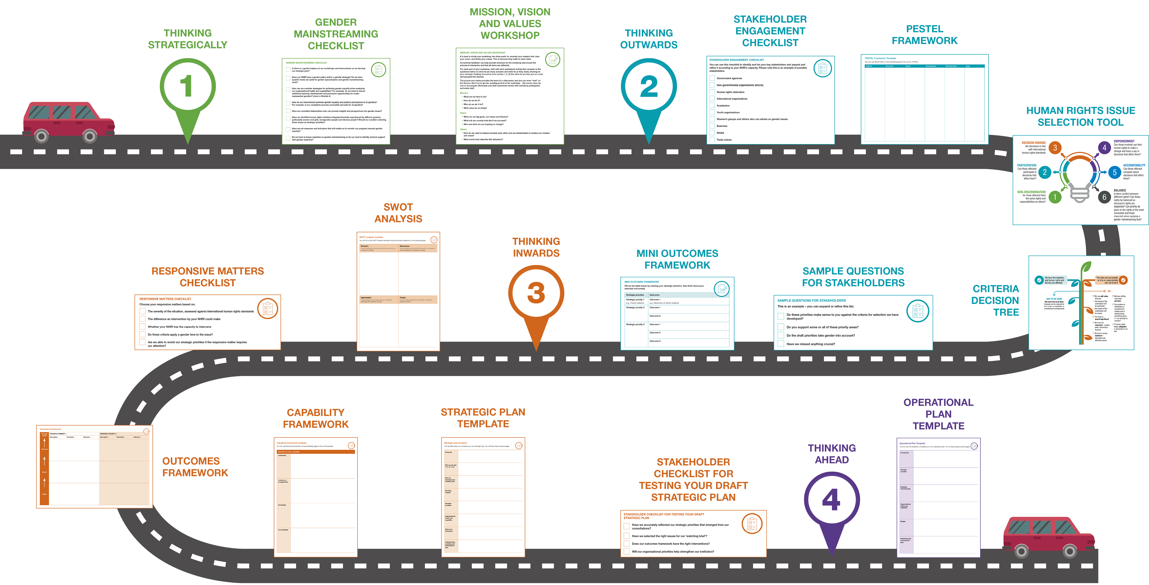

1. Available online in the APF Learning Community.