
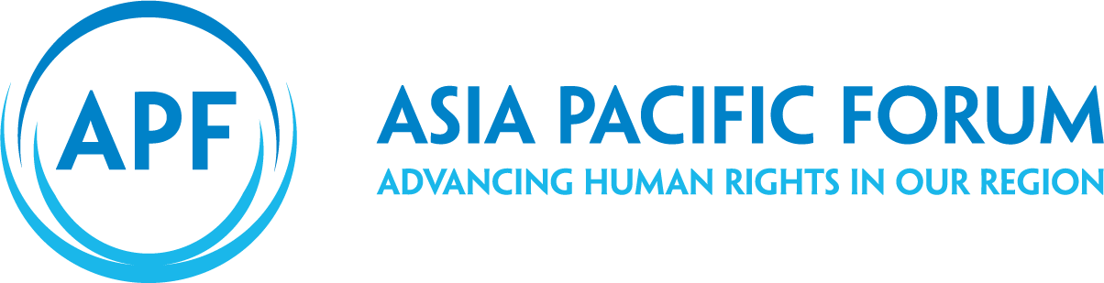

CALL FOR ACTION

NHRIs and CSW 63, 2019

Pip Dargan, Deputy Director, APF

Contents

Engage with your governments in capital and in New York 3
1.1 CSW 63 Agreed Conclusions 3
1.2 Proposed Language for the CSW 63 Agreed Conclusions 3
1.3 Country statement 5
1.4 Advocate for UN Women to produce a report for States re NHRI enhanced participation 5
Attend CSW 63 6
NHRI caucus meeting – Monday 11 March 2019. 6
UNFPA-APF-GANHRI side-event 6
CSW Members 7
Arrange meetings 7

Dear NHRIs,

Please find below a number of actions that you can take to encourage States to support NHRI engagement and participation rights at CSW in 2019. CSW 63 will be held in New York from 11-22 March 2019.

We encourage you to engage with your government regarding a stand-alone paragraph on NHRIs; to attend CSW and participate at the NHRI side-event and encourage your government to make a statement at CSW supporting NHRIs. Further information is set out below. We will keep you informed of dates for the NHRI side event and NHRI caucus meeting to be held the first week of CSW as it comes to hand.

We wish to particularly draw your attention to the proposed stand-alone paragraph and the proposed language that we will mobilise and lobby for inclusion in CSW 63’s Agreed Conclusions. We urge you to make this a priority out of all the actions.

Engage with your governments in capital and in New York

1.1 CSW 63 Agreed Conclusions
Agreed Conclusions are the CSW’s principal outcome each year. NHRIs (whether attending CSW 63 or not) can constructively engage their respective governments (especially those ministries responsible for CSW such as departments of foreign affairs, women’s affairs or others) for the inclusion of language in this year’s Agreed Conclusions that recognises NHRIs as independent national mechanisms that have the mandate work to promote and protect the rights of women and girls.

1.2 Proposed Language for the CSW 63 Agreed Conclusions
Early next year a ‘zero draft’ Agreed Conclusions for CSW 63 will be in circulation amongst States and should become publicly available on the UN Women website.
Over the past several years NHRI advocacy with the support of some States and civil society have managed to secure a stand-alone paragraph on NHRIs. This paragraph has been a significant development and has enhanced NHRI participation at CSW. However, at this point, NHRIs do not enjoy the same formal and independent recognition at CSW as they do at the UN Human Rights Council or other UN fora. Ultimately full independent participation of NHRIs at CSW is the goal of the NHRI advocacy; however, and, in the meantime, we continue to make step by step gains to continue to build our case as well as continue our momentum on this campaign.
Now is the time to encourage your government to support the inclusion of the proposed paragraph below. This language will not be automatically included. It will require States to negotiate it into the Agreed Conclusions. In this regard, NHRIs can strongly encourage their States to be supportive of the language or at the least not take a negative or obstructionist approach.
The following paragraph in bold is the proposed language (given due consideration to the CSW difficult political context) to be negotiated by States into the Agreed Conclusions:
The Commission recalls General Assembly resolution 72/181 and requests the secretariat to report at the sixty-fourth session of the Commission on the participation of national human rights institutions that are fully compliant with the principles relating to the status of national institutions for the promotion and protection of human rights (Paris Principles), in the work of the Commission and request the secretariat to also consider how to further enhance the participation of such national human rights institutions, and their networks, at the sixty-fourth session of the Commission, in compliance with the rules of procedure of the Economic and Social Council.
The timeframe (to be confirmed) in relation to the Agreed Conclusions is as follows:
1. February 5: Zero draft will be circulated for comments by member states.
2. Early-mid March: Document with comments by member states will be ready.
3. Mid-March: Document will be introduced.
4. March 11-22: Informal consultations on Agreed Consultations.
5. March 22: Agreed Conclusions Adopted (if consensus by States).
NHRIs can engage with their governments in the lead up and throughout this process.

1.3 Country statement
NHRIs (whether attending CSW 63 or not) can strongly encourage their governments to make a country statement at CSW 63 supportive of NHRI independent participation at CSW. If your government indicates it is willing to support NHRIs in its country statement at CSW please immediately advise Pip Dargan, Deputy Director/Gender Focal Point at pipdargan@asiapacificforum.net or Katharina Rose, Permanent Representative, GANHRI at k.rose@ganhri.org.
We recommend the following language for a country statement:
The [X] Government supports the Commission on the Status of Women taking steps to provide NHRIs and their coordinating bodies with independent participation status at the Commission as recommended by General Assembly resolutions A/RES/70/163 (2016) and A/RES/72/181(2017). Independent participation status of NHRIs should be on a comparable basis to the independent participation status of NHRIs in the procedures of the UN Human Rights Council and other United Nations human rights mechanisms. We request that UN Women provide a report to Member States with an update on progress and next steps.

1.4 Advocate for UN Women to produce a report for States re NHRI enhanced participation
Since 2016 CSW’s Agreed Conclusions have called for the secretariat to consider how to enhance the participation of NHRIs at CSW. There has been some good progress in that in the last two years (2017 and 2018) UN Women have invited 2-3 NHRI representatives to speak at the high-level interactive dialogue on Accelerating implementation of the Beijing Declaration and Platform for Action which had not occurred previously. However, it is not clear if this is now a practice of ‘convention’ or simply discretionary. It would be timely now for UN Women to report to CSW on what steps it has taken to enhance NHRI participation and what it will propose for the future. NHRIs should be actively encouraging their governments to support such a report.

Attend CSW 63
If your NHRI is able to attend CSW 63, please notify Pip as soon as possible by emailing pipdargan@asiapacificforum.net. Pip will assist you and keep you updated on developments. Pip’s mobile and WhatsApp number is +61 439 300 466.
However as you know NHRIs do not have separate registration at CSW unlike the UN Human Rights Council. NHRIs need to be invited by States as part of their delegations or NHRIs need to register with an ECOSOC-accredited NGO.
Important events at CSW specific to NHRI participation that your institution should attend include:

NHRI caucus meeting – Monday 11 March 2019.

The APF organises an NHRI caucus meeting for those NHRIs attending CSW in the first week of its session. The caucus meeting is an opportunity to meet peer NHRI representatives, APF and GANHRI representatives as well as exchange information and ideas.

The NHRI caucus meeting with be held Monday 11 March, 09:00 – 12:00, Rio Room, UNDP, FF building, 304 East 45th Street, New York.

This will provide NHRIs, APF and GANHRI representatives with the opportunity to meet each other and exchange information.

UNFPA-APF-GANHRI side-event
UNFPA-APF-GANHRI side event on “Advancing Gender Equality and SRHR: the Role of NHRIs” will be held on Wednesday 13 March 2019, 4:45-6:00 PM, United Nations Headquarters – Conference Room A.
Please encourage your government to be a co-sponsor for this event and advise Pip or Katharina of its agreement to do so.
In addition, many NHRIs hold their own side-events at CSW or speak at a range of side and parallel events so if participating NHRIs could share details of any other side events or parallel events they may be speaking at or organising please inform Pip so can get develop a centralised list of documenting NHRI engagement at CSW and for reporting.

CSW Members

We strongly urge NHRIs and regional networks to review CSW Membership http://www.unwomen.org/-/media/headquarters/attachments/sections/csw/63/membership%20csw_%2063%20(2019).pdf?la=en&vs=1831 to see if your Government is one of the 45 member states on the CSW or its Bureau. If it is please consider pro-actively engaging your Government and encourage it to take a positive position that supports the strategies outlined in this paper.

Arrange meetings
Please arrange meetings with your Government’s mission in New York and where possible invite Pip and Florence to attend to support your message. Consider organising other meetings with UN Women, OHCHR, NGOs and members of the CSW Bureau. Information about meetings can also be shared at the NHRI caucus meeting.

