

Annual Report

1 July 2013 – 30 June 2014

Contents
List of abbreviations 3
Introduction 4
The Asia Pacific Forum 4
Strategic objectives and activities 5
1 Enhance members’ institutional capacity 7
1.1 Training 7
1.2 Capacity assessments 16
1.3 Specialist capacity projects 19
2 Enhance members’ communication, cooperation and engagement 22
2.1 Cooperation and engagement 22
2.2 Communications 27
3 Promote compliance with the Paris Principles 31
3.1 Accreditation 31
3.2 Provision of advice to members and others 33
3.3 Establishment of NHRIs 35
4 Engage with international and regional human rights mechanisms 37
4.1 International mechanisms 37
4.2 Regional mechanisms 40
4.3 Advocacy 41
5 Effective, efficient and strategic management of the APF 43
5.1 Strategic management 43
5.2 Gender mainstreaming 45
5.3 Environmental impact 46
5.4 Financial management 47
5.5 Corporate governance 49

List of abbreviations
ACJ Advisory Council of Jurists
ANNI Asian NGOs Network on NHRIs
APF Asia Pacific Forum of National Human Rights Institutions
APT Association for the Prevention of Torture
ASEAN Association of Southeast Asian Nations
CA capacity assessment
CESR Center for Economic and Social Rights
ICC International Coordinating Committee of National Institutions for the Promotion and Protection of Human Rights
NGO(s) non-governmental organisation(s)
NHRI(s) national human rights institution(s)
NPM(s) national preventive mechanism(s)
OEWG UN Open-ended Working Group on Ageing
OHCHR Office of the High Commissioner for Human Rights
OPCAT Optional Protocol to the Convention against Torture and Other Cruel, Inhuman and Degrading Treatment or Punishment
Paris Principles Principles relating to the Status of National Institutions for the Promotion and Protection of Human Rights
PIFs Pacific Islands Forum secretariat
RWI Raoul Wallenberg Institute for Humanitarian Law
SCA Sub-Committee on Accreditation of the ICC
SEO(s) senior executive officer(s)
UN United Nations
UNDP United Nations Development Programme
UPR Universal Periodic Review
VLE virtual learning environment

Introduction
The Asia Pacific Forum of National Human Rights Institutions (APF) is a regional organisation that supports the establishment and strengthening of national human rights institutions (NHRIs) in the Asia Pacific. It provides practical assistance and support to its individual member institutions to enable them to more effectively undertake their own human rights protection, monitoring, promotion and advocacy.

The Asia Pacific Forum
The work of the APF can be categorised under three broad areas:
- Strengthening the capacity of individual APF member institutions to enable them to more effectively undertake their national mandates.
- Assisting governments and civil society to establish and strengthen NHRIs in compliance with the minimum criteria contained in the Paris Principles.
- Promoting sub-regional, regional and international cooperation on human rights issues.
Throughout the reporting period the APF worked with its member NHRIs, local, regional and international non-governmental organisations (NGOs), governments, and international organisations to bring about improvements in human rights.
The APF currently has the following 21 member institutions:
- the Afghanistan Independent Human Rights Commission
- the Australian Human Rights Commission
- the National Human Rights Commission of Bangladesh
- the National Human Rights Commission of India
- the Indonesian National Commission on Human Rights
- the Jordan National Centre for Human Rights
- the Human Rights Commission of Malaysia
- the Human Rights Commission of the Maldives
- the Myanmar National Human Rights Commission
- the Human Rights Commission of Mongolia
- the National Human Rights Commission of Nepal
- the New Zealand Human Rights Commission
- the National Human Rights Commission of Oman
- the Palestine Independent Commission for Human Rights
- the Philippines Commission on Human Rights
- the National Human Rights Committee of Qatar
- the National Human Rights Commission of the Republic of Korea
- the Ombudsman of Samoa
- the Human Rights Commission of Sri Lanka
- the National Human Rights Commission of Thailand, and
- the Provedor for Human Rights and Justice of Timor-Leste.
The APF’s membership increased by two institutions since the last Annual Report with the inclusion of the National Human Rights Commission of Oman and the Ombudsman of Samoa as associate members.
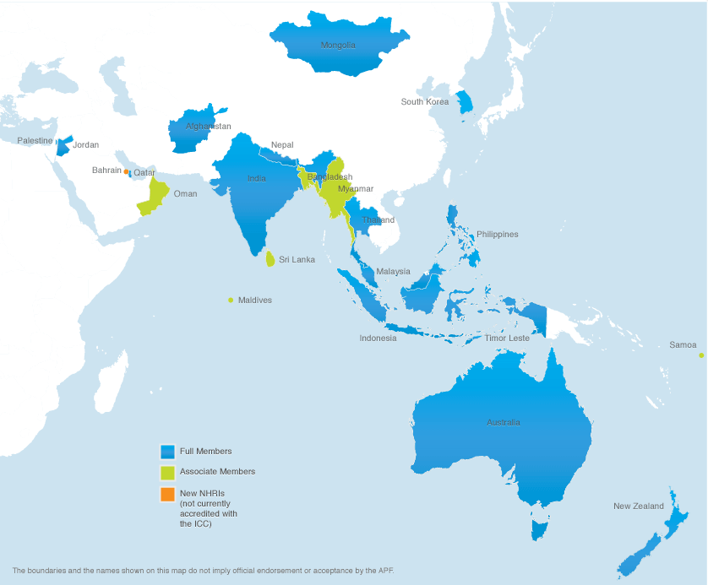
Further information on the APF and its individual members is available at www.asiapacificforum.net.

Strategic objectives and activities
This Annual Report covers the period 1 July 2013 to 30 June 2014. The report details the APF’s activities under the following five key strategic objectives:
- Enhance members’ institutional capacity
- Enhance members’ communication, cooperation and engagement
- Promote compliance with the Paris Principles
- Engage with international and regional human rights mechanisms, and
- Effective, efficient and strategic management of the APF.
The Swedish International Development Cooperation Agency’s support has enabled the APF to deliver key services with regards to its core mission of strengthening the capacity and regional representation of its members. The support has enabled the APF to implement activities within the following key strategic objectives, detailed in the following sections.

Enhance members’ institutional capacity
The APF works to protect and promote the human rights of people in the Asia Pacific region through the work of its member institutions. Many of the APF’s activities are directed towards supporting and strengthening its members, including:
- training programs to build knowledge and skills that are central to the work of effective NHRIs
- capacity assessments that enable its members to identify achievable and sustainable steps to strengthen their institutions, and
- specialist programs tailored to meet specific requests of individual member institutions.

Training
Evaluation findings
Output indicator: Training
Performance rating: On track
The APF’s training programs are designed to assist its member institutions in carrying out their core functions, which include investigating and resolving complaints, monitoring human rights, providing advice to government, reviewing laws and policies and undertaking human rights education programs. The APF’s training programs help build the professional and knowledge-based skills that strengthen the capacity of more than 155 Commission members and 3,100 staff employed in our 21 member institutions.
The APF, with its partners, conducted a total of 19 training courses for NHRI staff during the reporting period. This included courses which used the blended learning approach of combined online and face-to-face components. Additionally, the APF ran four high-level dialogues for Commissioners and senior staff of the NHRIs from Samoa, Indonesia, Malaysia and Palestine.
Evaluations indicate that both the participants and the member institutions themselves regarded the courses as highly relevant and of a high quality. The average response on relevance across courses and participants was 4.6 out of 5. Participants also consistently regarded courses as of a very high quality (an average response across courses of 4.4 out of 5).
In response to the issue of the relevance of courses to the member institutions themselves (as opposed to the individual course participants), all but one NHRI confirmed that knowledge gained from training had been disseminated to other staff. Members, on average, thought the courses extremely relevant (5 out of 5), indicating that the expectations of member NHRIs continue to be aligned with course participants’ experiences of training courses. Members were also asked to indicate how effective they found the use of APF training manuals. 81% of members said that they had been very effective.
Members were asked to indicate whether they agreed with a series of statements relating to the way knowledge gained from training has been disseminated. All members agreed that training participants report back to their manager. Most members also agreed that training participants report back to their colleagues and distribute training resources and materials.
When asked whether English language skills were a barrier to their staff making the most effective use of APF training over the last five years, the member institutions from West Asia and North Asia largely agreed. The proportion of member institution staff that had sufficient English language skills is shown in Figure 1. The lack of English language skills in West Asia reinforces the APF’s decision to upgrade its virtual learning environment in order for it to run Arabic only training courses; and to progressively translate all APF training into Arabic.
The APF is currently considering how to address the issue of the accessibility of its training courses and language in the development of its 2015–2020 Strategic Plan. To this end the APF has integrated a training needs analysis into the strategic planning process.

Figure 1: Percentage of member staff with sufficient English language skills to use APF training
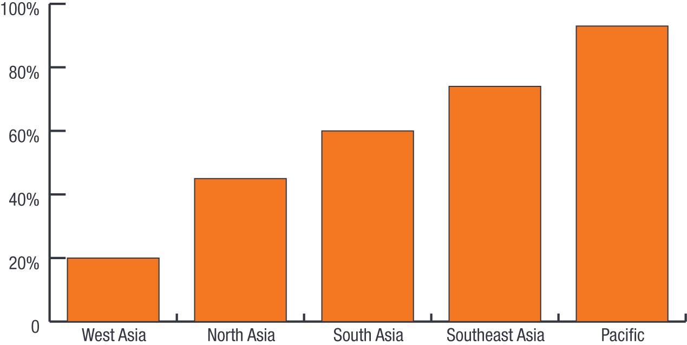
In line with best practice adult education approaches, APF training is contextualised to the operational requirements of the participating NHRIs through the use of work-based projects. Only one member indicated that their institution did not incorporate action plans developed in training into their planning. When asked to rate the relevance of the specific action plans, members indicated that the action plans developed during the South Asian media and communications training, held in the Maldives in April 2014 were very relevant (median rating of 4.5 out of 5). Members identified quite a number of projects that had benefited from this training approach, including:
- the conduct of a national inquiry on rape and honour killing by the Afghanistan Independent Human Rights Commission
- the development of a work plan for the betterment of migrant workers by the National Human Rights Commission of Bangladesh and improvements to complaints handling from migrant workers by the Jordan National Centre for Human Rights
- a project on access to education for children with learning disabilities by the Human Rights Commission of Malaysia and a National Inquiry on the same topic by the Human Rights Commission of the Maldives
- formulation of an action plan in the conduct of a national Inquiry on the rights to health and education of Indigenous peoples by the Philippines Commission on Human Rights, and
- the creation of an effective media strategy by the Provedor for Human Rights and Justice of Timor-Leste.
Further details of the APF’s training activities are set out below.

Blended learning
Since 2009, the APF has delivered its core training programs online as an integral part of its training strategy. The courses use a blended learning approach, which includes an introductory online program, usually run over five to six weeks, followed by a face-to-face workshop for participants who successfully complete the online component.
This approach allows participants to explore core human rights concepts in detail over an extended period of time, to raise questions directly with the trainers and to discuss issues with colleagues from other NHRIs. It also offers participants flexibility in how they learn and ensures there is greater opportunity for detailed and practical discussions during the face-to-face workshops.
The online training program presents key information in a variety of ways, including through set readings, discussion topics, quizzes and video webinars. Up to 30 participants take part in each course. They are expected to contribute to weekly online discussions and to submit regular assignments. To date, the APF has delivered the following training programs online:
- Prevention of torture
- Foundation course for NHRIs
- National inquiries
- Training-of-trainers, and
- Migrant workers.
The APF’s online training programs are directly coordinated by the APF through its own virtual learning environment (VLE). In early 2013 the APF launched a new Arabic interface for the VLE which will enable all of the APF’s existing training programs to be run in Arabic.
There were 5,473 visits to the APF’s VLE and 30,284 page views during 2013–2014. This compares with 4,693 visits and 27,590 page views in the previous year.

National inquiries training
NHRIs have used national inquiries to place a broad range of issues at the centre of public attention, including among others, human rights and mental illness (Australia); the right to food (India); the land rights of Indigenous peoples (Malaysia); freedom from torture (Mongolia); and accessible public transport for people with disabilities (New Zealand).
The APF, in partnership with the Raoul Wallenberg Institute for Humanitarian Law (RWI), undertakes training for APF member institutions on running effective national inquiries. The training provides NHRI representatives with a step-by-step understanding of the process of establishing and conducting a national inquiry.
The training covers a range of practical issues, such as:
- selecting the inquiry subject
- setting the terms of reference
- appointing the inquiry team
- collecting evidence
- engaging the media, and
- planning follow-up activities to promote inquiry findings and advocate for recommendations.
The APF has produced a training manual and accompanying DVD, Conducting a National Inquiry into Systemic Patterns of Human Rights Violation which draws on the experiences of NHRIs from across the Asia Pacific and the lessons learnt from holding public inquiries into a broad spectrum of issues.
These five-day courses are a joint initiative of the APF and the RWI. They explore the practical steps involved in establishing and running an effective national inquiry for each of the participating NHRIs. The program includes sessions on selecting the inquiry subject, appointing the inquiry team, the role of the media, holding public hearings, developing recommendations, writing the report, and planning follow-up activities to advocate for the inquiry’s recommendations. The workshops also feature a range of practical exercises and role-plays as well as discussion of good practice examples from across the Asia Pacific region.
During the reporting period, the APF conducted training with the following NHRIs:
- Philippines Commission on Human Rights, Manila, Philippines, 29 July – 2 August 2013
- Northern Ireland Human Rights Commission, Belfast, Northern Ireland, 6-12 January 2014
- Indonesian National Commission on Human Rights, Bogor, Indonesia, 10-14 February 2014, and
- National Human Rights Commission of Bangladesh, Dhaka, Bangladesh, 31 March – 4 April 2014.

NHRI foundation training
From 14 October – 3 November 2013, the APF and the RWI jointly ran an online course for the staff of NHRIs, with the aim of introducing NHRI staff to the history, concept, role and mandates of NHRIs, and to encourage sharing of good practices of NHRIs. The course was structured into four core modules:
- the origin, mandate and concept of NHRIs
- the advisory and educational mandate of NHRIs
- the investigative and monitoring mandate of NHRIs, and
- NHRI engagement with international and regional stakeholders.
Participants from NHRIs from across the Asia Pacific region participated in the online course. In addition to guided readings and video materials, the online course utilised a range of learning activities, including quizzes and assignments, and online discussions aimed at encouraging participants to share their experiences and learn from each other.
Participants who completed the online course then went on to participate in a face-to-face training workshop held from 25 November – 5 December 2013 in Bangkok, Thailand.
In line with the APF and RWI’s emphasis on blended learning, the online course included assignments that directly linked to sessions during the face-to-face workshop in Bangkok. The program for the workshop built on the syllabus of the online course. It also included additional thematic sessions exploring human rights issues of concern to many NHRIs in the region, including human rights and business, and the engagement of NHRIs with international human rights mechanisms. Several days were also devoted to presentations by the participants, regarding the achievements and challenges of their own NHRI, with the aim of facilitating peer-to-peer learning amongst NHRI staff. The facilitation of the workshop in Bangkok was led by the RWI with the participation of the APF for specific topics.

Prevention of torture
During the reporting period, the APF partnered with the Association for the Prevention of Torture (APT), to run a blended learning training course on the prevention of torture for the NHRIs of West Asia in Arabic.
Participants from the NHRIs of Jordan, Oman, Palestine, Qatar, Iraq and Bahrain participated in the training program. The APF-APT blended learning course – the first to be conducted totally in Arabic – included five weeks of online learning and discussions (27 January – 28 February 2014), followed by a week-long workshop in Amman, Jordan (24-28 March 2014) hosted by the Jordan National Centre for Human Rights.
The training focused on:
- international standards relating to torture and other cruel, inhuman or degrading treatment or punishment
- the concept of torture prevention
- cooperating with the international human rights system
- promoting public awareness and training law enforcement officials, and
- the practice of monitoring places of detention.
Building on the online learning and discussions, the face-to-face workshop concentrated on planning for and undertaking preventive monitoring of places of detention. Two staff members from the NHRIs of Palestine and Jordan who have been appointed as accredited trainers of the APF assisted in the implementation of the workshop. They were supported by staff and Arabic consultants from the APT and APF.
From 28 October – 1 November 2013 the APF joined forces with a number of its key partners to work on a series of programs for national stakeholders in Mongolia on implementing the Optional Protocol to the Convention against Torture (OPCAT).
After sustained advocacy on behalf of the Human Rights Commission of Mongolia, the Parliament of Mongolia signed OPCAT in September 2013 and it is expected to ratify the treaty within the coming year. States that ratify OPCAT are required to establish or designate an independent national body – known as a national preventive mechanism (NPM) – to conduct regular, unannounced inspections of all places of detention. In addition, States are obliged to allow an international body of experts – the UN Subcommittee for the Prevention of Torture – to conduct inspections of any places of detention in the country.
It is anticipated that once Mongolia ratifies OPCAT, the Human Rights Commission of Mongolia will be designated as Mongolia’s NPM. This will give the Commission responsibility for conducting monitoring visits to prisons, police stations, pre-trial detention centres and all other places in Mongolia where people may be detained.
The national training program – led by the APT and supported by the APF and the Open Society Foundation – was held for Commission staff to explore the theory and practice of undertaking effective monitoring visits. The program, led by Marco Mona, a member of the APT’s Advisory Council and a representative of Switzerland’s NPM, included a visit to a pre-trial detention centre in Ulaanbaatar where Commission staff inspected the facilities and conducted interviews with detainees.
In addition, two half-day events were organised by the Commission to build understanding about the requirements of OPCAT among a number of key Mongolian institutions and organisations. On 31 October 2013, a meeting was held with around 200 law enforcement personnel representing government agencies regarding the prevention of torture, including the General Intelligence Agency and the State Investigation Office. Discussions focused on existing areas of cooperation with the Commission, which form part of its torture prevention memorandum of understanding with five government agencies.
Later that day, a meeting was organised with representatives from a number of other closed institutions – including psychiatric institutions, juvenile justice facilities, aged care homes, orphanages and ‘sobering-up’ centres – to explain the role and activities of the future NPM, including visits to all places where persons are deprived of their liberty.

Media and communications
Representatives from the NHRIs of South Asia participated in a blended learning course to share experiences and develop skills in engaging the media on the pressing human rights issues in their countries.
The blended learning course was facilitated by APF media consultant James Iliffe; Professor Judy McGregor, former Equal Employment Opportunities Commissioner with the New Zealand Human Rights Commission; and APF cccredited trainer Aishath Fasoha from the Human Rights Commission of the Maldives.
The four-week online course, which ran from 17 February – 16 March 2014, explored the rapidly expanding role of social media in sharing information, connecting people and promoting community action on human rights issues.
As part of the blended learning course, 20 participants from Afghanistan, Bangladesh, India, the Maldives, Nepal and Sri Lanka contributed to online discussions on:
- working effectively with the media
- tools and strategies to engage journalists
- using social media – possibilities and pitfalls, and
- supporting journalists in their work and promoting freedom of expression.
Participants who successfully completed the online course then took part in a face-to-face workshop in Male’, the Maldives, from 7-10 April 2014, which was hosted by the Human Rights Commission of the Maldives.

Human rights investigations training
During the reporting period the APF launched a new blended learning course to provide human rights investigators with a comprehensive overview of the skills needed to conduct thorough and impartial investigations. The training draws heavily on the principles and methodology outlined in the APF’s publication Undertaking Effective Investigations: A Guide for National Human Rights Institutions.
The five-week online course ran from 24 March – 25 April 2014. It examined:
- fundamental investigative principles
- how to plan an investigation
- how to conduct interviews (run over two weeks), and
- collecting and using digital and documentary evidence.
Course participants drawn from all APF member institutions undertook set readings, completed weekly quizzes, contributed to online discussions and submitted assignments related to the key themes.
Participants from the NHRIs of Australia, Bangladesh, India, Korea, Nepal, Malaysia, the Maldives, Mongolia, Palestine, the Philippines, Sri Lanka, Thailand and Timor-Leste who successfully completed the online course then took part in a week-long, face-to-face workshop hosted by the Human Rights Commission of Malaysia (SUHAKAM) from 19-23 May 2014. The program included a range of practical exercises that focused on planning an investigation; interviewing techniques for different groups of witnesses; collecting and assessing digital and documentary evidence; and preparing reports of investigations. Participants also discussed the steps involved in undertaking investigations into multiple complaints on the same issue.
The blended learning course was led by Gareth Jones, a former Director of Major Investigations at the Canadian Military Ombudsman’s Office. He was assisted by APF accredited trainer, Abdul Rahman Abdullah, from SUHAKAM.

APF accredited trainers
Human rights education is critical to building a human rights culture within a country and an essential part of the work of NHRIs. Across the Asia Pacific, NHRIs develop programs that engage and empower children, young people, adults and communities to identify and address the human rights issues facing them. Many NHRIs also design and deliver training programs to support public officials – such as law enforcement agencies, the judiciary, parliamentarians, the military and others – to understand and meet their obligation to respect, protect and fulfil the human rights of those within their jurisdiction.
The APF has established a blended learning training course to support and equip human right trainers in APF member institutions to carry out this important work. It was developed following a comprehensive training needs assessment of APF members in 2010, which noted the need for a larger number of highly skilled human rights trainers in the Asia Pacific region.
The training-of-trainers course provides knowledge and skills on the planning, design, delivery and evaluation of human rights training programs. It combines a four-week online training component with a regional face-to-face workshop, encouraging participants to share strategies for conducting effective human rights training.
Participants who run, evaluate and report back on a human rights training session that they deliver within three months of returning to their respective NHRIs can apply to be APF accredited trainers. These trainers are provided with opportunities to assist in the delivery of future APF training programs.
During the reporting period the APF brought together APF accredited trainers from the NHRIs of India, Indonesia, Malaysia, the Maldives, New Zealand and Palestine to review the operation of the scheme, make recommendations for change, plan for future courses and renew their skills. This meeting was hosted by the National Human Rights Commission of India in New Delhi, India from 9-10 June 2014.

Advanced human rights education
The APF produced and launched a new training program on human rights education during the reporting period.
From 11-13 June 2014, the National Human Rights Commission of India hosted the APF’s advanced human rights education program in New Delhi, India. The training brought together experienced trainers and educators from the NHRIs of Afghanistan, India, Indonesia, Jordan, Korea, Malaysia, the Maldives, Mongolia, Nepal, New Zealand, Palestine, the Philippines, Sri Lanka and Thailand.
The program drew on the knowledge and skills of participants to identify effective approaches for planning, leading and evaluating human rights education activities with a broad range of groups, from public officials and law enforcement agencies through to schools and communities.
There was also a strong focus on building a deep understanding of the theory and principles that underpin adult education and human rights education.

Capacity assessments
Evaluation findings
Output indicator: Capacity assessment
Performance rating: On track
The capacity assessment (CA) program is an initiative that supports APF member institutions to identify the capacities they have, and those they need to develop, in order to fulfil their respective mandates to promote and protect rights at the national level. The CA program proposes strategies to strengthen NHRIs as a whole, to develop the capacities of staff members and to make the internal processes of NHRIs more efficient and more effective. The program is jointly facilitated by the APF, the United Nations Development Programme (UNDP) and the Office of the High Commissioner for Human Rights (OHCHR).
The overall goals of the CA initiative are to:
- assist NHRIs to generate an understanding of NHRI strengths and capacity gaps constraining an NHRIs’ ability to deliver on their mandates
- assist in developing strategies to address capacity gaps, and
- enable and support South-South cooperation and provide a platform for mutual support and peer-to-peer and learning among NHRIs.
The CA process is facilitated by a team of external experts consisting of representatives from the APF, UNDP, OHCHR and one representative from a NHRI that has already been through a CA process. At the end of the principal mission, a draft report with a series of capacity development recommendations to address the capacity gaps is submitted to the NHRI. This report is subsequently finalised and is expected to form the basis of the capacity development strategy. In addition to Commissioners and staff, the CA team also engages with other key institutional partners including donors, government departments or ministries and civil society organisations through the process. The entire process is outlined in detail in the APF-UNDP publication Capacity Assessment Manual for National Human Rights Institutions.
Over the last five years since the introduction of this program, CAs have been conducted with the following NHRIs:
- Human Rights Commission of Malaysia (2008)
- Human Rights Commission of the Maldives (2009)
- Jordan National Centre for Human Rights (2010)
- National Human Rights Commission of Thailand (2010)
- Palestinian Independent Commission for Human Rights (2011)
- Afghanistan Independent Human Rights Commission (2011)
- National Human Rights Commission of Mongolia (2011)
- Human Rights Commission of Sri Lanka (2012)
- Australian Human Rights Commission (2012)
- Philippines Commission on Human Rights (2012), and
- New Zealand Human Rights Commission (2012).
During the reporting period, the APF facilitated a CA with the following five NHRIs:
- National Human Rights Commission of Nepal (2-22 July 2013)
- National Human Rights Commission of Bangladesh (1-11 December 2013)
- National Human Rights Commission of Oman (preliminary visit from 13-15 January 2014 and assessment from 2-13 March 2014)
- Ombudsman of Samoa (13-21 February 2014), and
- Indonesian National Commission on Human Rights (12-23 May 2014).
In addition, at the request of the National Human Rights Commission of Bangladesh and the UNDP country office, the APF returned to Bangladesh twice during the reporting period to assist the Commission and UNDP to plan for the implementation of the CA recommendations. These missions took place from 28-30 May 2014 and 23-26 June 2014.
Impacts and outcomes directly linked to the CAs are set out below.
At 30 June 2014 all of the 16 NHRIs that have participated in the CA process to date reported either complete or partial implementation of the action plans. Figure 2 shows the collective progress in implementing the action plans. The figure shows an apparent decline in implementing recommendations regarding situational assessment, defining visions and mandates, formulating policies and strategies, monitoring, evaluation and reporting, the management of human rights cases, and those regarding the conduct of human rights analysis. This decline can be attributed to the large number of CAs recently undertaken (six have been completed in the last 18 months). These members have not yet had time to completely implement, or in some cases to start, their responses. For instance, since 2013 the National Human Rights Commission of Nepal and the National Human Rights Commission of Bangladesh have both completed implementation of recommendations in four areas, but have only had the opportunity to partially progress implementation in the remaining three.

Figure 2: Implementation of capacity needs assessment recommendations (percentage of participating NHRIs reporting fully, partially or not implementing recommendations, by year)
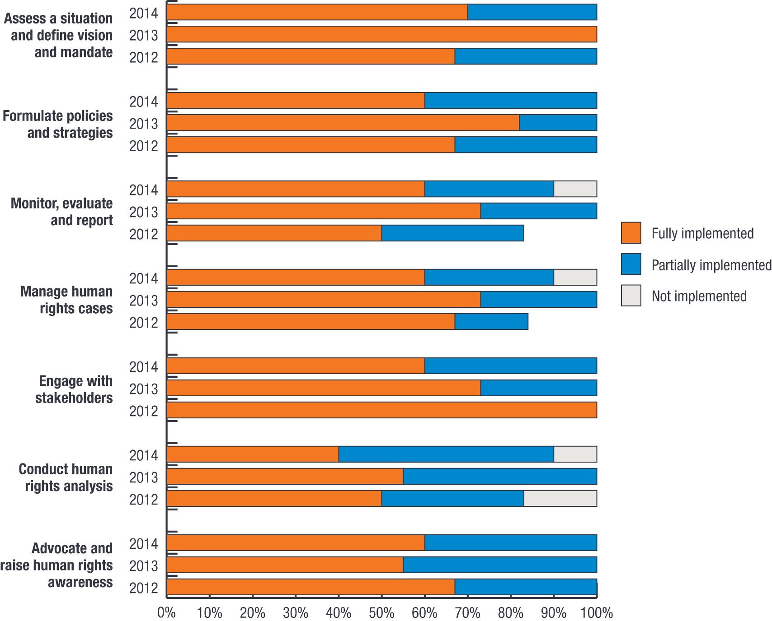
The Palestinian Independent Commission for Human Rights, which last year had progressed implementation, now acknowledges complete implementation of the recommendations. The New Zealand Human Rights Commissions noted that they accepted the CA report and its analysis and recommendations have been drawn on to shape the outcomes of the Commission’s organisation review. This review was completed last year and the outcomes are now being implemented.
Figure 3 shows the extent to which the CAs have improved capacity by NHRI, as measured by the median of each participating NHRIs’ views on the degree to which the CAs have been effective. Most members participating in the CA program to date agree that the recommendations arising from the CA have improved their capacity in all areas (the median response across the participating NHRIs and across different themes was 4 out of 5). Only one member response indicated that they disagreed that any of the recommendations had improved their capacity. The consistently high rating given to the effectiveness of the CA process by participating members over the last three years indicates that this program is having a measurable and substantial impact. The program is improving the capacity of members to deliver improved human rights outcomes in the region.
In 2012 the project partners commissioned a review of the CA process, so as to highlight its strengths and weakness, propose changes to the methodology, and outline measures for future institutionalisation and consolidation. The APF has adopted all the recommendations of the review. In addition the APF is working to ensure that the CA program informs the APF measurement, evaluation and reporting framework by formalising APF member commitment to evaluating program outcomes, as modelled in the 2014 memorandum of understanding with the Indonesian National Commission on Human Rights in relation to its CA.

Figure 3: Perceived impact of implementing capacity needs assessment recommendations from 2012 to 2014 (median ratings across participating NHRIs and different themes)
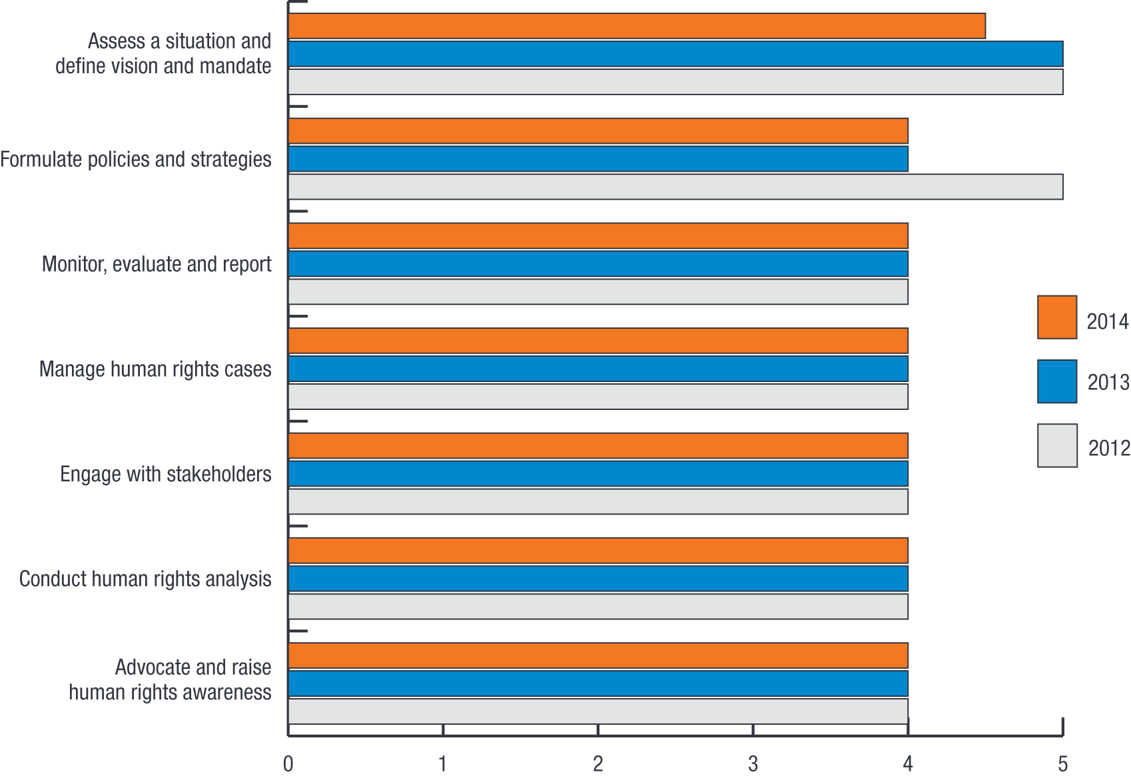

Specialist capacity projects
Within available resources, the APF responds to requests from individual member institutions for the delivery of specialist capacity projects. In a recent survey 63% of responding members indicated that high-level dialogues for NHRI leadership on governance of NHRIs was a highly important service provided by the APF.
As part of its 2015–2020 strategic planning process the APF is considering the development of evaluation processes for specialist capacity building projects and how better to integrate these activities into the monitoring and evaluation framework.
During the reporting period the following activities were undertaken.

Myanmar

From 2-6 September 2013, the APF travelled to Yangon, Myanmar to work with the Myanmar National Human Rights Commission in developing its first strategic plan for the period 2014 to 2016. The strategic plan was subsequently adopted by the Commission.

Economic and social rights
The APF, in partnership with the Center for Economic and Social Rights (CESR), continued its work with a third and final pilot project in expectation of developing a regional training program on measuring economic and social rights. Following a competitive selection process, the Palestinian Independent Commission for Human Rights was selected as the third pilot institution.
From 12-14 May 2014, the APF and CESR ran a workshop for 30 staff of the Commission’s headquarters and West Bank and Gaza field offices to develop its project on applying the ESCR tool to monitor the Palestinian Authority’s development plan and measure the protection of economic and social rights in Palestine, especially for marginalized groups.
The participants developed an understanding of the tools and techniques that underpin the ESCR framework, including the identification of relevant indicators and benchmarks, gathering primary and secondary data and analysing budgets.

High-level dialogues
The APF offers its members a high-level dialogue program, where the APF engages a senior Commissioner or Secretary General from one of its member institutions to facilitate a dialogue with another Commission on a range of administrative and operational issues, such as:
- the role of NHRIs
- the importance of engaging with both the State – including the government, parliament, judiciary, police and military – and with the community to promote and protect fundamental rights
- the importance of drafting and finalising founding legislation in conformity with the Paris Principles
- developing effective complaint handling procedures
- establishing human rights education programs and partnerships, and
- building relationships with NHRIs in the region and internationally.
The program is often implemented for recently established NHRIs or with NHRIs that have recently had a change in leadership.
During the reporting period, the APF ran high-level dialogues for the following NHRIs:
- Ombudsman of Samoa, Apia, Samoa, 14-19 July 2013
- Indonesian National Commission on Human Rights, Bogor, Indonesia, 15-16 August 2013
- Human Rights Commission of Malaysia, 18-20 August 2013, and
- Palestinian Independent Commission for Human Rights, Ramallah, Palestine, 24-26 April 2014.

European Network of NHRIs
From 11-15 November 2013, at the request of the recently established European Network of NHRIs, the APF participated in the regional meeting of the network to assist in the development of its strategic plan. The NHRIs from Europe particularly wanted to find out about the role and functions of the APF and the lessons learned from its establishment and functioning.

Enhance members’ communication, cooperation and engagement
A strength of the APF is the quality and depth of collaboration that exists between its members. The APF’s annual meetings, professional networks and staff placement programs each provide opportunities to deepen those links, share experiences and develop cooperative programs of work.

Cooperation and engagement
Evaluation findings
Outcome indicator: Engagement
Performance ratings: On track
The APF benefits from the expertise, knowledge and support that its member institutions contribute through participating on the Forum Council (which is the APF’s board of directors) and at APF annual meetings. In turn, member institutions benefit from the cooperative relationships established through the APF’s programs and services. Overall, members remain highly engaged with APF processes and find the APF’s services relevant.

Paris Principles Conference
An international workshop to celebrate the 20th anniversary of the adoption of the Paris Principles was hosted by the National Human Rights Commission of the Republic of Korea, in Seoul, Korea on 13 September 2013.
With more than a hundred NHRIs now operating in countries across the globe, the workshop examined the extent to which the Paris Principles are able to fulfil their goal of promoting and protecting human rights. Adopted by the UN General Assembly in 1993, the Paris Principles set out the minimum standards required by NHRIs to be considered credible and to operate effectively.
Workshop participants also shared examples of good practice regarding the establishment and operation of NHRIs; considered how to build closer partnerships between NHRIs and other stakeholders; and looked at strategies to increase their engagement with the international human rights system.

18th Annual Meeting and Biennial Conference
The National Human Rights Committee of Qatar hosted the APF’s 18th Annual Meeting and Biennial Conference in Doha, Qatar, from 1-3 October 2013.
The Annual Meeting was attended by representatives from all the APF’s member institutions. The APF Forum Council unanimously approved the applications of the NHRIs of Oman and Samoa for associate membership. This increased the number of APF member institutions up to 21, including 15 full members and six associate members.
The National Human Rights Commission of Oman was established by Royal Decree in 2008 for the “protection of human rights and freedom in the Sultanate according to basic statute of the state and the international covenants and agreements”. The Decree specifies that the Commission shall be independent.
On 30 May 2013, the Parliament of Samoa passed legislation to establish an independent NHRI for the Pacific Island country. The legislation broadens the role of the Office of the Ombudsman (Komesina o Sulufaiga) to include a range of human rights functions.
The 18th APF Annual Meeting also included:
- a report from the International Coordinating Committee of National Institutions (ICC) Chairperson, Laurence Mushwana, on the activities of the ICC since May 2013, including its strategic planning
- a report from the Chairperson of the Human Rights Commission of Malaysia on the fourth session of the United Nations Open-ended Working Group on Ageing, and
- a dialogue with representatives from the Asian NGOs Network on NHRIs (ANNI) on supporting human rights defenders in the region.
Forum Councillors appointed the National Human Rights Committee of Qatar as APF Chairperson, with the NHRIs of Thailand and Mongolia appointed as Deputy Chairpersons. The Forum Council also decided that the National Human Rights Commission of India will host the APF Annual Meeting in 2014 and that the National Human Rights Commission of Mongolia will host the APF Annual Meeting and Biennial Conference in 2015.
With a number of countries in the Asia Pacific undergoing fundamental political transformations, the Biennial Conference considered the opportunities and challenges involved in charting a peaceful course to democracy. Around 150 representatives from NHRIs, governments, civil society organisations and UN agencies from across the Asia Pacific discussed strategies for working together in order to support a genuine and inclusive transition to democracy. Speakers considered developments in a number of West Asian countries, while the Chair of the Myanmar National Human Rights Commission outlined progress that had been made in Myanmar. Participants also examined a range of related topics during the two-day conference, including:
- the role of women in political and democratic reform
- the role of NHRIs in working with police and security forces, and
- the role of NHRIs in democracy and good governance.

Asian NGOs Network on NHRIs
At the APF’s 18th Annual Meeting and Biennial Conference held in Doha, Qatar, ANNI held its co-located conference from 29-30 September 2013.
The APF promotes cooperation between NHRIs and NGOs and at each Annual Meeting and Biennial Conference, the APF facilities interaction and cooperation with ANNI NGOs. ANNI held an NGO meeting in parallel with the APF’s Annual Meeting and representatives from ANNI were invited to meet with all APF member institutions during the APF’s Forum Councillor meeting on 1 October 2013. The APF’s Forum Councillors expressed their appreciation for the constructive contribution of ANNI.
The APF also participated in the 7th Regional Consultation of ANNI which was held from 22-23 April 2014 in Taipei, Taiwan. Participants included the national NGO members of Forum-Asia and ANNI from Bangladesh, Burma-Myanmar, Hong Kong, India, Japan, Maldives, Mongolia, Pakistan, Philippines, South Korea, Sri Lanka, Taiwan, Thailand and Timor-Leste. Issues discussed included:
- review of national human rights developments
- progress on establishment of NHRIs (Burma-Myanmar, Japan, Pakistan and Taiwan)
- relationship with APF
- engagement with NHRIs, and
- engagement with parliaments and governments.

Staff placements
The APF facilitates staff placements and exchanges between APF member institutions to ensure ‘south-south’ cooperation and the exchange of information.
From 15-21 December 2013, two representatives of the Human Rights Commission of Malaysia visited the National Human Rights Commission of India. The placement focused specifically on the Indian Commission’s compliant handling procedures and computerised complaints management system.
From 5-8 May 2014, two representatives of the Danish Institute for Human Rights visited the APF secretariat to examine its blended learning approach, in particular the APF’s virtual learning environment. The Danish representatives also discussed mutual cooperation between the two organisations.

Senior Executive Officers Network
From 23-24 June 2014, the senior executive officers (SEO) from each APF member institution met in Sydney, Australia for a roundtable discussion of issues related to the administration of effective NHRIs. The two-day meeting, hosted by the Australian Human Rights Commission, allowed members of the APF’s SEO Network to share their experiences on key management issues, such as, building relationships with key stakeholders, refugees and asylum seekers, NHRIs operating in times of civil unrest, and business and human rights.

Rights of Older Persons Workshop
From 13-15 May 2014, the APF brought together representatives from all 21 APF member NHRIs to identify and discuss the key elements that should be included in a possible international convention on the rights of older people. The meeting was held in Sydney, Australia and hosted by the Australian Human Rights Commission.
The workshop provided an opportunity for NHRIs to share their views, find common ground and develop a clear regional direction on the content and focus of a potential new UN convention which is currently under consideration by the UN Open-ended Working Group on Ageing (OEWG). The OEWG was established by the United Nations General Assembly in December 2010 to examine the gaps in the current international human rights protection system and identify how best to address them. It has met four times, most recently in August 2013.
The work of the OEWG was further bolstered in December 2012 when the General Assembly requested it to consider proposals for an international legal instrument to promote and protect the rights and dignity of older persons.
The workshop participants agreed to form an APF working group and appoint an APF spokesperson to progress the outcomes of the workshop and to present the region’s position to the OEWG and in other relevant meetings.
Impacts and outcomes directly linked to the APF’s cooperation and engagement activities are set out below.
Although engagement is difficult to quantify, members’ active participation in annual meetings provides some indication. At the 18th Annual Meeting in 2013, all members contributed oral interventions or written submissions. The high level of member’s participation in the annual meeting reflects the success of the meeting processes. A survey of members’ views on the quality of events organised by, or in partnership with, the APF indicated ongoing very high satisfaction (an average across the median rating for all events of 4.5 out of 5, slightly up from the previous year). The highest-rated events, in terms of networking (all rating a median response of 5 out of 5), were:
- APF Biennial Conference, held in Doha, Qatar in October 2013
- Regional Workshop on the Rights of Older Persons, held in Sydney, Australia in May 2014, and
- SEO Network meeting and the APF Forum Councillor Working Group on Strategic Plan, held in June 2014 in Sydney, Australia.
This year the APF surveyed its members and stakeholders to establish their views on the format and continued relevance of the SEO Network and APF biennial conference and annual meetings. Over 90% of APF members said that the SEO Network, APF annual meetings and biennial conferences were highly important services. Members and stakeholders agree that the conferences provide an effective platform to:
- develop relationships with other APF members and the secretariat
- understand regional human rights issues
- focus and discuss human rights themes, and
- engage with human rights NGOs, human rights experts, governments and UN agencies.
Further, APF members and stakeholders agreed that the APF Annual General Meeting is an effective platform to:
- decide upon APF strategy, policy and operations
- monitor, review and approve APF operations and finances, and
- develop relationships with other APF members.
Figure 4 shows APF members’ views on the relevance of training and communications services; the value of APF participation in UN processes to members; and the utility of APF advice, provides further indication of their engagement. In 2013–14 a composite index of members’ views in these areas showed a rating of 4.5 out of 5 – a return to the levels in 2012.
The separate data contributing to the high rating shown on the member engagement index is discussed in more detail in the relevant section of this report – training, communications, advice and advocacy.
As part of its 2015–2020 strategic planning process the APF is reviewing international best practice to identify innovative ways of enhancing and refreshing engagement.

Figure 4: Members’ perception of the APF’s services – 2010 to 2014
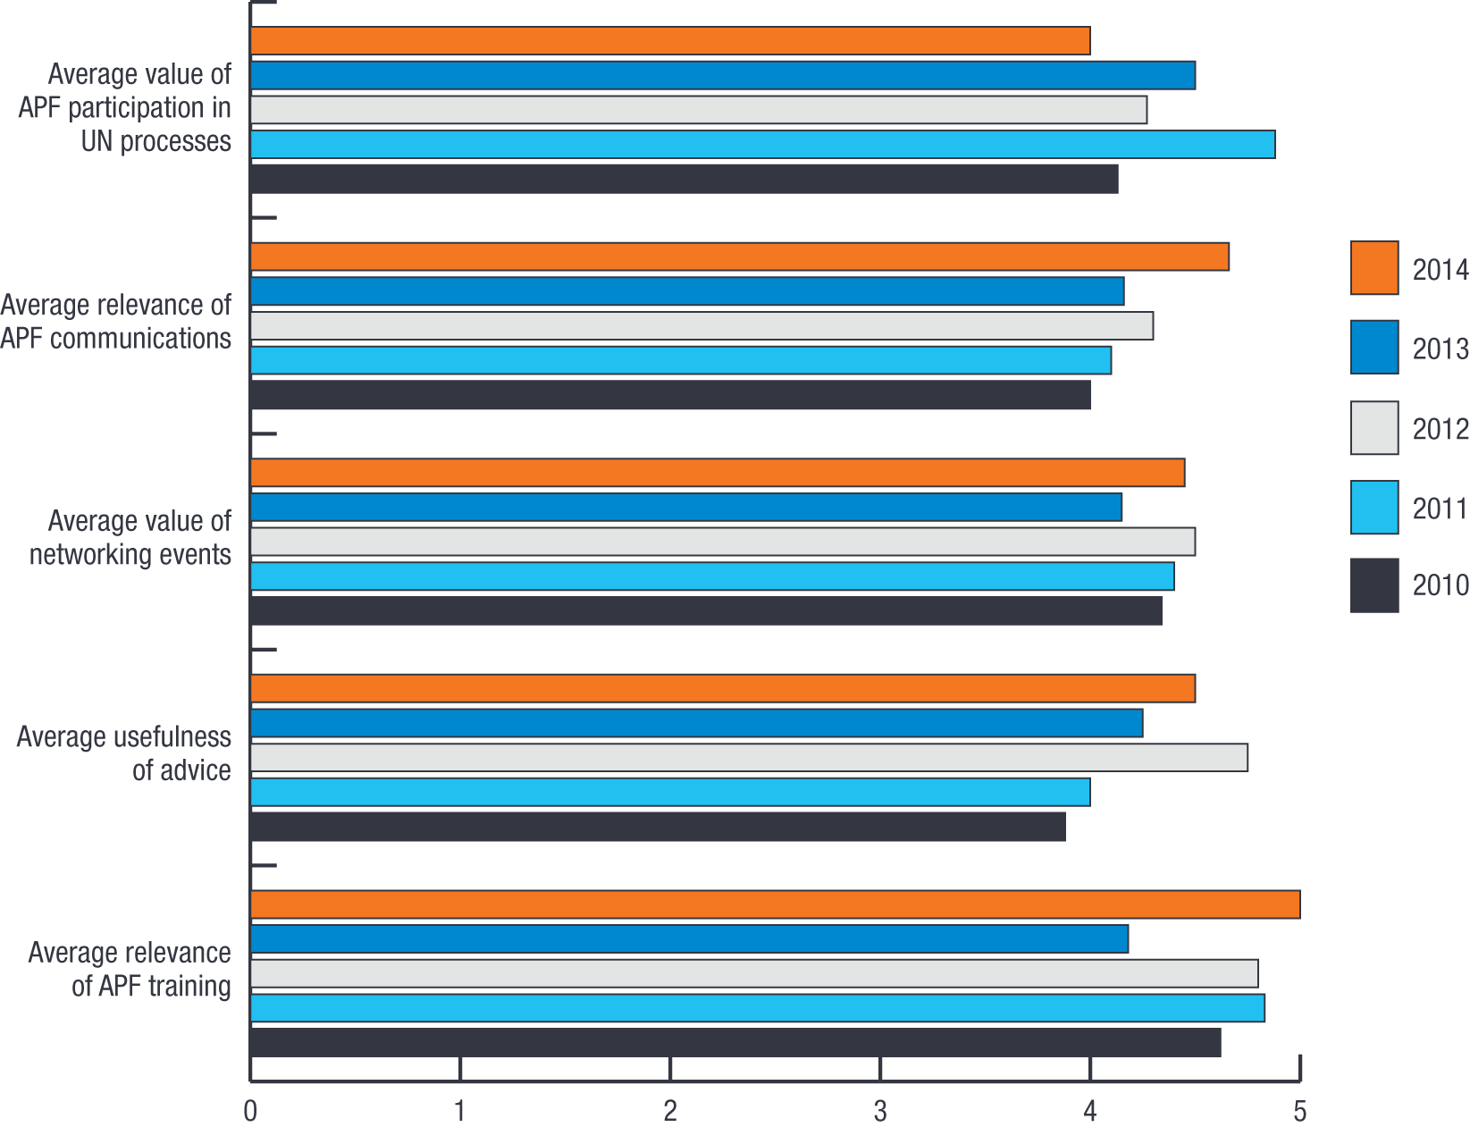

Communications
Evaluation findings
Output indicator: Communication
Performance rating: On track
During the reporting period, the APF undertook a range of information and promotional activities on the role and functions of NHRIs and the activities of the APF. These educational activities are designed to:
- improve awareness among political and administrative decision-makers and the wider community of the value and importance of NHRIs
- improve awareness among relevant regional governments and agencies of the appropriate functions, powers, structures and legislation for NHRIs established in accordance with the Paris Principles
- improve awareness among NHRIs of the legislation, casework, techniques, procedures and outcomes of other institutions both within and outside the region, and
- provide information about APF activities to member institutions, governments, UN agencies, NGOs and the general community.
The APF employs a number of communication channels to inform members on the role and function of NHRIs and to promote the activities of the APF.

APF website
The APF website was initially developed in 2007 and, while some updates to its ‘look and feel’ have been incorporated over the past two years, it has remained more or less the same with usage during 2013–14 at 45,399 visits and 119,175 page views, as shown in Figure 5.
Importantly, the satisfaction of members with the website remains very high, with all the members agreeing that the information on the site is accessible (a median rating of 5 out of 5). Members also totally agreed that the information was accurate and relevant (median ratings of 5 out of 5). These statistics indicate that the APF website continues to be well utilised by members and stakeholders.

Figure 5: Number of visits to, and pages viewed on, the APF website: 2008–09 to 2013–14
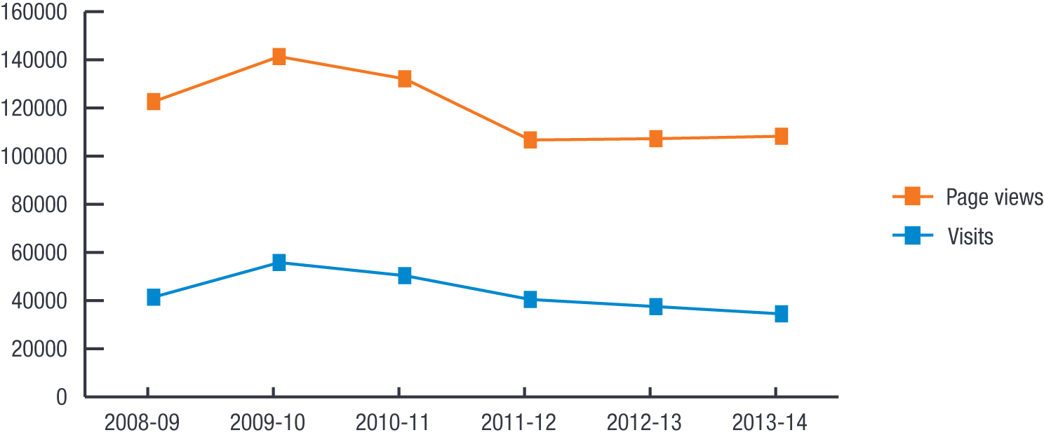
The APF has been aware that the usage of the website has plateaued in recent years and has been reviewing and redeveloping the APF website over the last year with the intention of implementing changes under the 2015–2020 Strategic Plan. Members and stakeholders have been asked to prioritise APF communications activities and have indicated that the continued development of the website is a high priority.
This year, visits from Australia, the United States, India and Malaysia accounted for just over half the traffic to the website, as show in Figure 6. Of the top ten countries of origin visiting the APF website, seven were from APF member countries. Of the top 25 countries of origin visiting the APF website, 13 were from APF member countries, the majority of others are countries of key APF stakeholders and donors. It is worth noting that the APF member countries not listed in the top 25 visitors to the APF website are predominantly West Asian, emphasising the importance of providing content in Arabic.

Figure 6: Visits to the APF website by country during 2013–14

APF YouTube channel
The APF has also developed its own YouTube channel featuring audio-visual training materials and interviews with representatives of APF member institutions and key stakeholders. During 2013–14, the site recorded 3,145 views, for a viewing time of approximately 90.5 hours. This is up from 2,179 views a year ago. The top ten videos viewed during the year were:
- Preventing torture: The role of national human rights institutions
- Twenty years of the Paris Principles
- Promoting the rights of lesbian, gay, bisexual, transgendered and intersex people in Mongolia
- Making economic and social rights a reality
- Advancing economic, social and cultural rights, and
- Mining and human rights in Mongolia.
The APF YouTube channel had 38 subscribers as at 30 June 2014, up from 20 subscribers a year ago.

APF e-Bulletin
The APF published monthly issues of its newsletter, the APF Bulletin, to keep APF members, governments, NGOs and stakeholders informed of important policy, legal, administrative and training developments in the region.
There are around 1,200 active subscribers to this service. The unique open rate has increased over the last year to 38%, which benchmarks well against the industry standard for non-profit organisations with more than 1,000 subscribers of 25%. The average ‘clicks’ to articles has also increased and was in the range of 41% to 57% in 2013–14, substantially more that the industry average of 3.25%. All this indicates that the APF Bulletin, distributed 11 times during 2013–14, has been well utilised by subscribers and is an effective tool in drawing visitors to the site. Members’ high rating of the relevance of the bulletin returned to the long-term average median rating of 4 out of 5.

Email broadcasts
Throughout the year regular email broadcasts were sent to Forum Councillors and their nominated staff contacts. These email broadcasts covered a range of APF specific thematic and operational issues. In addition, the APF acts as the relevant communication channel for correspondence from the UN and the ICC. In 2013–14, members rated the relevance of email broadcasts very highly, a median rating of 5 out of 5.

Promote compliance with the Paris Principles
The Paris Principles set out the minimum standards required of NHRIs if they are to be considered credible and to operate effectively. The guidelines were developed at a UN meeting held in Paris, France in 1991, which brought together representatives of NHRIs from all parts of the globe to define the core attributes that all new or existing institutions should possess. The UN General Assembly subsequently adopted the Paris Principles in 1993. The principles identify six criteria that NHRIs should meet in order to be effective, including:
- a clearly defined and broad-based mandate based on universal human rights standards
- autonomy from government
- independence guaranteed by legislation or the constitution
- pluralism, including membership that broadly reflects their society
- adequate resources, and
- adequate powers of investigation.
A fundamental role of the APF is to support its members, new NHRIs and governments looking to establish NHRIs, to comply with the Paris Principles. During the reporting period, the APF assisted in the reaccreditation of existing members and assisted the establishment of new complying NHRIs.

Accreditation
Evaluation findings
Outcome indicator: Accreditation
Performance rating: On track
The Paris Principles provide the core framework for assessing the independence and effectiveness of NHRIs. They are used by the ICC to determine the accreditation status of NHRIs. Accreditation assesses the extent to which an NHRI meets the minimum standards set out in the Paris Principles. It is a peer-based evaluation process.
NHRIs which are considered to fully comply with the Paris Principles are accredited as “A status” institutions, while those that partially comply are accredited as “B status” institutions. “A status” NHRIs are permitted to participate in the work and discussion of the UN Human Rights Council and its subsidiary bodies.
The APF adopts the accreditation decisions of the ICC to determine APF membership status.
- Full members of the APF are NHRIs in the Asia Pacific region that have been accredited with “A status” by the ICC. Each full member is represented on the Forum Council – the APF’s decision-making body – by a voting councillor. Full members also nominate a jurist to sit on the APF’s Advisory Council of Jurists (ACJ).
- Associate members of the APF are NHRIs in the Asia Pacific region that have been accredited with “B status” by the ICC. Associate members are entitled to participate in APF programs and activities, however, they are not entitled to vote on Forum Council decisions or nominate a jurist to the ACJ.
Since its inception in 1996, APF membership has steadily risen, as shown in Figure 7. Fifteen out of the APF’s 21 member institutions currently have “A status” and six have “B status”. The APF’s membership increased by two institutions during 2013–14, as the National Human Rights Commission of Oman and the Ombudsman of Samoa, were granted associate member status.

Figure 7: APF membership from 1996 to 2014 (“A” and “B status”)
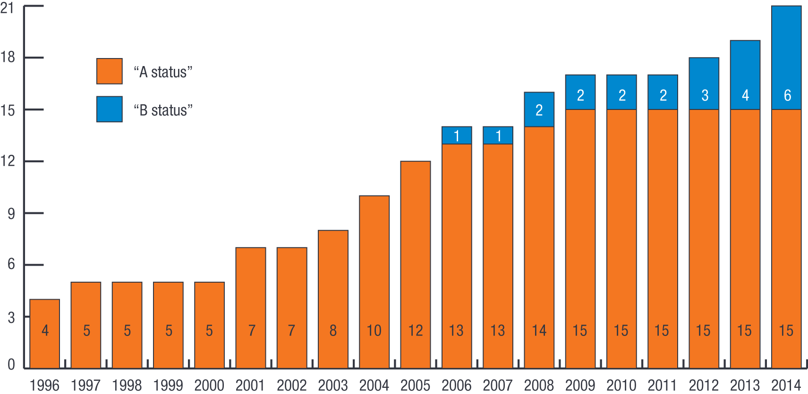
Accreditation by the ICC is an ongoing process, which may entail either the upgrading or downgrading of the status of individual NHRIs. The accreditation process aims to be comprehensive, rigorous and transparent. It is conducted by the Sub-Committee on Accreditation of the ICC (SCA), which is comprised of one representative from each of the four ICC regions of Africa, the Americas, the Asia Pacific and Europe, who are supported by their regional NHRIs secretariats.
The accreditation process considers the following:
- information provided by the NHRI including, a statement of compliance with the Paris Principles; its founding/empowering legislation or instrument; an outline of its organisational structure, including staffing and budget; its most recent annual report and any other relevant documents
- a summary of issues relevant to the application, which is prepared by the National Institutions and Regional Mechanisms Section of the OHCHR and provided to the NHRI for its review and response, and
- reports from other organisations, such as national or regional civil society organisations, that are able to provide information on the work of the NHRI.
Accreditation reviews of “A status” institutions occur every five years. The SCA meets twice a year, normally in March and November. An additional task of the SCA is to develop General Observations, which provide guidance to NHRIs on the interpretation and application of the Paris Principles.
The APF provides support to its regional representative on the SCA. The APF secretariat attends accreditation meetings in an ex-officio capacity and is a member of the SCA’s drafting group, which is responsible for revising the existing general observations and preparing drafts of new general observations. It provides advisory and drafting support to the SCA, however, it does not have a recommendatory role.
During 2013–14, there were two SCA meetings held from 18-22 November 2013 and 17-21 March 2014.
An important aim of the 2015–2020 strategic planning process is to continue to ensure the APF’s capacity to respond to requests for assistance, both in preparation for an accreditation review, and in response to accreditation outcomes. This includes both the provision of advice and, in the case of legislative review, face-to-face discussions where this is necessary.

Provision of advice to members and others
Evaluation findings
Output indicator: Advice
Performance rating: On track
A central focus of the APF is to support the establishment and/or strengthening of independent NHRIs in the region. To help achieve this goal, the APF provides advice to NHRIs, governments and civil society groups on the unique status of NHRIs; their roles and functions; their relationship with government, parliament and civil society; and the international accreditation process. This can also include technical advice on compliance with international standards set out in the Paris Principles; operational issues such as organisational structure, operational procedures and financial resources; and the development of best practice models.
In 2013–14 the APF provided advice to existing members, potential members, governments, international and regional organisations and other stakeholders, including legal and policy advice on topics such as, NHRI models; NHRI legislation; constitutional interpretation and amendment; international standards; accreditation; and institutional cooperation.
The APF secretariat was able to respond fully to 24 of the 25 requests for advice received, providing draft responses in the remaining one case. Advice was provided in a broad range of areas including:
- the impact of international standards on amended legislation or proposed amendments to NHRI law
- the accreditation of NHRIs
- the application of the constitution and rule of law in situations of conflict
- statutory interpretation and statutory amendment, and
- policy development including improvements to accreditation processes.
Members continued to value the APF’s advice highly this year, with the median member rating across a number of areas of advice rising from 4.25 out of 5 in 2013 to 4.5 out of 5 in 2014, the highest rating to date. This was largely attributable to the very high value placed on legal and policy advice, including legislative drafting, provided by the APF during 2013–14 by those members who requested this advice. More generally, another survey of members showed that advice on the ICC accreditation process was regarded as important and a high priority for the APF by 88% of members.
Figure 8 shows the rating out of five on the usefulness of advice requested by members. The value of the advice to some members grew, especially the NHRIs of Thailand, Palestine, Mongolia, Bangladesh and Afghanistan. For other members, the value of advice remained high, but steady. A number of members indicated that they did not request advice during the year.

Figure 8: Member rating of the utility of APF advice – 2010 to 2014 (out of 5)
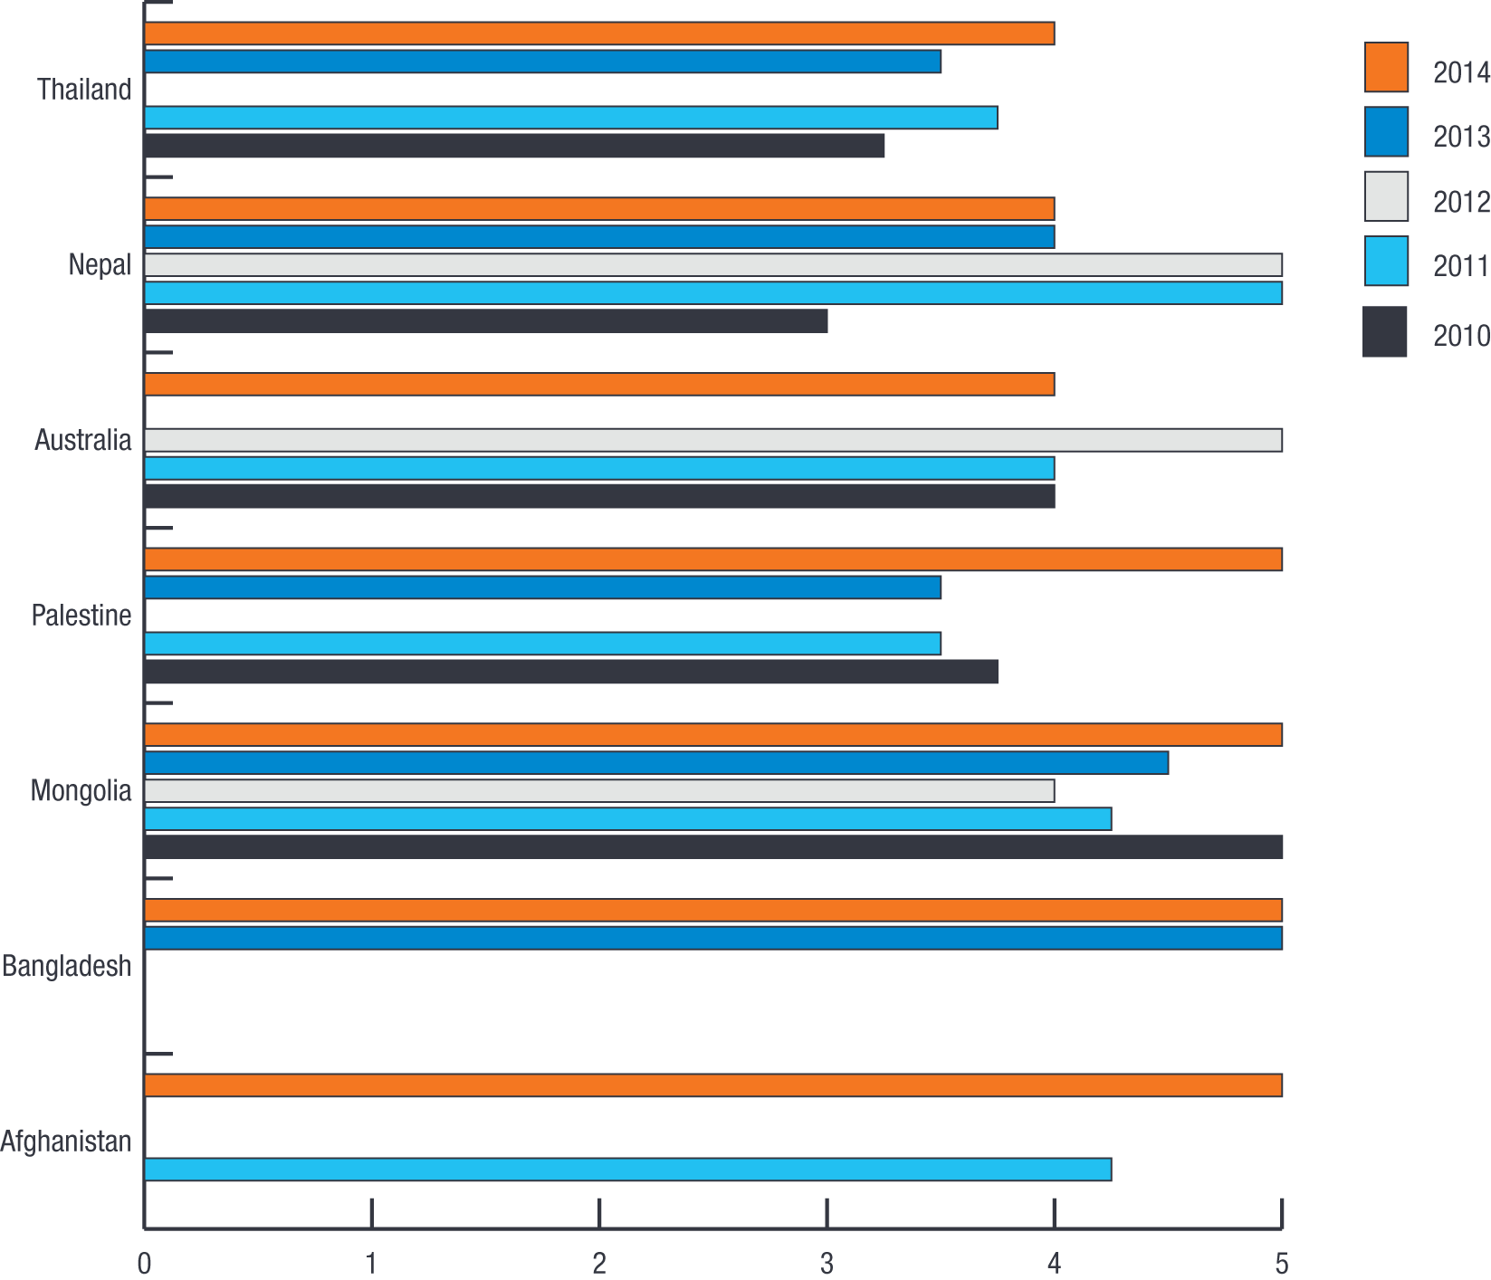
An important aim of the 2015–2020 strategic planning process is to continue to ensure the capacity to respond to requests for advice, including the capacity for face-to-face discussions where this is necessary and to continue to seek feedback on advice where possible, in particular on whether the advice is relevant, accurate and practical.

Establishment of NHRIs
Evaluation findings
Output indicator: Establishment
Performance rating: On track
The APF provides advice to countries within the region that are considering the development of a NHRI. The APF enters into a dialogue with government and civil society representatives, assists in drafting legislation and otherwise provides advice on establishing NHRIs in compliance with the Paris Principles. In a number of cases, the APF provides advisory services in collaboration with other partners in the region, including OHCHR and the Pacific Islands Forum secretariat.
During the reporting period, the APF responded positively to requests for missions and ongoing advice from Myanmar and Taiwan.

Myanmar
Since 2012, the APF has worked with the Myanmar National Human Rights Commission on the development of legislation to formalise the NHRI through an Act of Parliament.
The Parliament of Myanmar, the Pyidaungsu Hluttaw, passed the founding legislation for the Commission (Law No.21/2014 of 28 March 2014) and it was published in the State newspapers in Myanmar language on 5 April 2014.

Taiwan
On 21 and 23-25 April 2014, the APF participated in a national workshop on the establishment of a NHRI in Taiwan.
The workshop included human rights NGOs, representatives from the Control Yuan (Ombudsman's Office), members of the President's Human Rights Advisory Council, and the Ministry of Justice.
The APF conducted a session on the Paris Principles, highlighting specific principles and General Observations, and potential difficulties these might involve when applied to Taiwan.
The APF met with the Vice-President of Taiwan to discuss the establishment of a NHRI and constitutional challenges. The APF also met with various members of Parliament and the leader of the human rights caucus in the Congress, Mei-Nu Yu.

Engage with international and regional human rights mechanisms
The APF advocates for its members participation in international and regional mechanisms. The APF does this by promoting joint APF member policy positions and ensuring that NHRIs are effectively recognised in these mechanisms.
During 2013–14, the APF provided a strong and consistent voice for the region, influencing international mechanisms on behalf of its member institutions.

International mechanisms
Evaluation findings
Outcome indicator: Influencing
Performance rating: On track
The APF, with its member institutions and other partner organisations, seeks to support and engage with the various human rights protection systems internationally and across the region.

International Coordinating Committee of NHRIs
From 8-12 July 2013 and 9-16 June 2014, the APF participated in the annual ICC-UNDP-OHCHR tripartite review meetings. The focus of the meetings were: progressing the worldwide roll-out of the capacity assessment methodologies of the Asia Pacific and African regions; the potential development of a multi-partner trust fund; and business and human rights.
From 25-26 November 2013, NHRIs representing all four regions of the world met in Accra, Ghana for the ICC Bureau to map out a three-year strategy to guide the direction and activities of the ICC. The meeting was hosted by Ghana’s Commission on Human Rights and Administrative Justice.
The ICC’s strategic plan sets out a range of initiatives to build cooperation and promote information sharing between NHRIs and to support them to engage effectively with the international human rights system. The 16-member ICC Bureau comprises representatives of four NHRIs from each of the four global regions: Africa, Americas, Asia Pacific and Europe. The Asia Pacific region was represented by the NHRIs of Qatar, Thailand, Malaysia and Korea. The APF secretariat also attended the meeting.
Along with the other regions, the Asia Pacific NHRIs presented an overview of developments that have taken place over the past year, including outcomes from the 18th APF Annual Meeting and Biennial Conference, growing APF membership, APF initiatives to establish and strengthen new NHRIs, and NHRI efforts at the national level to advance the rights of women and girls.
From 12-14 March 2014, the APF and its members attended the 27th ICC General Meeting. The meeting examined four key themes:
- the participation of NHRIs in the second cycle of the Universal Periodic Review (UPR), including sharing examples of good practice
- the accreditation process for NHRIs and the international standards and ICC General Observations for the establishment and functioning of independent NHRIs
- the 2012 Belgrade Principles on cooperation between NHRIs and parliaments, and
- the development of national action plans on human rights.

United Nations
Figure 9 shows member participation in United Nations (UN) processes. The level of overall positive engagement with UN processes across the APF membership remains consistently high, with up to 71% of members participating during 2013–14.
The cyclical nature of the UN’s UPR and treaty body reviews account for the difference between years. Despite annual variations, however, there appears to be an increasing trend for member NHRIs to follow up recommendations with their States, to monitor proceedings and outcomes, to submit parallel reports, and to participate in proceedings independently as encouraged through capacity building by the APF.

Figure 9: Percentage of members participating in UN processes – UPR and treaty body reviews
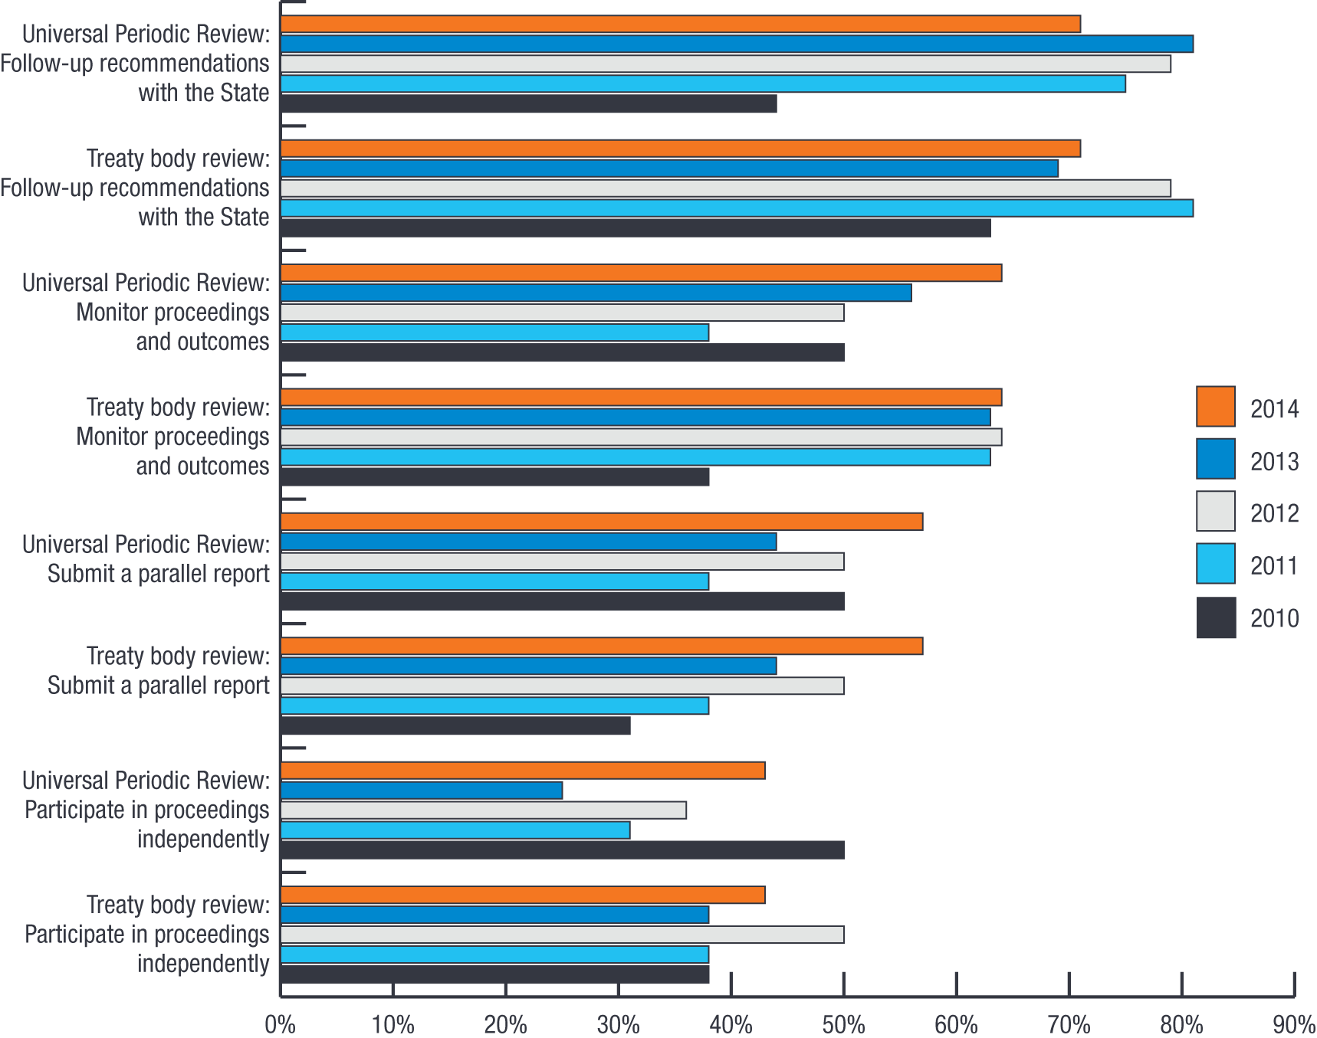
Members’ engagement in the targeted processes associated with the work of the special procedures mandate holders is less frequent than the universal cyclical processes, and therefore trends are more difficult to identify. As shown in Figure 10, there is a very high degree of annual variation in members’ engagement with special procedures mandate holders.

Figure 10: Percentage of members participating in UN processes – special procedures
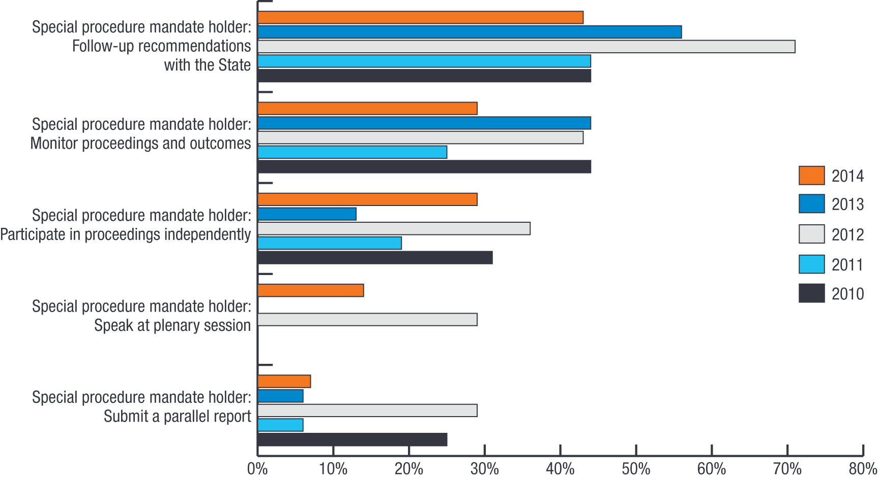

Regional mechanisms
The APF seeks to work with regional intergovernmental mechanisms to promote and protect human rights.

Pacific Islands Forum
The Pacific Islands Forum is an intergovernmental regional mechanism comprised of the member States from Australia, Cook Islands, Kiribati, Marshall Islands, Micronesia, Nauru, New Zealand, Niue, Palau, Papua New Guinea, Samoa, Solomon Islands, Tonga, Tuvalu and Vanuatu. The APF, the OHCHR and the Pacific Islands Forum secretariat (PIFs) developed a new memorandum of understanding to strengthen their partnership in promoting the establishment of NHRIs in the Pacific region. The new agreement builds on a 2009 memorandum of understanding between the APF and PIFs, and the APF’s partnership agreement with OHCHR.
The agreement will ensure the sustainability of the work in the region and will highlight the particular areas of expertise that each organisation brings to the partnership. The APF, OHCHR and PIFs are currently working with the Governments of Nauru, Palau, Papua New Guinea, Samoa, Solomon Islands and Vanuatu to set up NHRIs in their countries. OHCHR and PIFs also work in partnership with Pacific Governments and civil society to promote treaty ratification and to support their contributions to the work of the UN’s human rights mechanisms, including the human rights treaty bodies, the special procedures and the UPR mechanism.
The memorandum of understanding was signed by the three parties in March 2014.

Association of Southeast Asian Nations
The Association of Southeast Asian Nations (ASEAN) is an intergovernmental regional mechanism comprised of the member States from Brunei Darussalam, Cambodia, Indonesia, Laos People’s Democratic Republic, Malaysia, Myanmar, the Philippines, Singapore, Thailand and Vietnam.
The APF participated in an ASEAN regional dialogue held from 4-6 November 2013 on advancing the rights of women and girls and their access to justice. The dialogue brought together the NHRIs of Indonesia, Malaysia, Myanmar, the Philippines, Thailand and Timor-Leste, as well as members of ASEAN’s human rights mechanisms.
A goal of the meeting was to discuss how the key principles that underpin the Convention on the Elimination of Discrimination Against Women – in particular, non-discrimination, substantive equality and the obligation of States – can be used as a framework to guide efforts at the national, regional and international levels.
Discussions also focused on the ways in which NHRIs can build a greater focus on gender issues into their regular functions, such as monitoring and investigating human rights violations; advising governments on laws, policies and procedures; human rights education and awareness raising; and engaging with the international human rights system.

Arab Court of Human Rights
From 25-26 May 2014, the APF and West Asian NHRIs participated in a two-day meeting to discuss the rules of procedure of the new Arab Court of Human Rights. The proposal to set up a human rights court for all Arab states was first announced in November 2011 by Bahrain’s King Hamad Bin Eisa Al Khalifa.
The meeting brought together more than 150 Arab human rights organisations and prominent activists, representatives from other regional human rights courts (Europe, Americas and Africa), the Arab League and the OHCHR.
Manama, the capital of the Bahrain, has been chosen to host the Arab Court of Human Rights, a decision taken by the Arab League’s foreign ministers at a meeting in Cairo in September 2013.

Advocacy
Evaluation findings
Outcome indicator: Advocacy
Performance rating: On track
The APF seeks to play an active role to support APF members at the international and regional level in the protection and promotion of human rights. One function of the APF is to advocate common policy positions adopted by the APF membership.
In response to a survey question on the value of this work, as shown in Figure 11, the APF’s work with the ICC is consistently very highly valued, that its work with the UN OEWG is increasingly highly valued and that the APF’s role in the Conference of State Parties on Disability is also highly valued.
The APF’s strategic focus on engaging in thematic mechanisms to promote APF-wide policy positions reflects the relatively lower value placed by members on its engagement generally with UN Human Rights Council and its mechanisms and the UN General Assembly. The APF’s focus here is rather to promote the engagement of individual NHRIs themselves rather than advocating APF-wide policy positions.

Figure 11: Member ratings of the value of APF participation in UN mechanisms
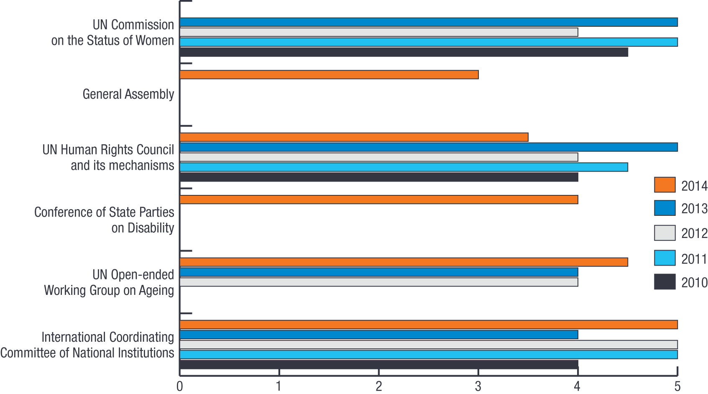
In another member survey conducted in 2014, 88% of responding members indicated that they thought APF participation at ICC annual meetings was highly important.
Figure 12 shows combined relative priority that should be given to international and regional engagement. The survey shows the preference of APF members to seek APF support to promote their engagement in the regional bodies relevant to their respective sub-regions, for example ASEAN, PIFs and SAARC.

Figure 12: Combined member and stakeholder views on the relative priority of international and regional engagement
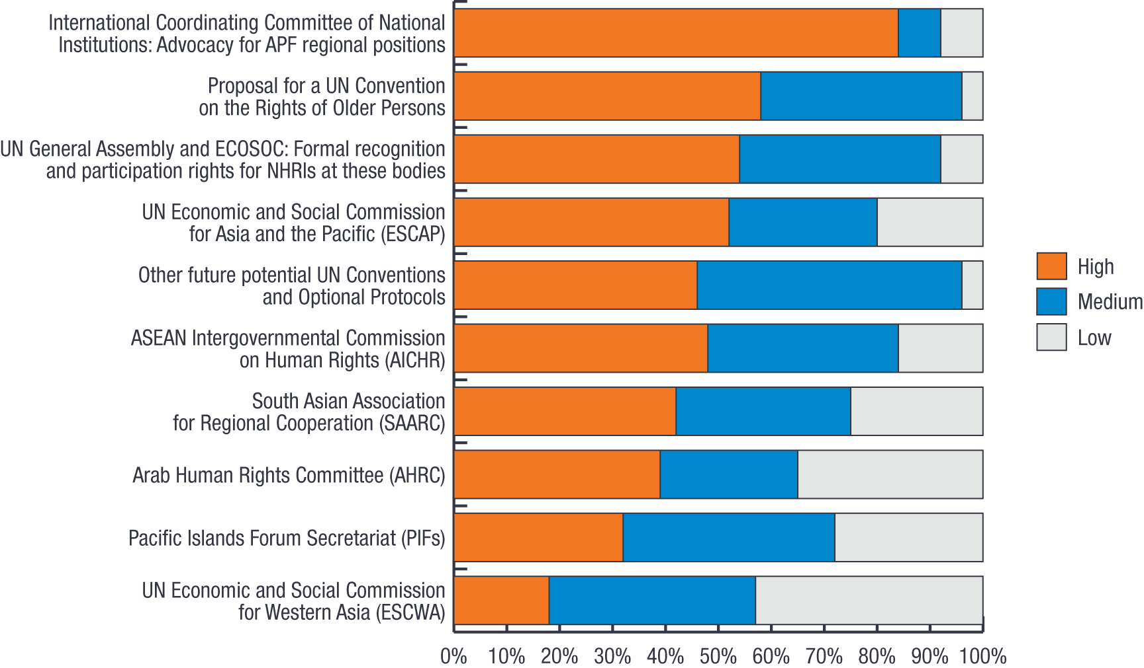

Effective, efficient and strategic management of the APF
The APF operates as an independent, non-profit legal entity, with a board of directors – the Forum Council – that reflects the APF’s broad regional diversity.
The key elements of the APF’s organisational structure are as follows:
- The Forum Council is the decision-making body of the APF. Established by the APF Constitution, the Forum Council is comprised of one voting councillor nominated by each full member. It sets the APF’s policies and priorities, determines membership applications and exercises all the powers set out in the constitution.
- The Forum Council elects, from within its membership, a Chairperson and two Deputy Chairpersons of the APF.
- Forum Councillors can establish committees of councillors to administer different aspects of the APF’s operations. A management committee has been established to oversee the operations of the APF.
- The APF secretariat is responsible for implementing the decisions of the Forum Council. The Director of the secretariat reports to the Chairperson of the Forum Council on a regular basis and to the Forum Councillors. The Forum Council meets each year as part of the APF’s annual meeting and on other occasions as required. Meetings are run according to the APF rules of procedures for Forum Councillors’ meetings.

Strategic management
Evaluation findings
Outcome indicator: Strategy
Performance rating: On track
During the year, the APF secretariat was responsible for the strategic management of the organisation and its operations, which involved:
- servicing the APF Chairperson, meetings of the full Forum Council and sub-committees established by the Council and providing policy advice to the ICC Chairperson
- implementing all the activities approved by the Forum Council in the APF’s strategic plan
- completing all monitoring, evaluation and reporting requirements
- identifying international issues and pursuing activities that support the APF’s mission and vision for the region
- identifying and pursuing opportunities to increase regional participation and representation across the breadth of its activities including the involvement, wherever possible, of non-member institutions, governments and civil society
- identifying and implementing risk management strategies for all project activities and the overall operation of the APF
- implementing a long-term fund development strategy, and
- managing in an effective, efficient and equitable manner the APF’s financial and human resources.
Members’ feedback on the management of the APF was again positive and the median rating of various strategic management services, shown in Figure 13, remains high (4.1 out of 5). A number of members commented on the effectiveness of the APF secretariat, for example: “the work done by the secretariat promptly responds to the needs of the member institutions in dealing with the human rights issues both at a national and international level.”

Figure 13: Members’ ratings of the APF’s strategic management services – 2010 to 2014
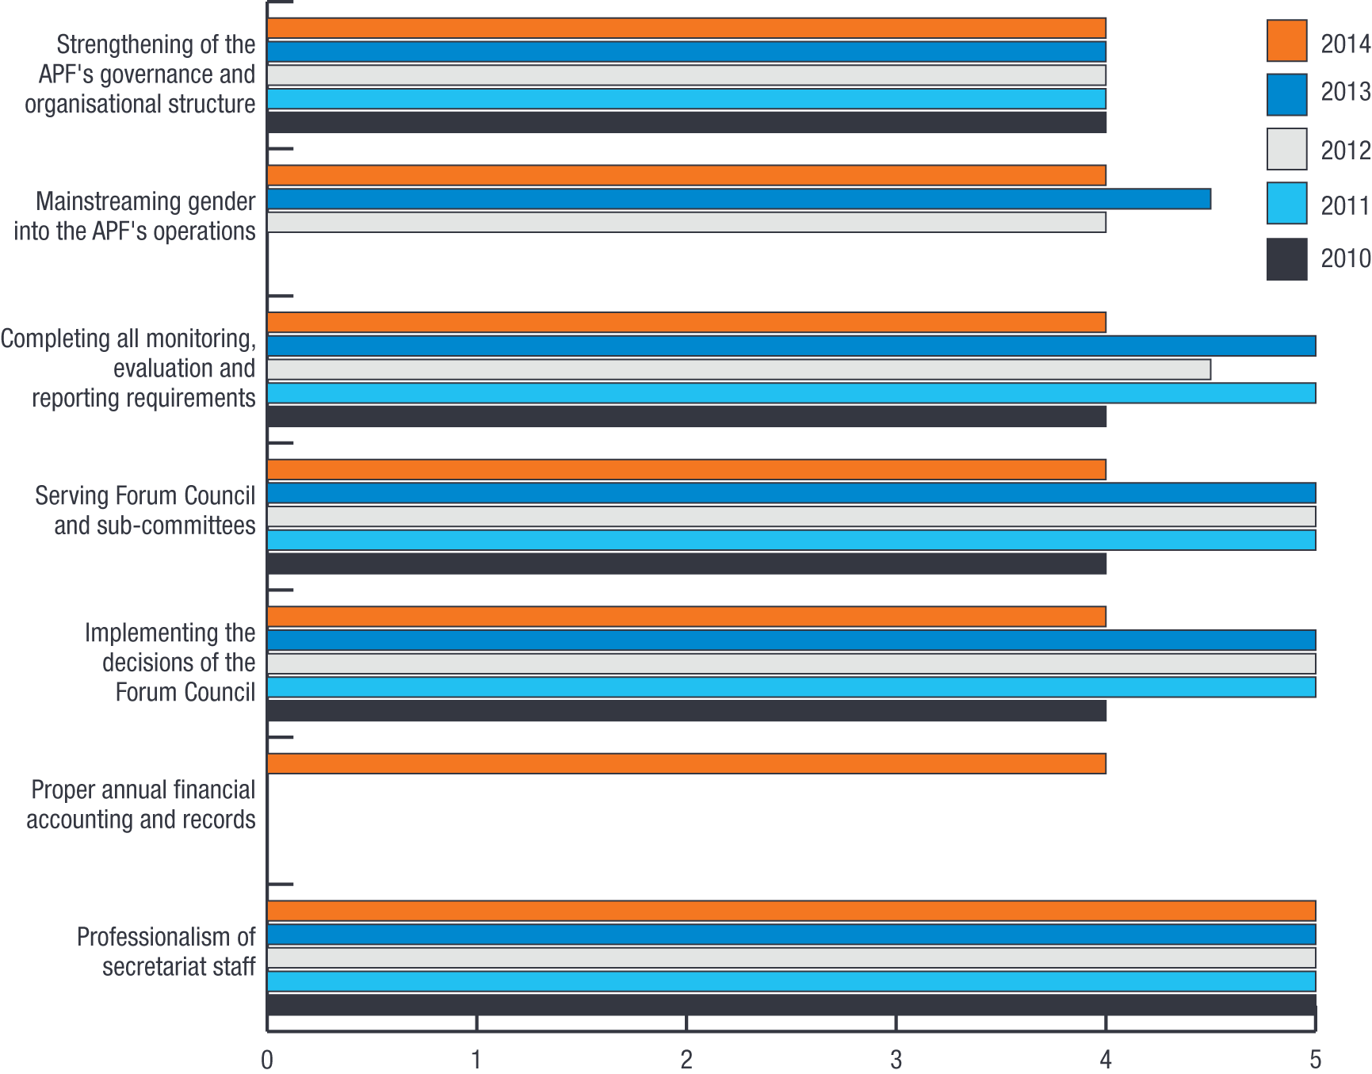
In 2014, the APF commenced an 18-month period of strategic planning aimed at producing its five-year Strategic Plan 2015–2020. The APF has adopted a participatory approach to strategic planning, drawing on its members’ and other stakeholders’ (partners, donors, experts and NGOs), expertise and knowledge. Members have been engaged in analysing the context for the operation of NHRIs in the region, in arriving at a consensus on the priority human rights issues and on key NHRI functions, providing robust guidance to the APF in planning its objectives for the coming five years. A member institution in their annual survey of APF performance commented that they had been “particularly impressed with the strategic planning process for 2015–2020 and the secretariat’s vision to make the APF’s governance structure more effective and efficient moving into the future.”

Gender mainstreaming
Evaluation findings
Output indicator: Gender mainstreaming
Performance rating: On track
The APF has adopted a gender policy, established a gender focal point, and is progressively mainstreaming gender across its objectives. For the third year members were asked to rate the APF’s efforts at mainstreaming gender into its operations. A median response of 4 out of 5 or above over the last three years, indicates an ongoing high degree of satisfaction with this initiative.
The average ratio of males to females at the level of Commissioner, senior staff and junior staff for the 14 members who have responded is shown in Figure 14. On average, there is slightly higher proportion of men overall except in junior staff. The results this year show a slight decrease in women serving as commissioners, on average, although it is not possible to say whether this is a trend or annual variation at this point. It is important to note that there is significant variation in the gender balance across the membership, with South East Asian and Pacific members having a preponderance of females in senior and junior staff roles and West and South Asian members having a higher proportion of males in commissioner, senior and junior staff roles.

Figure 14: Average gender ratios at different levels of member institutions
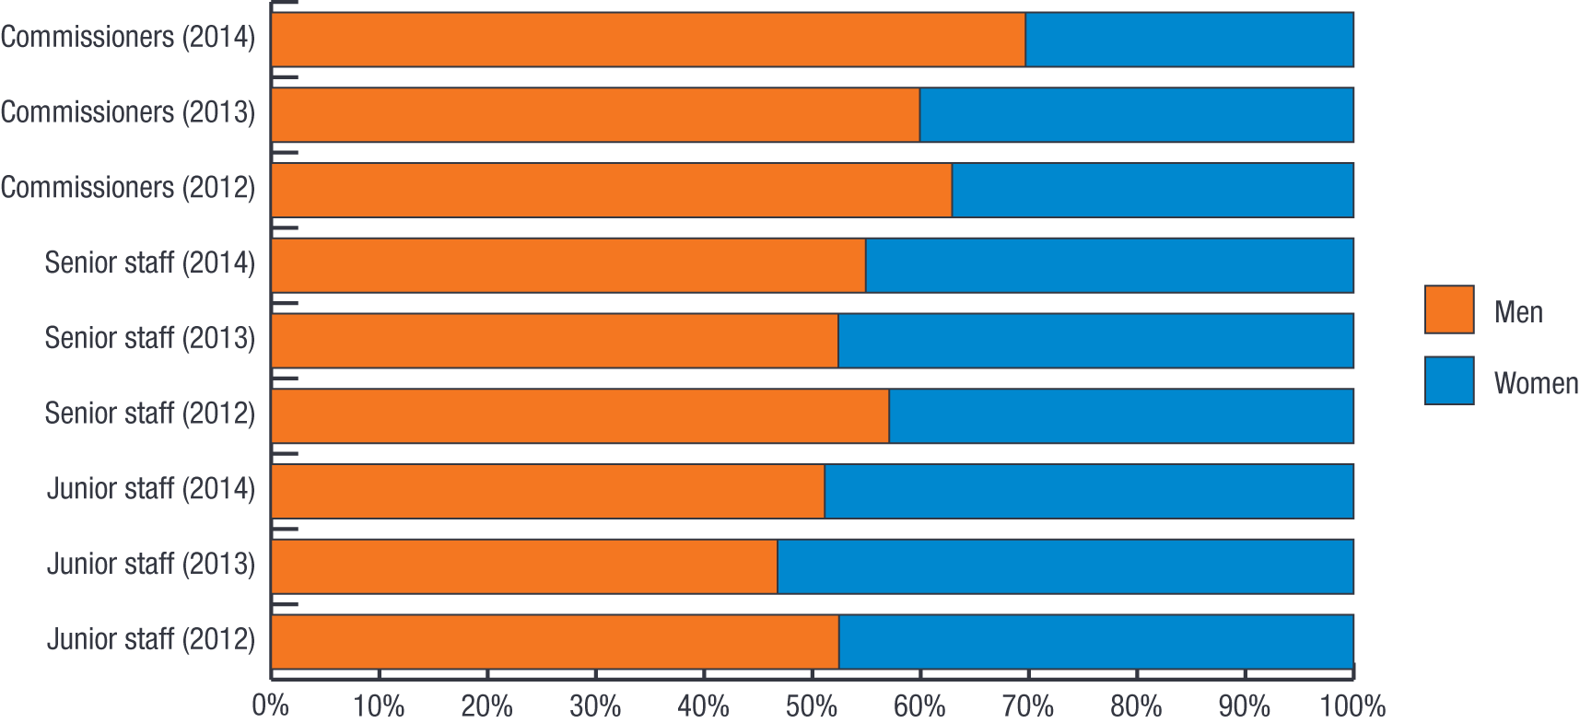
An important aim of the 2015–2020 strategic planning process is to develop more effective monitoring and evaluation measures on gender for future APF strategic objectives, planning and activities; as well as a better understanding of impact and outcomes. The rollout of gender across all strategic objectives has required a step-by-step approach to ensure that the appropriate shifts in organisational culture and planning are sustainable into the future.

Environmental impact
Evaluation findings
Output indicator: CO2 emissions
Performance rating: On track
The APF’s small secretariat operates from leased premises in a water and energy efficient building with a certified four-star green star rating and best practice waste recycling systems. The secretariat uses few other resources, creates only minor waste streams and has been able to reduce its environmental impact further through the introduction of a virtual learning environment that has reduced the need for training-related air travel. The APF conferences and meetings have also moved from providing meeting documents and resources in hard copy to soft copy – available on the APF website and USB drives.

Financial management
Evaluation findings
Output indicator: Spending by objective
Performance rating: On track
The APF is a non-profit organisation supported entirely by membership fees, voluntary contributions and grants. The APF receives its funding from APF members, governments, foundations, UN agencies and other NGOs. To ensure its continued independence and impartiality, the APF endeavours to maintain a diversified base of support for its activities.
The APF is very grateful for the generous contributions of its donors and the commitment they share in advancing human rights in the Asia Pacific region. Supporters have included the APF’s member institutions (through membership fees and other financial and in-kind donations), the Governments of Australia, India, New Zealand, the Republic of Korea, Sweden and Thailand (often as a result of the direct advocacy of the NHRIs from those States), philanthropic organisations such as the MacArthur Foundation, the RWI, philanthropic individuals and intergovernmental organisations such as the UNDP, and other private donors.
Figure 15 compares the spending by objective for the last five financial years (noting a change in reporting year from April/March in 2010 and 2011 to July/June from 2012 due to alignment of strategic processes). The total revenue available for distribution was larger than the previous year, largely due to increased or new funding from donors and members, in particular the National Human Rights Commission of India, the Swedish Government and the European Union. Some unspent grant funds from the previous year were also rolled over into this year. Expenditure closely matched the budget for the year, leaving only a small surplus.
APF auditors have completed their audit of the APF financial operations for the 2013–14 year. An auditor’s statement will be available by late August 2014 and will be tabled with the annual report at the APF’s 19th Annual General Meeting in September 2014. No changes are anticipated.

Figure 15: APF spending by objective – 2010 to 2014
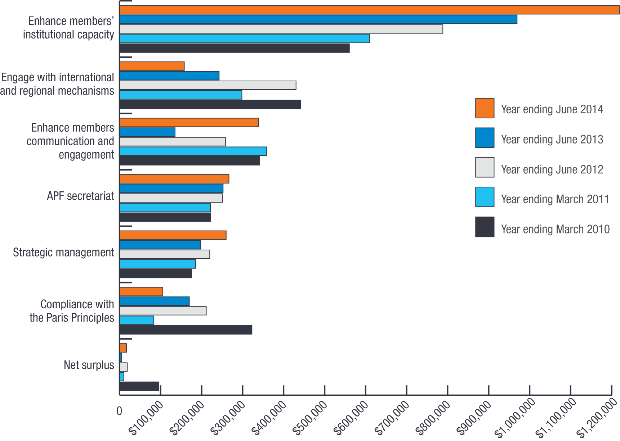
The allocation of spending has changed marginally from 2012–13 to 2013–14. The main changes in this reporting period compared with the previous year are:
- Spending on enhance members’ institutional capacity has increased slightly from the previous year. This has included the development of enhanced training resources in the areas of disability and torture prevention, the holding of a regional workshop on the rights of older persons and the continuation of the CA program with the NHRIs of Bangladesh, Oman, Samoa and Indonesia.
- There has been a further reduction in spending on engagement with international and regional human rights mechanisms due to the end of the APF region’s chairpersonship of the ICC (and the associated financial support for this role provided by the APF) and the completion of the APF’s advocacy at the UN Commission on the Status of Women in New York.
- A return to historical levels of spending on enhancing members’ communication, cooperation and engagement due largely to the costs associated with holding the 2013 Biennial Conference in Doha, Qatar.
- A reduction in spending on promoting compliance with the Paris Principles due to the reduced expenditure in Samoa and Myanmar as the legislative drafting processes have largely been completed. Ongoing support costs to these NHRIs are now allocated to institutional capacity building.
- Increased spending in strategic management, which is attributable to an expanded donor fundraising campaign and the holding of the Forum Councillors working group on the development of the next APF five-year strategic plan.
The above information for the 2013–14 financial year is reflected in Figure 16 below.

Figure 16: APF expenditure by objective for 2013–14
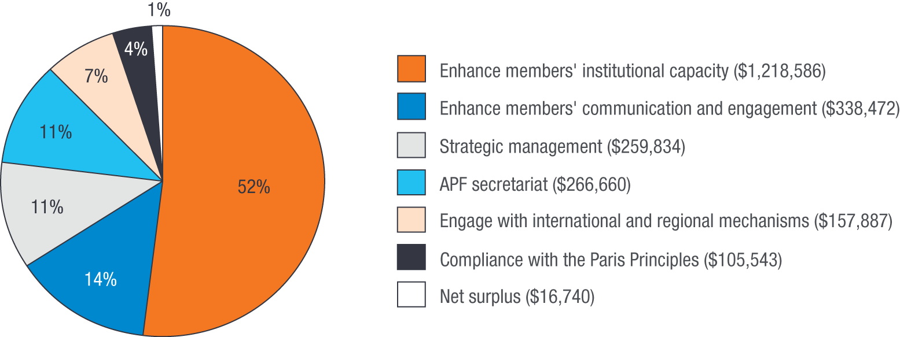

Corporate governance
Evaluation findings
Output indicator: Compliance
Performance rating: On track
The APF is a company limited by guarantee and is required to meet a range of regulatory obligations. Directors of a company limited by guarantee are subject to all of the duties and obligations for a company as set out in the Corporations Act 2001. This includes the preparation of an audited financial report in accordance with the Australian Accounting Standards and a Directors' report in accordance with the Corporations Act. There are also compliance requirements on companies limited by guarantee relating to health and safety, equal opportunities and industrial relations. During 2013–14, no non-compliance incidents in any of these areas were recorded. All financial, regulatory and statutory obligations have been undertaken.

As amended by Forum Councillors at the 16th Annual Meeting of the APF to include gender mainstreaming as a cross-cutting strategic objective.
Averages of the gender distributions reported by members responding to the survey each year (14 of 18 in 2012, 16 of 19 in 2013 and 14 of 21 in 2014).

