June 6, 2017
GANHRI  Palais des Nations, 1211 Genève, Switzerland  www.ganhri.org | 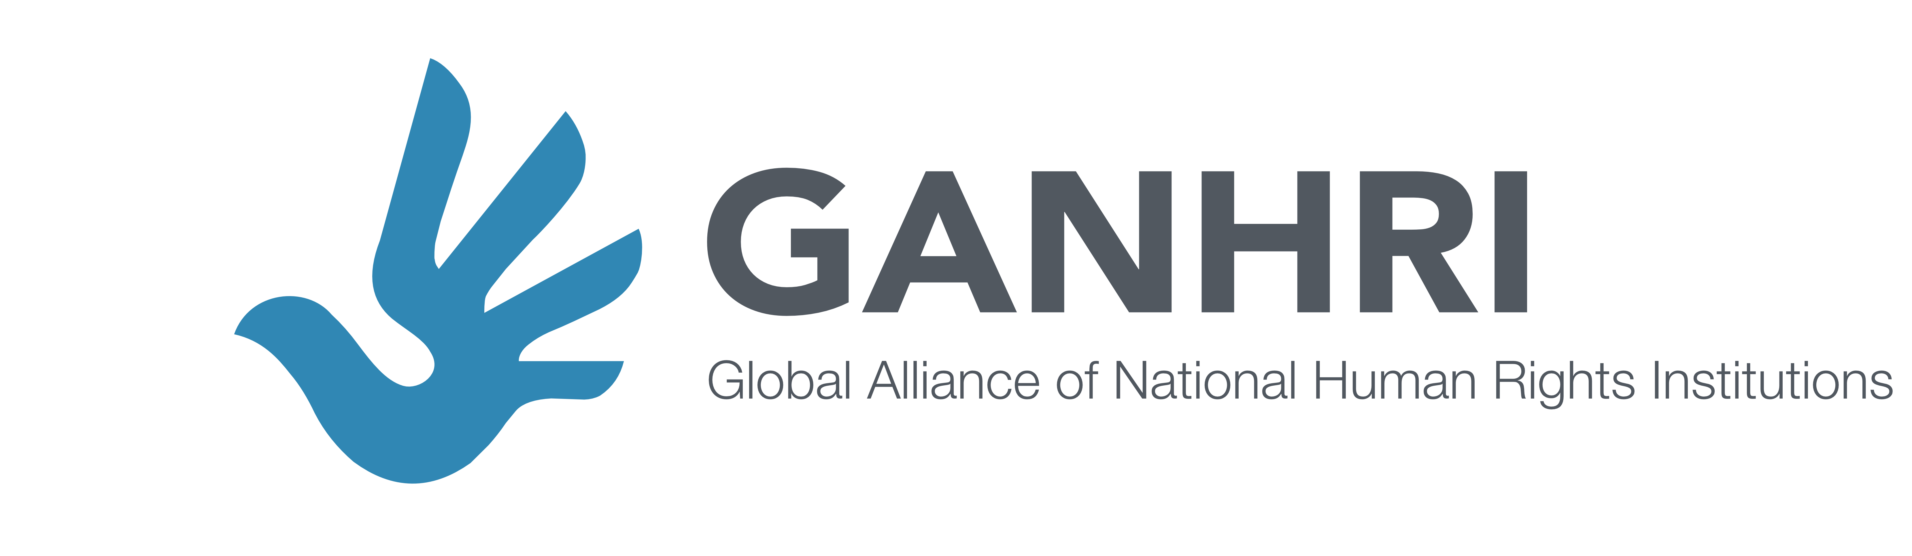

STATEMENT

GANHRI statement to the 35th session of the Human Rights Council

Item 3 Clustered interactive dialogue with the Independent Expert on sexual orientation and gender identity and the Special Rapporteur on summary executions

Mr President,
Independent Expert,
The Global Alliance of National Human Rights Institutions (GANHRI), speaking on behalf of 78 A status accredited NHRIs from all regions, congratulates the Independent Expert on protection against violence and discrimination based on sexual orientation and gender identity on his appointment and welcomes his first report to the Council. GANHRI appreciates the Independent Expert's engagement with states, civil society, NHRIs and other stakeholders in open and public consultations in preparing this report, which enhances the quality of the report. GANHRI fully shares the understanding underlying this engagement that there can be no justification for violence and discrimination.
The Independent Expert has identified six (6) underpinning priorities to help in the prevention and protection against violence and discrimination based on sexual orientation and gender identity. GANHRI and its members look forward to his future reports with a more comprehensive analysis of each priority, considering also the role of NHRIs.
Human rights apply to everyone, irrespective of their sexual orientation or gender identity, as UN treaty bodies and special procedures have repeatedly emphasized.
As the Independent Expert stresses in his report, however, the phenomenon of violence and discrimination based on sexual orientation and gender identity exists at all levels and different layers of society, in all regions.
NHRIs work for the human rights of all people. Often an NHRI will identify those specific population groups within its country that are especially vulnerable to actual human rights violations or the risk of human rights violations. Many NHRIs identify lesbian, gay, bisexual, transgender and intersex people (LGBTI) as among those groups most at risk. Certainly international reports by United Nations agencies and mechanisms consistently reveal widespread patterns of human rights violations affecting lesbian, gay, bisexual, transgender and intersex people.
The Asia Pacific Forum of National Human Rights Institutions (APF) has a partnership program with the UNDP Bangkok Regional Hub to provide practical support to strengthen the capacity of NHRIs in Asia and the Pacific to work with LGBTI people and communities and to more effectively advocate for their rights. It also seeks to support and encourage mutual cooperation between NHRIs and LGBTI people. It has conducted sub-regional blended learning training on LGBTI human rights with NHRIs and CSOs in South Asia, South East Asia and the Pacific. It has also developed various resources to support NHRIs. The APF also partnered with UNDP to host a global Conference on the Yogyakarta Principles in April 2017 where the Independent Expert on SOGI gave a keynote presentation.
GANHRI welcomes and fully supports the Independent Expert’s recommendation to the international community for more cooperation with NHRIs, given their bridging role between the national and international level, but also between civil society, governments and the UN system, and their role in protecting the rights of most marginalized.
“Diversity in humanity, humanity in diversity”. GANHRI and its members echo the Independent Expert report’s main message, as also highlighted in UDHR article 1, and stand ready to work with him throughout his mandate in the protection against violence and discrimination based on sexual orientation and gender identity. We encourage all states and stakeholders to cooperate with the mandate holder so as to ensure the human rights of everyone.

