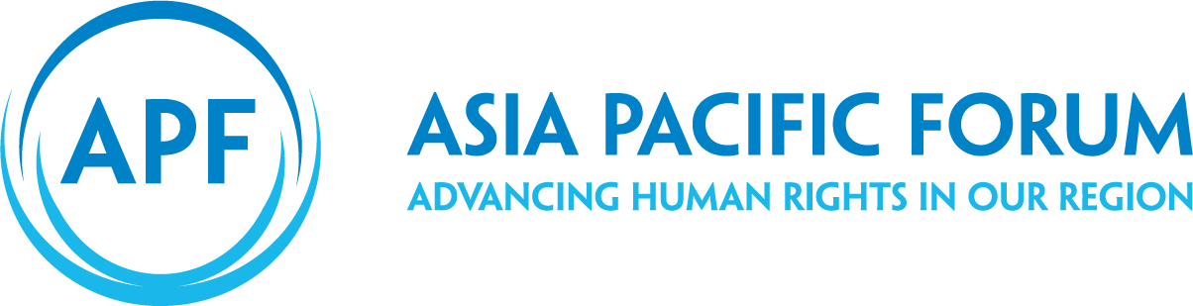Guide to Strategic Planning:  
Tools

#### Note

The designations employed and the presentation of the material in this publication do not imply the expression of any opinion whatsoever on the part of the APF concerning the legal status of any country, territory, city or area, or of its authorities, or concerning the delimitation of its frontiers or boundaries.

*Guide to Strategic Planning: Tools*

© Copyright Asia Pacific Forum of National Human Rights Institutions, February 2020

No reproduction is permitted without prior written consent from the APF.

Asia Pacific Forum of National Human Rights Institutions

GPO Box 5218

Sydney NSW 1042

Australia

# tool iconTools Roadmap

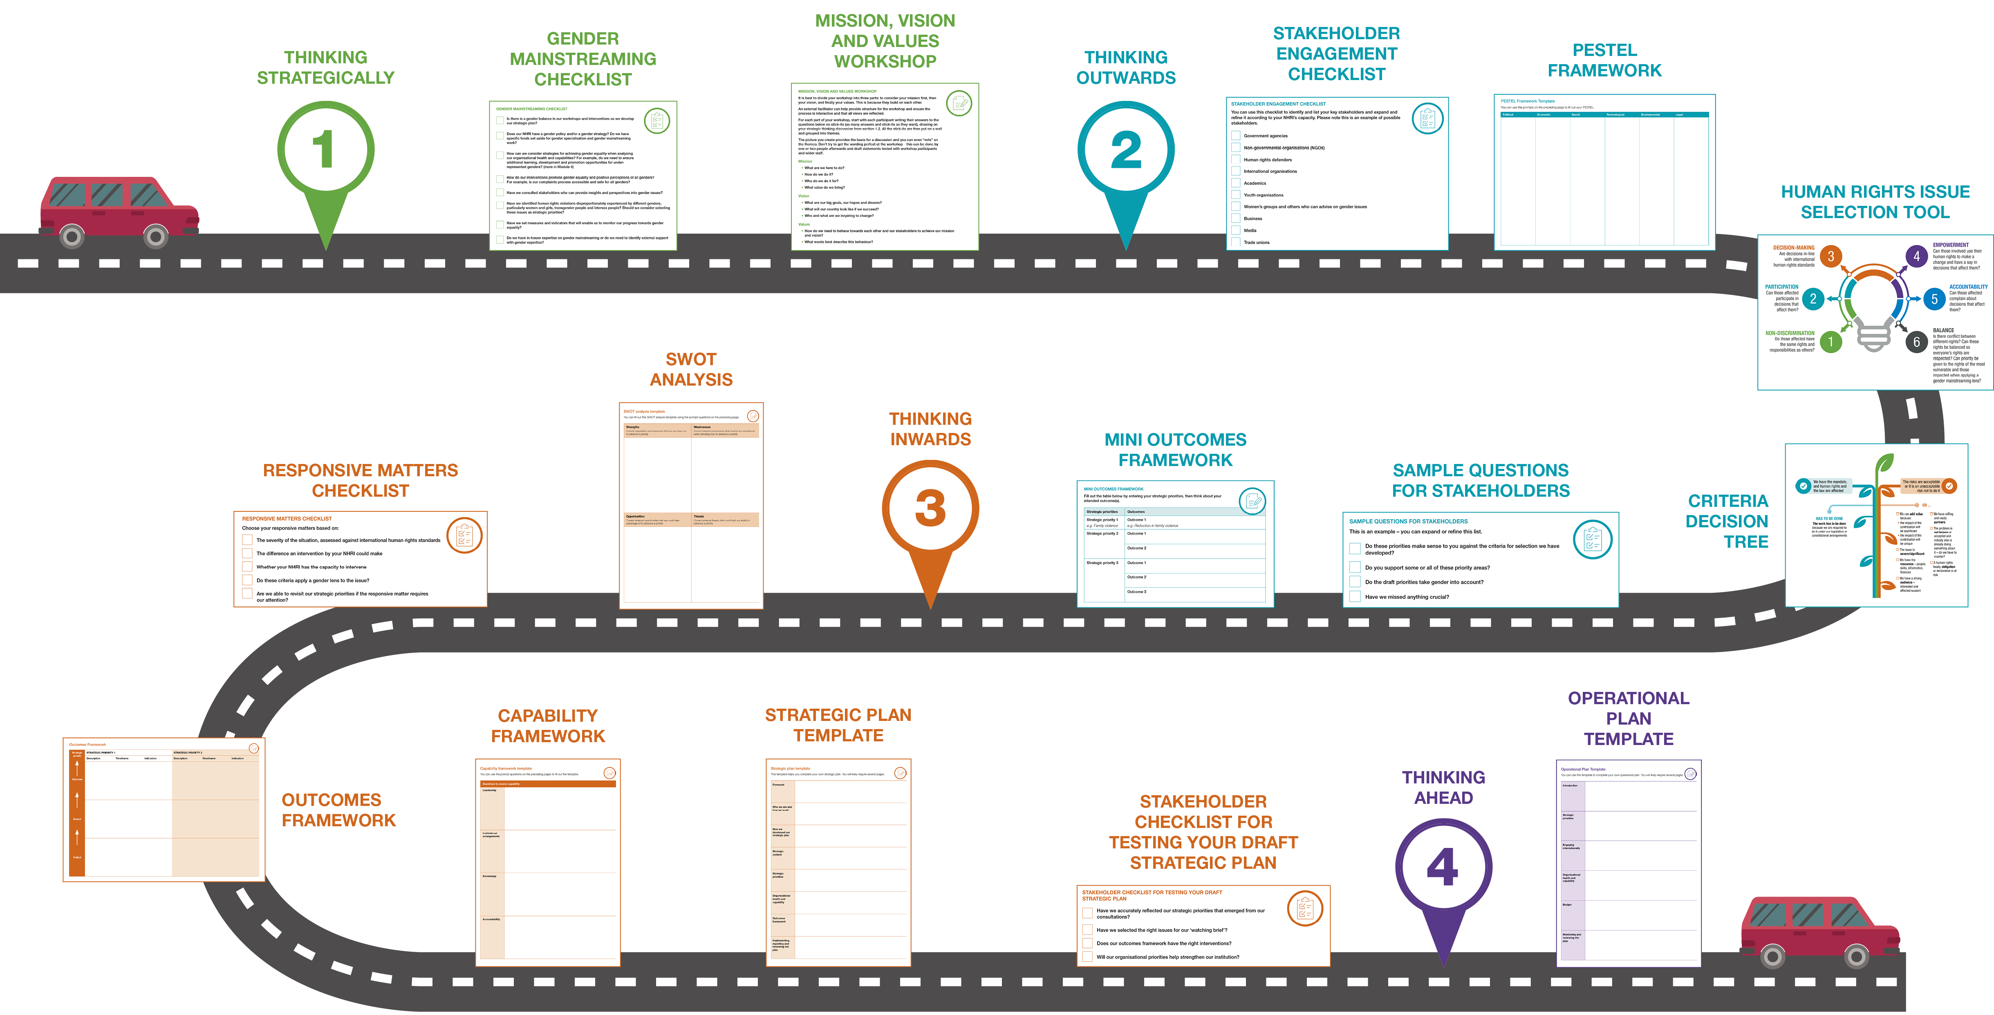

#### Gender mainstreaming in strategic planning

You can use the checklist below to apply gender mainstreaming in your strategic planning. This is known as applying a ‘gender lens’ to your thinking, your activities and your decisions.

gender mainstreaming checklist

Is there a gender balance in our workshops and interventions as we develop our strategic plan?

Does our NHRI have a gender policy and/or a gender strategy? Do we have specific funds set aside for gender specialisation and gender mainstreaming work?

How can we consider strategies for achieving gender equality when analysing our organisational health and capabilities? For example, do we need to ensure additional learning, development and promotion opportunities for under-represented genders? (more in Module 4)

How do our interventions promote gender equality and positive perceptions of all genders? For example, is our complaints process accessible and safe for all genders?

Have we consulted stakeholders who can provide insights and perspectives into gender issues?

Have we identified human rights violations disproportionately experienced by different genders, particularly women and girls, transgender people and intersex people? Should we consider selecting these issues as strategic priorities?

Have we set measures and indicators that will enable us to monitor our progress towards gender equality?

Do we have in-house expertise on gender mainstreaming or do we need to identify external support with gender expertise?

mission, vision and values workshop

It is best to divide your workshop into three parts: to consider your mission first, then your vision, and finally your values. This is because they build on each other.

An external facilitator can help provide structure for the workshop and ensure the process is interactive and that all views are reflected.

For each part of your workshop, start with each participant writing their answers to the questions below on stick-its (as many answers and stick-its as they want), drawing on your strategic thinking discussion from section 1.2. All the stick-its are then put on a wall and grouped into themes.

The picture you create provides the basis for a discussion and you can even “vote” on the themes. Don’t try to get the wording perfect at the workshop – this can be done by one or two people afterwards and draft statements tested with workshop participants and wider staff.

**Mission**

* What are we here to do?
* How do we do it?
* Who do we do it for?
* What value do we bring?

**Vision**

* What are our big goals, our hopes and dreams?
* What will our country look like if we succeed?
* Who and what are we inspiring to change?

**Values**

* How do we need to behave towards each other and our stakeholders to achieve our mission and vision?

What words best describe this behaviour?

stakeholder engagement checklist

You can use this checklist to identify and list your key stakeholders and expand and refine it according to your NHRI’s capacity. Please note this is an example of possible stakeholders.

Government agencies

Non-governmental organisations (NGOs)

Human rights defenders

International organisations

Academics

Youth organisations

Women’s groups and others who can advise on gender issues

Business

Media

Trade unions

#### practical exercise iconPESTEL Framework Template

|  |  |  |  |  |  |
| --- | --- | --- | --- | --- | --- |
| **Political** | **Economic** | **Social** | **Technological** | **Environmental** | **Legal** |
|  |  |  |  |  |  |

#### Human Rights Issue Selection Tool

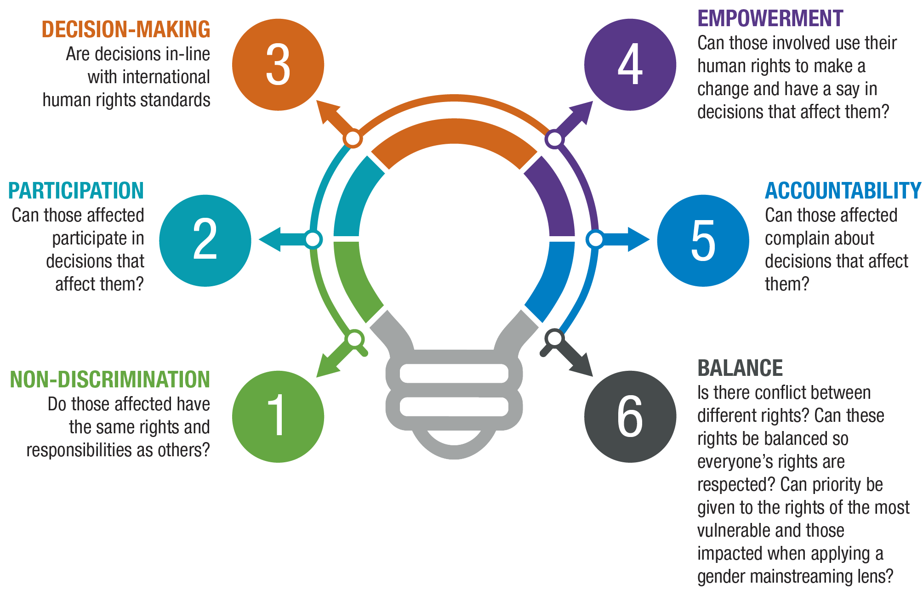

#### Criteria Decision Tree

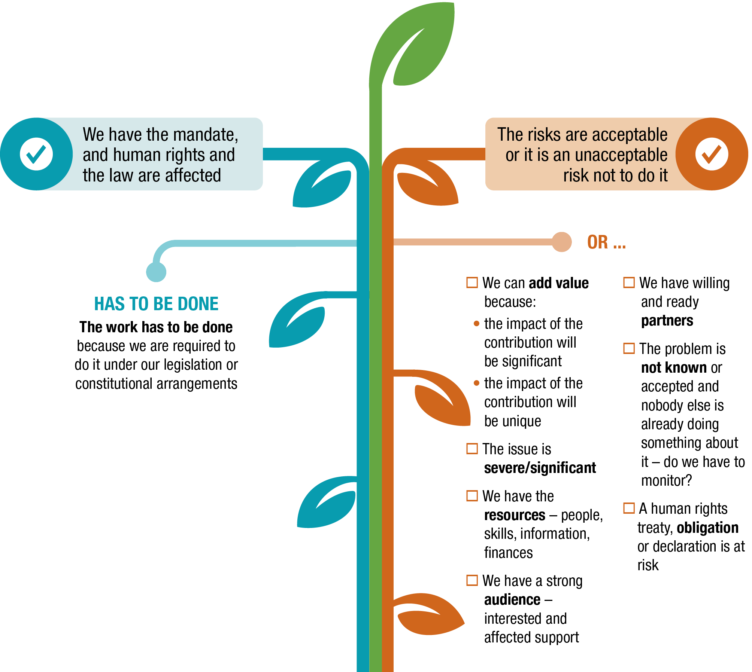

sample questions for stakeholders

This is an example – you can expand or refine this list.

Do these priorities make sense to you against the criteria for selection we have developed?

Do you support some or all of these priority areas?

Do the draft priorities take gender into account?

Have we missed anything crucial?

mini outcomes framework

Fill out the table below by entering your strategic priorities, then think about your intended outcome(s).

|  |  |
| --- | --- |
| **Strategic priorities** | **Outcomes** |
| **Strategic priority 1**  *e.g. Family violence* | **Outcome 1**  *e.g. Reduction in family violence* |
| **Strategic priority 2** | **Outcome 1** |
| **Outcome 2** |
| **Strategic priority 3** | **Outcome 1** |
| **Outcome 2** |
| **Outcome 3** |

#### practical exercise iconSWOT Analysis Template

|  |  |
| --- | --- |
| **STRENGTHS**  *Current capabilities and resources that we can draw on to advance a priority* | **WEAKNESSES**  *Current internal weaknesses that need to be considered when deciding how to advance a priority* |
|  |  |
| **OPPORTUNITIES**  *Current external opportunities that we could take advantage of to advance a priority* | **THREATS**  *Current external threats that could limit our ability to advance a priority* |
|  |  |

responsive matters checklist

Choose your responsive matters based on:

The severity of the situation, assessed against international human rights standards

The difference an intervention by your NHRI could make

Whether your NHRI has the capacity to intervene

Do these criteria apply a gender lens to the issue?

Are we able to revisit our strategic priorities if the responsive matter requires our attention?

#### practical exercise iconOutcomes Framework

|  |  |  |  |  |  |  |
| --- | --- | --- | --- | --- | --- | --- |
| **Strategic priority**  **Outcome** | **STRATEGIC PRIORITY 1** | | | **STRATEGIC PRIORITY 2** | | |
| **Description** | **Timeframe** | **Indicators** | **Description** | **Timeframe** | **Indicators** |
|  |  |  |  |  |  |
| **Impact** |  |  |  |  |  |  |
| **Output** |  |  |  |  |  |  |

#### practical exercise iconCapability Framework Template

| **QUESTIONS TO ASSESS CAPABILITY** | |
| --- | --- |
| **Leadership** |  |
| **Institutional arrangements** |  |
| **Knowledge** |  |
| **Accountability** |  |
| **Protecting human rights** |  |
| **Promoting human rights** |  |
| **Advice and assistance to government** |  |
| **Stakeholder engagement** |  |
| **Human rights monitoring** |  |

#### practical exercise iconStrategic Plan Template

This template helps you complete your own strategic plan. You will likely require several pages.

|  |  |
| --- | --- |
| **Foreword** |  |
| **Who we are and how we work** |  |
| **How we developed our strategic plan** |  |
| **Strategic context** |  |
| **Strategic priorities** |  |
| **Organisational health and capability** |  |
| **Outcomes framework** |  |
| **Implementing, reporting and reviewing the plan** |  |

STAKEHOLDER CHECKLIST FOR TESTING YOUR DRAFT  
STRATEGIC PLAN

Choose your responsive matters based on:

Have we accurately reflected our strategic priorities that emerged from our consultations?

Have we selected the right issues for our ‘watching brief’?

Does our outcomes framework have the right interventions?

Will our organisational priorities help strengthen our institution?

#### Practical exercise iconOperational Plan Template

You can use this template to complete your own operational plan. You will likely require several pages.

|  |  |
| --- | --- |
| **Introduction** |  |
| **Strategic priorities** |  |
| **Engaging internationally** |  |
| **Organisational health and capability** |  |
| **Budget** |  |
| **Monitoring and reviewing the plan** |  |