Annual Report  
2016–2017

# 

Our vision is for an Asia Pacific where everyone enjoys human rights

About the APF | What we do 3

Our members 4

Protecting people, securing rights 7

Making change happen 9

Our achievements in 2016–17 11

Providing advice and expertise 13

Building stronger national human rights institutions 15

Promoting gender equality 17

Collaborating for change 19

Contributing at the national, regional and international level 21

Strong organisational leadership and governance 23

Copyright Asia Pacific Forum of National Human Rights Institutions 2017

The APF permits free reproduction of extracts from this publication provided that due acknowledgement is given and a copy of the publication carrying the extract is sent to the following address:

Asia Pacific Forum of National Human Rights Institutions  
GPO Box 5218  
Sydney NSW 1042  
Australia  
E: [apf@asiapacificforum.net](mailto:apf@asiapacificforum.net)  
W: [www.asiapacificforum.net](http://www.asiapacificforum.net)

# About the APF

For more than 20 years, the APF has helped build communities across the Asia Pacific where human rights are better respected and protected.

Our goal is to ensure that all people in the region can live with dignity, free from violence and discrimination.

We draw on the unique powers and position of our members – national human rights institutions (NHRIs) – to drive genuine and lasting change.

Established in 1996 with five members, our membership has grown to include 24 NHRIs from all corners of the Asia Pacific.

“Your work is fundamental to securing sustainable peace, with sound, transparent and accountable institutions, and a healthy social fabric. This essential role played by NHRIs is recognised more and more widely.”

Zeid Ra'ad Al Hussein, UN High Commissioner for Human Rights  
addressing the Annual Conference of the Global Alliance of National Human Rights Institutions, March 2017

# What we do

We provide practical support so our members can be as effective as possible in promoting and defending human rights and holding perpetrators to account.

We bring our members together to develop shared strategies that address some of the most serious human rights challenges in our region.

We provide advice and support to governments and civil society groups in their efforts to establish independent NHRIs.

We develop partnerships at the international and regional levels to advance human rights and amplify the voice of our members.

# Our members

The APF includes 15 full members and nine associate members, drawn from all corners of the region.

* **Afghanistan** Independent Human Rights Commission
* **Australian** Human Rights Commission
* National Institution for Human Rights in the Kingdom of **Bahrain**
* National Human Rights Commission of **Bangladesh**
* National Human Rights Commission of **India**
* **Indonesian** National Commission on Human Rights
* High Commission for Human Rights of **Iraq**
* **Jordan** National Centre for Human Rights
* National Centre for Human Rights of **Kazakhstan**
* Human Rights Commission of **Malaysia**
* Human Rights Commission of the **Maldives**
* **Myanmar** National Human Rights Commission
* Human Rights Commission of **Mongolia**
* National Human Rights Commission of **Nepal**
* **New Zealand** Human Rights Commission
* **Oman** Human Rights Commission
* **Palestine** Independent Commission for Human Rights
* Commission on Human Rights of the **Philippines**
* National Human Rights Committee of **Qatar**
* National Human Rights Commission of **Korea**
* Ombudsman of **Samoa**
* Human Rights Commission of **Sri Lanka**
* National Human Rights Commission of **Thailand**
* Provedor for Human Rights and Justice of **Timor-Leste**.

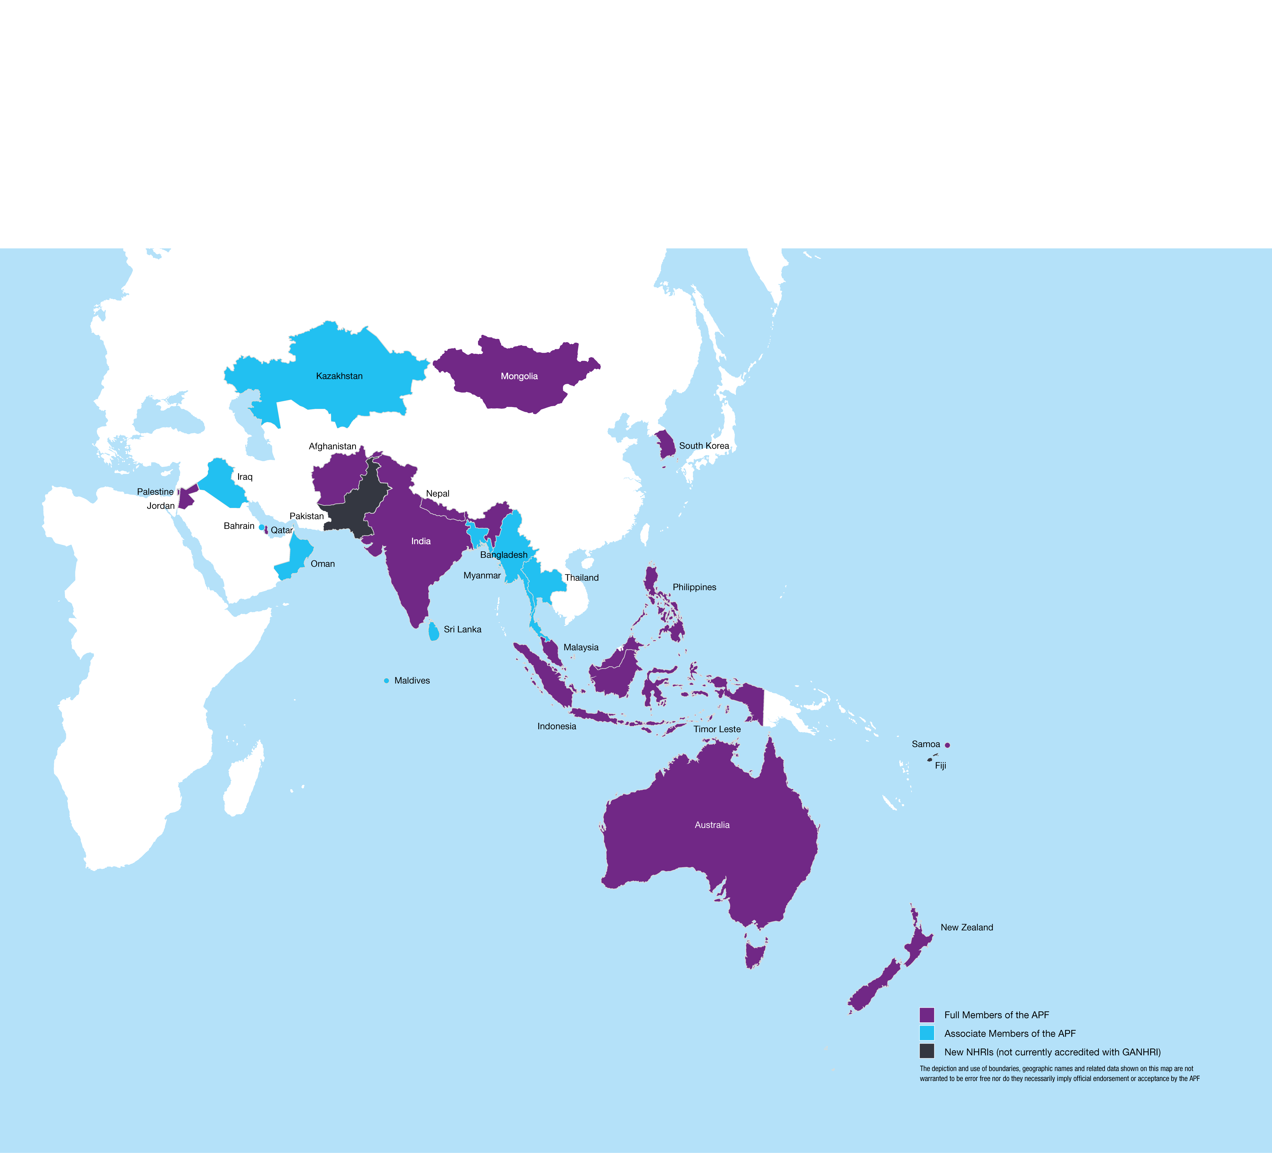

## NHRIs are drivers of change

NHRIs are **established by law** with **powers to promote and protect human rights**. Importantly, they **operate independently from government**.

This means they are uniquely positioned to make change happen by:

* Monitoring the human rights situation in the country and making their findings available to the public in order to raise awareness of human rights abuses, to publically hold perpetrators to account, and to protect and uphold the rights of vulnerable peoples
* Providing advice to government so that laws and policies reflect and comply with fundamental national and international human rights standards
* Receiving, investigating and resolving complaints so that victims of human rights violations can be heard, have a means of seeking redress and can be protected against further abuse
* Delivering human rights education programs that help change attitudes and behaviour on the part of institutions, law enforcement agencies and the community, particularly in relation to the use of violence and torture, and the treatment of marginalised and discriminated persons
* Engaging with the international human rights community to raise pressing issues and advocate for recommendations that make a difference back home.

“National human rights institutions are independent of government and they become, in a sense, the conscience of the country.”

Professor Gillian Triggs  
President, Australian Human Rights Commission  
(2012-2017)

# Protecting people, securing rights

The Asia Pacific – the world’s most populous and diverse region – is in a state of enormous flux, with many vulnerable people whose fundamental human rights are under grave threat.

Conflict and insecurity has led millions of people to flee across borders in recent years, forced from their homes to seek safety but often left in precarious and exploitative situations.

The rise of populism and extremism in some countries has seen basic human rights come under direct challenge, while also fanning division, blame and mistrust within communities. Individuals and groups calling for justice and equality have been detained and threatened under new and old laws.

At the same time, entrenched discrimination continues to undermine the dignity and limit the opportunities of women, ethnic minorities, indigenous peoples, LGBTI communities, people with disabilities and many others.

The human rights challenges across the Asia Pacific are vast. But change is possible. People’s lives can be improved.

“A difficult job is more interesting for me, to break some taboos and prepare the ground for others. There have been a lot of attacks against me but if I give up there will be no space for the human rights defenders.”

Dr Sima Samar  
Chairperson, Afghanistan Independent Human Rights Commission

Strong and independent NHRIs, often working in very challenging situations, are making a lasting difference in the lives of people of all ages and backgrounds. For those on the margins of society, NHRIs are often their only avenue to seek protection and justice.

Our members investigate complaints and secure redress for people whose rights are violated, while also helping to protect others from abuse.

They inspect places of detention to put an end to torture and ill-treatment, hold perpetrators to account and improve conditions for those detained.

They speak up against the voices of division and counter the prejudice and stereotypes that can lead to violence, harassment and discrimination.

They also empower vulnerable communities to stand up for their own rights.

**The APF provides the NHRIs in our region with advice, training and support so they can be powerful advocates for and defenders of human rights and deliver tangible changes that improve people’s lives.**

Workers receive justice after being held in modern-day slavery

A complaint made to the National Human Rights Commission of Bangladesh has secured justice for exploited workers and family members on a major tea estate.

About 2,400 people on the Boikunthapur Tea Estate, including labourers and their children, claimed they had been denied wages, rations and medical care, trapped in a form of modern day slavery.

For almost four months they had survived on liquid extract from boiled rice, mashed tea leaves and chillies. The lone medical clinic on the estate had been closed for the previous six months and children of labourers had stopped going to school.

As soon as the Commission received the tea workers’ complaint in August 2016, it sent a team of investigators to the Boikunthapur Tea Estate to gather evidence. The Commission then held a hearing, where the estate owner pledged to provide the workers with all outstanding wages and rations.

As a newly-established NHRI, the APF has provided training and support to strengthen the Commission’s work to protect human rights and deliver redress for victims of violations.

## **“THIS HAS BEEN OUR LAND FOR GENERATIONS”**

The Human Rights Commission of Malaysia (SUHAKAM) has stood shoulder-to-shoulder with a group of Orang Asli villagers who claimed that their ancestral lands had been encroached by the state government.

In January 2017, the group told SUHAKAM that the unannounced push into their ancestral lands in Johor National Park had violated their human rights and threatened to strip them of their livelihood.

SUHAKAM committed to immediately investigate the matter.

“We have heard their complaints and we will not keep quiet. We will investigate and take necessary action,” Commissioner Datuk Lok Yim Pheng told reporters.

SUHAKAM has championed the rights of indigenous peoples for many years. It released the report of its national inquiry into the land rights of indigenous peoples in 2013 and has been a vocal advocate ever since.

The APF played a pivotal role in supporting SUHAKAM’s national inquiry and placing the issue firmly on the national agenda.

# Making change happen

Respect for human rights helps create communities where each person can live with dignity and make choices for their life.

Respect for human rights is not an abstract concept. It is grounded in day-to-day life.

It is about being able to go to school and get a decent education, and to receive adequate medical help when it is needed.

It is about being treated fairly by others, regardless of your race, gender, age, what you look like, who you love or what you believe.

It is about having safe working conditions and being paid fairly for your labour.

It is also about being free from torture and ill-treatment, from arbitrary arrest, and from all forms of violence and harassment.

NHRIs work to deliver on the promise of human rights so that people can lead the lives they choose and contribute to their communities.

As independent bodies with powers to investigate and report on human rights violations, NHRIs stand up for those in need of protection and hold their governments to account for their human rights obligations.

The APF provides support and advice for our members so they can help build fair, just and inclusive communities. We are supported in this work by a wide range of partners, including leading UN agencies and non-governmental organisations.

#### Our theory of change

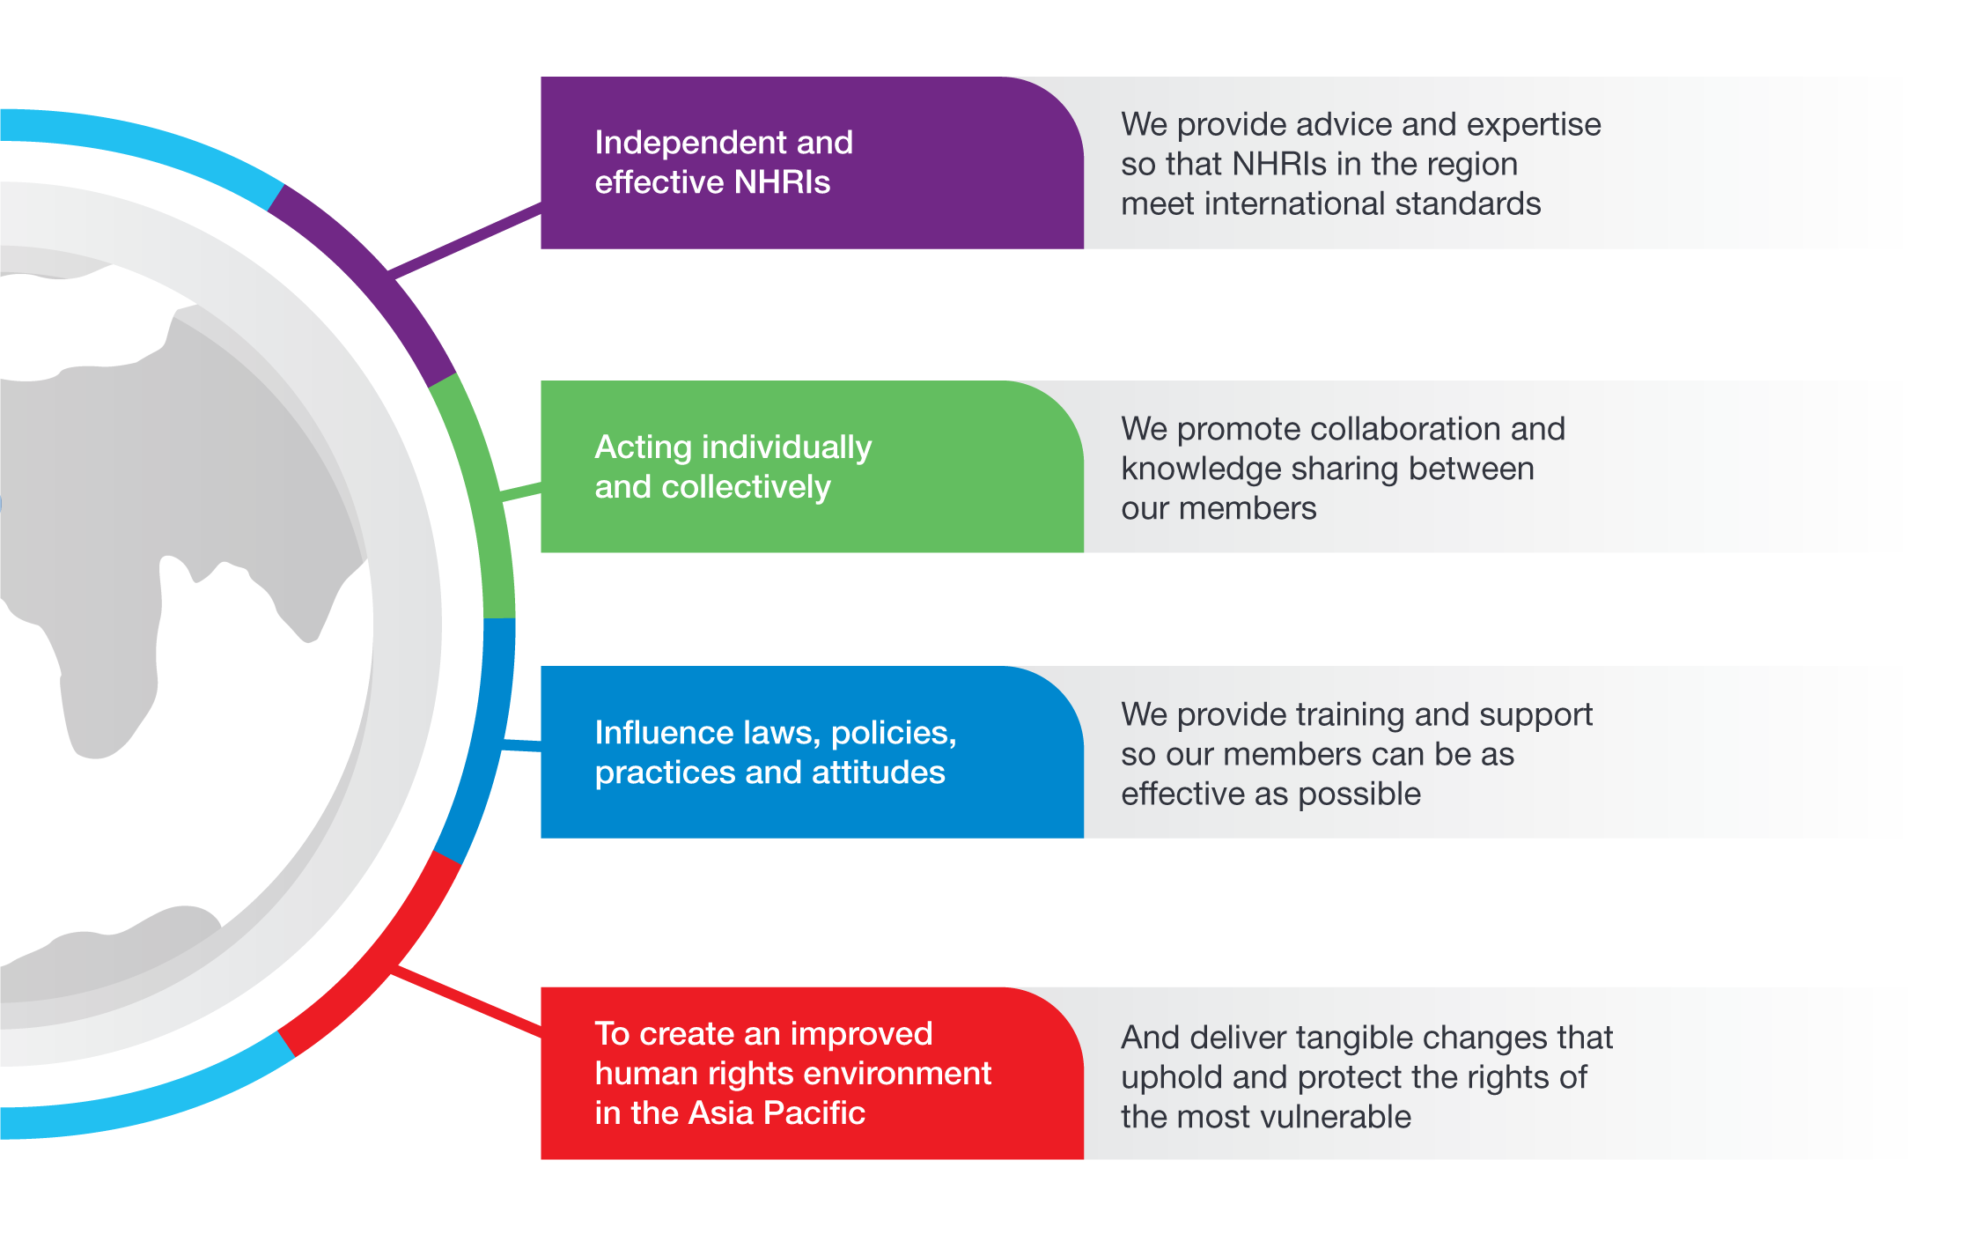

## What does change look like?

Change can take many forms: removing discrimination in laws and policies, improving the practices of law enforcement and government officials, giving vulnerable groups a say in decisions that affect them, promoting better ways of doing business, and challenging the prejudice and stereotypes that can lead to discrimination and violence.

These changes – big and small – make a lasting difference in the lives of individuals and strengthen the fabric of our communities.

Serving people at their door step

In May 2017, individuals from across Assam and Meghalaya in north-east India, were encouraged to bring their complaints directly to the National Human Rights Commission.

The Commission – led by its Chairperson, Justice Dattu – heard 43 matters during a two-day open hearing and camp sitting.

The Commission took up issues such as the forest rights of the Chakma people, a 2014 massacre incident, trafficking of girls, child labour, the rape on a tribal minor girl, and denial of basic amenities to local people.

Cases of deaths during police action and deaths of persons in custody were also raised.

The Commission has been holding camp sittings and open hearings across India “to serve people at their door step”.

# Our achievements in 2016–17

## New partnerships to counter violence and discrimination

Lesbian, gay, bisexual, transgender and intersex (LGBTI) people in the Asia Pacific can experience shocking levels of violence, harassment and discrimination. However, a series of ground-breaking APF-UNDP workshops has helped establish country-level partnerships across the region to better promote and protect the rights of LGBTI people. These workshops brought NHRIs and LGBTI civil society groups together for the first time in order to build mutual understanding and identify areas where they could work together for genuine change. The workshops were part of a comprehensive program of activities delivered by the APF and UNDP over the past year.

## Addressing the root causes of family violence

A landmark national inquiry was launched by Samoa’s NHRI in December 2016 to identify the factors contributing to the widespread incidence of family violence in the Pacific island nation. It will also seek to improve support for the women and children affected. The Ombudsman of Samoa first drew attention to the disturbingly high levels of violence and abuse, including sexual abuse of children, in his 2015 State of Human Rights report. With gender equality a priority for the APF, we have provided financial and technical assistance to support the NHRI undertake this important work, including providing training for staff members in all aspects of conducting a national inquiry.

## NHRIs given participation rights at UN body

The unique contribution that NHRIs can offer to international discussions of human rights has been recognised in an historic decision to include them as independent participants in the work of the UN Open-Ended Working Group on Ageing (OEWG). The decision was adopted during the 7th session of the OEWG, held in December 2016. It means that ‘A status’ NHRIs are now be able to contribute directly to the work of the OEWG as it deliberates on a possible convention on the rights of older persons. This outcome is the end result of consistent and ongoing advocacy by the APF and GANHRI to secure independent participation for NHRIs in the work of New York-based UN bodies.

## Stronger NHRIs building fairer communities

The APF invests in building strong and effective NHRIs because, when they are able to deliver on their mandate, they protect and uphold the human rights of vulnerable people and marginalised communities. Drawing on a range of data sources, we have seen the capacity of APF members grow steadily in collective terms over the two-year period from 2015. It means that our efforts to support NHRIs through training, advice, networking and other services are making a meaningful difference, with direct benefits for people in countries across the Asia Pacific region.

## Growing APF membership

Membership of the APF grew to 24 in 2016–17, with the NHRIs of Bahrain and Iraq admitted as associate members at the 21st APF Annual Meeting in October 2016. Both the National Institution for Human Rights of Bahrain (established in 2014) and the Iraqi High Commission for Human Rights (established in 2008) have been accredited by GANHRI with “B status”. The APF now includes 15 full members and nine associate members. Full membership is equivalent to the GANHRI accreditation of “A status” and associate membership is equivalent to the GANHRI accreditation of “B status”.

## Widespread support for rights bodies in the Pacific

Over the past 12 months, community members, NGOs and government officials from different corners of the Pacific have highlighted the human rights challenges they face during consultations with the APF and the South Pacific Community’s Regional Rights Resource Team. The consultations in Tuvalu, Nauru, the Cook Islands and the Marshall Islands showed strong support for the establishment of NHRIs that could help address these challenges. A Bill to establish an NHRI in Tuvalu, which the APF helped to draft, is currently before that nation’s parliament.

## Equipping NHRI staff with new skills

In 2016–17, we delivered 18 training activities benefiting APF members, with some APF members involved in up to nine training courses. A combined total of 276 NHRI representatives (59% female, 41% male) took part in our training programs. The courses covered a diverse range of topics including, among others, the human rights of women and girls, LGBTI people, workers in the garment sector, people with disabilities, human rights and climate change, and monitoring economic, social and cultural rights.

# Providing advice and expertise

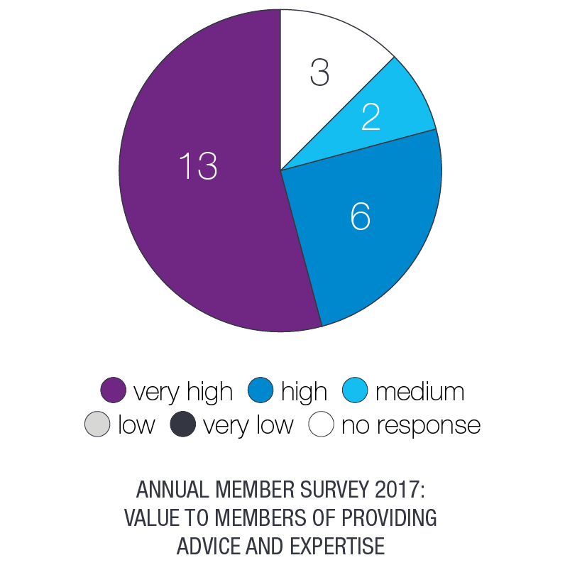What we achieved in 2016–17

* Held consultations in four countries across the Pacific to explore possible pathways for establishing an NHRI.
* Helped prepare draft legislation to establish an NHRI in Tuvalu, with the Bill presented to the Parliament in early 2017 for discussion and debate.
* Provided support to five APF members seeking international accreditation with the Global Alliance of National Human Rights Institutions.

Responded to 20 requests for legal advice from APF members, governments, international organisations and civil society groups.

People who have experienced abuse and human rights violations need somewhere to turn to. Some institutions, such as the police, may not be appropriate. Others, like the courts, can be costly, inaccessible and intimidating.

This is why strong and independent NHRIs are so important. They provide a safe and informal place where all people – men and women, young and old, citizen and non-citizen – can bring complaints and seek redress.

The APF works with governments and civil society groups in the region to help establish NHRIs that are strong defenders of human rights.

This year we joined with the South Pacific Community’s Regional Rights Resource Team to conduct scoping visits to four Pacific Island countries:

* Tuvalu (5-12 July 2016)
* Nauru (6-10 March 2017)
* Marshall Islands (18-24 March 2017)
* Cook Islands (15-24 April 2017).

During our consultations, we were told about the challenges facing women and girls, young people and workers, among others. We also heard about the threat that climate change poses for the livelihood and safety of whole communities.

Our discussions in each country found strong support for the establishment of an NHRI that could protect the rights of individuals and also address community-wide challenges.

Progress to establish an NHRI in Tuvalu has been especially swift, with the APF assisting in the preparation of draft legislation that was presented to the Parliament in early 2017. The Bill includes explicit protection for the rights of women and girls.

## Recognition on the international stage

Five APF members sought reaccreditation with the Global Alliance of National Human Rights Institutions (GANHRI) during the year, with the APF providing each with advice and support.

The NHRIs of Australia, Indonesia, Jordan and the Philippines were re-accredited with ‘A status’, while the re-accreditation decision relating to the National Human Rights Commission of India was deferred until November 2017.

‘A status’ accreditation allows NHRIs to participate in meetings of the UN Human Rights Council, the human rights treaty bodies and in the Universal Periodic Review, where they raise pressing issues and recommend solutions that will deliver meaningful change for vulnerable groups back home.

The Office of the Ombudsman of Samoa officially became an ‘A status’ NHRI in August 2016, following its review by GANHRI in May 2016.

It is uncommon for an NHRI to be awarded “A status” at the initial accreditation. However, GANHRI’s decision was based, among other things, on the broad human rights mandate of Samoa’s NHRI. The APF played a key role in drafting the founding legislation that underpins the work of the Ombudsman.

Landmark inquiry tackles climate change threats

As the impacts of climate change hit home, communities across the Philippines are in crisis.

In some parts of the country, people have been forced to relocate because of rising sea levels, while others struggle to make ends meet with dwindling fishing stocks and falling agricultural yields.

Many live in fear of deadly super-charged storms, following Typhoon Yolanda in 2013 which devastated parts of the Philippines and killed more than 6,000 people.

A ground-breaking inquiry by the Commission on Human Rights of the Philippines is investigating the links between carbon emissions, climate change and human rights.

Those who brought the case argue that climate change threatens a range of fundamental human rights, most critically the rights to life, to health, to food, to water, to sanitation, to adequate housing, and to self-determination.

The activities of 47 ‘carbon majors’ – investor-owned oil, natural gas and coal producers and cement manufacturers – are the focus of the Commission’s inquiry.

The APF, in partnership with GANHRI, submitted an amicus brief to the inquiry and noted that the adverse connection between climate change and human rights “is supported in numerous Human Rights Council resolutions and can therefore be regarded as uncontroversial”.

We also concluded that the Commission has the authority to investigate the petition, on the basis of both domestic and international law.

# very high - 13, high - 8, no response - 3Building stronger national human rights institutions

What we achieved in 2016–17

* Helped build new country-level partnerships to counter the violence, discrimination and prejudice that LGBTI people in the region face.
* Contributed to a measurable growth in the capacity of APF members, in collective terms, over the two-year period from 2015.

Provided 276 representatives from 23 APF members with new skills in promoting and protecting human rights.

From conducting inquiries and investigating complaints through to running outreach programs and advising government on laws and policies, the work of NHRIs is all about building fair, just and inclusive communities.

The APF provides a broad range of services to support our members in their work to promote and defend human rights, especially on behalf of those most vulnerable to violations.

During 2016–17, the APF hosted High Level Dialogues with the leadership teams of the:

* **Human Rights Commission of Malaysia** (9-10 November 2016)
* **Commission on Human Rights of the Philippines** (8-11 February 2017)

Depending on its founding legislation, a new leadership team will be appointed to an NHRI every three to five years. The High Level Dialogues provide an opportunity for newly-appointed Commission members to agree on the human rights priorities for their NHRI and how they will drive change.

During the year, the Commission on Human Rights of the Philippines specifically requested a High Level Dialogue to reflect on how it could best respond to the surge in extra-judicial killings during the government’s “war on drugs” and the threats it has faced for carrying out its investigations.

Between March and April 2017, the **National Human Rights Institution of Bahrain** conducted a capacity assessment, in partnership with the APF, UNDP and OHCHR. Capacity assessments enable our members to identify the practical and strategic steps they can take to strengthen their institutions.

The APF also supported the **National Human Rights Commission of Bangladesh** by reviewing progress and challenges in implementing recommendations following its capacity assessment in 2014.

## Professional development training and resources

Staff and Commissioners of NHRIs work on the frontline of human rights. They inspect places of detention. They investigate allegations of abuse. They monitor issues and places of concern. They train law enforcement officials.

It is demanding work, which the APF supports through a broad range of professional development training programs and resources.

In 2016–17, we conducted 18 training activities benefitting APF members, with some APF members involved in up to nine training courses. A combined total of 276 NHRI staff (59% female, 41% male) took part in our training programs.

The courses covered a diverse range of topics including, among others, the human rights of women and girls, LGBTI people, workers in the garment sector, people with disabilities, human rights and climate change, and monitoring economic, social and cultural rights.

In addition to APF members, representatives from five additional NHRIs in the region took part in our training programs: Pakistan, Fiji, Kyrgyzstan, Turkmenistan and Uzbekistan.

The right to live free & equal

Lesbian, gay, bisexual, trans and intersex (LGBTI) people in the Asia Pacific region can experience shocking levels of violence, harassment and discrimination.

For a number of years now, many APF members have played an important role in responding to these violations and countering the prejudice that fuels these acts.

In 2016, the APF and UNDP Asia Pacific Regional Hub launched an 18-month program of support to equip our members with additional knowledge and tools to bolster their work with LGBTI communities.

The partnership has delivered:

* Training for 60 representatives from NHRIs and LGBTI organisations in South Asia, South East Asia and the Pacific
* Guidelines to support NHRIs in their efforts to “mainstream” LGBTI human rights considerations into their strategic plans and work programs
* A world-first publication on human rights in relation to sexual orientation, gender identity and sex characteristics

An international conference to mark the 10th anniversary of the adoption of the Yogyakarta Principles.

“The APF has helped deliver a ground-breaking initiative that will make a genuine difference for LGBTI communities across the Asia Pacific.”

Edmund Settle, UNDP Bangkok Regional Hub

# Promoting gender equality

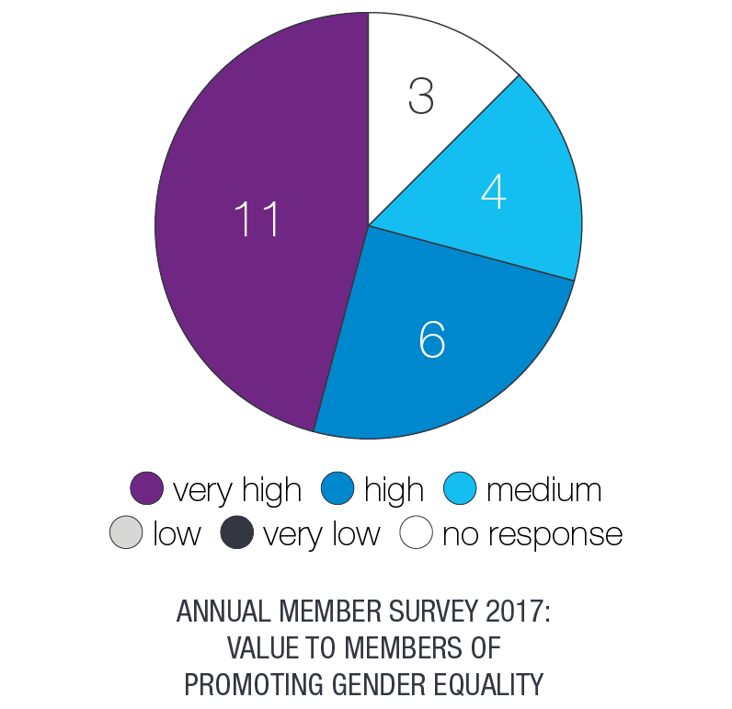What we achieved in 2016–17

* Provided APF members with practical support to promote and protect the rights of women, including a ground-breaking national inquiry into family violence in Samoa.
* Conducted an analysis of gender equality among APF members and continued to encourage decision makers to ensure equal representation of women at all levels of NHRIs.

Developed guidelines to ensure that all APF secretariat staff, consultants and trainers address gender-related issues in a consistent manner.

Across the Asia Pacific, entrenched roles, attitudes and stereotypes mean that many women and girls experience poverty, discrimination and unequal access to basic services. And while positive changes are taking place, the pace of that change remains slow.

Many APF members have been extremely courageous in confronting the complex issues that place women and girls at risk of discrimination and serious human rights violations, such as rape, “honour killings”, family violence and human trafficking.

Their vital work continued this year, with the APF providing training and support to the:

* **National Human Rights Commission of Nepal** to conduct a public inquiry on access to justice of survivors of rape in Kavre District, as a follow-up activity our inaugural training program on the human rights of women and girls in 2015
* **Commission on the Human Rights of the Philippines** to assist the NHRI bolster its advocacy and complaint handling work, as well as deliver on its mandate as the nation’s Gender Ombud
* **Office of the Ombudsman of Samoa** to conduct a ground-breaking national inquiry into family violence.

## A powerful voice for women and girls

In the past year, our members have spoken out strongly to defend the fundamental right of women to be free from violence and exploitation and to be treated with fairness and dignity.

APF members have:

* Called for improved data collection to better respond to domestic and family violence homicides (Australia)
* Conducted a major study to document the scale and emerging trends in human trafficking (Nepal)
* Made practical recommendations to improve access to reproductive health information and services for all women, following a national inquiry (Philippines)
* Advocated raising the minimum age of marriage for Muslim girls (Malaysia)
* Drawn attention to the “pathetic” conditions of women workers in textile retail shops (India)
* Empowered young women with information and tools to tackle the gender pay gap (New Zealand).

Gathering the stories of family violence survivors

Samoa’s Office of the Ombudsman has invited survivors of family violence to come forward and share their stories as part of the country’s first national inquiry into the issue.

Perpetrators, family members and support providers have also been asked to contribute their views and experiences.

The inquiry team will work with government service providers and NGOs to ensure that people can share their stories in a safe and secure environment.

The Family Violence Inquiry was launched on 10 December 2016. Since then, the Ombudsman’s Office has carried out consultations with a broad range of NGOs, government bodies, international partners and community groups.

The inquiry is based on the understanding that the most effective solutions to end family violence will come from survivors and those who have a direct influence on the lives of Samoan families.

The APF has provided financial and technical assistance to support the Ombudsman undertake this important national inquiry, including providing practical training for the inquiry team members.

“We need to explore why people do what they do so we can better address the problem here in Samoa.”

Maiava Iulai Toma, Ombudsman of Samoa

# Collaborating for change

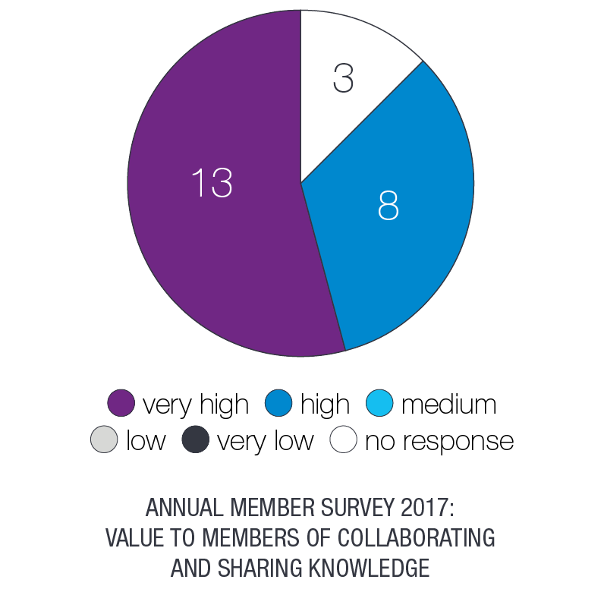What we achieved in 2016–17

* Brought Commissioners and staff of APF members together to deepen their connections and establish joint projects to tackle critical human rights issues, including in relation to the death penalty, and rights of migrant workers, refugees and persons with disability.
* Worked with our members to launch an Arabic language version of the APF website to make information more accessible to NHRIs and partners in West Asia.

Created opportunities for NHRIs to build relationships with civil society organisations in the region, especially groups advocating for the rights of LGBTI people.

Despite the diverse social, cultural and political environments in which they operate, APF members face a raft of common human rights challenges.

Further, a growing number of human rights violations – like human trafficking, exploitation of migrant workers and the impact of corporate activities – are crossing borders.

It means that collaboration is increasingly important to monitor and counter human rights abuses.

One of the great strengths of the APF is the collegiality that exists between our members and their desire to work together and share information to more effectively tackle pressing human rights issues.

In the past year, APF members have formed partnerships to address issues related to business and human rights, abolition of the death penalty, promoting the rights of migrant workers, refugees and asylum seekers; and advocating for the rights of people with disabilities.

Each year, the APF hosts a range of meetings that provide opportunities for discussion and networking among our members, as well as facilitating joint action on human rights abuses. We also convene professional networks so that Commissioners and staff from different NHRIs can meet together and learn from each other.

These opportunities to collaborate and network are highly valued by our members, and have led to significant joint efforts to strategically address issues.

Through our partnership with UNDP this year, we brought NHRIs and civil society organisations together to develop projects that counter the violence, discrimination and prejudice that LGBTI people experience.

#### Audience engagement with APF video resources



Working together for workers’ rights

In December 2016, the NHRIs of Nepal and Qatar signed an 11-point “action plan” to protect the rights of Nepali migrant workers in the Gulf country.

Key elements of the plan include appointing a contact person in the respective NHRIs to exchange information; delivering training to private employment agencies; and providing legal support to Nepali workers in Qatar.

The APF and the National Human Rights Committee of Qatar also hosted a workshop in November 2016 to strengthen the work of NHRIs in countries of origin, transit and destination for migrant workers.

Representatives from the NHRIs of Afghanistan, Bahrain, Bangladesh, Indonesia, Jordan, Kuwait, Nepal, Palestine, Philippines and Qatar, as well as representatives from the Saudi Government, attended the two-day workshop.

Advocating to abolish the death penalty

Over the past year, a number of APF members have taken a strong stand against the death penalty, including in Malaysia and Palestine, and the proposed reintroduction of the death penalty in the Philippines.

Despite positive developments in other parts of the world, there is patchy progress towards the abolition of the death penalty in countries across the Asia Pacific.

A new report by the APF highlighted the pivotal role that NHRIs can play to reduce the use of the death penalty in their countries; for example, by making recommendations to amend their State’s criminal code, by monitoring trials in all capital cases, and by monitoring pre-trial and post-trial detention.

To bolster their efforts, we have invited APF members to submit a project proposal to reduce the use of the death penalty in their respective countries. We will provide financial and technical support for those members whose projects are selected.

# very high - 11, high - 9, medium - 1, no response - 3Contributing at the national, regional and international level

What we achieved in 2016–17

* Helped lead ground-breaking advocacy that resulted in ‘A status’ NHRIs being given an independent voice at the UN Open Ended Working Group on Ageing.

Provided support and assistance for APF members that faced reprisals and threats to their independence.

## Opening up new avenues for advocacy

As part of their role to drive change at the national level, NHRIs are increasingly turning to the international human rights system to share information, draw attention to pressing issues and advocate for recommendations that can be made to their States.

A number of our members made submissions to UN human rights treaty bodies and the Universal Periodic Review during the year.

While ‘A status’ NHRIs are able to contribute to the work of the Human Rights Council in Geneva, participation in the mechanisms of the General Assembly in New York has been extremely limited.

The APF has been at the forefront of a global campaign to secure the independent participation of NHRIs in these UN bodies for a number of years.

Our advocacy was rewarded in December 2016 when the **UN Open Ended Working Group on Ageing** became the first General Assembly mechanism to formally include NHRIs in its work.

This is an historic achievement and sets an important precedent to make space for the independent participation of NHRIs in other bodies of the General Assembly.

During the year, the APF and our members led similar advocacy efforts at the **UN Commission on the Status of Women** (March 2017) and the **UN Permanent Forum on Indigenous Issues** (May 2017).

## Supporting members facing attacks and reprisals

A vital role of the APF is to support our members to maintain their independence from government, in accordance with the law establishing them.

Independence and integrity are central to being effective and trusted human rights defenders.

The APF has been gravely concerned by the political attacks, reprisals and budget cuts that some of our members– including the NHRIs of Australia, Afghanistan, Malaysia, the Maldives and the Philippines – have faced for undertaking human rights work in accordance with their legal mandate.

We mobilise support for APF members facing attacks and reprisals, where they request it, and highlight to governments the important role of NHRIs.  They need to perform their duties with integrity, independence and impartiality, drawing on national and international human rights standards.

Putting an end to “routine torture”

In October 2016, the Human Rights Commission of Sri Lanka provided a detailed submission to the Committee against Torture that highlighted the “routine” practice of torture across the island nation, regardless of the nature of the suspected offence for which the person is arrested.

“For instance, those arrested on suspicion of robbery, possession of drugs, assault, treasure hunting and family disputes have been subjected to torture,” the Commission said.

The report described “the prevailing culture of impunity” as a contributing factor to the routine use of torture in interrogations and investigations.

The Committee drew on this information when it provided recommendations – or “concluding observations” – to the Government of Sri Lanka to improve protections for detainees, especially during the interrogation phase, and to ensure judicial oversight following their arrest.

Deaths should not be an “inevitable consequence”

After coming to power in May 2016, the President of the Philippines, Rodrigo Duterte, launched a “war on drugs” that has resulted in thousands of extrajudicial killings.

The Commission on Human Rights of the Philippines has been the subject of consistent attacks by the President and other senior officials for its investigation into deaths linked to the crackdown.

In May 2017, President Duterte threatened to “behead” human rights advocates who criticised the country’s record.

“Words matter,” the Commission said in a statement. “We are disturbed that such statements may be taken as incitement to violence and create a climate of impunity.”

“In principle, we support [this administration’s] vision of improving the lives of our people,” the Commission continued, “but a number of human rights violations, including deaths, should not be its inevitable consequence.”

The APF held a High Level Dialogue with the Commission’s leadership team in February 2017 to discuss its role to monitor and investigate these serious human rights violations, as well as the challenges it faces in doing so.

# Very high - 15, high - 6, no response - 3Strong organisational leadership and governance

What we achieved in 2016–17

* Agreed on new governance arrangements that will better meet the needs of our growing membership and our ability to respond to pressing human rights challenges.

Provided a stable funding base that allowed us to deliver services focused on the needs of vulnerable individuals and groups across the region.

The APF is an independent, non-profit organisation, with a board of directors – the Forum Council – that reflects the regional diversity of our membership.

As an organisation, we seek to operate according to the highest levels of accountability, efficiency, transparency and member participation.

The APF secretariat manages the day-to-day operations of the APF and implements the decisions of the Forum Council.

A proposal to reinvigorate the APF’s governance structure to better meet the needs of our growing membership was approved at the APF’s annual meeting in October 2016.

The decision means that the APF will establish a General Assembly that will be responsible for setting strategy and making high-level decisions. The General Assembly will include ‘A status’ members (with voting and participatory rights) and ‘B status’ members (with participatory rights)

We will also establish a five-member Management Advisory Board, elected from ‘A status’ members, who will make recommendations to the General Assembly on a range of issues. The composition of the elected Management Board will reflect our regional diversity and promote gender equality.

## Building ownership and belonging

A sense of ownership and belonging among our members is what gives the APF its strength and effectiveness.

Our members place significant value on their membership of the APF and all rate their overall satisfaction with the APF’s governance and organisational structure as high or very high.

Our members all said they were highly satisfied with the performance of the APF secretariat, reflecting the efficiency and professionalism of its small staff of seven.

#### APF membership growth from 1996

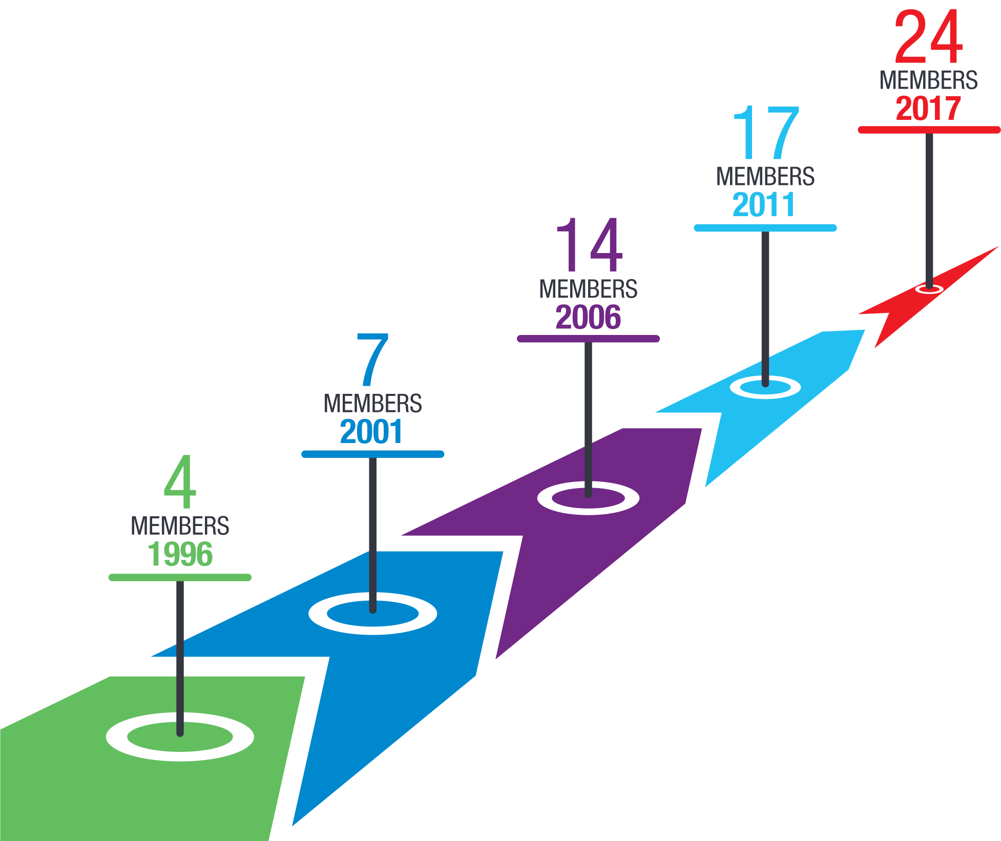

## Funding

The APF receives funding from governments, institutional donors and member contributions.

Total income and expenditure for 2016–17 was approximately AUD 2.9 million, which was slightly higher than in the previous years.

Additional funding was received this year from UNDP and the European Union to run a series of new training programs with our members, including a world-first course on human rights and sexual orientation, gender identity and sex characteristics.

Our expenditure in 2016–17 reflects our work to improve the lives of people who are vulnerable to human rights violations and abuse.

#### APF activities per beneficiary groups in 2016–17

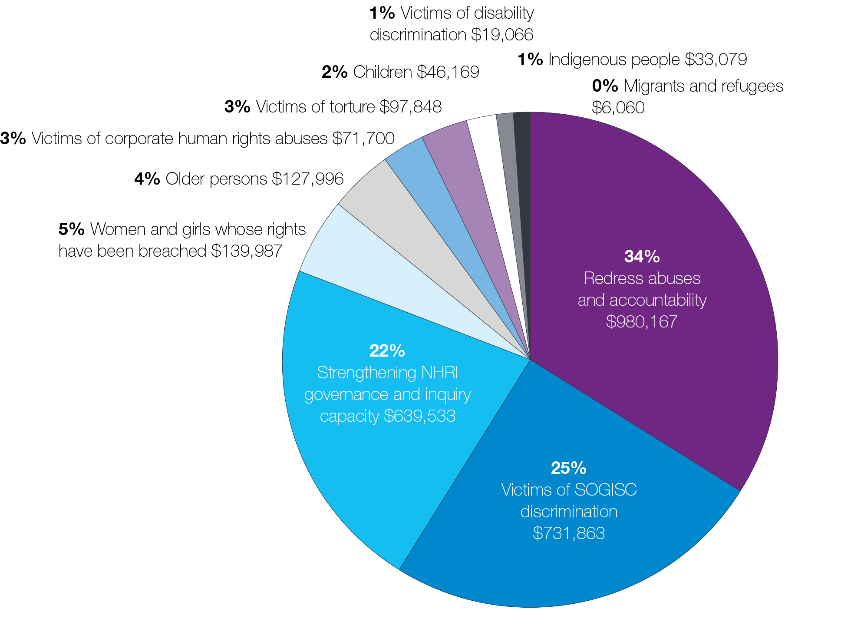

**We are grateful for the support of partners and donors who share our commitment to an Asia Pacific where everyone enjoys human rights.**