Programme announced for Camden zero-waste design festival in September 2025

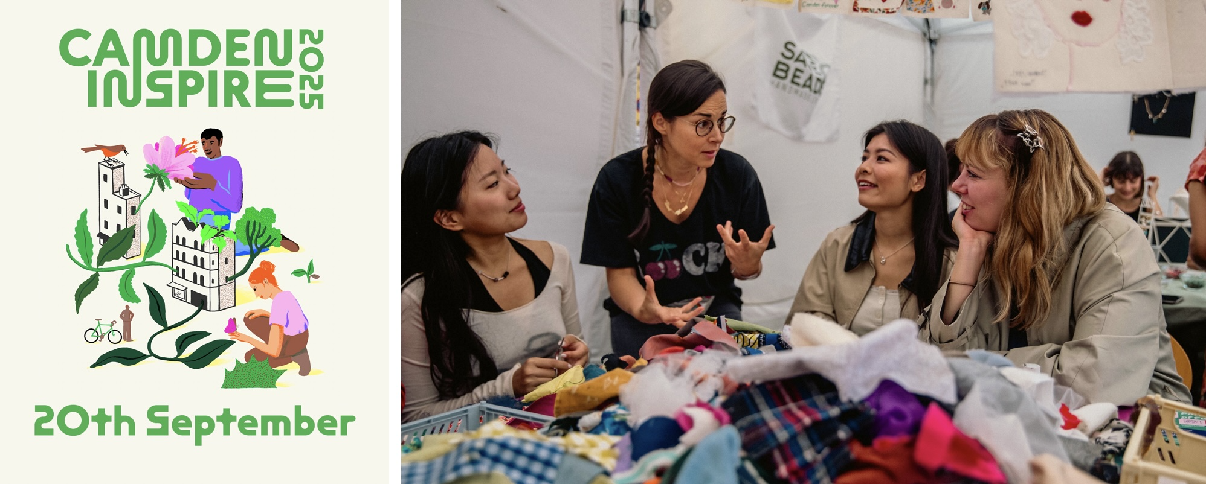
Camden Inspire: Green Loop Takeover has announced the programme for its free, one-day climate festival taking place in Camden on Saturday 20th September.

Bringing together dozens of organisations, artists, designers, makers, chefs, activists and musicians, the full day of activities explores reuse, zero waste and imagines bold new creative ways of living with less.
Part of London Design Festival, Camden Inspire will take place in Camden Collective’s two coworking meanwhile-use buildings located on Buck Street, less than 5 mins walk from Camden Town tube station and is organised by Camden Town Unlimited and Euston Town Business Improvement Districts.
For the full Camden Inspire 2025 Programme please see: www.camdeninspire.com/programme

The events are broken down into Make, Do and Discuss, highlighting the range of different activities available during the day, with booking required for some sessions, while others are offered as a drop-in.
Festival Highlights

World-renowned Camden organisations will host a full range of hands-on workshops including: The British Library have appointed Alain Fusion Clapham to host a transformational storytelling workshop for young people, podcasting interviews around waste and climate change with Roundhouse, HvH arts host a nature photography workshop, design plant pots with Rochester Square Gardens, take part in Wayward Architecture’s plant rescue scheme and learn to repair your electricals with The Fixing Factory.

In additions other creative workshops will be held throughout the day: Things Matter CIC will host creative fashion upcycling, Protest Placard Design sessions by artist Molly Hankinson, a kintsugi session by Dotty by Design, Studio Kuhu revitalising fashion with a fabric dying workshop and EcoArtivist Francesca Busca will turn discarded materials into artworks. Insight into plastic recycling will be provided by Are You Mad?, while STORE explores experimental techniques and creative collaborations with artists and designers.
A Pop-Up Cinema will host screenings of local project films and documentaries to be confirmed, as well as performances by musicians Alice Boyd and more TBC.
A midday food waste panel discussion including Taz Khan of the London Community Kitchen will be followed by a special Community Feast by Caribbean & African kitchen Garden of Afruika.
And the day will conclude with a panel discussion Less is More: The Future of Design with Longevity with Studio Bark, Nina + Co, Studio Tip and Debika Ray.

UnBroken Exhibition and Auction
At the heart of the festival is a show-stopping exhibition of salvaged furniture, saved from landfill and transformed by celebrated designers into one-of-a-kind creations. The show will give new life to old materials donated by Camden based PropUp Project. Showcasing the power of design to inspire change, guests are invited to an exclusive auction and will have the chance to bid for the furniture, with all proceeds supporting local climate causes.
Designers include a range of established and emerging talents from London’s world class designer scene, they include: Pearson Lloyd, MUF architecture, Charlie Boyden
2LG Studio, Francesco Feliziani, Sebastian Bergne, Jaclyn Pappalardo, Andre Kong
Following Camden Inspire the UnBroken exhibition will run into the evening of Saturday 20th September.

Simon Pitkeathley, CEO, Camden Town Unlimited and Euston Town
“I’m incredibly proud of our team for delivering such a powerful and inspiring event. This festival is a celebration of what can happen when creativity meets climate action, built on months of work from both our BIDs and the consistent support of the local business community. We’ve always believed that local communities hold the key to genuine, grassroots solutions to the climate emergency. The reception to our call-to-action proves that belief. It’s also been a privilege to host so many climate tech startups in the Collective Climate School workspace and see firsthand how innovation and sustainability can thrive side by side. This festival is a clear example of the leadership BIDs can bring in uniting business, creativity, and sustainability for lasting impact.”

Alain ‘Fusion’ Clapham, Educator & Creative Producer, in partnership with the British Library:
"I'm honoured to be part of the Camden Inspire festival this year, appointed by the British Library, who are partnering on the programme. I’ll be hosting a transformational storytelling workshop, empowering young people to take a creative journey exploring sustainability, consumption and their own agency. We have very exciting plans to continue working with those participants and build a growing network of young people who really care about the future. This event is not a one-off, it’s about building something with longevity - and I’m excited to see where it leads to.”
Marcus Davey, Chief Executive & Artistic Director, Roundhouse
“At the Roundhouse, we believe in the power of young voices to shape the future. We are hosting sessions at Camden Inspire that will give a real insight to the art of podcasting, whilst amplifying fresh perspectives from young people on climate change and waste - issues that urgently demand creative and courageous thinking. We’re proud to support a festival that is dedicated to platforming new ideas, empowering communities, and placing young creators at the heart of the conversation”
Orla Daisy, Camden Inspire Young Ambassador
“I’ve been waiting for an opportunity like this to come into my radar. As an artist, I've found it difficult to feel motivated due to being distracted by world affairs, harbouring a sense that I should be helping in some way. Community and creativity tied to an important theme is needed right now, at a time where there is a general feeling of disconnect and destruction. I think this festival is the start for more such collectives that address the issues we are facing as a community. As an ambassador, I'm excited and pleased to be running my own workshops leading up to the September festival and hope to bring together likeminded people who have- like me- been waiting for an open community that prioritizes the wellbeing of ourselves and the environment and the arts.'”
Notes to editors
Press contact: rob@robertfiehn.com / bobby@bobby-jewell.com
Images can be downloaded here
About Camden Inspire
Camden Inspire is an annual community festival that celebrates creativity, culture and local connection. First launched in 2021 by Camden Town Unlimited Business Improvement District, the festival was born out of a desire to bring life back to Camden’s streets post-lockdown. Each year, it brings together artists, institutions and residents for a day of workshops, performances and public art. In 2025, Camden Inspire is evolving and will be partnering with the Camden Green Loop to focus on sustainability, repair and climate action through hands-on, community-led programming.
Camden Inspire: Green Loop Takeover will still celebrate Camden Town’s wonderful arts scene, but through an environmental lens. This is a festival of ideas around how we live, what we value and how we can shape a bright, shared future.
camdeninspire.com
@camdeninspire
www.camdentownunlimited.com

Camden Green Loop
The Camden Green Loop is a neighbourhood strategy developed by Camden Town Unlimited and Euston Town Business Improvement Districts. It aims to connect green spaces, cultural institutions and local communities through walking routes, environmental initiatives and placemaking projects.
Camden Green Loop

Camden Collective
Camden Collective is an independent registered charity that transforms vacant buildings into vibrant community hubs. Operating on a meanwhile-use basis, it offers free co-working spaces, subsidised offices and tailored business support for creative and climate-focused start-ups in Camden Town. Since its inception, Camden Collective has supported hundreds of small businesses and freelancers providing affordable workspace, mentorship and opportunities for collaboration.

Camden Collective is currently based in two repurposed sites: the former Hawley Infants Primary School and a former auction house on Buck Street, just off Camden High Street.
camdencollective.co.uk

