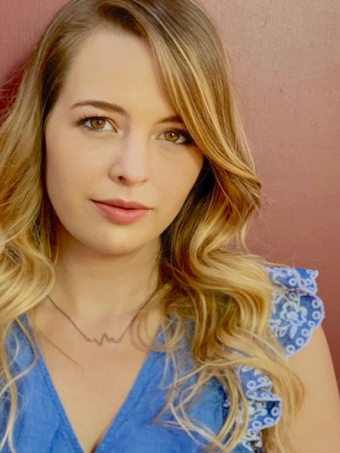
Mariah Moore
Actor mariah32leigh@gmail.com
(928) 242-7570
Height: 5’4”
Hair: Dirty Blonde
Eyes: Hazel

THEATER:
The Immoral Miss O’Neill Deirdre O’Neill 2016
Machinal Telephone Girl 2017
FILM:
Clare Control Clare 2018
Evelyn and Ace Isabel Wilson 2019
The Mix-Up The Writer 2019
Life Under the Stars Mel 2019
Thoroughbreds Amanda 2020
Sophie Soulmates 2020
Rachel Getting Married Kym 2020
TRAINING:
Acting Course Northland Pioneer College Dr. Michael Solomonson
Acting for Camera American Academy of Dramatic Arts Los Angeles, California
(Summer Intensive)
BFA (Acting) Academy of Art University San Francisco, California
SPECIAL SKILLS:
Guitar Ukulele Singing Juggling Beginning Sign Language Stage Combat

