Julia L. Eggert
3900 SE 183rd Avenue, Vancouver Washington 98683
503.819.6397- jl.eggert@gmail.com

Objective
I am seeking an entry-level landscape architect position where I can grow and contribute to a variety of design projects. A small company where people work and depend on each other for inspiration and support would be ideal. My creative design skills would be an asset to your design team.

Design Experience
Montessori Outdoor School
    - Drafted and submitted plans
    - Supervised construction
    - Selected planting material chosen for texture, edible, tough and child friendly
    - Handled communication with headmaster and parents of students
    - Investigated and recommended hardscape materials
Alpine View Consultation
    - Suggested native and sustainable planting materials with special attention to seasonal color
    - Suggested improvements to grading and drainage
    - Suggested reorganization of existing planting material
Frewing Court Consultation
    - Consultation on existing landscape
    - Advised material and placement of new deck

Prior Administrative Experience
- 2010-2012: Tom Walsh Construction, Portland
- 1986-1988: Walsh Construction Co., Seattle
- 1982-1986: Walsh Construction, Co., Portland

Technical and General Skills

- Microsoft Office Suite
- Vectorworks Designer, 2D & 3D
- Adobe Suite
- Autodesk
- Color theory
- Site Analysis and Inventory
- Sustainable plant material and methods
- Space planning
- Grading and drainage
- Hardscape material

- Hand drafting, 2D and Perspective
- Budgeting and estimating
- Rhino
- Qgis
- Twinmotion
- Supervision and people management
- General office skills and management

Accomplishments
- Garden was chosen for the 2014 Garden Tour Fundraiser – with over 250 visitors
- APLD/Habitat for Humanity garden design - Honorable mention and design was used for installation

Education
- 2014-2022 Academy of Art University, BFA Landscape Architecture
- 2015 The Permaculture Institute, Certification

- 2015 Landscape for Life Organization, Certification
- 2009-2014 Portland Community College, Landscape Technology and Landscape Design

Portfolio

LAN 350 SUSTAINABILITY SITE DESIGN
SUSTAINABLE SITE – 13500 SW HALL BLVD, TIGARD, OREGON
In this class, we explored opportunities and constraints for implementing sustainable design strategies by applying the principles of green infrastructure to a site through its use, its inhabitants and its surrounding context. It is through the processes of Site Inventory and Site Analysis that I determined where the positive addressed sustainable strategies that would positively impact my selected site through careful review of case studies and extensive research of the site and the surrounding area.
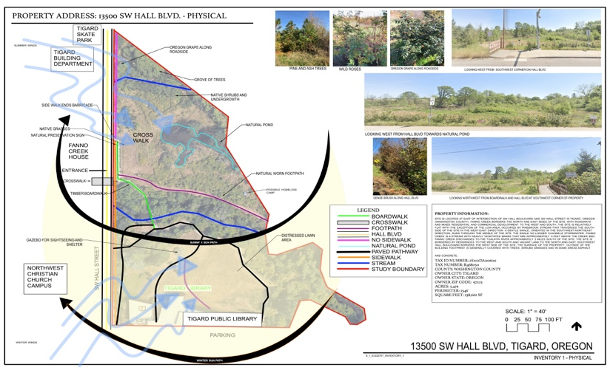
The Site Inventory and Site Analysis were performed at all three scales of physical, cultural and biological. Some challenges the site exhibited were asphalt pollutant runoff and other impervious surfaces from surrounding mixed use facilities of medium density residential and industrial sites and adjacent SW Hall Boulevard as well as nearby school transportation holding area which effect Fanno Creek and various wildlife in the area. Other problems concerning active beaver building dams on Fanno Creek slow and cause the river to flood during high precipitation periods of the year. Hazardous water quality of the creek despite years of attempts of cleaning

Material selections were made keeping in mind the importance of recycling, repurposing and choosing pervious products that were more sustainable than current concrete and asphalt applications. Finally, a Final Site Plan came together with final perspectives, sections and details; a Planting Plan; sections and elevations relating to the Planting Plan; a material plan with enlarged plans and details related to material selection and any other drawings that further illustrated my vision of this site.

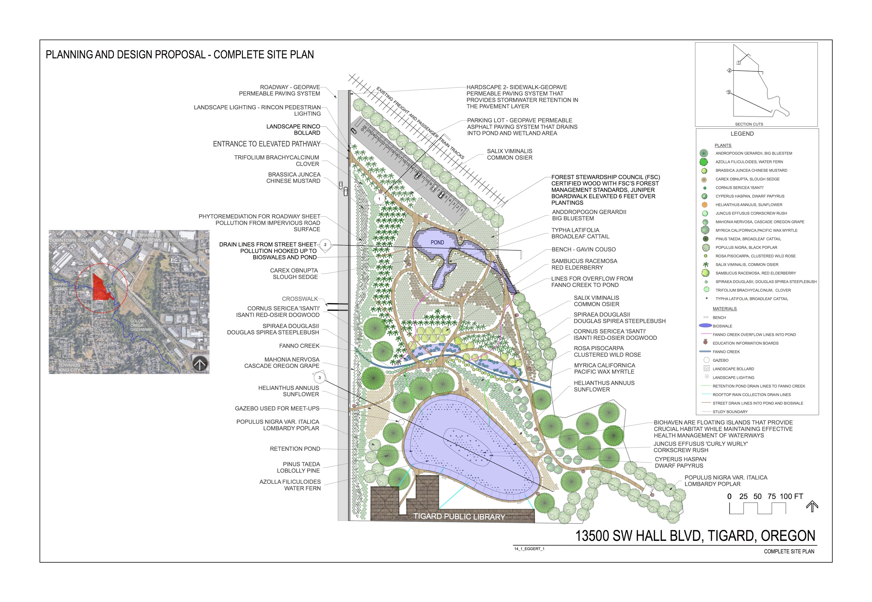
it up. Once we identified the opportunities, constraints and ecological challenges, we began to develop a plan based on sustainable practices. Three conceptual site plans were developed including sketches, sections and a written description of which option suited the site best. Next, a Preliminary Site Plan was drawn up not only considering our site on how we expected our site to transform but to include surrounding areas. Different ideas were explored, brainstormed and tossed about in this part of refining our ideas and vision of what this project could become. After this stage of the process was complete, more refining was done to the site plan and we began to propose planting strategies were studied for plants best suited to enhance the wetlands and Fanno Creek on the site. Since possible arsenic contamination still existed on the site as a previous hazelnut orchard, phytoremediation would require careful selection of plants to best extract contaminates in a biological manner. The watershed area hosts over 100 bird species, mammals and fish wildlife species and is plagued by invasives such as Reed Canary grass, Himalayan Blackberries, Japanese Knotweed, Meadow Knapweed, Giant Hogweed, Garlic Mustard and Loosestrife.

THE HIGH LINE, NEW YORK CITY CASE STUDY
This was a four-module long case study to explore the application of contemporary sustainable strategies that involved reclamation, re-use and mitigation of a site. Through understanding of how the site was organized through its topographies, research and interpretations of the site identified and described environmental issues that were present on the site and surrounding areas. A rich history was highly influential to the site through its redesign, reclamation and re-use that was communicated and understood through the close relationship developers had with the community. This project shows what can happen when leaders of a community work together with a common goal in mind.
