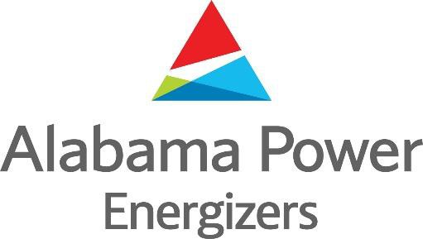

2025 Membership Application

Circle the chapter you are joining:

Corporate HQ Birmingham Eastern Gadsden Jasper Mobile Southeast Southern Western

Please provide all information to ensure you receive all Energizer communication.

Retiree Name: Spouse:

Mailing Address: _________________________________________

City: State: Zip:

Cell Phone ( ) Home Phone: ( )

Email Address: _________________________

Enclosed is my check for $
($15.00 for retiree only; $30.00 for retiree and spouse)

Please return check payable to the Energizers and mail check and membership form to:

Kim Savage
Alabama Power Company 600 18th Street North
17N-0671
Birmingham, AL 35203

Contact Info:
Kim Savage (Energizer Executive Director)
kssavage@southernco.com
O: 205-257-2473
C: 205-427-7279

