Luciferase

Bioluminescence has become a crucial analytical method over the last two decades in molecular biology, diagnostic testing, and cellular pathway research. The most exploited bioluminescence systems are firefly luciferases especially Photinus pyralis luciferase (Ppy luci) and nanoluciferase.

Photinus pyralis luciferase (Ppy luci) : Luciferase enzymes are oxidative enzymes and belong to the class of oxidoreductase enzymes, capable of decarboxylation and ATP hydrolysis. The emission of light is the result of a biochemical reaction in which substrates, i.e. luciferins, are oxidized by luciferase enzyme in presence of ATP, oxygen, and magnesium ions as cofactors.⁴ The decay of excited oxyluciferin to the ground state generates photons, producing bioluminescent light. Oxyluciferin, CO₂, and AMP are generated as byproducts in this reaction. With great advancement in the understanding of protein engineering and synthetic chemistry, attempts have been made to improve bioluminescent activity and specificity. Despite this research establishing significant precedents, factors and interactions contributing to Ppy luci inhibition by resveratrol are not clear. Furthermore, a comprehensive mechanistic framework elucidating how particular physicochemical alterations in structurally analogous inhibitors influence binding, stability, and catalytic interference also remains unattained. In our work, resveratrol and its analogs have been chosen as the model system to understand how subtle changes in the functional group can affect inhibition through a combination of thermodynamic forces, conformational changes, and oxidative interactions. Piceatannol and pterostilbene, analogous to resveratrol, are examined for their inhibitory efficacy on luciferase protein, as they have not yet been extensively investigated.

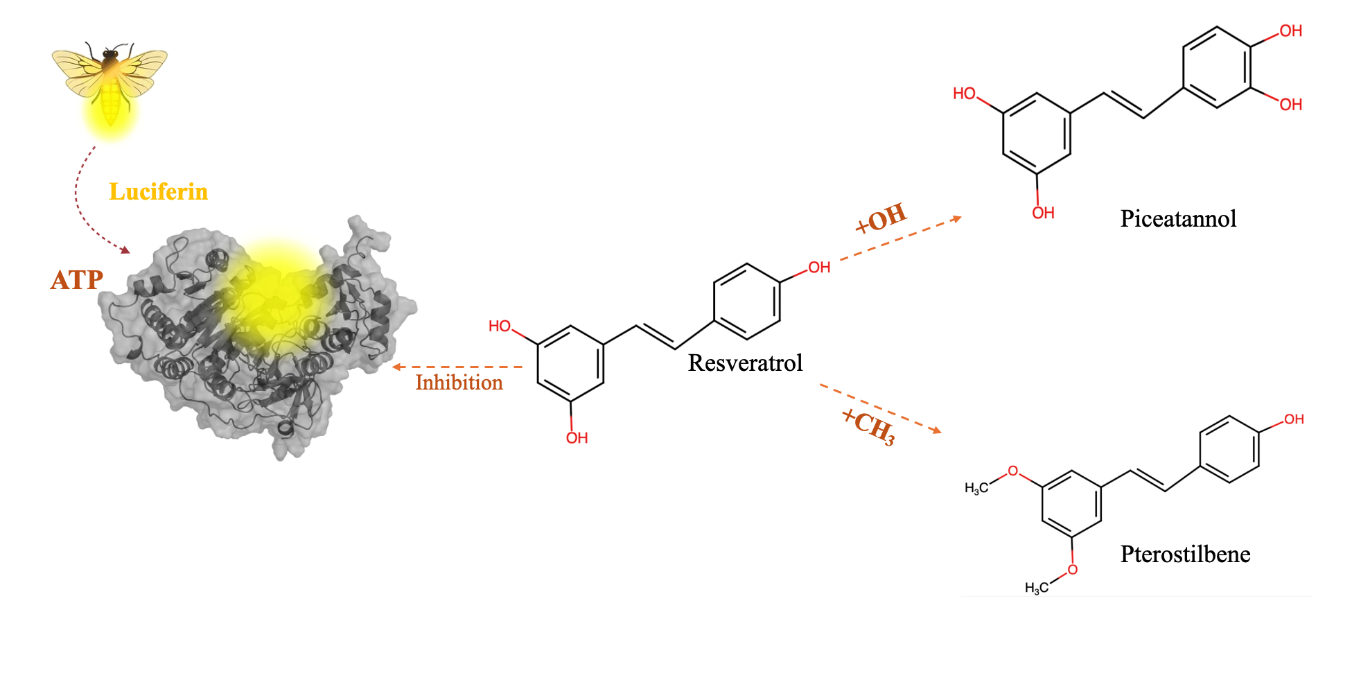

Nanoluciferase : Nanoluciferase, engineered from oplophorus luciferase (Oluc), is one such recent addition that has attracted researchers worldwide. Oplophorus luciferase (Oluc) obtained from deep marine shrimp, Oplophorus, is identified as a heterotrimeric enzyme having two catalytic 19 kDa parts and one non-catalytic leucine-rich 35 kDa. Even though Nanoluciferase, has been actively utilized in several technology, research, and development frontiers, there is a need for more dynamic and stability-based studies. With the increasing demand of luminescence in multiple domains, there is a need to enhance the thermostability of these enzymes to improve their industrial application. Industrial applications require very high temperature for processing, and thermostable protein would allow usage of substrates soluble at high temperature. Sustained luminescence activity at high temperature would allow us to exploit them for high sensitivity and precisions devices and biosensors. While high temperature may have deleterious consequences on the protein structure, protein engineering approach could be adapted to improve fieldability. Using prior art, flexible regions in Nluc protein were identified. Three flexible residues were chosen, namely : H57, V98, K123 and mutated to arginine. These mutations were targeted towards increasing the number of salt bridge, and improve the structural rigidity.

