Project Title: Dnazyme-HCR based AMR gene detection
One crucial unmet need in clinical diagnostics is the rapid and accurate identification of antimicrobial resistance (AMR), especially in high-burden and resource-constrained situations. In order to detect total resistant microbial populations, we present a hybrid dual-mode biosensing device that combines HCR based DNAzymes and ATP-dependent bioluminescent quantification.
The platform creates the folding-driven catalytic activation of metastable DNAzymes at the molecular level, where conformational rearrangement into catalytically competent structures is induced by target-specific recognition of resistance-associated DNA sequences. According to the folding-function paradigm formerly shown in DNAzyme-based biosensing devices, these programmable DNAzyme constructions behave as highly selective molecular switches, allowing accurate identification of AMR determinants by folding-mediated activation.
A luciferase-based ATP quantification offers a real-time microbial count in accordance with this specificity. A quantifiable luminescence signal proportional to the entire microbial load is produced by the enzymatic assay, which is fuelled by intracellular ATP generated from living bacteria. Crucially, the technique allows differential stratification of total and resistant populations within a single experiment by combining ATP-dependent luminescence with DNAzyme-mediated resistance detection. The sensitivity and dynamic range of this method are highlighted by the robustness of luciferase as an ATP-responsive reporter, which has been extensively verified in biochemical and viability experiments.
This integrated approach provides quick, amplification-free, and functionally informative detection, overcoming major drawbacks of traditional culture-based and molecular diagnostics. The combination of enzymatic bioluminescence readout and DNA folding-driven molecular identification creates a flexible platform that can be adjusted to a variety of pathogens and resistanceindicators. By combining structural DNA nanotechnology and metabolic activity sensing, this work presents a next-generation AMR diagnostic and biosensing platform that offers rapid,scalable, and therapeutically useful insights into antimicrobial resistance.
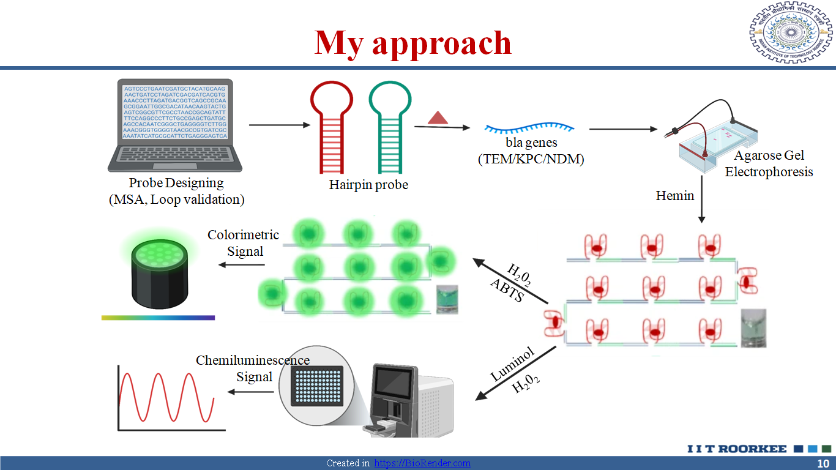

Publications: SR Nair, Adwaita, Arup Samanta, and Saugata Hazra. "Revolutionizing DNAzyme Biosensors: Pioneering Strategies, Advanced Immobilization, Versatile Applications, and Future Frontiers." ACS Synthetic Biology (2025). (Cover Art Published as well)
