5.04 Worksheet: Changing Temperature
Name:
Class:

Instructions:
Go to Lumen on the platform and choose a colour to describe. Write down the response from Lumen below.

Now generate another description from Lumen by selecting the same colour again and write down this response.

Is this different to the first response?

Select the “Model Settings” in the top right of the Lumen display


You should see the following:

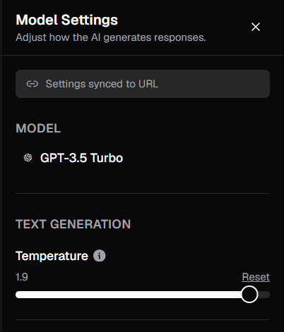

What is the temperature set to?

Now set the Temperature to 0, by dragging the slider to the left.

Choose the same colour as before and generate the one-line description again and write it in the box below.

Repeat this with Temperature = 0 and write it in the box below.

What was the effect of setting the temperature to 0?

