01.04 Worksheet: Haiku
Name:
Class:

Aim:
In this activity you will use Lumen to generate haikus, which are poems with three lines. Haikus don’t have to rhyme, they just need to follow these rules:
- Haikus have three lines
- The first line has 5 syllables
- The second line has 7 syllables
- The third line has 5 syllables

For example, the following is a haiku about possums (generated with Google Gemini):
Pink nose, pointy face,
Hiding in a hollow tree,
Sleeping all day long.

Instructions:
Generate a haiku from Lumen’s options. Write down the poem generated by Lumen below. Does it follow the rules for haikus?

Generate another haiku using the same prompt and write it below. Is it the same poem? Does this surprise you?

You can choose a different LLM to use when generating your haiku by clicking the settings menu on the top right, as shown below:


Then clicking the model name that’s there already (Claude Haiku 4.5), highlighted in blue:

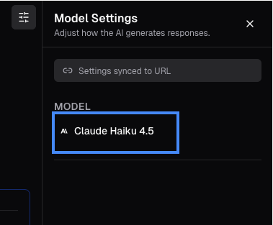

You should then see the following list of LLMs:
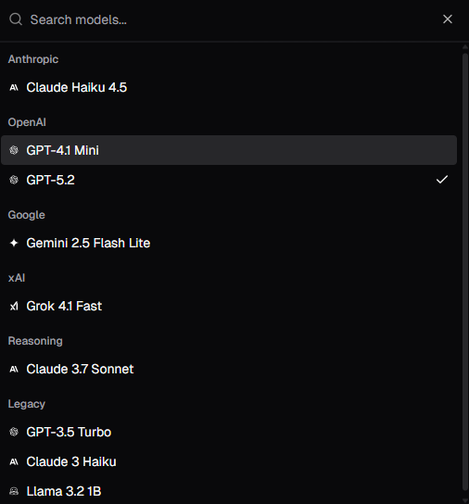

You can click one of the model names to choose another LLM. Now choose 3 different LLMs and generate 3 more haiku poems.

Write the LLMs used and the generated poems. Can you notice any difference between these poems?

