3.04 Worksheet: Training a model
Name:
Class:

Instructions:
Follow the steps on the Training a model page on the platform for training a model. Once you have trained the model, review how well it classified the test images and fill out the Version 1 row for the different images.

Next, follow the steps on the Training a model page to add more images to the training for the model. Then review how well Version 2 classified the test images.

Image | Classification (Cat or Dog?) | Confidence (%) | Correct?
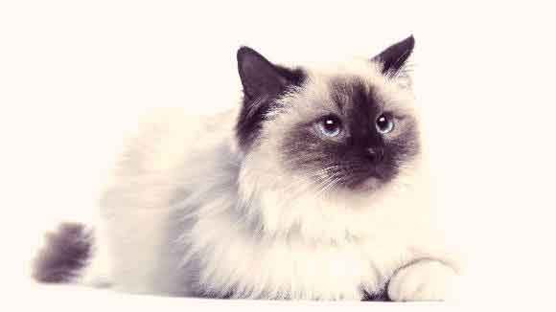 | Version 1
 | Version 2 (after retraining)
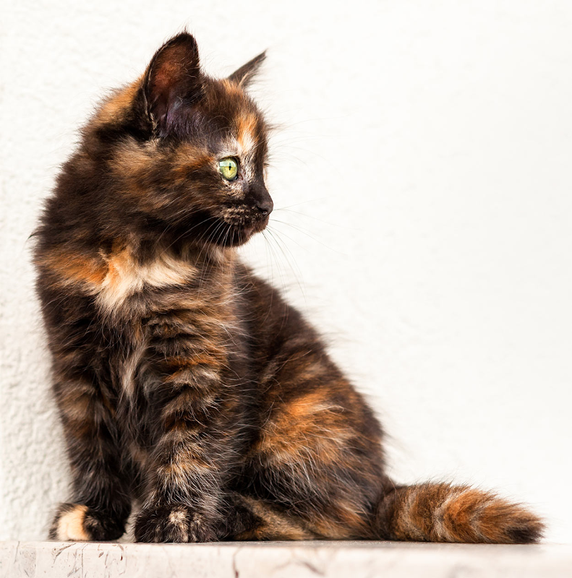 | Version 1
 | Version 2 (after retraining)
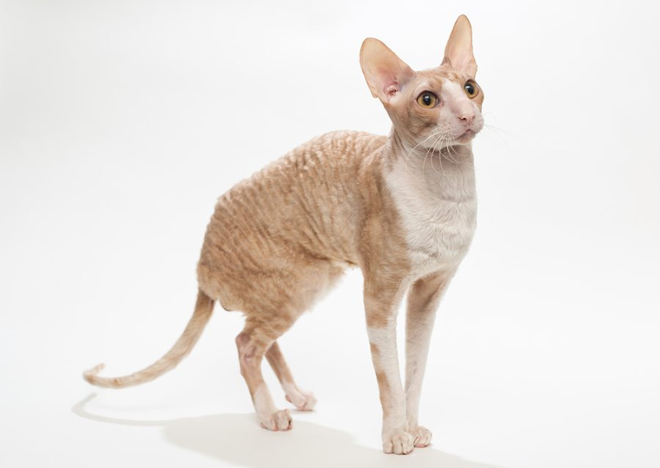 | Version 1
 | Version 2 (after retraining)
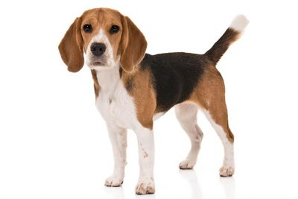 | Version 1
 | Version 2 (after retraining)

Image | Classification (Cat or Dog?) | Confidence (%) | Correct?
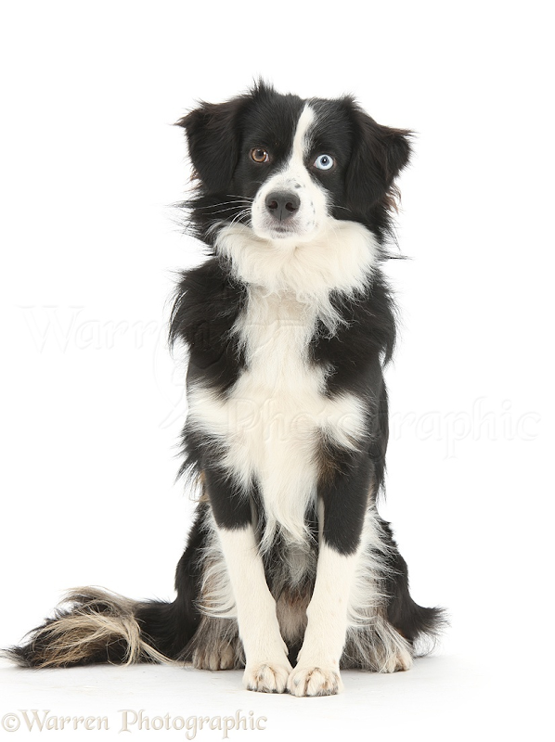 | Version 1
 | Version 2 (after retraining)
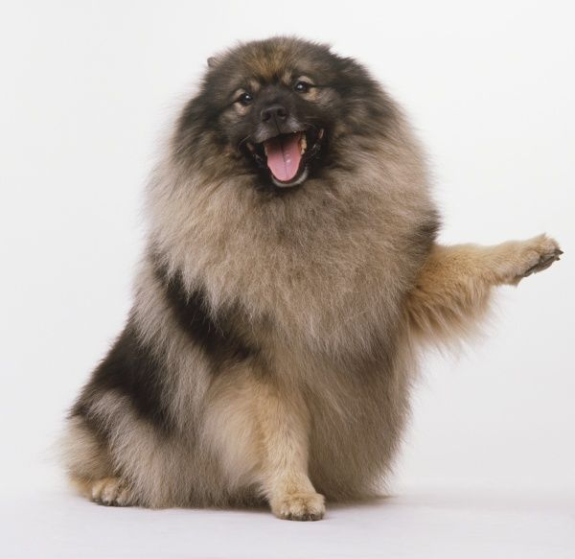 | Version 1
 | Version 2 (after retraining)
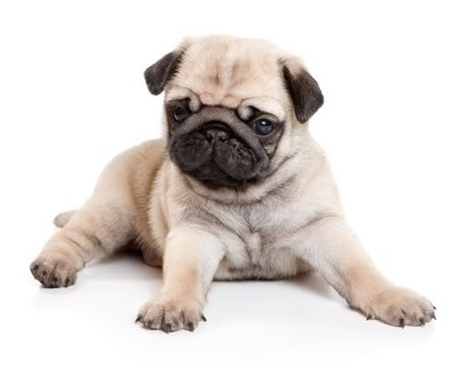 | Version 1
 | Version 2 (after retraining)

Did your model do a better job of identifying cats and dogs after you added more images for Version 2?
Did you notice any bias in the training data? If so, what bias?

