5.03 Worksheet: Human word map
Name:
Class:

Instructions:
Cut out each card below. Your group will place these on the grid using the Living-ness and Size scales. Alternatively, you can just copy and paste the words onto the grid if you are doing this activity virtually.

dog | cat | wolf
goldfish | car | bicycle
truck | sun | lamp
candle | ocean | puddle

Score each word on both scales (1-10), then place its card at the matching spot on the grid.

Living-ness: 1 = definitely not alive, 10 = definitely alive.
Size: 1 = tiny, 10 = huge.
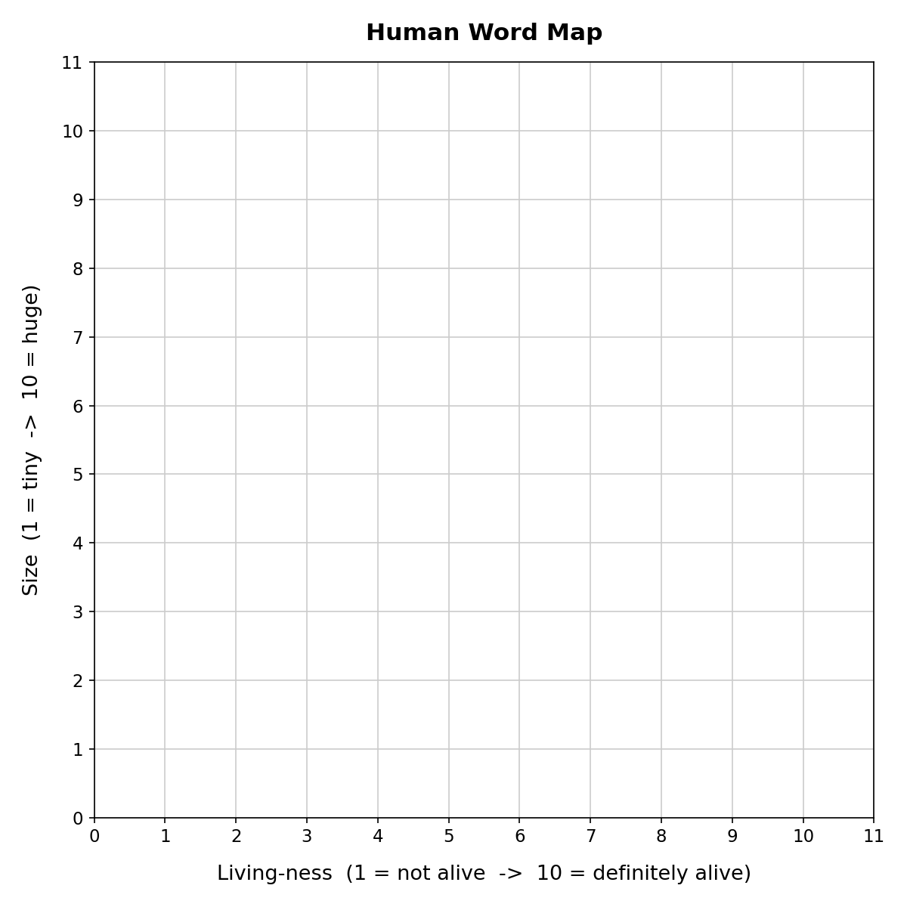

Which words ended up clustered close together? Why?

