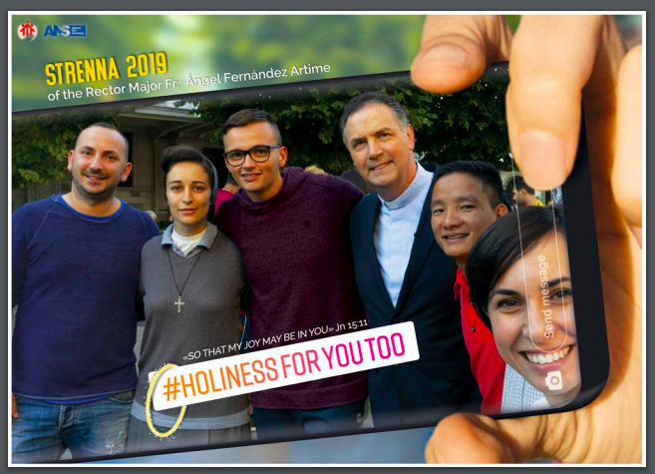
Holiness for You too:
The Beatitudes of the Salesian Family
1. Blessed is the Salesian Family that finds joy in poverty, imbued with God’s grace, it will work amongst the poorest and marginalised youth – this is holiness!
2. Blessed is the Salesian Family that embodies the docility and love of the Good Shepherd. It thus welcomes and accompanies youth with loving kindness, forming them toward dialogue and the welcoming of diversity - this is holiness!
3. Blessed is the Salesian Family that accompanies others, heals the wounds of those who suffer and gives hope to those who feel hopeless, thus bringing the joy of the Risen Christ – this is holiness!
4. Blessed is the Salesian Family that hungers and thirsts for justice and accompanies youth on their mission to actualise their life project within their families, in the workplace, and within political and social commitment – this is holiness!
5. Blessed is the Salesian Family that has a living experience of mercy, opening its eyes and heart to active listening and forgiving. It thus becomes a home that welcomes others – this is holiness!
6. Blessed is the Salesian Family that seeks to be authentic, whole and transparent whilst cultivating a loving gaze that goes beyond appearances and recognises the grace of God within each person – this is holiness!
7. Blessed is the Salesian Family, that draws from the truth of the Gospel and remains faithful to the charism of Don Bosco. It thus becomes yeast for a new humanity and joyfully embraces the joy of the Cross for the Kingdom of God – this is holiness!

