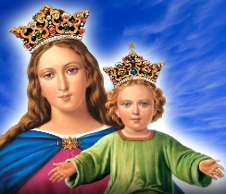
Salesians of Don Bosco
From the Provincial…

Dear Confreres,

I draw your attention to the Most Sacred Heart of Jesus as many Catholics, including most Salesians, pay extra attention and devotion in this month of June. In fact, 24th June this year is the solemnity of the Sacred Heart of Jesus. The 24th June is also the annual feast of the Rector Major. I am sure you will say an extra prayer for Fr Angel.

One of the last significant projects of our father St John Bosco was to build the Church of the Sacred Heart of Jesus at the centre of Rome as requested by Pope Leo XIII. I believe this was to prove his ultimate devotion to the Sacred Heart of Jesus even in his days of frailty. The Church was consecrated on 14th May 1887. The following day, 15th May, was more memorable for Don Bosco himself and for us, his sons.

Don Bosco celebrated a Mass of Thanksgiving at the altar of Mary Help of Christians on 15th May, nine days before the solemnity of Mary Help of Christians. During this Mass, Don Bosco couldn’t control his emotions.

He was in tears, grateful to God and the guidance of the heavenly Mother who showed him the path of his life at nine years of age in that famous dream.

Issue 643 JUNE 24, 2022

In this issue …….

- From the Provincial
- Birthdays & Anniversaries
- Let Us Pray
- Australian Plenary Council
- Provincial Chapter 22
- Fr Cassius Correya
- Visit of the Regional
- Br John Tam SDB
- Child Protection Corner
- RIP Fr John Readman
- Prayer for Ukraine

From the Provincial

Dear Confreres,

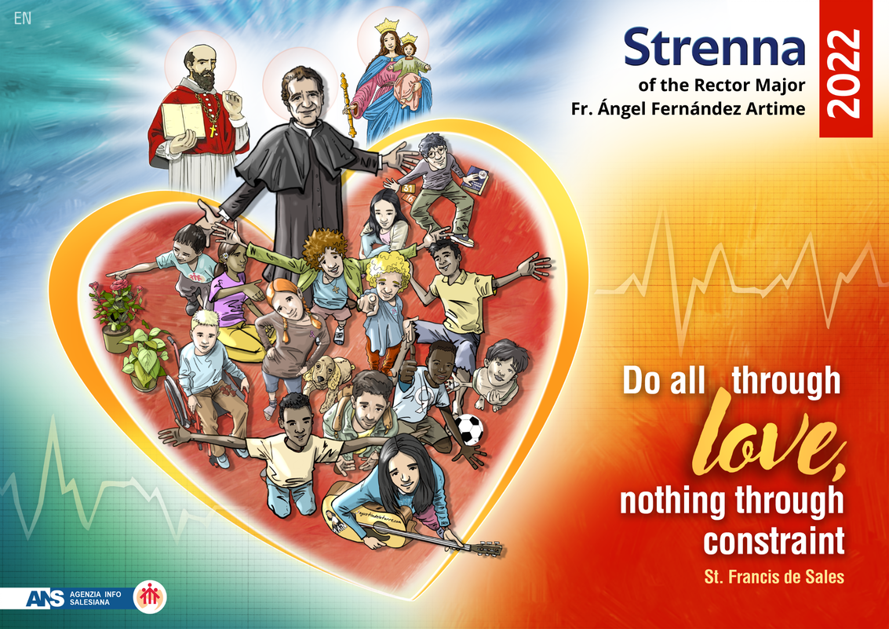

Provincial Circular  Province of Mary Help of Christians  Australia – Fiji – New Zealand - Samoa |  | Issue 635 October 24, 2021  In this issue ……….  - From the Provincial  - Birthdays & Anniversaries

From the Provincial

Let us pray for… | Fr Peter Rankin Br Joe Ellul  Fr Lawrie Moate Br Silvio Quaranta  Fr Lionel Henry Fr Michael Ledda

,  During the celebration of this Eucharist, Don Bosco finally understood his mission, the meaning of the dream at nine, to be a shepherd for the young in the heart of Jesus.  Now after 135 years since the consecration of Sacro Cuore, minor basilica at present, we rejoice at Don Bosco’s greatest work to the glory of God and the salvation of souls. It was not just the Church Don Bosco built, he also established a hostel and an oratory next to it for the poor and the abandoned. The ultimate purpose of life and work for Don Bosco was to bring the young to Jesus, not just necessarily to the Sacred Heart, but the unfathomable love of God and of His glory.  In this month of the Most Sacred Heart of Jesus, we thank God for our consecrated vocation and renew our commitment for God’s glory and the salvation of souls.  Most Sacred Heart of Jesus, have mercy on us!  Yours in St John Bosco,  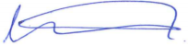  William Matthews SDB  Provincial  Impossible without Christ  The presence of God becomes tangible when we meet consecrated people who live with joy the total gift of self, and for whom chastity, obedience and poverty are indeed the fullness of love received and given. The beauty of their lives touch many hearts, and there are so many examples we can recall in history. Consecrated life thus becomes a sign to the laity and also to the members of the hierarchy, in a communion that expands in concentric circles.  The Salesian Rector, p. 36 | Birthdays & Anniversaries July  2nd Jan Walenciej  4th Peter Varengo  9th Filipo Kapeli  11th Chris Ford  18th Afia Enosa  22nd Pati Ioane  26th John Prest  27th Dave O’Brien  30th Jose Pazheparambil  31st Norm Ford  Special Birthday  A very happy 60th birthday on Monday 11th July to Fr Chris Ford. Chris is a member of the Gawler community in South Australia, actively serving as a Chaplain to the ever-expanding Xavier community.  Many happy returns !!
  Let us pray for … | Br Silvio Quaranta Fr James Adayadiel  Fr Lawrie Moate Br Joe Ellul  Fr Norm Ford Fr Lionel Henry  Fr James Adayadiel who passed away on 22 June in New Zealand  Fr John Readman who passed away recently

Australian Plenary Council

Four Salesians will take part in the Second General Assembly of the Australian Plenary Council on 4-9 July at St Mary's College in Sydney. Archbishop Timothy Costelloe as the President of the Council, Professor Francis Moloney as a Peritus, and Sr Louise McKeogh and Fr Will Matthews as superiors of the religious congregation.
The theme of the Council is ‘Listen to what the Spirit is saying…’
During this assembly, around 300 delegates of different backgrounds and ages from all parts of Australia will be discerning together the will of God through hearing each other’s experience, expertise and wisdom.
Salesians and members of the Salesian Family are kindly invited to accompany the Assembly with prayers.

Provincial Chapter 22

The Provincial Chapter 22 concluded successfully on Tuesday 24th May with the Eucharistic celebration of Mary Help of Christians during which the 2022 Jubilarians of the province are honoured and celebrated.
Most delegates of the Chapter were able to take part in this triannual celebration. Yet, the delegates from Samoa and some others from Fiji and New Zealand were not able to attend in person due to border restrictions and personal hurdles respectively.
The significant presence of lay mission partners on 21 & 22 May also made the Chapter more uplifting with their enthusiasm and love for Don Bosco.
During the concluding dinner on 24th May, Fr Greg Chambers was the toast master for the jubilarians who celebrated various milestones in 2022.

Salesian Professions

- Fr Bob Curmi [75 years]
- Fr Peter Varengo [60 years]
- Fr Will Matthews [25 years]

Ordination
- Fr John Briffa [65 years]
- Fr Chris Riley [40 years]
- Fr Peter Hoang [25 years]

Father Cassius Correya

Under a temporary transfer agreement between the Provincial of Chennai and the Provincial of Australia-Pacific, Fr Cassius joined the Formation Community in Clifton Hill on 8th June. Cassius is known to a number of Salesians in Melbourne as he has visited Australia many times before. All his family lives here in Melbourne. Sadly, Cassius lost his mother earlier this year.

Being a professed Salesian for 28 years, ordained in 2004, completing a Licentiate in Christology at UPS in 2012, and a PHD in 2018. Cassius has been teaching theology for many years at Don Bosco Theological Centre in Kavarapettai, India.
Welcome Cassius to our Province. Hope your service and collaboration in the mission of the Australia-Pacific Province is a happy and rewarding experience.

Most Sacred Heart of Jesus,
Guide into the Salesian congregation many good and zealous apostles and help them to persevere in their vocation

We humbly pray, Amen!

Visit of the Regional

Fr Joseph Phuoc, the Regional of the East-Asia Oceania, is planning to visit Australia and the Pacific from 22nd August 2022. More information will be available when the visa and flights to Australia are confirmed. All rectors will be contacted soon for Fr Joseph’s visit to each community during his stay.

Brother John Tam SDB

Brother John Tam who is a Vietnamese missionary from Hong Kong, will join the Salesian community in Clifton Hill formation community from 27th June.

A professed Salesian Brother for 14 years, Br Tam is here to study computing at RMIT in Melbourne for 12 months.

Welcome Br Tam! We hope your stay here in Melbourne will be a fruitful and enjoyable one.

Child Protection Corner

The new Standards have been updated from 7 to 11 Standards and include new requirements such as:

- involving families and communities in organisations’ efforts to keep children and young people safe
- a greater focus on safety for Aboriginal children and young people
- managing the risk of child abuse in online environments.

Victoria has over five years’ experience of mandatory Standards, so many organisations will already have well developed child safety frameworks. Most organisations will need to make some changes to comply with the new Standards.

The new Standards provide more clarity for organisations and are more consistent with standards in the rest of Australia.

Most organisations that work or volunteer with children and young people are required to meet the Standards. An ‘organisation’ can include a business, group, club, government, not-for-profit or volunteer organisation.

Source: https://ccyp.vic.gov.au/

Holy Hour for Vocations
You are invited to support Salesian Vocations through prayer and to invite others who may be discerning the way forward.
1st July, 7.30pm-8.30pm at St John the Baptist Church, Clifton Hill
This is a monthly opportunity to pray for discernment of your vocation or pray for others who are discerning their vocation in life.
If you would like a running sheet for your own church or community interstate, please contact Brian Ahern at bahern@salesians.org.au

Re:

RIP FR JOHN READMAN

Father John Readman was born in the Mallee, and first met the Salesians as a resident at the Don Bosco Hostel in Brunswick in the early 1940s. He knew Fr Cerrutti and Fr Biloni, who inspired him to consider the priestly vocation. He thought about becoming a Salesian; but his interest in the Salesian way of life did not survive a weekend at Rupertswood, where he found the porridge “un-eatable”! But his love for Don Bosco and the Salesians remained strong all his life.

John went to the seminary in Werribee, and was ordained a priest for the diocese of Sale in 1956. John spent many years as Director of Education for the diocese of Sale. At that time he was also Parish Priest of Neerim South – the parish of the Rankin family. The Salesians from Lysterfield used to help out in that parish, when John was engaged with the education ministry or was on holidays.

He was the founding Parish Priest of the parish of Narre Warren. His Salesian influence came to the fore: he wanted the church dedicated to Mary, Help of Christians; and the primary school dedicated to Don Bosco. Later on, he was the Assistant Priest in the parish of Bairnsdale, where he may have had some influence when the Salesians were asked to take over “Nagle” College.

Upon his retirement from active ministry, he asked the Salesians if he could join the community at Lysterfield.
And the old “dairy shed” was transformed, at the cost of the diocese of Sale, into a comfortable flat by Marco Pradel, and occupied by Fr Readman for several years.

He was also keen on the garden patch around the “Casa Bianca” – as he called the flat. Several fruit-bearing trees still produce good fruit to this day...

Fr John spent the last years of his life in a retirement village at Pakenham. He died on 25th May 2022. In his funeral homily, Fr Peter Slater, Vicar General of the diocese of Sale, made several references to Fr John’s Salesian connections, and his love for Don Bosco and the Salesians.

May Fr John Readman rest in peace, somewhere in the “Salesian garden” in heaven!

Fr Frank Bertagnolli SDB

Prayer for Ukraine

Please join Catholic Religious Australia for a prayer service, in the wake of the outbreak of war with the invasion of Ukraine by Russia in February 2022. We will unite in prayer for dialogue and peace, for a genuine end to the ongoing violence. Bishop Mykola Bychok, CSsR, Eparch for Ukrainian Catholics in Australia, New Zealand and Oceania will join us for this important prayer.

Date: Tuesday 28 June 2022 Time: 11.30am

Duration: 30 – 40 minutes
Format: Zoom link will be sent out two days prior
to the event to participants who have
registered.

REGISTRATION Free online registration:
https://www.trybooking.com/BZWZN

Contact Us  Salesians of Don Bosco | Salesian Province Centre  3 Middle Street [PO Box 264] | Ascot Vale 3032 | Australia Ph: +61 3 9377 6000 Web: www.salesians.org.au | Email: sdbaul@salesians.org.au

