COMPETITION PROGRAMME 2025
TEYLERS TWEEDE GENOOTSCHAP
HAARLEM

In keeping with the Teylers Stichting’s 200-year-old tradition of promoting academic research, the Directors of this foundation Teylers Stichting, together with the members of the Teylers Tweede Genootschap (Teyler’s Second Society), have decided to hold a competition for the year 2025 on a subject relating to art history.

SUBJECT
We invite an original study that contributes to our knowledge of how drawings were made, used and valued between approximately 1450 and 1800, with an emphasis on the Northern and Southern Netherlands.

EXPLANATORY STATEMENT
Of all the disciplines within art history, the study of old Dutch and Flemish drawings is one of the most conservative. Research into drawings from before 1800 is often primarily focused on matters of attribution: by whom was a drawing made? Issues of authorship can be complicated due to a lack of signed drawings and can often only be solved by specialists who have studied drawings for years and are able to recognize ‘hands’ thanks to their great expertise. This ensures that the area of expertise is rather closed.
Publications about old drawings are also often traditional in nature. Besides predominantly monograph-oriented articles in scholarly journals such as Master Drawings, Oud Holland and Delineavit et sculpsit, drawings mostly feature in collection and exhibition catalogues, in which groups of drawings from a particular period or around a specific theme are described. A collection catalogue traditionally opens with an introduction on the history of the collection, after which the selected drawings are discussed individually. Such publications are important to present collections of drawings and to open them up to further research, but this format does tend to be somewhat predictable.
Fortunately, research into early modern Dutch and Flemish drawings has begun to expand in recent years. That is partially because countless drawings – which have in fact been stored in boxes in depots – are now easily accessible through many online collection catalogues of museums across the globe. For researchers of drawings, this can yield some great discoveries and insights from the comfort of home, at one’s own desk. Incentive funds such as The Getty Paper Project have also led to more young art historians nowadays focusing on drawings. There is a growing focus on the function and iconography of drawings and material-technical research on paper, watermarks and drawing materials used. Of particular significance is the exhibition Drawings for Painting in the Age of Rembrandt (Fondation Custodia, Paris and National Gallery of Art, Washington, 2017), which was dedicated to drawings as preliminary studies for paintings. A more recent example is the exhibition From Scribble to Cartoon. Drawings from Bruegel to Rubens in Flemish Collections (Museum Plantin-Moretus in Antwerp and the Ashmolean Museum in Oxford 2023/2024), in which the main focus was the function of Flemish drawings; from first sketch to collectors’ items.
In order to stimulate innovative art-historical and material-technical research on drawings and the art of drawing, this competition invites an original study that contributes to our knowledge of how drawings were made, used and valued. This could, for example, be a study of paper use, drawing materials and techniques, of the function of drawings during the training of young artists and as study material in the workshop, of the role of drawings in the exchange of styles, themes and ideas, or of the appreciation for drawings as collectible items. The study can span a period of between approximately 1450 and 1800, with a focus on the Northern or Southern Netherlands. This may involve one or more case studies, or a more summary study that highlights one or more aspects of the subject.

FORM OF CONTRIBUTION
Entries should consist of:
- A longer study in the form of a publication-ready paper. If a dissertation is part of the submission, the date of the PhD defence will be considered the publication date.
- One or more publications (mostly published during the last three years before 1 January 2028 and of which the submitter is the author or one of the main authors), accompanied by a piece written for the occasion of the competition that has not yet been published and that places the previous publications in a broader scientific context.

PROCEDURE
In order to qualify for the competition, candidates should submit four copies of their contribution to the Directors of the Teylers Stichting (Spaarne 16, 2011 CH Haarlem) by 1 January 2028 at the latest. Contributions received after that date will not be considered.
In accordance with the provisions of Pieter Teyler van de Hulst’s will, the author’s name may not appear on the unpublished texts. Instead, they should be submitted anonymously, identifiable only by a motto. Submissions should be accompanied by a sealed envelope, marked with the motto that identifies the entry and containing the author’s name and address.
To avoid a long wait before hearing the result of the evaluation, in case an award has not been made, authors are requested to send together with the sealed envelope an open envelope containing the name and full address of a person with whom the Directors of Teylers Stichting may enter into correspondence confidentially.

JUDGING
Judging will be carried out by the members of the Teylers Tweede Genootschap, who will submit their recommendation to the Directors of the Teyler Foundation within four months of the closing date for submissions. The Directors’ decision, which will be made within one month, will be final. All candidates will be notified as soon as a decision is made.

PRIZE
The prize consists of a medal struck from the Teylers Tweede Genootschap’s dies. The medal will be awarded to the winner(s) at a special ceremony in the Teylers Museum. Professional journals and the press, and possibly other interested parties and institutions, will receive ample advance notice of the award ceremony.

PUBLICATION
Responsibility for publication rests with the author of the winning contribution, although the Teylers Stichting and the Teylers Tweede Genootschap may consider lending assistance. On publication, reference should be made to the fact that the text has received an award from the Teylers Stichting.

INFORMATION
Further information may be obtained from the secretary of the society (see below). Journal editors and others who wish to draw the attention of their readership to the competition, but who do not wish to print the competition details in full, are urged to advise intending candidates to consult the programme for full details of the competition. The application form can be found on www.teylersstichting.nl.
For more information about Pieter Teyler van der Hulst, the Teylers Stichting and its related institutions, such as the two learned societies, the museum and the almshouse, please consult Teyler 1778-1978 (Haarlem 1978), De idealen van Pieter Teyler. Een erfenis uit de Verlichting (Haarlem 2006) and www.teylersstichting.nl.

CURRENT COMPETITIONS
* Competition 2023 (Literature): a study of how the Middle Ages and/or the Golden Age have been represented in the literature and culture of the Low Countries since 1800 (deadline before 1 January 2026).
* Competition 2024 (Biology): a critical study on predicting the risk of invasiveness of exotic species (deadline before 1 January 2027).
For full details of both competitions please contact the secretary or visit www.teylersstichting.nl

SECRETARY
Prof. dr. Y.L. Bleyerveld: bleyerveld@rkd.nl

SUBMISSIONS
Submissions should have reached the Directors of the Teylers Stichting (Spaarne 16, 2011 CH Haarlem) before 1 January 2028. (Spaarne 16, 2011 CH Haarlem).

MEMBERS OF TEYLERS TWEEDE GENOOTSCHAP
Prof. dr. W. van Anrooij, Professor emeritus of Dutch Literature before Romanticism, Leiden University
Prof. dr. Y.L. Bleyerveld, Senior Curator Drawings and Prints c. 1500-1800, RKD – Netherlandish Institute for Art History, The Hague / Professor by special appointment Leiden University
Dr. L.M.G.F.E. Claes, University lecturer at the Institute for History, Leiden University
Prof. dr. J. Ellers, Professor of Evolutionary Ecology, Head of Department of Ecological Science, and Director of Amsterdam Institute for Life and Environment (A-LIFE), Vrije Universiteit Amsterdam
Prof. dr. B.A. de Graaf, Professor of History of International Relations & Global Governance, Utrecht University
Prof. dr. M.W. van der Heijden, Professor of Science Communication in Physics, Eindhoven University of Technology (TU/e)
Prof. dr. F.H. van Lunteren, Professor of History of Natural Sciences, Leiden University

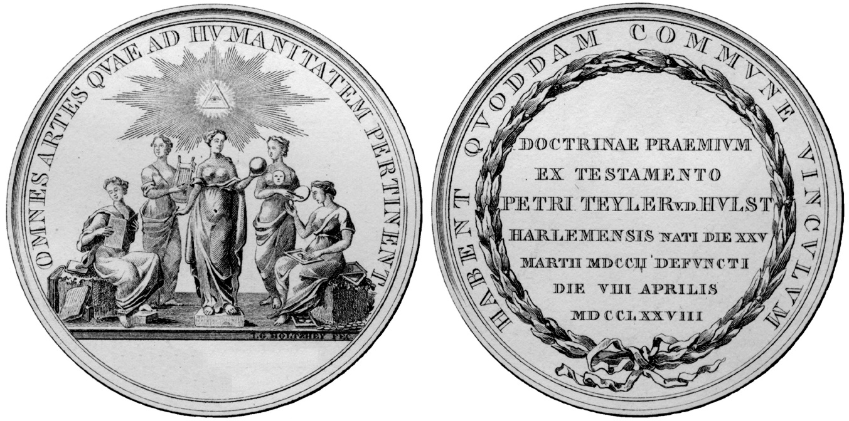

Medal of the Teylers Tweede Genootschap (gold, 72 mm, c. 120 g, 14 carat); dies by J.G. Holtzhey, 1778:
- beneath the radiant all-seeing eye of Providence are Physics with her globe and compass, Poetry with her lyre, History with her book, Drawing with her brush and palette, and Numismatics bearing a tray of medals; OMNES ARTES QVAE AD HVMANITATEM PERTINENT HABENT QVODDAM COMMVNE VINCVLVM (all arts and sciences relating to human civilisation share a common bond)
- in a laurel wreath DOCTRINAE PRAEMIVM EX TESTAMENTO PETRI TEYLER V D HVLST HARLEMENSIS NATI DIE XXV MARTII MDCCII DEFVNCTI DIE VIII APRILIS MDCCLXXVIII (prize for scholarly achievement in accordance with the last will and testament of Pieter Teyler van der Hulst of Haarlem, born 25 March 1702, died 8 April 1778).

