Halle, Howard. Time Out New York. 26 Mar. – 1 Apr. 2015.

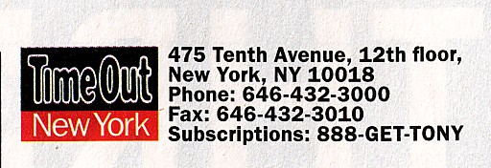

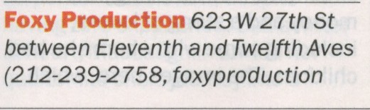

FOXYPRODUCTION.COM 623 W 27 ST NYC 10001 USA +1 212 239 2758

