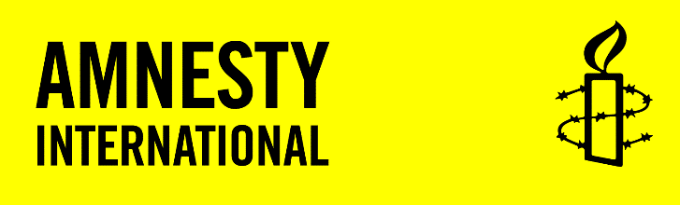
AMNESTY INTERNATIONAL AOTEAROA NEW ZEALAND
PO BOX 5300
VICTORIA STREET WEST
AUCKLAND 1142
0800 AMNESTY (266 3789)
advocacy@amnesty.org.nz
amnesty.org.nz

Rt Hon Christopher Luxon, Prime Minister of New Zealand
Hon Mark Mitchell, Minister for Ethnic Communities
Hon Paul Goldsmith, Minister of Justice
Freepost Parliament Buildings
PO Box 18888
Wellington 6160
christopher.luxon@parliament.govt.nz
mark.mitchell@parliament.govt.nz
paul.goldsmith@ministers.govt.nz

25 June 2026
Tēnā koutou,
Everybody has the right to be safe, to participate and to practice their faith.
Recent public statements by Brian Tamaki, leader of Destiny Church, calling for New Zealand to be “purged” of Hindu, Sikh and Muslim communities and suggesting that mosques and temples be burned, is a serious threat to these rights.
Amnesty International Aotearoa condemns Brian Tamaki’s statements without reservation.
We stand alongside the affected communities, faith leaders, the Race Relations Commissioner and the many New Zealanders who have made clear that this rhetoric has no place in Aotearoa.
We acknowledge the Government’s response, including the Ethnic Communities Minister’s public criticism of these remarks and Police confirmation that the matter has been referred for legal assessment.
Now, more action is required. Your response is an opportunity to show communities that this Government will not allow hate speech to go unchecked. Not all hateful expression should be criminalised, a spectrum of action is needed, but it is clear an urgent part of this work is on strengthening safeguards.
Incitement is a type of speech prohibited under several international human rights treaties that Aotearoa New Zealand is a signatory to, including the International Covenant on Civil and Political Rights (ICCPR). This creates a positive obligation on Government, for example, Article 20(2) of the ICCPR requires states to prohibit by law “any advocacy of national, racial or religious hatred that constitutes incitement to discrimination, hostility or violence”.
Incitement to hatred can cause real harm and have a profound and chilling effect on the ability of targeted communities to safely go about their lives. However, current incitement provisions need work. For example, currently incitement law does not include religious belief.
It’s not too late to show a strong and compassionate response.
We call on the Government to prioritise work to address hate including, but not limited to:
- Prioritise work on the recommendations of the Royal Commission of Inquiry into the terrorist attack on Christchurch masjidain, including work on our incitement laws.
- Prioritise work on Te Aka Matua o te Ture | Law Commission’s Ia Tangata report including implementation of the main recommendation to add new prohibited grounds of discrimination to the Human Rights Act to more clearly protect people who are transgender or non-binary or who have an innate variation of sex characteristics.
- Address online harm by implementing and promoting basic rules that ensure social media platforms and search engines are designed with user safety in mind.
- Invest in preventative measures, including ensuring organisations working to prevent hate are adequately resourced.
Crucially, how this work occurs is important. The Government must progress work in a way that upholds Te Tiriti o Waitangi and engages meaningfully with impacted communities to explore what effective responses look like.
Legislative reform alone cannot address the root causes of intolerance. Genuine engagement with communities most affected by hatred remains essential to building an Aotearoa New Zealand that fully realises human rights for all.
It is vital we see leaders, especially you as Government, calling out hate speech and actively promoting a society that upholds our constitutional foundation of Te Tiriti o Waitangi, where everyone can live with dignity and diversity is valued and seen as a shared strength. By doing this on an ongoing basis, you help draw lines about what is acceptable in our society and what is not.
I would welcome the opportunity to meet with you to discuss these matters.
Nāku noa, nā,
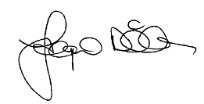
Jacqui Dillon
Executive Director
Amnesty International Aotearoa New Zealand

