- IDENTIFICATION OF THE SUBSTANCE/MIXTURE AND OF THE COMPANY/UNDERTAKING

  - Product Identifier

Product Name: ELVON
Product Code: 160-01
UFI Code : NTFX-2K6S-J403-VHWM

  - Relevant identified uses of the substance or mixture and uses advised against

Product Use: Fungicide

  - Details of the supplier of the safety data sheet

Company: Life Scientific Ltd,
Block 4,
Belfield Office Park,
Beech Hill Road,
Dublin 4,
Ireland
Telephone: +353 (0) 1 2832024
Email: info@lifescientific.com
Web: www.lifescientific.com

  - Emergency contact information

In case of Emergency: Tel. NHS 111

- HAZARD IDENTIFICATION

  - Classification of the substance or mixture

Classification according to Regulation (EU) No. 1272/2008

Acute toxicity - oral Category 4 H302
Serious eye damage Category 1 H318
Acute toxicity - inhalation Category 4 H332
Specific target organ toxicity
- single exposure Category 3 H335
Reproductive toxicity Category 2 H361d
Specific target organ toxicity
- repeated exposure Category 2 H373
Aquatic Acute Category 1 H400
Aquatic Chronic Category 1 H410

  - Label Elements

Labelling according to Regulation (EU) 1272/2008

Hazardous components which must be listed on the label:
- Bixafen
- Prothioconazole
- N,N-Dimethyldecanamide

Hazard Pictograms:

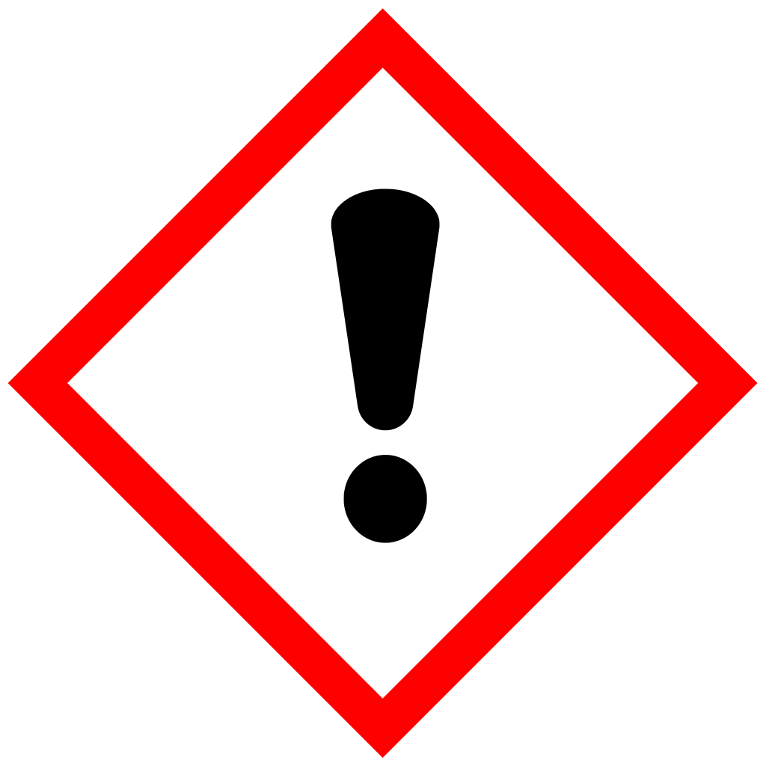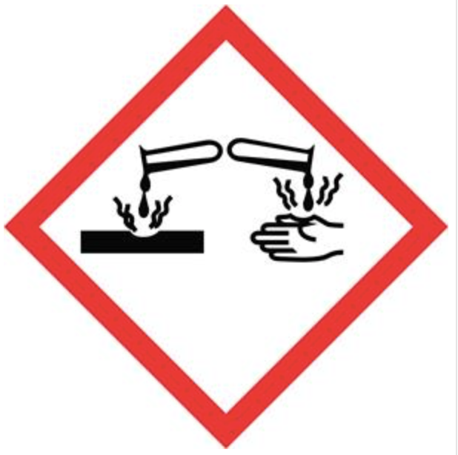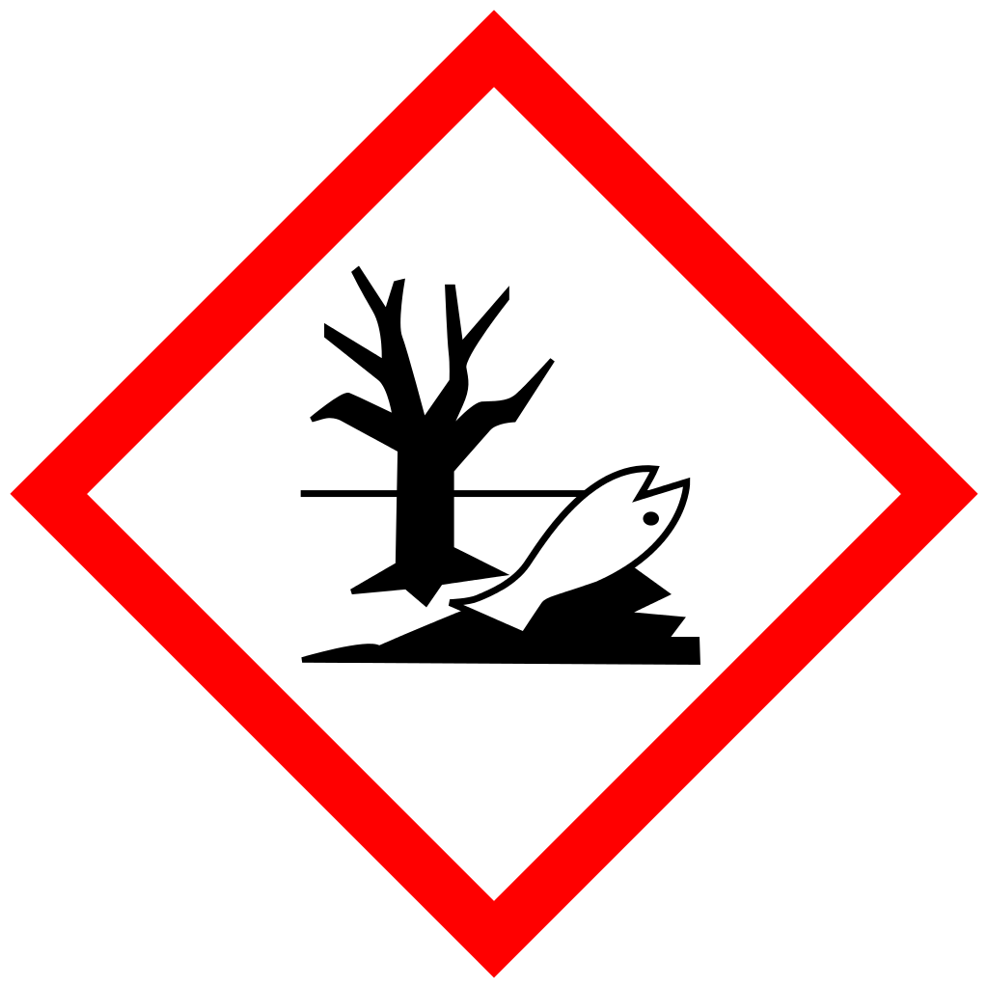

Signal Word:

Danger

Hazard Phrases:

H302 Harmful if swallowed.
H318 Causes serious eye damage.
H332 Harmful if inhaled.
H335 May cause respiratory irritation.
H361d Suspected of damaging the unborn child.
H373 May cause damage to organs through prolonged or repeated exposure.
H410 Very toxic to aquatic life with long lasting effects.

Precautionary Phrases:

P102 Keep out of reach of children.
P280 Wear protective gloves/protective clothing/eye protection/face protection.
P305+P351+P338 IF IN EYES: Rinse cautiously with water for several minutes. Remove contact lenses, if present and easy to do so. Continue rinsing.
P310 Immediately call a POISON CENTRE or doctor/physician.
P391 Collect spillage.
P501 Dispose of contents/container to a licensed hazardous waste disposal contractor or collection site except for triple rinsed empty containers which can be disposed of as non-hazardous waste.

Other Phrases:

EUH208 Contains 2-[2-(1-chlorocyclopropyl)-2-hydroxy-3-phenylpropyl]-2,4-dihydro-3H-1,2,4-triazole-3- thione. May produce an allergic reaction.
EUH208 Contains spiroxamine. May produce an allergic reaction.

EUH401 To avoid risks to human health and the environment, comply with the instructions for use.

  - Other Hazards

Substance does/does not meet the criteria for vPvB according to regulation (EC) No 1907/2006, Annex III.

The substance/mixture does not contain components considered to have endocrine disrupting properties according to
REACH Article 57(f) or Commission Delegated regulation (EU) 2017/2100 or Commission Regulation (EU) 2018/605
at levels of 0.1% or higher.

- COMPOSITION / INFORMATION ON INGREDIENTS

  - Substances

No substances fulfil the criteria set out in Annex II, Part A of the REACH Regulation (EC) No 1907/2006.

  - Mixtures

Chemical Name | CAS | EC | Classification  (Regulation (EC) No 1272/2008) | Concentration  (% ^{w}/_{w})
Spiroxamine | 118134-30-8 | - | Acute Tox., 4, H302  Acute Tox., 4, H312  Skin Irrit., 2, H315  Skin Sens., 1, H317  Acute Tox., 4, H332  STOT RE, 2, H373  Repr., 2, H361d  Aquatic Acute 1, H400  Aquatic Chronic 1, H410 | 25.25
Prothioconazole | 178928-70-6 | - | Aquatic Acute 1, H400  Aquatic Chronic 1, H410 | 10.10
Bixafen | 581809-46-3 | - | Aquatic Acute 1, H400  Aquatic Chronic 1, H410  M-Factor: 10 (acute) | 5.05
2-Ethylhexanol propylene ethyleneglycol ether | 64366-70-7 | - | Acute Tox. 4, H332  Aquatic Chronic 3, H412 | >1 - <25
N,N-Dimethyldecanamide | 14433-76-2 | 238-405-1 | Skin Irrit. 2, H315  Eye Irrit. 2, H319  STOT SE 3, H335  Aquatic Chronic 3, H412 | >=25

- FIRST AID MEASURES

  - Description of first aid measures

General information: Move out of dangerous area. Place and transport victim in stable position (lying sideways). Remove contaminated clothing immediately and dispose of safely.

Inhalation: Move to fresh air. Keep patient warm and at rest. Call a physician or poison control center immediately.

Ingestion: Rinse mouth. Do NOT induce vomiting. Call a physician or poison control center immediately.

Skin contact: Wash off thoroughly with plenty of soap and water, if available with polyethyleneglycol 400, subsequently rinse with water. If symptoms persist, call a physician.

Eye contact: Rinse immediately with plenty of water, also under the eyelids, for at least 15 minutes. Remove contact lenses, if present, after the first 5 minutes, then continue rinsing eye. Call a physician or poison control centre immediately.

  - Most important symptoms and effects, both acute and delayed

Symptoms: None known.

  - Indication of any immediate medical attention and special treatment needed

Notes to physicians: There is no specific antidote available. Treat symptomatically. In case of ingestion, gastric lavage should be considered in cases of significant ingestions only within the first 2 hours. However, the application of activated charcoal and sodium sulphate is always advisable.

- FIREFIGHTING MEASURES

  - Extinguishing media

Suitable: Use water spray, alcohol-resistant foam, dry chemical or carbon dioxide.
Unsuitable: High volume water jet.

  - Special hazards arising from the substance or mixture

In the event of fire, the following may be released: Hydrogen chloride (HCl), Hydrogen cyanide (hydrocyanic acid), Hydrogen fluoride, Carbon monoxide (CO), Nitrogen oxides (NOx), Sulphur oxides.

  - Advice for firefighters

Special protective equipment In the event of fire, do not breathe fumes and wear self-contained
for fire fighters: breathing apparatus .
Further information: Contain the spread of the firefighting media. Do not allow run-off from firefighting to enter drains or water courses.

- ACCIDENTAL RELEASE MEASURES

  - Personal precautions, protective equipment and emergency procedures

Use personal protective equipment. Avoid contact with spilled product or contaminated surfaces.

  - Environmental precautions

Do not allow contamination of public drains or surface or ground waters. Inform local water plc if spillage enters drains and the Environment Agency (England & Wales), the Scottish Environmental Protection Agency (Scotland), or the Environment and Heritage Service (Northern Ireland) if it enters surface or ground waters.

  - Methods and materials for containment and cleaning up

Soak up with inert absorbent material (e.g. sand, silica gel, acid binder, universal binder, sawdust). Clean contaminated floors and objects thoroughly, observing environmental regulations. Keep in suitable, closed containers for disposal.
  - Reference to other sections

Information regarding safe handling, personal protection and waste disposal considerations can be found in section 7, 8 and 13.

- HANDLING AND STORAGE

  - Precautions for safe handling

No special measures necessary if stored and handled correctly. Follow relevant manual handling advice. Ensure thorough ventilation of stores and work areas. Hands and/or face should be washed before breaks and at the end of the shift. Avoid contact with skin, eyes and clothing. Keep working clothes separately. Remove soiled clothing immediately and clean thoroughly before using again. Garments that cannot be cleaned must be destroyed (burnt).

  - Conditions for safe storage, including any incompatibilities

Keep away from direct sunlight. Store in original container. Keep containers tightly closed in a dry, cool and well-ventilated place. Store in a place accessible by authorized persons only. Protect from frost.

Suitable materials: HDPE – steel case.

  - Specific end use(s)

For the relevant identified use(s) listed in Section 1 the advice mentioned in this section 7 is to be observed.

- EXPOSURE CONTROL/PERSONAL PROTECTION

  - Control parameters

Component | CAS-No. | Exposure Limit | Value Type | Source
Spiroxamine | 118134-30-8 | 0.6 mg/m³ | SK-SEN | Supplier
Bixafen | 581809-46-3 | 0.6 mg/m³ | TWA | Supplier
Prothioconazole | 178928-70-6 | 1.4 mg/m³ | SK-ABS | Supplier

8.2 Exposure controls

Refer to COSHH assessment (Control of Substances Hazardous to Health (Amendment) Regulations 2004). Engineering controls should be used in preference to personal protective equipment wherever practicable. Refer also to COSHH Essentials.

In normal use and handling conditions please refer to the label for details. In all other cases, use the following Personal Protective Equipment:

Respiratory protection: Wear respirator with an organic vapours and gas filter mask (protection factor 10) conforming to EN140 type A or equivalent.
Respiratory protection should only be used to control residual risk of short duration activities, when all reasonably practicable steps have been taken to reduce exposure at source e.g. containment and/or local extract ventilation. Always follow respirator manufacturer's instructions regarding wearing and maintenance.

Skin and body protection: Wear standard coveralls and Category 3 Type 4 suit.
If there is a risk of significant exposure, consider a higher protective type suit.
Wear two layers of clothing wherever possible. Polyester/cotton or cotton overalls should be worn under chemical protection suit and should be professionally laundered frequently.
If chemical protection suit is splashed, sprayed or significantly contaminated, decontaminate as far as possible, then carefully remove and dispose of as advised by manufacturer.

Hand protection: Please observe the instructions regarding permeability and breakthrough time which are provided by the supplier of the gloves. Also take into consideration the specific local conditions under which the product is used, such as the danger of cuts, abrasion, and the contact time.
Wash gloves when contaminated. Dispose of when contaminated inside, when perforated or when contamination on the outside cannot be removed. Wash hands frequently and always before eating, drinking, smoking or using the toilet.
Material Nitrile rubber
Rate of permeability > 480 min
Glove thickness > 0.4 mm
Protective index Class 6
Directive Protective gloves complying with EN 374.

Eye protection: Wear goggles (conforming to EN166, Field of Use = 5 or equivalent) and faceshield (conforming to EN166, Field of Use = 3 or equivalent).

- PHYSICAL AND CHEMICAL PROPERTIES

  - Information on basic physical and chemical properties

Appearance

Form: Liquid, clear to slightly turbid
Colour: Yellow to brown
Odour: Aromatic

Chemical properties

Odour Threshold: No data available
pH (at 23 °C): 6.5 – 8.5 (1%) (deionised water)
Boiling point (°C): No data available
Melting point (°C): No data available
Flammability: No data available
Upper explosion limit: No data available
Lower explosion limit: No data available
Auto-ignition temperature: No data available
Self-accelerating decomp- No data available
osition temperature (SADT):
Flash point: > 103 °C
Ignition point: 360 °C
Density (at 20 °C): ca. 0.99 g/cm³
Viscosity, dynamic: No data available
Viscosity, kinematic: 85.5 mm²/s (20 °C)
Shear rate of 100/sec
Solubility in water: Dispersible
Partition coefficient
n-octanol/water: Bixafen: log Pow: 3.3 (40 °C)
Prothioconazole: log Pow: 3.82 (20 °C) (pH 7)
Spiroxamine: log Pow: 2.8 - 3.0 (20 °C) (pH 7)
N-N-Dimethyldecanamide: log Pow: 2.46
Surface tension: 26 mN/m (25 °C).
Determined in the undiluted form
Vapour pressure: No data available
Relative density: No data available
Relative vapour density: No data available
Assessment nano This substance/mixture does not contain nanoforms
particles:

  - Other Information

Oxidising properties : Not oxidising
Explosive properties: Not explosive
Evaporation rate: No data available
Orther physico-chemical Further safety related physical-chemical data are not known.
properties:

Data based on a similar composition.

- STABILITY AND REACTIVITY

  - Reactivity

Stable under normal conditions.

  - Chemical Stability

Stable under recommended storage conditions.

  - Possibility of hazardous reactions

Hazardous reactions do not occur if stored and handled as prescribed/indicated.

  - Conditions to avoid

Extremes of temperature and direct sunlight.

  - Incompatible material

Store only in the original container.

  - Hazardous decomposition products

No hazardous decomposition products if stored and handled as prescribed/indicated.

- TOXICOLOGICAL INFORMATION

  - Information on toxicological effects

Acute oral toxicity: LD₅₀ oral (rat): 550 - 2000 mg/kg

Acute dermal toxicity: LD₅₀ (rat): > 2000 mg/kg

Acute inhalation toxicity: LC₅₀ (rat): 3.326 mg/L
Exposure time: 4 h
Determined in the form of a respirable aerosol.

Serious eye damage/
Eye irritation (rabbit): Risk of serious damage to eyes.

Skin corrosion/irritation (rabbit): Not irritating.

Respiratory or skin sensitisation: Not a skin sensitiser (mouse).
OECD Test Guideline 429, local lymph node assay (LLNA)

STOT (single exposure): Spiroxamine: Based on available data, the classification criteria are not met.
Bixafen: Based on available data, the classification criteria are not met.
Prothioconazole: Based on available data, the classification criteria are not met.
N,N-Dimethyldecan-1-amide: May cause respiratory irritation.

STOT (repeated exposure): Spiroxamine caused specific target organ toxicity in experimental animal studies in dogs in the following organ(s): Eyes.
Bixafen did not cause human relevant specific target organ toxicity in experimental animal studies.
Prothioconazole did not cause specific target organ toxicity in experimental animal studies.
N,N-Dimethyldecanamide did not cause specific target organ toxicity in experimental animal studies.

Mutagenicity: Spiroxamine was not mutagenic or genotoxic in a battery of in vitro and in vivo tests.
Bixafen was not mutagenic or genotoxic in a battery of in vitro and in vivo tests.
Prothioconazole was not mutagenic or genotoxic based on the overall weight of evidence in a battery of in vitro and in vivo tests.
N,N-Dimethyldecanamide was not genotoxic in a battery of in vitro tests.

Carcinogenicity: Spiroxamine was not carcinogenic in lifetime feeding studies in rats and mice.
Bixafen was not carcinogenic in lifetime feeding studies in rats and mice.
Prothioconazole was not carcinogenic in lifetime feeding studies in rats and mice.
N,N-Dimethyldecanamide is not considered carcinogenic.

Developmental Toxicity: Spiroxamine caused developmental toxicity only at dose levels toxic to the dams. The developmental effects seen with Spiroxamine are related to maternal toxicity.
Bixafen did not cause developmental toxicity in rats and rabbits.
Prothioconazole caused developmental toxicity only at dose levels toxic to the dams. The developmental effects seen with Prothioconazole are related to maternal toxicity.
N,N-Dimethyldecanamide did not cause developmental toxicity in rats and rabbits.

Reproductive Toxicity: Spiroxamine caused reproduction toxicity in a two-generation study in rats only at dose levels also toxic to the parent animals. The reproduction toxicity seen with Spiroxamine is related to parental toxicity.
Bixafen did not cause reproductive toxicity in a two-generation study in rats.
Prothioconazole caused reproduction toxicity in a two-generation study in rats only at dose levels also toxic to the parent animals. The reproduction toxicity seen with Prothioconazole is related to parental toxicity.
N,N-Dimethyldecanamide is not considered a reproductive toxicant at non- maternally toxic dose levels.

Aspiration hazard: Based on available data, the classification criteria are not met.

Further information: Irritating to respiratory system.

Data based on a similar composition.

11.2 Information on other hazards

Endocrine disrupting properties

Product:
Assessment: The substance/mixture does not contain components considered to have endocrine disrupting properties according to REACH Article 57(f) or Commission Delegated regulation (EU) 2017/2100 or Commission Regulation (EU) 2018/605 at levels of 0.1% or higher.

- ECOLOGICAL INFORMATION

  - Toxicity

Toxicity to fish: LC₅₀ Oncorhynchus mykiss (96 h): 1.55 mg/l

Toxicity to aquatic
Invertebrates: EC₅₀ Daphnia magna (48 h): 4.6 mg/l

Toxicity to aquatic plants: IC₅₀ Raphidocelis subcapitata (72 h): 0.0499 mg/l
EC₁₀ Skeletonema costatum (72 h): 0.01427 mg/l (prothioconazole)
ErC₅₀ Skeletonema costatum (72 h): 0.03278 mg/l (prothioconazole)

  - Persistence and degradability

Biodegradability

Spiroxamine: Not rapidly biodegradable.
Bixafen: Not rapidly biodegradable.
Prothioconazole: Not rapidly biodegradable.
N,N-Dimethyldecanamide: Rapidly biodegradable.

Koc

Spiroxamine: Koc: 2415
Bixafen: Koc: 3869
Prothioconazole: Koc: 1765

  - Bioaccumulative potential

Does not bioaccumulate.

Spiroxamine: BCF 87
Bixafen: BCF 695
Prothioconazole: BCF 19

  - Mobility in soil

Slightly mobile in soils.

  - Results of PBT and vPvB assessment

The product does not contain a substance fulfilling the PBT (persistent/bioaccumulative/toxic) criteria or the vPvB (very persistent/very bioaccumulative) criteria.

12.6 Endocrine disrupting properties

The substance/mixture does not contain components considered to have endocrine disrupting properties according to REACH Article 57(f) or Commission Delegated regulation (EU) 2017/2100 or Commission Regulation (EU) 2018/605 at levels of 0.1% or higher.

  - Other adverse effects

None.

- DISPOSAL CONSIDERATIONS

  - Waste treatment methods

Product: In accordance with current regulations and, if necessary, after consultation with the site operator and/or with the responsible authority, the product may be taken to a waste disposal site or incineration plant. Advice may be obtained from the local waste regulation authority (part of the Environment Agency in the UK).

Contaminated packaging: Small containers (< 10 L or < 10 kg) should be rinsed thoroughly using an integrated pressure rinsing device, or, by manually rinsing three times.
Add washings to sprayer at time of filling.
Empty containers should be taken for local recycling or waste disposal.
Follow advice on product label and/or leaflet.

- TRANSPORT INFORMATION

Transport the product in accordance with the provisions of ADR for road, RID for rail, IMDG for the sea, and ICAO / IATA for air transport

  - UN Number

3082

  - UN proper shipping name

ENVIRONMENTALLY HAZARDOUS SUBSTANCE, LIQUID, N.O.S., (SPIROXAMINE, PROTHIOCONAZOLE SOLUTION)

  - Transport hazard class(es)

9

  - Packing group

III

  - Environmental hazards

Yes - Marine Pollutant.

Hazard no. 90

This classification is in principle not valid for carriage by tank vessel on inland waterways. Please refer to the manufacturer for further information.

Emergency action code: 3Z

  - Special precautions for user

See Sections 6 to 8 of this Safety Data Sheet.

  - Transport in bulk according to Annex II of Marpol 73/78 and the IBC code

No transport in bulk according to the IBC Code.

- REGULATORY INFORMATION

  - Safety, health and environmental regulation/legislation specific for the substance or mixture

UK and Northern Ireland Regulatory References

This material may be subject to some or all of the following regulations (and any subsequent amendments). Users must ensure that any uses and restrictions as indicated on the label and/or leaflet are followed.

Transport

Carriage of Dangerous Goods and Use of Transportable Pressure Equipment Regulations 2009 (SI 2009 No 1348). Merchant Shipping (Dangerous Goods and Marine Pollutants) Regulations 1997 (SI 1997 No 2367).
Air Navigation Dangerous Goods Regulations 2002 (SI 2002 No 2786).

Supply and Use

Chemical (Hazard Information and Packaging for Supply) Regulations 2009 (SI 2009 No 716).
Chemical (Hazard Information and Packaging for Supply) (Northern Ireland) Regulations 2009.
Control of Substances Hazardous to Health Regulations 2002 (SI 2002 No 2677).
EH40 Occupational Exposure Limits - Table 1 List of approved workplace exposure limits.
Control of Pesticide Regulations 1986 Dangerous Substances and Explosive Atmospheres Regulations 2002.

Waste Treatment

Environmental Protection Act 1990, Part II.
Environmental Protection (Duty of Care) Regulations 1991.
The Waste Management Licensing Regulations 1994 (as amended).
Hazardous Waste Regulations 2005 (Replacing Special Waste Regulations 1996 as amended).
Landfill Directive.
Regulation on Substances That Deplete the Ozone Layer 1994 (EEC/3093/94).
Water Resources Act 1991 Anti-Pollution Works Regulations 1999.

Further information

WHO-classification: II (Moderately hazardous).

  - Chemical safety assessment

A chemical safety assessment is not required.

- OTHER INFORMATION

Full list of relevant hazard and precautionary statements that were not given in full in sections 2 and 3.

H302 Harmful if swallowed.
H312 Harmful in contact with skin.
H315 Causes skin irritation.
H317 May cause an allergic skin reaction.
H318 Causes serious eye damage.
H319 Causes serious eye irritation.
H332 Harmful if inhaled.
H335 May cause respiratory irritation.
H361d Suspected of damaging the unborn child.
H373 May cause damage to organs through prolonged or repeated exposure.
H400 Very toxic to aquatic life.
H410 Very toxic to aquatic life with long lasting effects.
H412 Harmful to aquatic life with long lasting effects.

EUH208 Contains 2-[2-(1-chlorocyclopropyl)-2-hydroxy-3-phenylpropyl]-2,4-dihydro-3H-1,2,4-triazole-3- thione and Spiroxamine. May cause an allergic reaction.

EUH401 To avoid risks to human health and the environment, comply with the instructions for use.

The information presented in this document is accurate to the best of our knowledge at the date of its publication. However, the information given is designed only as a guide for the methods of handling, storage, use, transportation and disposal of the product and is not considered a warranty or quality specification. Life Scientific Limited cannot be held responsible for any loss or damage resulting from the handling, storage, use or disposal of the product. The information contained in this document relates only to this specific product.

First Issuance: 16/04/2026
Current Issuance: 16/04/2026

