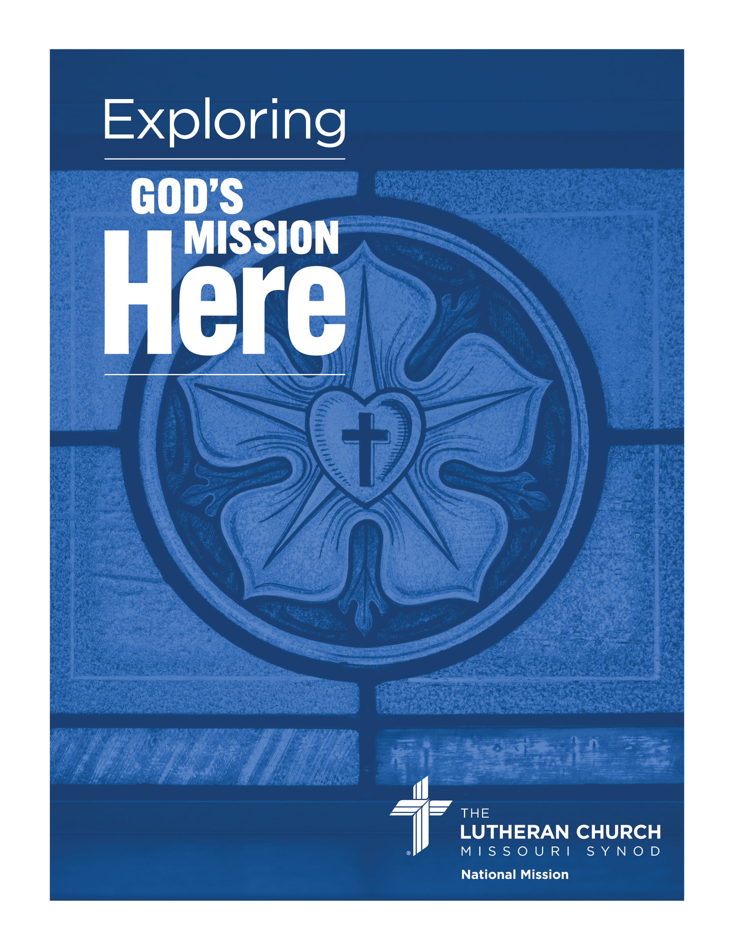
Facilitator Instructions and Mapping Key
Appraisal Questions Mapping Key and Results
Notes for Facilitator
Provide the mapping key (pages 2-9 below) only after the participants have completed all the appraisal questions in parts 2, 3 and 4.
The participants will use the mapping key to create a scatter diagram (Step 1 in Part 5 Appraisal). Encourage participants to complete the scatter diagram without commentary or analysis (that was captured when answering the appraisal questions earlier).
After the participants have completed mapping their answers, have them summarize the results (Step 2 in Part 5 Appraisal).
If there are multiple small groups of participants, combine the results from the small groups for the congregation.
After all results are compiled, identify which of the four focus areas is predominant in the mapping. (Note: In some cases, there may be two focus areas that are predominant. In such cases, highlight that this indicates that the congregation has a wider range of options than congregations with a single predominant focus area.)
It should be noted that neither the questions nor the answer choices are weighted in any way. Thus, it would be appropriate for the facilitator to look through the questions and answer choices in advance of the session to determine if some are more relevant for the local context of the congregation. These questions should be identified in the scoring boxes.
After identifying the predominant focus area, share the descriptive titles for the focus areas:
I – Alignment
II – Revitalization
III – Church Planting/Replanting
IV – Finishing Well
Then reiterate the focus area that is predominant for the congregation based on the mapping of the appraisal questions. Also, share with the group the locations of the most relevant questions as identified earlier and consider the ways in which these might affect the predominant focus area.
Continue the Bible Study and Discussion using the resources for the identified focus area. The resources available through the Office of National Mission by focus area are:
I – Alignment (Partnerships) Partnership Project Resources
II – Revitalization LCMS Revitalization Resources
III – Church Planting/Replanting LCMS Church Planting Resources
IV – Blessed End
Complete the Bible Study and Discussion with Part 6: What Will We Do?
Appraisal Questions Mapping Key

Using the following answer key, enter the question number in the diagram on the “Part 5 Appraisal” page for each answer from the appraisal questions. Note that many of your answers will lead to more than one number being entered into the diagram. For example, if your answer for question 2-1 (see below) was “d”, you would enter “2-1” into each of boxes I and II. If your answer for question 2-1 was “e”, you would enter “2-1” into each of boxes I, II, and III.

2-1. Which statement best describes the growth or decline of our community?

a. IV
b. III
c. II
d. I, II
e. I, II, III

2-2. Which statement best describes the economic status of our community?

a. IV
b. I, II
c. I, II
d. I, II
e. I, II, III

2-3. Is there a significant change expected in our community that might have an impact on our population and/or economy (e.g., the loss of a major employer or a new employer coming into the community)?

a. IV
b. I, II
c. I, II
d. I, II
e. I, II, III

2-4. Which statement best describes the changes in the demographic make-up of our community over the past ten years?

a. I, II
b. I, II
c. I, II
d. I, II, III
e. I, II, III

2-5. Which statement best describes the demographic make-up of our congregation compared to the make-up of our community?

a. I, II
b. I, II
c. I, II
d. I, II, III

2-6. Which statement best describes the religious nature of our community?

a. IV
b. II
c. II
d. II, III
e. II, III

2-7. What is the driving distance from our congregation to the nearest LCMS congregation?

a. I, IV
b. I, IV
c. II
d. II
e. II, III

2-8. If our congregation were to close what are the majority of our current members most likely to do?

a. I, IV
b. I, IV
c. II
d. II
e. II

3-1. Which statement best describes how our congregation is receiving pastoral care?

a. I, II, III
b. I, II
c. I
d. I
e. I
f. I, IV
g. I, IV

3-2. [If question 3-1 was answered “a”] What percentage of our district’s compensation guidelines are we currently providing in our pastor’s compensation?

a. I, II
b. I, II
c. I
d. I
e. I, IV
f. I, IV

3-3. How many hours per week does our pastor work in a second occupation to supplement his income from the congregation?

a. I, II
b. I, II
c. II
d. I, IV
e. I, IV
f. I, IV
g. I, II

3-4. How long has our pastoral care situation been what it now is?

a. I, II
b. I, II
c. I, IV
d. I, IV

3-5. How many pastors have served our congregation on an ongoing basis over the past ten years (i.e., including interim pastors but excluding visiting pastors)?

a. I, II
b. I, II
c. I, II
d. I
e. I, IV

3-6. Over the past ten years, how many different sole or senior pastors (other than vacancy or interim pastors) have served our congregation?

a. I, II
b. I, II
c. I, II
d. I
e. IV

3-7. How old is our current pastor?

a. I, II
b. I, II
c. I, II
d. I
e. I, IV
f. I, IV

3-8. Without borrowing any money or using a line of credit, how long could our congregation continue ministry if all contributions stopped today?

a. IV
b. IV
c. I, IV
d. I, II
e. I, II, III

3-9. What is our status with Concordia Plans or another benefits provider?

a. II
b. I
c. I, IV
d. I, IV
e. I, IV

3-10. What is our status on our mortgage or facility lease payments?

a. II, III
b. II
c. I, II
d. I, II
e. I, IV

3-11. [If you answered 3-10 “c”, “d”, or “e”] Which action best describes our current situation?

a. I, II
b. I, II
c. I, II
d. I, IV
e. I, IV

3-12. Which of the following statements best describes our congregation’s debt status?

a. I, II, III
b. I, II
c. I
d. I
e. I, IV
f. I, IV

3-13. What is the status of our congregation’s line of credit?

a. I, II
b. I, IV
c. I, II
d. I, II
e. I, II
f. I, II
g. I, IV

3-14. How do this year’s weekly offerings (excluding special gifts) compare to last year’s weekly offerings?

a. II, III
b. II
c. II
d. I, II
e. I, IV

3-15. What percentage of our current budget is designated for supporting outside entities (e.g., District support, funding missionaries, contributing to Seminaries or Concordia Universities, supporting RSOs, etc.)?

a. I, IV
b. II
c. II
d. II
e. II, III

4-1. How does our total worship attendance compare to what it was 5 years ago?

a. I, IV
b. I, II
c. I, II
d. II
e. II, III

4-2. How many local children have been baptized in our congregation during the past 3 years?

a. I, IV
b. I, II
c. I, II
d. II
e. II, III

4-3. How many local children have been confirmed in our congregation during the past 3 years?

a. I, IV
b. I, II
c. I, II
d. II
e. II, III

4-4. How many local adults have been baptized in our congregation during the past 3 years?

a. I, IV
b. I, II
c. I, II
d. II
e. II, III

4-5. How many local adults have been confirmed in our congregation during the past 3 years?

a. I, IV
b. I, II
c. I, II
d. II
e. II, III

4-6. How many funerals for local congregational members have we conducted during the past year?

a. II
b. I, II
c. I, II
d. II
e. II, IV

4-7. On average, how many unique first-time local visitors per congregational family unit (i.e., people from the same household) have we had during the past year? For example, if a congregation has 10 family units and there have been 35 unique local visitors during the year, the answer would be “c” (35/10 = 3.5 visitors per family unit).

a. I, IV
b. I, II
c. I, II
d. II
e. II, III

4-8. Over the past year, what percentage of local first-time visitors returned for a second or subsequent visit?

a. I, IV
b. I, II
c. I, II
d. II
e. II, III

4-9. What percentage of our current members have been members for 5 or more years?

a. II
b. II
c. II
d. I, II
e. I, IV

4-10. On average, how many people attended weekly worship service during the past year?

a. I, IV
b. I, II
c. I, II
d. II
e. II, III

4-11. How many conflicts have there been in our congregation within the past ten years that led to a loss of contributions, a loss of membership, or our pastor leaving?

a. III
b. I, II
c. I, IV
d. IV

4-12. Our congregation is united in vision and practice.

a. III
b. III
c. II
d. I, II
e. IV

4-13. Our congregation has a clear mission and purpose.

a. III
b. III
c. II
d. I, II
e. IV

4-14. Which image best describes the age distribution of active membership within our congregation? (The wider the bar, the higher the percentage for that age range.)

a. IV
b. I, IV
c. II
d. II, III
e. III

Supplemental Materials for the Facilitator
Foundational Questions
Note: These foundational questions are not necessarily the questions that the congregational leaders and members will discuss. Instead, these question shape the narrative that frames the discussion and leads to the discussion questions.
- What does God’s Mission look like in our context?
  - What is God’s Mission?
  - What is our current context?
    - Who are the people who make up our community?
      - Demographics (e.g., Mission InSite)
    - What is the economic situation in our area?
    - What are the prospects for our community?
  - Is our congregation needed in our current context?
    - Are there other congregations that can reach the lost people in our community with the pure Gospel?
    - What other options for faithful Word and Sacrament ministry are available to our members?
- What has God provided for us to do our part in His Mission?
  - What resources has the Lord provided (e.g., people, leaders, facilities, money)?
  - Are the resources we have adequate to do the work that we desire to do?
    - Assessment of congregation’s health (viability)
    - Determining the season of ministry (e.g., Pacific-Southwest District’s categories)
- Given our congregation’s context and status, how can we best serve the people God has called us to serve?
  - Do we have the time, energy, resources, and desire to revitalize on our own?
  - What partnership opportunities exist?
  - What are the pros and cons of forming a multi-congregation parish?
  - What would finishing well look like?
    - What would happen to our members?
    - Who would continue God’s Mission in our community?
    - How could we support God’s Mission elsewhere?
Workshop Schedule

A discussion-based Bible study shouldn’t be constrained by a rigid schedule. However, it’s imperative that the participants complete the entire workshop in the time available. The following schedule provides guidelines to keep the workshop on track. Adjust as necessary and add time for breaks and/or a meal.

Session | Time Allotted for Study | Time Allotted for Discussion Questions | Time Allotted for Appraisal | Total Time Allotted for Session
Introduction | 10 | n/a | n/a | 10
Part 1:God’s Ongoing Mission | 15 | 15 | n/a | 30
Part 2: The People Whom God Has Called Us to Serve | 15 | 15 | 30 | 60
Part 3: What Can We Do? | 15 | 20 | 40 | 75
Part 4: What Have We Been Doing? | 15 | 15 | 30 | 60
Part 5: What Should We Do? | 15 | 15 | 30* | 60
Part 6: What Will We Do? | 15 | 15 | n/a | 30
Total | 1 hr 40 min | 1 hr 35 min | 2 hr 10 min | 5 hrs 25 min

* Includes time for presenting resources for focus areas based on appraisal results

