
Appraisal Questions

Part 2 Appraisal Questions

2-1. Which statement best describes the growth or decline of our community?

a. The population in our community is significantly declining.
b. The population in our community is somewhat declining.
c. The population in our community is steady.
d. The population in our community is somewhat growing.
e. The population in our community is significantly growing.

2-2. Which statement best describes the economic status of our community?

a. The economy of our community is significantly worsening.
b. The economy of our community is somewhat worsening.
c. The economy of our community is holding steady.
d. The economy of our community is somewhat growing.
e. The economy of our community is significantly growing.

2-3. Is there a significant change expected in our community that might have an impact on our population and/or economy (e.g., the loss of a major employer or a new employer coming into the community)?

a. Yes, it will have a significant negative impact on our community.
b. Yes, it will have a minor negative impact on our community.
c. No, there’s nothing in the near future.
d. Yes, it will have a minor positive impact on our community.
e. Yes, it will have a significant positive impact on our community.

2-4. Which statement best describes the changes in the demographic make-up of our community over the past ten years?

a. There hasn’t been any significant demographic change in our community.
b. There’s been some demographic change in our community, but it hasn’t changed much.
c. Our community has noticeably changed but it is mostly the same.
d. The demographic make-up of our community has changed significantly.
e. Our community is completely different.

2-5. Which statement best describes the demographic make-up of our congregation compared to the make-up of our community?

a. The mix of people in our congregation is very similar to that of our community.
b. The mix of people in our congregation is becoming more like that of our community.
c. The mix of people in our congregation is becoming less like that of our community.
d. The mix of people in our congregation is unlike that of our community.

2-6. Which statement best describes the religious nature of our community?

a. Most people attend a Christian church of some kind.
b. Most people attend a non-Christian church.
c. Most people are loosely connected to a Christian church.
d. Most people are not interested in organized religion.
e. Most people are not interested in spiritual matters.

2-7. What is the driving distance from our congregation to the nearest LCMS congregation?

a. Under 10 minutes
b. 11-20 minutes
c. 21-30 minutes
d. 31-45 minutes
e. Over 45 minutes

2-8. If our congregation were to close what are the majority of our current members most likely to do?

a. Attend the nearest LCMS congregation.
b. Attend another Lutheran congregation.
c. Attend a Protestant or non-denominational church.
d. Attend a Roman Catholic church.
e. Stop attending church or attend a church online.

Part 3 Appraisal Questions

3-1. Which statement best describes how our congregation is receiving pastoral care?

a. We have a called pastor serving us full-time.
b. Our pastor works another job in addition to serving us.
c. We share a pastor with one or more other congregations.
d. We have a retired pastor or interim pastor serving us as a vacancy pastor.
e. A pastor from a neighboring congregation is serving us as a vacancy pastor.
f. We have to find available pastors on a weekly or monthly basis.
g. We don’t have a pastor at this time.

3-2. [If question 3-1 was answered “a”] What percentage of our district’s compensation guidelines are we currently providing in our pastor’s compensation?

a. 100% or more
b. 90-99%
c. 80-89%
d. 70-79%
e. Under 70%
f. N/A

3-3. How many hours per week does our pastor work in a second occupation to supplement his income from the congregation?

a. 0
b. 1-10
c. 11-20
d. 21-30
e. 31-40
f. Over 40
g. N/A

3-4. How long has our pastoral care situation been what it now is?

a. Less than one year
b. 1-3 years
c. 3-5 years
d. More than five years

3-5. How many pastors have served our congregation on an ongoing basis over the past ten years (i.e., including interim pastors but excluding visiting pastors)?

a. 1
b. 2
c. 3
d. 4
e. 5 or more

3-6. Over the past ten years, how many different sole or senior pastors (other than vacancy or interim pastors) have served our congregation?

a. 1
b. 2
c. 3
d. More than 3
e. None

3-7. How old is our current pastor?

a. Under 40
b. 41-50
c. 51-60
d. 61-70
e. Over 70
f. N/A

3-8. Without borrowing any money or using a line of credit, how long could our congregation continue ministry if all contributions stopped today?

a. 1 month or less
b. Up to six months
c. Up to one year
d. Up to two years
e. More than two years

3-9. What is our status with Concordia Plans or another benefits provider?

a. Current
b. 30-60 days behind
c. 61-90 days behind
d. More than 90 days behind
e. N/A (we don’t pay for church worker benefits)

3-10. What is our status on our mortgage or facility lease payments?

a. We don’t have a mortgage (i.e., we own our property free and clear).
b. We are current on our payments.
c. We owe 2 payments.
d. We owe 3 payments.
e. We owe 4 or more payments.

3-11. [If you answered 3-10 “c”, “d”, or “e”] Which action best describes our current situation?

a. We have contacted our lender and are awaiting instructions.
b. We are making interest-only payments.
c. We are in the process of refinancing our mortgage.
d. We have already refinanced our mortgage (and are behind again).
e. We are in default (we are facing foreclosure/eviction).

3-12. Which of the following statements best describes our congregation’s debt status?

a. We don’t have any debts.
b. We are current on paying our debts.
c. We are 30-60 days behind on our debt payments.
d. We are 61-90 days behind on our debt payments.
e. We are 91-120 days behind on our debt payments.
f. We are more than 120 days behind on our debt payments.

3-13. What is the status of our congregation’s line of credit?

a. We do not have a line of credit, though we are able to secure one.
b. We do not have a line of credit and are not able to secure one
c. Our line of credit balance is 0.
d. Our line of credit balance is under 25% of the amount available.
e. Our line of credit balance is over 25% but under 50% of the amount available.
f. Our line of credit balance is over 50% but under 75% of the amount available.
g. Our line of credit balance is over 75% of the amount available.

3-14. How do this year’s weekly offerings (excluding special gifts) compare to last year’s weekly offerings?

a. Significantly higher
b. Somewhat higher
c. About the same
d. Somewhat lower
e. Significantly lower

3-15. What percentage of our current budget is designated for supporting outside entities (e.g., District support, funding missionaries, contributing to Seminaries or Concordia Universities, supporting RSOs, etc.)?

a. 0%
b. 1-3%
c. 4-8%
d. 9-10%
e. More than 10%

Part 4 Appraisal Questions

Note: ‘Local’ refers to people living in your community (members and nonmembers). It does not include people who live outside of the community, such as out-of-town relatives.

4-1. How does our total worship attendance compare to what it was 5 years ago?

a. Significantly lower
b. Slightly lower
c. About the same
d. Slightly higher
e. Significantly higher

4-2. How many local children have been baptized in our congregation during the past 3 years?

a. None
b. 1-2
c. 3-4
d. 5-6
e. More than 6

4-3. How many local children have been confirmed in our congregation during the past 3 years?

a. None
b. 1-2
c. 3-4
d. 5-6
e. More than 6

4-4. How many local adults have been baptized in our congregation during the past 3 years?

a. None
b. 1-2
c. 3-4
d. 5-6
e. More than 6

4-5. How many local adults have been confirmed in our congregation during the past 3 years?

a. None
b. 1-2
c. 3-4
d. 5-6
e. More than 6

4-6. How many funerals for local congregational members have we conducted during the past year?

a. None
b. 1-2
c. 3-4
d. 5-6
e. More than 6

4-7. On average, how many unique first-time local visitors per congregational family unit (i.e., people from the same household) have we had during the past year? For example, if a congregation has 10 family units and there have been 35 unique local visitors during the year, the answer would be “c” (35/10 = 3.5 visitors per family unit).

a. Less than 1
b. 1.0-2.9
c. 3.0-4.9
d. 5.0-6.9
e. 7 or more

4-8. Over the past year, what percentage of local first-time visitors returned for a second or subsequent visit?

a. Less than 10%
b. 10-25%
c. 26-50%
d. 51-75%
e. Over 75%

4-9. What percentage of our current members have been members for 5 or more years?

a. Less than 25%
b. 26-50%
c. 51-75%
d. 76-90%
e. Over 90%

4-10. On average, how many people attended weekly worship service during the past year?

a. Less than 25
b. 25-50
c. 51-75
d. 76-100
e. Over 100

4-11. How many conflicts have there been in our congregation within the past ten years that led to a loss of contributions, a loss of membership, or our pastor leaving?

a. 0
b. 1
c. 2
d. 3 or more

4-12. Our congregation is united in vision and practice.

a. Strongly agree
b. Agree
c. Neither agree nor disagree
d. Disagree
e. Strongly disagree

4-13. Our congregation has a clear mission and purpose.

a. Strongly agree
b. Agree
c. Neither agree nor disagree
d. Disagree
e. Strongly disagree

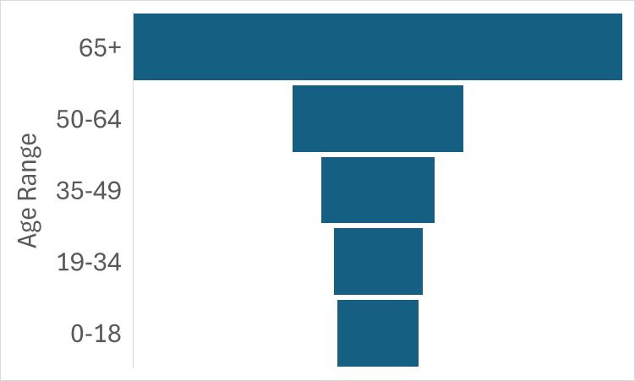
4-14. Which image best describes the age distribution of active membership within our congregation? (The wider the bar, the higher the percentage for that age range.)
a.


b.

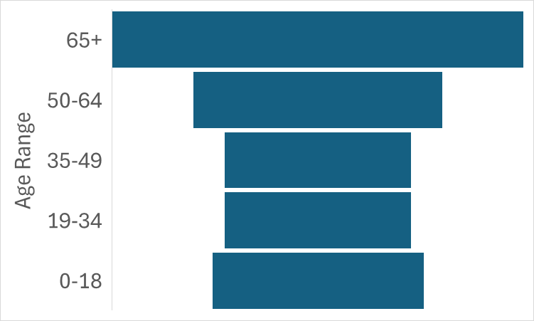
c.

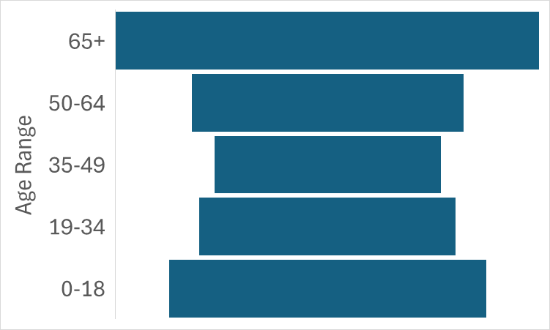
d.


e.

